**CORRELATION BETWEEN THE FORMATIVE AND SUMMATIVE SCORE ASSESSMENTS AMONG THE II YEAR PATHOLOGY STUDENTS, KANYAKUMARI MEDICAL COLLEGE**

**P.Leo David1, Valarmathi.S2, Krishna Prasanth.B3**

1. Professor, Department of Pathology, Kanyakumari Medical College.

2. Research Officer(Statistics), The TamilNadu Dr. M.G.R Medical University

3. Assistant Professor & Epidemiologist, Venkateshwara Institute of Medical Sciences, Gajraula, Uttar Pradesh.

**ABSTRACT**

**Introduction:** Regular, on-going formative assessments and the end of term summative assessment are used to assess students’ progress. The literature regarding the coincidental use of both types of assessment is scarce. This study investigated whether there was any correlation between the routinely used formative assessment,as prescribed by the University and the final summative assessment marks. **Materials and Methods:** The formative assessment (internal assessment marks) and summative assessment (University marks) in both theory and practical examinations of II M.B.B.S. students of Pathology who appeared for the University examination (summative assessment) in February 2014 (n=89) and February 2015 (n=95), were analysed statistically using mean, standard deviation, correlation and Chi square. **Results:** The mean mark was higher in summative assessment, both in theory and practical for both the batches. The standard deviation is highest (σ= 9.97) for the theory summative assessment mark in February 2015 batch. Positive significant correlation was observed between the formative and summative assessment marks both in theory and practical examinations.

**Conclusion:** This study reveals that the students who performed well in formative assessment got better marks in summative assessment too. Summative assessment marks are more than the formative assessment marks. Positive significant correlation was found between formative and summative assessment marks. The predictive validity of formative assessment is good.

**i. Background**

It is the responsibility of the teacher to report on students’ progress through assessment. Formative and summative assessments are considered as a must for learning. They play an important role in grading the students. So it is imperative to evaluate whether the assessment system that is prevailing is valid, facilitates learning and assesses the progress of the students.

Formative assessments are an integral part of learning. Formative assessment is commonly referred to as assessment for learning in which the focus is on monitoring student response and progress with instruction. It provides immediate assessment for learning.

Summative assessment is commonly referred to as assessment of learning; focus is on determining what the student has learned at the end of a grade level or term or certifying a degree. It is assessment of learning.

Formative (Internal)assessment system is often criticized as there is misuse of power by the faculty who handle the subject. The internal marks scored by the students are more than that of the external marks as the teachers are liberal in awarding marks. However there are situations where the external marks (University examination) are more than internal marks. Hence it is the duty of the researchers to find out whether the internal marks are more and if yes, what are the reasons for that? or the external marks are more and if yes, what are the reasons for that?

The purpose of this study is to establish if there is a relationship between formative and summative assessment.

**ii. Review of Literature**

Assessment has a strong impact on what and how students study, how much they have to study and how effectively they study.1 Both formative and summative assessment are the two methods that are commonly used in education to assess the progress of the students.2 It is reasonable to suggest that marks obtained in the formative assessment of students’ progress might correlate with their performance in the summative assessment. If not, the validity of both the assessments should be questioned. 2 The past assessments may predict the future examination results. One study suggests that formative and summative examination can be used to predict the Physician Assistant National Certifying Examination (PANCE) scores. 3

**iii. Aims and Objectives**

* To compare the formative assessment marks with the summative assessment marks and to assess the predictive validity of formative assessment on the summative assessment.

**iv.Methodology**

Ethics committee clearance was obtained from Kanyakumari Government Medical College.

The type of study design is descriptive. Formative assessment (internal assessment) and summative assessment (University Examination) marks of the II. M.B.B.S students from Pathology department of Kanyakumari Government Medical College who appeared for the University examination of February 2014 (n=89) and February 2015 (n=95), were collected. Both theory and practical marks were analysed separately.

The question paper patterns and total marks in both formative and summative examinations were identical. Analytical tools like mean, standard deviation and correlation were applied.To test the difference between formative and summative assessment marks χ2 (Chi square) test was done.

**v. Observation andResults**

**a. Analysis of Marks**

Marks collected were related to two academic years, 2014 and 2015. Table 1 and 2 shows the percentage of formative and summative assessment marks in both theory and practical examinations scored by the students.

**Table 1: Percentage of Marks Scored by Students in 2014**

|  |  |  |  |  |
| --- | --- | --- | --- | --- |
| **Marks**  **(%)** | **No. of Students** | | | |
| **Practical Marks** | | **Theory Marks** | |
| **Formative assessment** | **Summative assessment** | **Formative assessment** | **Summative assessment** |
| 0-20 | 0 | 0 | 1 | 0 |
| 21-30 | 0 | 0 | 4 | 0 |
| 31-40 | 6 | 0 | 25 | 0 |
| 41-50 | 23 | 0 | 46 | 0 |
| 51-60 | 47 | 17 | 12 | 6 |
| 61-70 | 10 | 16 | 1 | 35 |
| 71-80 | 3 | 33 | 0 | 40 |
| 81-90 | 0 | 20 | 0 | 7 |
| >90 | 0 | 3 | 0 | 1 |
| Total | 89 | 89 | 89 | 89 |

**Table 2: Percentage of Marks Scored by Students in 2015**

|  |  |  |  |  |
| --- | --- | --- | --- | --- |
| **Marks**  **(%)** | **No. of Students** | | | |
| **Practical Marks** | | **Theory Marks** | |
| **Formative assessment** | **Summative assessment** | **Formative assessment** | **Summative assessment** |
| 0-20 | 0 | 0 | 4 | 0 |
| 21-30 | 0 | 0 | 19 | 0 |
| 31-40 | 9 | 0 | 40 | 0 |
| 41-50 | 27 | 0 | 14 | 3 |
| 51-60 | 48 | 24 | 13 | 27 |
| 61-70 | 5 | 31 | 4 | 45 |
| 71-80 | 6 | 31 | 1 | 19 |
| 81-90 | 0 | 5 | 0 | 1 |
| >90 | 0 | 4 | 0 | 0 |
| Total | 95 | 95 | 95 | 95 |

The maximum marks for practical examination was 25 and for theory it was 80 in both formative and summative assessment . The marks scored by the students and their distribution is shown in the box plot (Diagrams 1, 2 and 3)

**Diagram 1: Examination Marks –Formative assessment**

**vsSummative assessment–February 2014 & 2015**

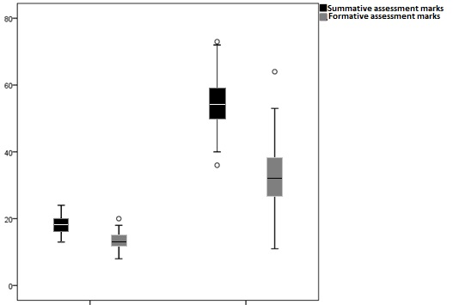

Practical Theory

**Diagram 2: Examination Marks – Formative assessment**

**vsSummative assessment– February 2014**

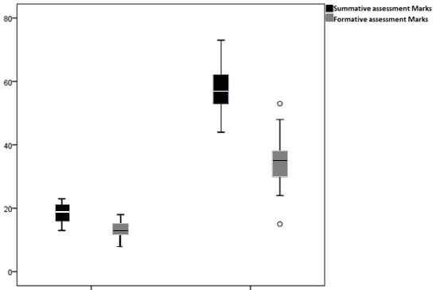

Practical Theory

**Diagram 3: Examination Marks –Formative assessment**

**vsSummative assessment – February 2015**

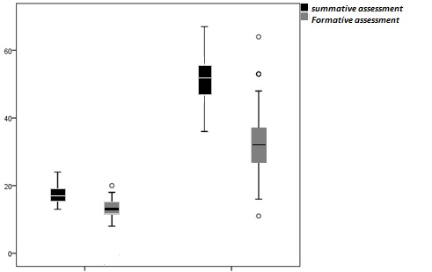

Practical Theory

**Table 3: Lowest and Highest Marks in Both Batches**

|  |  |  |  |  |  |  |  |  |
| --- | --- | --- | --- | --- | --- | --- | --- | --- |
| **Year** | **Practical Examination** | | | | **Theory Examination** | | | |
| **Formative assessment** | | **Summative assessment** | | **Formative assessment** | | **Summative assessment** | |
| **Lowest** | **Highest** | **Lowest** | **Highest** | **Lowest** | **Highest** | **Lowest** | **Highest** |
| 2014 | 8 | 18 | 13 | 23 | 15 | 53 | 44 | 73 |
| 2015 | 8 | 20 | 13 | 24 | 11 | 64 | 36 | 67 |

To analyse any data average () is the simplest method. Hence average was calculated for each set of values, i.e. formative assessment practical, summative assessment practical, formative assessment theory and summative assessmenttheoryfor the data in 2014 and 2015. The mean was higher in summative Examination both in practical and theory. To know the consistency of data, standard deviation (σ) is the very popular method. So it was applied. The different standard deviation values show, to what extent individual values differ from the central value. To find out the relation existing between formative assessment marks and summative assessment marks, correlation coefficient values were calculated. If the correlation coefficient value is very close to one, it will mean that they are closely related or one can easily conclude that those who have scored high marks in formative assessment also scored high marks in summative assessment examination. If the value is negative then it will mean that those who have scored high marks in formative assessment have scored low marks in summative assessment examination. However, all the above calculated values cannot exactly measure whether the difference existing betweenformative assessment and summative assessment marks was significant or not. To know this Chi square (χ2) values were calculated. All calculated values are presented in the following tables (Table 4, 5, 6 & 7).

**Table 4: Calculated Values for Practical Examination– February 2014**

|  |  |  |  |  |
| --- | --- | --- | --- | --- |
|  | Mean | SD | Correlation Coefficient  (r) | Chi square test  (χ2) |
| **Formative assessment Marks** | 13.45 | 2.04 | 0.16  (0.13) | 14.4  (0.000) |
| **Summative assessment Marks** | 18.43 | 2.90 |

**Table 5: Calculated Values for Theory Examination – February 2014**

|  |  |  |  |  |
| --- | --- | --- | --- | --- |
|  | Mean | SD | Correlation Coefficient  (r) | Chi square test  (χ2) |
| **Formative assessment Marks** | 34.56 | 6.27 | 0.51  (0.000) | 35.59  (0.000) |
| **Summative assessment Marks** | 57.37 | 5.93 |

**Table 6: Calculated Values for Practical Examination –February 2015**

|  |  |  |  |  |
| --- | --- | --- | --- | --- |
|  | Mean | SD | Correlation Coefficient  (r) | Chi square test  (χ2) |
| **Formative assessment Marks** | 13.27 | 2.14 | 0.39  (0.000) | 15.01  (0.000) |
| **Summative assessment Marks** | 17.26 | 2.51 |

**Table 7: Calculated Values for Theory Examination –February 2015**

|  |  |  |  |  |
| --- | --- | --- | --- | --- |
|  | Mean | SD | Correlation Coefficient  (r) | Chi square test  (χ2) |
| **Formative assessment Marks** | 31.85 | 9.97 | 0.35  (0.001) | 19.92  (0.000) |
| **Summative assessment Marks** | 51.54 | 5.76 |

**vi. Discussion**

The main aim of formative assessment is to guide and train the students towards successful completion of a semester or course. Is there a statistically significant correlation between formative and summative examination results?

Regarding the practical examination in both the years, the summative assessment marks are more than the formative assessment marks. The average () formative assessment practical mark is only around 13 while it is around 18 for the Summative practical examination for both the batches. On the other hand the Summative theory marks are much higher than the formative theory marks. The mean of formative theory marks is 34.56 in 2014, while it is 31.85 in 2015. On the other hand the mean of summative marks is 57.37 in 2014 whereas it is 51.54 in the year 2015. It means that the average marks scored in 2014 is higher than the average marks scored in 2015. Further it is also easy to observe that there is a wide range in the marks scored in formativetheory examination than the marks scored in University theory examination.

The standard deviation values show that there is very limited inconsistency (less deviation) among the practical examination marks in both the years. Against this there is high variation in theory marks. It is the maximum (σ=9.97) for the formative assessment theory marks in 2015. All these mean that the examiners are consistent in giving marks for practical examination while it is not so for the theory examination. This may be due to the fact that Summative assessment theory examination is controlled by the University i.e. preparation of question paper and valuation of answer sheets are by the University. But as far as practical is concerned both the formative and summative assessment examinations are under the control of the department.Even though external examiners will be present for University practical examination, the exam pattern and questions will be more like an formative examination and also the presence of internal faculty as one of the examiners may also influence University practical examination.

It is a natural instinct for the researchers to know whether the students who have scored high marks in internal have scored high marks or low marks in University examination. For that, the correlation values were calculated. Correlation coefficient values and their significance levels shown in brackets (Table 4,5,6,7) indicate that there is positive significant correlation between internal and University marks except for the internal practical marks and University practical marks in 2014. It clearly indicates that the students who have scored high marks in internal have scored high marks in University examination and the students who have scored low marks in internal have scored low marks in University examination.

As it is very clear from various average () values there is difference between internal marks and University marks. Internal marks for all examinations are lower than the University marks. However, it is not possible to say that the internal marks are less than University marks unless testing tools are applied. The χ2 values calculated show whether the difference is significant or not. It is highly interesting to know that all χ2 values significantly indicate that University marks are more than internal marks. Correlation has been reported between the internal assessment marks and the term–end examination scores.4 In one another study the external assessment scores tend to be higher.5 One more study shows students who scored high in the formative assessment managed to get only medium scores in the summative assessment and vice versa.6

**vii. Conclusions**

Student who performed well in the formative assessment could reasonably be expected to perform better in their summative assessment. This study reveals that the students who performed well in formative assessment got better marks in summative assessment too. Summative assessment marks are more than the formative assessment marks.Positive significant correlation was found between formative and summative assessment marks.The predictive validity of formative assessment is good.

**viii. Implications**

This study can be extended to analyse the rank correlation. All departments of this college and also other colleges can conduct this study. The results give an idea whether the current methods of assessments are valid and reliable. Based on the observation the formative and summative assessments can be modified.

**ix. Ethics committee approval-** This study was duly approved by the ethics committee of Goverment Kanyakumari Medical College & Hospital.

**x. Source of funding-** self

**xi.Conflicts of Interest-** None

**xii. REFERENCES**

1. Jimma S. The impact of assessment on student learning. Procedia – Social and Behavioural Sciences. 2011; 28: 718-21.
2. Helen Anziani, Justin Durham, Undrell Moore. The relationship between formative and summative assessment of undergraduates in oral surgery. Eur J Dent Educ. 2008: 12: 233-38.
3. Scott Massey, John Stallman, Louise Lee, Kathy Klingaman, David Holmerud. The Relationship between formative and summative examinations and PANCE scores; can the past predict the future? The Journal of Physician Assistant Education. 2011; vol22 No.1: 41-45.
4. Gunasekaran K, Jeyanthi P.A. study of the continuous internal assessment and the university examination marks of the undergraduate semester course (1976-77 batch). Examination Reform Unit. Madras University. 1980-3.
5. Nath B. University examination – an analytical study of the conduct of pre-university degree and master degree examinations of Gauhati University. Ph.D. Edu., Gauhati University. 1980-3.
6. Rajalingam S, Zeya Oo. Finding the correlation between formative and summative assessments by Spearman’s Correlation Coefficient: A Case Study [Internet]. Miri, Sarawaki: Curtin University; 2011 Nov. Available at: http://www.espace.library.curtin. edu.au/webclient/StreamGate?Folderid=0&dvs=1440822343124~936&usePid2=true (accessed on 27.05.15)