Dear Editor,

This is to confirm that the article titled *“The need for adolescent health programmes in India to have a community-based approach to be more effective”* submitted to the Indian Journal of Medical Ethics is original and has been authored by the undersigned.

The authors has participated in the work sufficiently to meet the ICMJE guidelines for authorship.

The submission is not under consideration for publication in any other journal.

Please contact Ojaswini for further correspondence.

The author has read the terms and conditions of authorship of IJME and accept them.

Contact details:

Ojaswini Bakshi

Mailing address: 34B, Centre for Media Studies, Anupam PVR Complex, Ashok Vihar, Saket, New Delhi, 110017

Email ID: [ojaswinibakshi@gmail.com](mailto:ojaswinibakshi@gmail.com)

Affiliation: Centre for Health and Mental Health, School of Social Work, TISS, Mumbai (2015-17)

Signatures of author:

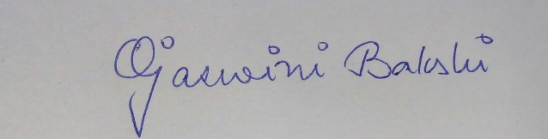

(Ojaswini Bakshi)