COVER LETTER

Dear Editor,

This is to confirm that the article entitled “The Ethics of Penal Amputations” submitted to the Indian Journal of Medical Ethics is original and has been co-authored by the undersigned.

All authors have participated in the work sufficiently to meet the ICMJE guidelines for authorship.

All have read and approved the manuscript.

The submission is not under consideration for publication in any other journal.

We give consent to Dr Anjan K Das to act as the author for correspondence.

Details of sponsorship or relevant competing interests, financial or otherwise: None

We have read the terms and conditions of authorship of IJME and accept them.

Contact details (mailing address, email id) and affiliation of all authors:

Dr Anjan K Das, Associate Professor,

Taylor’s University School of Medicine, Faculty of Health and Medical Sciences, Taylor’s University, 1, Jalan Taylor’s ,47500, Subang Jaya, Selangor, Malaysia .

Email : [AnjanKumar.Das@taylor’s.edu.my](mailto:AnjanKumar.Das@taylor's.edu.my)

Signatures

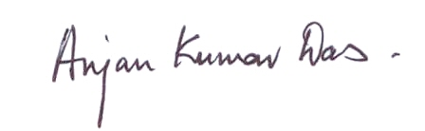

Anjan K Das

Dated: 27 July,2019