Patients' and Physicians' viewpoints on interns’ Professional Dressing: A survey in an Iranian teaching hospital

Fatemeh Fathian1, Mohammad Reza Shakibi2, Majid Fasihi Harandi3, Habibeh Ahmadipour4, Mina Mobasher5\*

1. Medical student, Afzalipour Faculty of Medicine, Kerman University of Medical Sciences, Kerman, Iran. Email: [F.fathian72@gmail.com](mailto:F.fathian72@gmail.com)
2. Associate Professor, Department of Internal Medicine, Afzalipour Faculty of Medicine, Kerman University of Medical Sciences, Kerman, Iran. Email: [mr\_shakibi@kmu.ac.ir](mailto:mr_shakibi@kmu.ac.ir)
3. Professor of Medical Parasitology, Research Center for Hydatid Disease in Iran, Afzalipour Faculty of Medicine, Kerman University of Medical Sciences, Kerman, Iran. Email: [majid.fasihi@gmail.com](mailto:majid.fasihi@gmail.com)
4. Associate Professor, Community and Family Medicine, Afzalipour Faculty of Medicine, Kerman University of Medical Sciences, Kerman, Iran. Email: h[abibehahmadipour@gmail.com](mailto:abibehahmadipour@gmail.com)
5. Assistant Professor, Department of Medical Ethics and History of Medicine, Faculty of Iranian Traditional Medicine, Kerman University of Medical Sciences, Kerman, Iran. Email: workmaiiiiil2019@gmail.com

The authors declare that they have no conflicts of interest in this study.

The authors declare this article doesn’t submit anywhere.

Abstract

This study aimed to investigate patients’ and physicians’ viewpoints on the professional outfits of interns in one of the teaching hospitals.

This is a descriptive–analytical, cross-sectional study, that was done in a teaching hospital of Kerman University of Medical Sciences in 2018.

Totally, 381 patients and 34 physicians participated in this study. Participants most often prefer professional outfit A for female interns and the professional outfit 1 for male interns in response to questions regarding their knowledge, responsibility, patient-care, hygiene, reliability of diagnosis and treatment of diseases, giving emergency consultations, the possibility for discussing sexual and psychiatric problems, as well as life problems.

Patients and physicians prefer professional style dressing for interns in the hospital. However, this selected clothing set was recommended in professional dress code in educational setting, which is barely obeyed by the Iranian interns. Therefore, training interns for this kind of dressing should be considered.

Key words: Dressing, Hospitals, Teaching, Iran, Physicians, Patients,

Introduction

A person’s appearance and his/her adherence to the dress code standards are essential in the medical profession. The very first encounter of physicians and patients, both verbally and non-verbally, plays an important role in forming their relationship. Thus, as the society grants especial privileges upon the medical society, it has certain expectations from them. Patients expect physicians to have a decent appearance, as well as an especial outfit, the one that represents respect and formality in their relation with the patients (1).

It was in the late 19th century, that the white uniform was chosen to be the physicians’ professional outfit. This may be due to its symbol of scientific credibility, sincerity and morality (2). In a study conducted in 2012, based on literature review and content analysis, 23 factors were derived for trust in the patient-physician relationship. As a result, the author states that, the trust between physicians and patients can be analyzed through three dimensions: from the patients’ perspective, the physicians’ perspective, and the third, from the perspective of the patient-physician relationship. The author believes that without knowing these factors and discerning them, one cannot analyze or see~~k~~ through the actual materialization of trust (2).

On the other hand, the appropriate appearance characteristics are the elements that increase trust toward the health service providers, since, the posture and behavior of physicians mean a lot to the patient and his/her family. Human interactions will be more efficiently executed through trust, and the existence of trust in the patient-physician relationship leads to autonomy of the patient and getting his/her informed consent for the medical interventions. (2) A doctor’s dress code is not just for the protection from microscopic beings, but it also is a symbol of qualification and the position of a physician. (3)

Furthermore, a study was conducted in 2011 on the views of interns and residents of three hospitals in Tehran based on the 5 dimensions of characteristics of appearance, the professional outfit, makeup, accessories and keeping personal hygiene by medical students. It turned out that being trained for using the professional outfit is an important measure to be taken toward the promotion of the standards of the dress code for the students, the codification of which will be of great help to this purpose. (4)

Numerous studies have shown that patients consider the outfit of a doctor as a criterion of his/her qualification, as well as an indicator of his/her professional abilities. Therefore, the patients’ satisfaction of medical services is affected by the physicians’ professional appearance (1). In a study in 2008 about the views of psychologists and the psychology assistants toward the effect of physical appearances on disentangling and comforting patients to communicate, they found that paying attention to the appearance of the psychologist and how they address the patients’ need according to their characteristics will significantly improve patient-physician relationship (1).

As a result, informing medical students from their professional role, and their position as the representatives of the medical society, leads to future adoptions of professional behavior principles and to educate the future professionals in the field of medicine in the country, as well as having the development of respect for this sacred profession. This important notion will bring about a suitable perspective and a professional performance of the students during their training time in academic centers. In order to plan for adopting the necessary measures, we should consider the views of stakeholders on the underlying approaches, so that we end up having more precise schemes for this realm. Therefore, this study aimed to examine patients’ and physicians’, currently working in a teaching hospital of Kerman University of Medical Sciences, viewpoints on the issue of “interns’ dressing style.”

Methods

A descriptive–analytic cross-sectional study was carried out at Kerman University of Medical Sciences (KMUS), Kerman province in south- eastern of Iran from May to September, 2018. The statistical populations were all patients, who have been admitted to the internal medicine, surgery, pediatrics, and gynecology departments during the study period and all physicians working in these departments. Inclusion criteria for the patients were age equal or more than 18 years and an informed consent to participate. Patients with visual or auditory disorders, psychiatric patients who were not able to cooperate, patients who needed special care or those who could not be interviewed were excluded. Physicians entered the study after oral consent, regardless of their work experience.

In this study, schematic images were designed by an expert to examine the patients' and physicians’ perspective on the interns' professional dressing in the clinical setting. Some schematic images were designed based on the academic dressing codes, what is usually observed in the male and female interns' professional dressings at Iranian academic clinical setting, and literature reviews (1, 4, 5, and 6). The designed images were discussed and revised according to our expert panel and finally, six schematic images, three for males (1,2,3) and three for females (A, B, C), extracted and printed in color to use for the upcoming interviews. (Figure 1,2)

Data were collected through a structured interview by a trained interviewer (A medical student at the final stages of the internship). Then, the schematic images were displayed to the participants and they were asked to express their perspective on the images using a series of questions, eleven for the patients and eight for physicians. Questions were based on the review of similar literatures (5,6,7). In the first five questions (1,2,3,4,5), the participants were asked to express which of the interns; respecting to his/her dressing style, is more knowledgeable, responsible, reliable, and has careful attention to the patients and observance of the sanitation principles.

In the next five questions (6,7,8,9,10), the participants expressed which of the interns they preferred to talk with, according to his/her dressing style, about their therapeutic plan, psychiatric, sexual, and life problems or to have an emergency counselling. The questions about life, sexual, and psychiatric problems were asked only from the patients. The last question (No. 11) asked about which of the interns, the participants felt uncomfortable with. The participants' responses were recorded in an anonymous form. The participants were assured the data would be used only for research purposes. It took about ten to fifteen minutes to complete each interview. The study approved at KMUS ethics committee with the code: IR.KMU.REC.1396.1100.

Data were analyzed by SPSS version19 (SPSS Inc., Chicago, IL, USA) using chi square and Fisher exact test. The significant level was set as 0.05.

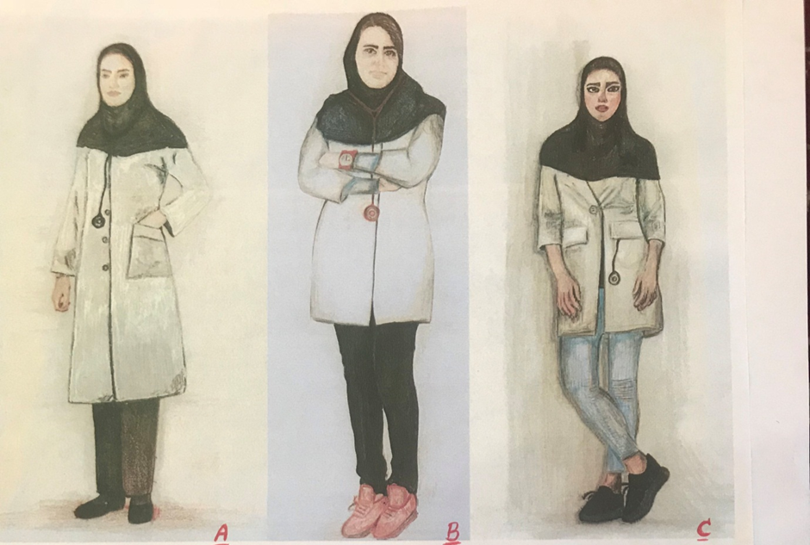

Figure1: The schematic images of female interns' professional dressings.

A: Hijab, no makeup looks, long and loose uniform, cotton pants, Suitable orthopedic Shoes

B: Hair out, without makeup, Short and tight uniform, Tight and bright pants, sport shoes

C: Hair out, with makeup, Short and tight uniform, Short and tight jeans, sport shoes

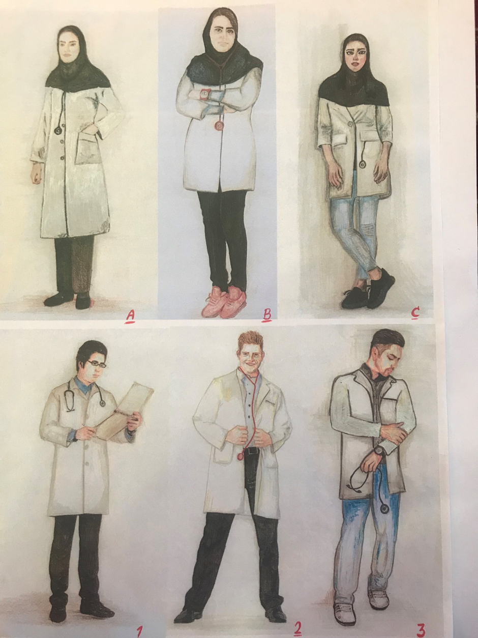

Figure2: The schematic images of male interns' professional dressings.

1: Ordinary hairdressing, Standard dress with closed buttons, Cotton trousers, Orthopedic Shoes

2: Special hairdressing, Standard dress with open buttons, Casual pants, Orthopedic Shoes

3: Special hairdressing, short dress with open buttons, jeans, sport shoes

Results

381 patients and 34 physicians participated in the study. The mean age of the patients and physicians were 34.4±11.2 and 40.0 ±2.8 years, respectively. The majority (56.2%) of the patients were female.

Figure 3 shows the frequency of the patients' perspective on the male interns’ professional dressing. Accordingly, among the three male interns' professional dressings, the patients expressed that the male interns with professional dressings similar to the image one, had more knowledge (81.4%), responsibility (81.4%), reliability (83.2%), careful attention to the patients (75.6%) and observance of the sanitation principals (63.8%). The patients expressed that they prefer to talk to male interns with professional dressings similar to the image one about their therapeutic plan (82.4%), psychiatric (74.0%), sexual (69.0%), and life (73.0%) problems and to have emergency counseling (79.5%) with him. The least (8.1%) discomfort was reported with this dressing style.

Figure 4 shows the frequency of the patients' perspective on the female interns’ professional dressing. Accordingly, among the three female interns' professional dressings, the patients expressed that female interns with professional dressings similar to the image A, had more knowledge (67.7%), responsibility (59.6%), reliability (68.5%), careful attention to the patients (53.0%) and observance of the sanitation principals (41.5%). The patients expressed that they prefer to talk to female interns with professional dressings similar to the image one about their therapeutic plan (64.6%), psychiatric (58.8%), sexual (58.5%), and life (65.1%) problems and to have emergency counselling (61.9%) with him. The least (7.3%) discomfort was reported with the female dressing style B.

The frequency of the physicians’ perspective on male and female interns’ professional dressing was just like the patient's perspective except for the discomfort criteria. Accordingly, most of the physicians had no idea on male interns’ professional dressing in this regard while expressing discomfort with female interns’ professional dressing image C.

Figure3: The frequency of the patients' perspective on male interns’ professional dressing: A teaching hospital, Kerman

Figure4: The frequency of the Patients' perspective on female interns’ professional dressing: A teaching hospital, Kerman

Discussion

According to the results, the importance of paying attention to the professional appearance of the medical students as well as instructing them in this field was demonstrated, and it turned out that physicians and patients who participated shared identical ideas, as they chose the outfit number one for the male and the outfit “A” for female interns, while answering the questions were about responsibility, patient care, hygiene, trustworthiness, the probability of initiating a negotiation or seeking counseling with the intern about the therapeutic plans and the emergency issues. Regarding the discomfort levels toward the presented outfits, they opted the outfit number 2 for male interns and the outfit “C” for the females.

According to the selected features of dress code in the current study, number one for male interns (an ordinary hairstyle, standard uniforms with buttons fastened, cotton pants, and orthopedic shoes), and the outfit A for female interns (wearing scarves, no-makeup looks, long and loose uniforms, simple cotton pants, suitable orthopedic shoes), it seems that in our society the professional dress code and its standards are acceptable as long as they are based on the dominant culture of the society. Patients and physicians conceive the qualification and the professional performance based on the dress code of male and female interns. In choosing the outfit number one for male and the outfit A for female interns, a high percentage of the patients associated them with the higher knowledgeability, while physicians held the opposite opinion about this issue. This notion is obvious that the professors contradict the patients, for they have a different sort of assessment toward the level of knowledge and information of the interns. The point to be made here is that, these results show how a special kind of professional dress code can acquire trust and approval of the patients to the extent that they believe a person with a decent professional outfit possesses a higher level of knowledge.

On the other hand, in expressing their discomfort with the presented outfits, the patients and the physicians shared the same opinion in choosing the outfit number 2 for male and outfit C for female interns’, so the conception of improper appearance was the same between the patients and physicians. Importantly, this shows that the two groups consider social norms through the same framework.

The results of our study comply with that of the other studies in different societies. In a study by Petrilli was conducted in ten academic centers in the US, with the use of questionnaires with pictures asking about the patients’ opinions about the effect of physicians’ dress codes, 4062 patients participated, 53% of who mentioned that the physicians’ dress code affect the treatment process, and that most of them preferred the white uniform (5).

In a research by Yonecura in 2013, in Brazil, 477 participants participated, for analyzing the views of patients and physicians and medical students’ pictorial questionnaire were used. Most of the patients, as well as physicians and medical students preferred the white uniform, as it showed more knowledgeability, trustworthiness, caring for patients, hygiene, responsibility, as well as the probability of discussing the treatment plans, emergency consulting, and talking about the life, psychiatric and sexual problems (6).

Another study in five different parts of Japan concluded that a doctor’s outfit is not only a way of protecting against microscopic beings, but it is also the symbol of qualification and position. The study by Kurihara, et.al reported that 70% of the participants believed that the outfits of physicians had affected their trust toward their physicians. Since most of the previous studies were conducted in one hospital or clinic, the results may be reflective of the culture of one specific environment and its effect on the patients (3).

In South Carolina, 400 patients participated in a study about the effect of the physicians’ dress code and decency of appearance on the degree of trust a patient has toward his/her doctor, 76.3% of the patients preferred the white uniform, derived by a pictorial questionnaire (7).

In the study by Batias in 2014, in Saudi Arabia, the patients’ views on the male physicians’ outfits, and with the use of a pictorial questionnaire, 311 patients participated, most of whom preferred the white uniform for the usual examinations and the treatment process, they also preferred the national white outfit of Saudi Arabia for expressing their sexual, psychological problems, as well as the life problems (8).

Apart from the cultural differences, these studies are similar to ours. The results of our study are differ the results of two of the studies. One of them is the study by Mason about the patients’ views on the outfits of physicians, that only 28% of the 295 patients chose the white uniform (9). Another study which was different from ours was the one conducted in Semnan about the views of psychologists about the outfits of psychologists, that 72.2% of them chose suits for male psychologists, and most of them preferred a uniform with color scarves for female psychologists. Needless to say, the opted choice was an instance of preference for professional outfit (1).

In a study by Edward about the views of patients about the outfits of surgeons in outpatient surgeries, most of them believed that a surgeon’s outfit will not affect the therapeutic services (10). In another study about the effect of a doctor’s outfit on the satisfaction of the patients in the gynecology department, as well as the emergency unit and the department of dermatology, most patients believed that the doctor’s outfit did not affect the degree of patients’ satisfaction (9, 11, 12).

Conclusion:

Our study shows that the outfits of physicians were considered by the participants in forming an effective relation between the doctor and the patient, the amount of patients’ trust, and generally the ease and accuracy of treatment. The long white uniform, orthopedic shoes and the no-makeup- look were selected for the best female look. Therefore, using an appropriate professional outfit based on the outfit number one for men and the outfit A for women was accepted by the patients and physicians. One point to be noted here is that, the results of this study were in line with most of the studies conducted in different societies and cultures. This shows a similar perception of the physicians’ professional dress code in different societies. However, it seems that more emphasis should be put upon the use of professional dress code of interns, who are the country’s future physicians, in educational and healthcare centers, so the interns will be aware of their professional role, and the effect it will have on their relation with the patients.

Limitation:

There were several limitations to this study:

1-There was a limited number of outfits for male and female interns, which was, on one hand, due to the limitation in choosing the proper dress code for the educational and health care environments, and on the other hand, due to the unfamiliarity of patients with the other outfits available for these environments.

2- The preparation of the hand drawn pictures was bound with problems, and it may also affect the patients’ perception of the selected outfit.

3-Researchers could not use real life pictures in order to demonstrate facial makeups and dress types, and chose to use hand drawn pictures complying with community norms.

Acknowledgment

The authors wish to express their deepest gratitude and warmest appreciation to the participants who have contributed and inspired the researchers to the overall success of the undertaking. This study was supported by a grant (number 9500641) from the Research Deputy of Kerman University of Medical Sciences.

References

1. Semnani Y, Shahpouri H-R. Psychiatrists’ attitude to the psychiatrist’s style of dressing and addressing. Iranian Journal of Forensic Medicine. 2007;13(1):21-4.

2. Shojaei A, Abolhasani-Niaraki F. Criteria of trust in the physician-patient relationship. Iranian Journal of Medical Ethics and History of Medicine. 2013;5(7):79-90.

3. Kurihara H, Maeno T, Maeno T. Importance of physicians’ attire: factors influencing the impression it makes on patients, a cross-sectional study. Asia Pacific family medicine. 2014;13(1):2.

4. Lorestani F, Dehghan-Nayeri N, Nouroozi M, Aramesh K. Dress code: interns' and trainees' perspective. Iranian Journal of Medical Ethics and History of Medicine. 2010;4(1):40-6.

5. Petrilli CM, Saint S, Jennings JJ, Caruso A, Kuhn L, Snyder A, et al. Understanding patient preference for physician attire: a cross-sectional observational study of 10 academic medical centres in the USA. BMJ Open. 2018;8(5).

6. Leiko Yonekura C, Certain L, Kee Karen SK, Sousa Alcântara GA, Gaspar Ribeiro L, Rodrigues-Júnior AL, et al. Perceptions of patients, physicians, and medical students on physicians’ appearance\*. Revista da Associação Médica Brasileira (English Edition). 2013;59(5):452-9.

7. Rehman S-U, Nietert P-J, Cope D-W, Kilpatrick A-O. What to wear today? Effect of doctor’s attire on the trust and confidence of patients. The American journal of medicine. 2005;118(11):1279-86.

8. Batais M-A. Patients’ attitudes toward the attire of male physicians: a single-center study in Saudi Arabia. Annals of Saudi medicine. 2014;34(5):383-9.

9. Mason L, Mason J. Patients’ attitudes regarding characteristics of physicians in ophthalmology. BMC Research Notes. 2017;10(1):733.

10. Edwards R-D, Saladyga A-T, Schriver J-P, Davis K-G. Patient attitudes to surgeons' attire in an outpatient clinic setting: substance over style. The American Journal of Surgery. 2012;204(5):663-5.

11. Fischer RL, Hansen CE, Hunter RL, Veloski JJ. Does physician attire influence patient satisfaction in an outpatient obstetrics and gynecology setting? American Journal of Obstetrics and Gynecology. 2007;196(2):186.e1-.e5.

12. Li S-F, Haber M. Patient attitudes toward emergency physician attire. The Journal of Emergency Medicine. 2005;29(1):1-3.