**Manuscript evaluation guidelines**Title:  
**Fake fades cost lives: Lessons from the sociolegal struggle with jeans sandblasting in Turkey**  
  
1. Importance of the paper  
  
           Does it address issues relevant to the fields of bioethics and medical ethics in the developing countries?

Yes  
  
2. Is it topical?  
  
           Is the issue discussed from another country's/culture perspective? Yes (Turkey)  
  
           Will it influence practice or policy? Yes- especially in South asia where awareness of this issue is low and textile industry is common  
  
           Is it too specialized for the journal? No- it is just right  
  
3. Originality  
  
           Is the information /comment new? It is a review of progress. There do not seem to be a similar collation of medical, labour and campaign references published elsewhere.

Is there any likelihood of plagiarism? Unlikely  
  
  
4. Conclusions  
           - Conclusions are warranted and the logic leading to them is articulated well  
  
           Does the article contain loose generalisations? There is one place where the size of sand used is confused with the silica particles reaching the alveoli  
  
           Are there any important omissions? Not apparent  
  
  
5. Other comments  
It may be possible to add a line or two (using the references from Sudhir Anand and Amartya Sen’s article) that state why it is **beneficial** and **just** to diagnose, campaign, legislate, monitor silicosis and listen to workers’ stories  
  
6. Recommendation  
  
   
  
 Accept with 2 minor modifications -  
  
-- one correction and one reference (it is mentioned later- but missed in the opening section). Both mentioned below in comments for author  
  
  
  
7. Separate comments for the author

i) Reference 1 and 28 could be introduced after this line- *Although widespread throughout the world, the first time this disease was associated anywhere with the sandblasting of denim was in Turkey in 2005*.

ii) Note

The particles reaching lung are not the sand (0.02 mm or larger) itself- “*Respirable*crystalline silica – very small particles at least 100 times smaller than ordinary sand you might find on beaches and playgrounds – is created (by).. (a)ctivities such as abrasive blasting with sand”… Size below 0.02mm is called silt. Size of silica to enter respiratory system are 10 microns= 0.01 mm (bronchus) and 2.5 microns= 0.0025 mm (alveolus)

Following may be of interest to lay readers-

Respirablecrystalline silica – very small particles at least 100 times smaller than ordinary sand you might find on beaches and playgrounds – is created when cutting, sawing, grinding, drilling, and crushing stone, rock, concrete, brick, block, and mortar. Activities such as abrasive blasting with sand; sawing brick or concrete; sanding or drilling into concrete walls; grinding mortar; manufacturing brick, concrete blocks, stone countertops, or ceramic products; and cutting or crushing stone result in worker exposures to respirable crystalline silica dust. Industrial sand used in certain operations, such as foundry work and hydraulic fracturing (fracking), is also a source of respirable crystalline silica exposure. <https://www.osha.gov/dsg/topics/silicacrystalline/>

[**https://safesilica.eu/respirable-crystalline-silica/**](https://safesilica.eu/respirable-crystalline-silica/)

The only place where these levels are close to being reached are in the direct vicinity of industrial processes – typically within 1-10 metres. Outside this immediate radius RCS disperses very rapidly, reducing concentrations back to background or near-background levels.

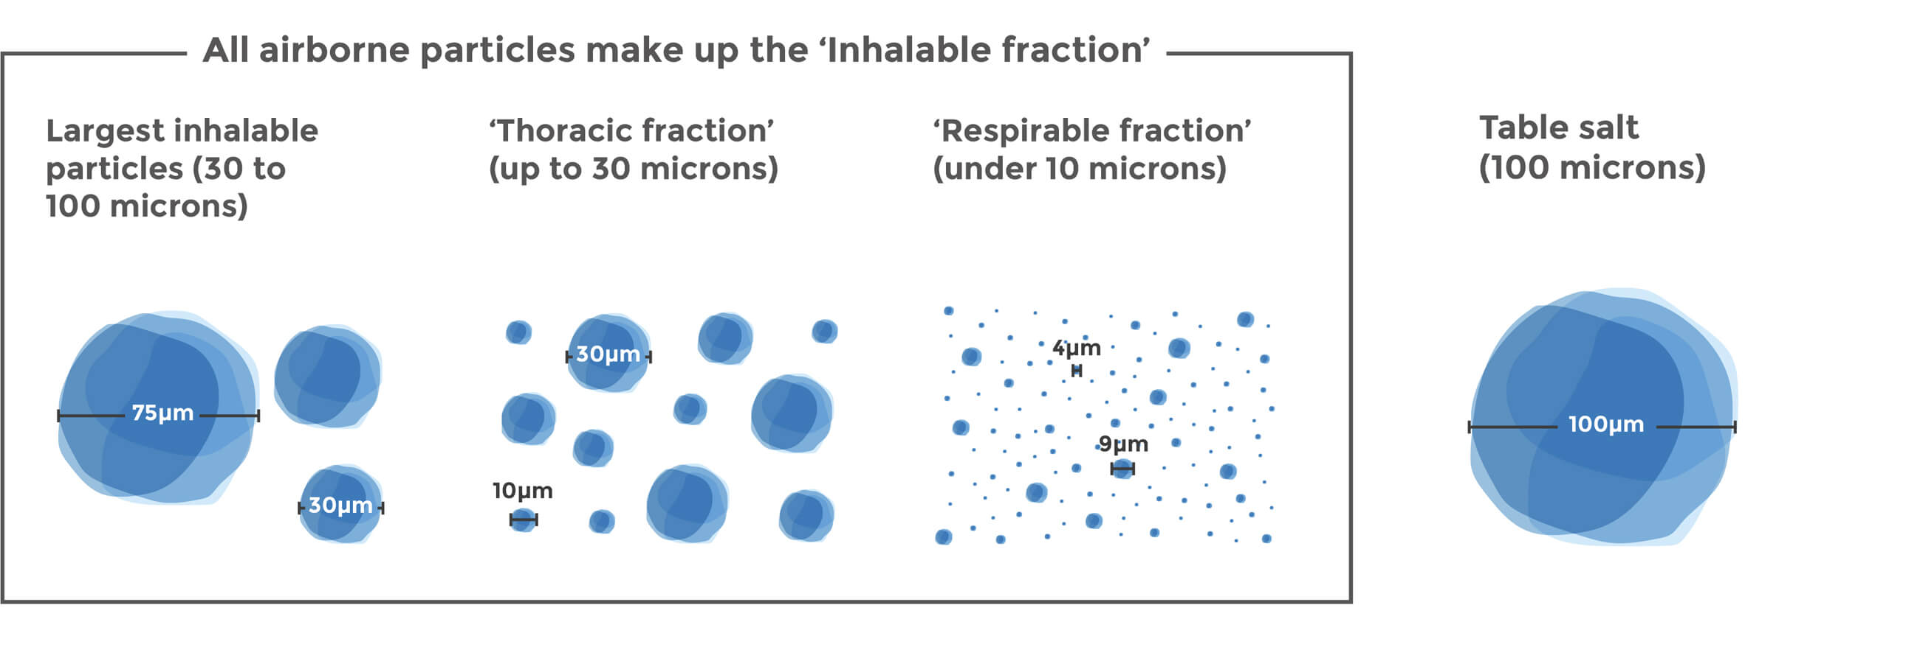

**Sand consists of local rocks or minerals ranging in particle size from .05 mm (50 microns) to 2 mm in diameter. Smaller particles are labeled as silt**

[**https://sciencing.com/measure-sand-particle-size-8542729.html**](https://sciencing.com/measure-sand-particle-size-8542729.html)

|  |  |  |
| --- | --- | --- |
| Bibliographic Entry | Result (w/surrounding text) | Standardized Result |
| *Earth Science: A Study of a Changing Planet*. Newton, MA: CEBCO, 1990. | "… as shown in table 14-1, particles that range from about 2 mm down to about 0.05 mm in diameter are called sand" | 0.05–2 mm |
| "Soil." *Microsoft Encarta*. CD-ROM. Redmond, WA: Microsoft, 1996. | "Particles of sand range in size from 2 to 0.05 mm in diameter; those of silt from 0.05 to 0.002 mm and those of clay smaller than 0.002 mm." | 0.05–2 mm |
| [Glossary](http://erosioncontrolforum.com/index_glossarypop-up.html). Erosion and Sediment Control Management System. Lake Macquarie, Australia: 9 September 1999. | "Sand consists of particles consisting largely of quartz grains between 0.02 mm and 2.00 mm in diameter. Fine sand is defined as particles between 0.02 mm and 0.2 mm and course [sic] sand as those between 0.2 mm and 2.0 mm." | 0.02–2 mm |
| Bloom, Arthur. *The Surface of the Earth*. Englewood Cliffs, NJ: Prentice Hall, 1969. | "… for sediment grains coarser than fine sand (average diameter 0.2 mm), the current velocity …." | 0.2 mm (average) |
| "Relationship of Transported Particle Size to Water Velocity." *1994 Earth Science Reference Tables*. Albany, NY: University of the State of New York, 1994. | [table] | 0.06–2 mm |

[**https://hypertextbook.com/facts/2000/IlanaPrice.shtml**](https://hypertextbook.com/facts/2000/IlanaPrice.shtml)

2.5 microns= 0.0025 mm (alveolus)

10 microns= 0.010 mm (bronchus)

20 microns= 0.020 mm (fine sand)

50 microns= 0.050 mm (human hair)

90 microns= 0.090 mm

<https://blissair.com/what-is-pm-2-5.htm>

PM2.5 refers to atmospheric particulate matter (PM) that have a diameter of less than 2.5 micrometers, which is about 3% the diameter of a human hair.

Commonly written as PM2.5, particles in this category are so small that they can only be detected with an electron microscope. They are even smaller than their counterparts PM10, which are particles that are 10 [micrometres](https://blissair.com/how-small-one-micron-why-matters.htm) or less, and are also called fine particles.

## Other serious diseases caused by exposure to RCS

In addition to causing silicosis and lung cancer, exposure to RCS can also cause the following:

* Infections, usually in addition to silicosis, such as tuberculosis (pulmonary and extra-pulmonary) or other mycobacterial, fungal, and bacterial lung infections;
* Chronic obstructive pulmonary disease (COPD);
* Autoimmune disease such as scleroderma and rheumatoid arthritis;
* Chronic kidney disease.

<https://oshwiki.eu/wiki/Respirable_Crystalline_Silica>

----------------------------------------------------------------------------------------------------------------------------------------