**Legality In Hospitals- Medico-Legal Case Management**

Ashwini Pandit1,Dhwani Patel2, Arushi Chawla3

1: Assistant Professor (MBA-Hospital & Healthcare Management), Institute of Management & Training, Gujarat Forensic Sciences University, Gandhinagar

2: Assistant Professor (Forensic Odontology), Institute of Forensic Sciences, Gujarat Forensic Sciences University, Gandhinagar

3: Postgraduate Student (Forensic Odontology), Institute of Forensic Sciences, Gujarat Forensic Sciences University, Gandhinagar

**Abstract**

The growing number of legal issues in various fields and specialties in the current era has been no different in the healthcare sector. The complexity associated with such issues has been the major concern of practicing doctors/healthcare professionals. In this article, an attempt has been made to focus the legalities in the field of medicine with an emphasis on the Indian set up and existing Laws governing such actions. The article comprises of medico-legal case management, awareness and prevalent practices among the health care professionals especially among those who are directly or indirectly involved with the treatment of patients. As far the awareness is concerned regarding a procedure, the documentation and various other medico-legal issues were studied in detail. Also, various aspects of medico-legal cases admitted in the hospital.

Keywords:-Medico-legal, Medicine, Law, MLC case management

**Introduction**

The health profession is taken into account to be one amongst the noblest professions within the world. The application of medication is capable of rendering noble service to humanity provided ordinary care, sincerity, efficiency, and professional skill is observed by the doctors. However, today, the patient-doctor relationship has nearly diminished its fiduciary character and has become additional formal and structured. The law, like medicine, is an inexact science. One cannot predict with certainty an outcome of cases many a time. It depends on the actual facts and circumstances of the case, and also the personal notions of the judge concerned who is hearing the case. The axiom “you learn from your mistakes” is too little honored in healthcare. The best way to handle medico-legal issues is by preventing them1. The survey deals with various aspects of medico-legal cases admitted in the hospital. The medical professionals need scientific knowledge, technical skill, moral understanding of profession and awareness about the relevant laws of the land. Primarily doctors but also on other ancillary and administrative staff of the hospital have several ethical and legal obligations in the performance of their duties.

**Methodology**

The material for the present study is comprised of information gathered from the medical professionals- Physicians, medical administrators, members of hospital ethical committee, who were directly or indirectly engaged in treatment and care of various kind of medico-legal case management. This study was carried out at five hospitals. The method used was interview with the concerned staff . The questions were designed to know the standard of knowledge and skill, practical application, customary practices, in their hospital as it may or may not be within the control of the doctors and ancillary staff. Appropriateness in documentation in case-files, record keeping, care of preserving material of evidence of medico-legal cases for purpose of the law as per guidelines of regulatory authorities. Also, lawyers and judicial officers were consulted to gain information for the same.

**Discussion**

Not only medical professionals but also various private medical institutions are usually apprehensive in dealing with MLC, for, according to them, an MLC (Medico-legal Case) implies a lot of disputes, unwanted burden, rough speaking police officials, inordinate hours in the court, unrelenting defense counsels, etc. Because of this fear-factor, they either try to avoid the cases or try to get rid of them as soon as possible. With these improper understanding of the implication of the cases, they invite mistakes, deliberation, which may land them in trouble. Members of the medical profession are liable to be called upon to give medico-legal assistance in varied circumstances and situations by police and law. Like any other witness, the medical practitioner is also bound to answer truly all questions posed to him in the court of law. The law usually requires reliable evidence of facts and authoritative opinions. Thus, a doctor has not only to play a vital role struggling to save the life of the patients or relieving their sufferings but also has to fulfill the required minimum formalities on medico-legal aspects in each case.

Medico-Legal Case

A medico-legal case is a case of injury/ illness/death of the subject where the attending doctor, after eliciting history and examining the patient, thinks that some investigation by enforcement agencies is important to ascertain and fix responsibility for the case in accordance with the law of the land. It may be described as a case of injury or ailment, etc., in which investigations by the law enforcing agencies are essential to fix the responsibility regarding the causation of the said injury or ailment. The doctor is ought to do everything possible to resuscitate the patient and make sure that he’s out of danger. All legal formalities stand suspended till the patient is out of danger. This has been clearly exemplified by the Honorable Supreme Court of India in Parmananda Katara Vs Union of India.Every doctor is bound to provide medical aid to the victims irrespective of the cause of the injury; he cannot take any excuse of allowing the law to take its course.

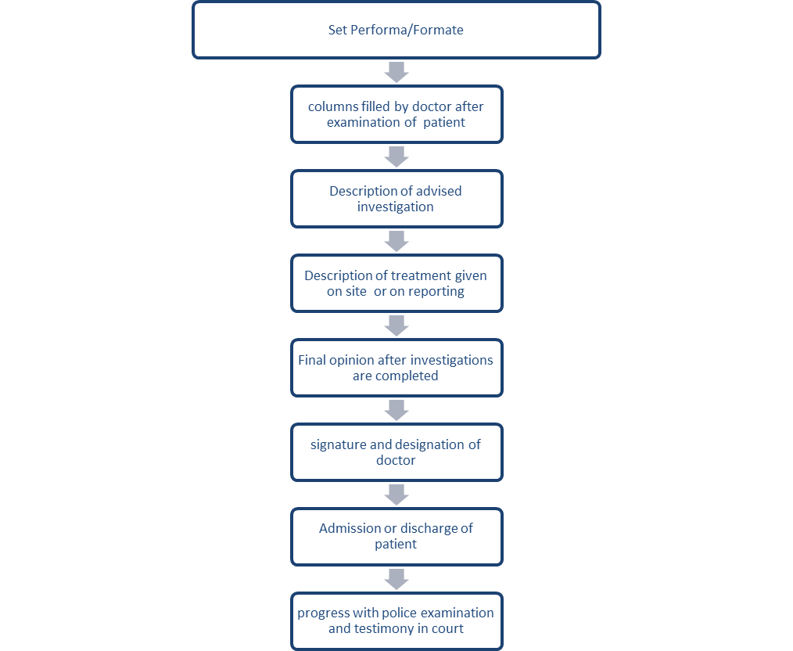

**Fig.1.1 Medico-legal Case process**

Receiving MLC

A Doctor will receive a Medico-Legal Case in any of the four situations:

• A case is brought by the police for examination and reporting or order of the Court for medico-legal examination.

• The person in question was already attended by a doctor and MLC was already registered in a previous hospital and the person is now referred for expert management/advice.

• When the patient himself expresses his intention to register a case against the alleged accused.

• By the doctor himself after eliciting history and examining the patient, if he feels so that the case in accordance with the law of the land. In such state of affairs, the doctor has to utilize his medical knowledge and judgment to decide whether the case should be treated as MLC or not, especially when the history is not fully concealed, either by the patient or his relatives/ friends, due to some motive.

Brought Dead Cases

In all the brought dead cases wherever casualty duty officer is extremely satisfied after taking history and researching the records present, that the death was natural, he may not label them as medico-legal strictly at his discretion. In the death certificate form against the column of the cause of death one should write “NOT KNOWN BROUGHT DEAD” In no case, it should be mentioned that cause of death should be determined after post mortem. A Doctor making MLC is a mere legal formality even in brought dead cases. It is practically impossible to diagnose the cause of death on external examination, history, etc. It is for the police being law enforcing personnel to decide whether it is natural or unnatural death or to submit for Post mortem examination to rule out.

Documentation of an MLC

Documentation is completed in duplicate in a set Performa (as per Hospital policy) with a ball-point pen, in clear and legible handwriting and incomplete words without using abbreviations. Cutting/ overwriting etc. should be avoided as much as possible and all corrections should be properly initialed. Abbreviations of any sort should be avoided. Separate Performa may be available for medical examination, an examination of drunkenness, etc. All columns are filled up fastidiously and by the identical Doctor who had examined the patient. Each MLC is given a recent MLC number consecutive. The details are completed there itself, leaving no provisions as to be completed later on. Investigations advised and found to be entered Treatment given at the site or on reporting. The opinion to be recorded in the MLC sheet, if an opinion cannot be given, under observation be given and signed by the doctor with name written in block letters. The Final opinion is given by the same doctor making MLC in the original MLC sheet. After all, investigations are completed. After completion, the Doctor must sign and mention his/ her full name below it with designation and Police constable on duty should be informed in each case. After registration of a case as MLC henceforth all documents and registration forms bear identical MLC number as well as the discharge slip. The patient is admitted or discharged with recommendation be entered into the case sheet. The doctor examining the patient should complete the MLC sheet before leaving the hospital. All MLC X-rays be kept in the department as evidence for a court of law. Special samples were taken to be entered into the MLC sheet. If the patient is dead or died when handed over to the police for post mortem and not to relatives, A copy of the MLC sheet is handed over to the police for further investigation against his signature and belt number on the copy.

Collection and preservation of samples

When a Medico-legal case is received by a Hospital, preservation, and collection is the prime concern of the hospital. The following samples are collected-Gastric lavage, Vomitus in poisoning cases, Blood in Alcoholic/poisoning cases/drug abuse/ or for DNA test (preserve in Refrigerator/ or in common salt),Clothes in Assault/Injury/Firearm/Burn cases, Nail clippings in Assault/Rape cases Pellets/Bullet etc. if recovered, Vaginal swabs/ smears /Pubic hairs in Rape cases, Swabs from firearm entry wounds, Urine for pregnancy test in Rape cases, Undergarments, Swabs from Glans penis in Rape/Unnatural sexual offences. Any other exhibit e.g., a bottle of poison, tablet or weapon if recovered should be properly labeled and sealed. Sample seal to be given and the endorsement of a sample of the seal should also be made in MLR.

Dying Declaration

A dying declaration or statement created by the person on the verge of death on the cause of his death or on to any of the circumstances of the transaction that resulted in his death, such a statement, oral or in writing, made by the deceased to the witness is a relevant fact and is admissible in evidence, provided it has been created by the deceased while in a fit mental condition as certified by the attending doctor. A Doctor should intimate the police for calling the Magistrate to record the declaration. If there’s no time the attending doctor ought to record the dying declaration in presence of police.

Examination of MLC Cases

It is advisable that a lady doctor should examine a woman, or, wherever this is not possible, a female attendant/nurse should be present during the examination. If a case is referred from another hospital where medico-legal case sheet has been prepared, the findings are attached to the same without making fresh MLC. If the date of incidence is delayed and the patient brought late, the present findings are to be entered in MLC.

Admission and Discharge

Whenever a medico-legal case is admitted or discharged, the same should be informed to the nearest police station at the earliest. It is better to tell the police through the casualty of the hospital wherever the medico-legal register is typically maintained and necessary entries may be made in it. While discharging or referring the patient, care should be taken to see that he/she receives the Discharge Card/Referral Letter, complete with the summary of admission, the treatment given in the hospital and also the directions to the patient to be followed when discharged. Failure to try and do therefore renders the doctor accountable for “negligence” and “a deficiency of service”. If the patient is not serious and can take care of him, he may be discharged on his own request, after taking in writing from him that he has been explained the doable outcome of such a discharge which he is happening on his own against medical advice. Police have to be informed before the said patient leaves the hospital..

Abscond/Death of Medico-Legal Case

In case an individual admitted as a medico-legal case expires or absconds, inform the police immediately. Send the body to the hospital mortuary for preservation, till the legal formalities are completed and the police release the body to the lawful heirs. Request a medico-legal Postmortem examination, providing a copy of the death summary. Do not issue a death certificate before post-mortem even if the patient was admitted. The dead body should NEVER be released to the relatives; it ought to solely be handed over to the police.

Copy of MLC to Individuals Other Than Police

A medico-legal report could be a report given by a professional and is of confidential nature and isn’t a public document. As such the accused or respondent is not entitled to get a copy of the same during the investigation of the case. In such cases, a no-objection certificate should be obtained from the police authorities investigating the cases, before a copy is supplied. In some cases, the police ask for a medico-legal report after the case has been discharged or expired. It is irregular to issue a medico-legal report on the MLC in such cases. The police, however, can ask for any specific information (including the details of injury), which may be supplied to them from a record of such case. If needed a fresh MLC to be made recording the present findings, after re-examining the patient on a new date.

Medical Testimony of Doctor In The Court Of Law

Do not misrepresent documents/medical literature in the Court of Law. When evidence is read into the record of a trial, only that portion of the document, which validates the information being discussed need to be read aloud. One paragraph or even one part of a paragraph may be all that is necessary to substantiate the point you are making. When a document is cut in a manner, which lends the quoted passage a meaning other than what would be derived from a more complete reading, you are misrepresenting the document.

Final Opinion

Final opinion is to incline on the original MLC sheet by the identical doctor preparing record reckoning on investigation findings or treating physician in admitted case. Final opinion in MLC to be given by the hospital where it had been made after obtaining a case summary from a referred hospital. After discharge of the patient or death the MLC record to be sent to MRD for preservation. The doctor needs to give a witness in court as an expert witness if summoned by the Honorable Court. At that point he could manufacture the case record or final opinion ahead of the magistrate.

**Conclusion**

Medico-legal cases have to be forbidden properly, following the latest prevailing guidelines. Even if due guidelines/procedures are not followed or not available, these cases pose no problem if one uses proper caution and due care and attention, while dealing with them. Proper documentation, Timely data, an organized and thorough examination together with all relevant investigations and referrals, etc. are all that is necessary to see such cases completed successfully.

**References**

1. Raveesh BN, Ragavendra B. Nayak, Shivkumar F. Kumbar;Preventing medico-legal issues in clinical practice; Annals of Indian Academy of Neurology 19(S1):15-20 · September 2016
2. Tanuja R. Brahmankar, Sachin K. Sharma, A record based study of frequency and pattern of medico-legal cases reported at a tertiary care hospital in Miraj, International Journal of Community Medicine and Public Health; Brahmankar TR et al. Int J Community Med Public Health. 2017 Apr;4(4):1348-1352
3. Sangeeta Rege;Medico-Legal Cases Across Various Hospitals -A review & Understanding of Procedures; Medico-Legal Update. July -December, 2011, Vol. 11, NO.2
4. AGGARWAL KK; Medicolegal Cases in Injury Patients and Indian Law; Indian Journal of Clinical Practice, Vol. 24, No. 7, December 2013
5. A.K.Singh,Kanchan Singh, Anoop Verma; Study of Medico-legal Case Management in Tertiary Care Hospital; J Indian Acad Forensic Med. October- December 2011, Vol. 33, No. 4
6. Yogender Malik,Rahul Chawla, Gaurav Sharma,; Profile of Medico-legal Cases in Casualty of a Rural Medical College of Haryana; J Indian Acad Forensic Med. October-December 2013, Vol. 35, No. 4
7. Singh MM, Garg US, Arora P. Laws Applicable to Medical Practice & Hospitals in India. Int J Res Foundation Hosp Healthc Adm 2013;1(1):19-24
8. Kumarasamy AP1 and Vasanthakumar P2; Medico Legal Case-The Enforcing Law in Patient Care; Nurs Health Care Int J; Volume 1 Issue 3; July 12, 2017