Seborrheic Dermatitis and Traditional Treatments

Huynh Tan Hoi

FPT University

E-mail: hthcolin@gmail.com

Tel: 0084-0965.460.459

**Abstract**

Nowadays, people are increasingly looking for traditional remedies to treat the disease with the desire to reduce the harmful side effects caused by the body in modern medicines. For scalp inflammation, many people wonder about this cure with oriental medicine. This is a skin disease that causes a lot of troubles in life, so learning about information and how to treat scalp inflammation is something that almost everyone should know. Despite this, the patient can still completely reduce the symptoms, restore skin and enhance resistance against recurrent illness in the long run. One of the fastest ways to treat seborrheic dermatitis is to apply Western medicine products including topical creams and oral medications. Each treatment has its advantages and disadvantages. However, herbs which are being used by traditional medications always show their very special role in the treatment of disease. This article focuses on the use of natural herbs to bring a better life for patients, help them have a better skin, a pleasant spirit. This research paper was written in order to mention some effective solutions to make our life a better place and to contribute to the development of the country.

**Keywords**

Health, Skin diseases; Seboherric Dermatitis; Traditional Treatment.

# INTRODUCTION

Seborrheic dermatitis is a persistent disease and difficult to treat, often confused with other skin diseases such as contact dermatitis, allergy or psoriasis, etc. The lesions caused by dermatitis are constantly flaking and can cause hair loss. Newborns can spread to the whole body very badly. In addition to affecting aesthetics and quality of life, it greatly affects the psychology of patients. According Tames (2018), “the prevalence of seborrheic dermatitis among adults” in the general population is about 1-10%. It is rather common in men than in women and the causes still remain unknown(1).

.

Seborrheic dermatitis is a persistent disease that is difficult to treat and relapses easily. The disease usually progresses worse in autumn - winter. Nowadays, 2-5% of the world population suffers from this disease, so it's important to know it. Seborrheic dermatitis is defined as a dermatological disease that warns of a patient's skin condition. Skin appears yellowish-yellow scales concentrated on the scalp and face. Seborrheic dermatitis in adults is often seen as dandruff. The disease develops strongly in areas of the skin where the sebaceous glands thrive. The disease causes aesthetic effects on the lives of patients.

This is considered a common disease that occurs at any age. The disease can be seen in young children, right after birth with scalp manifested as scalp. Adults tend to be between 20 and 50 years old and men are more ill than women. There are several studies showing the incidence rate in the population about 2-5%. Many people get sick but recover without relapse.

In parallel with the use of Western medicine, many patients take advantage of the herbs from Eastern medicine to improve symptoms and prevent the outbreak of the disease.

# What is seborrheic dermatitis?

Seborrheic dermatitis is a chronic scabby skin disorder that occurs in children and adults, in areas with many active sebaceous glands such as scalp, face, ears, upper body and folds (2). The disease is characterized by erythema and scab. The cause of seborrheic dermatitis is unknown(6), but due to many factors such as normal fungi living on our bodies, genes, stress, the health of each person and living people in a cold and dry climate.

It is a skin disease that causes our skin to dry, red, and scaly(2). The disease often affects the skin or oil secretions, most commonly in areas of the face, chest and back. However, in some cases, the disease may also occur in areas of thick and dry skin. This is a non-infectious disease that doesn't affect your health too much, but it can affect our appearance and make us uncomfortable. Seborrheic dermatitis usually persists for a long time and requires persistent treatment, repeated many times to reduce.

**Signs and symptoms of seborrheic dermatitis**

Its signs and symptoms vary with age. For adults and young people, there is a slightly yellowish erythematous patch, covered by scaly scales and the scales are easily separated on the skin. It can be seen on the eyebrows, cheekbones, curly ears and folds after the outer ear, chest, etc. On the scalp, we often see something like dry dandruff, yellow and pink scales, and even in the beard. The patients may feel itching, especially in the scalp. For young children or infants, there are common dry scales on the scalp, with reddish-yellow patches covered with scales. Children may have something like that on facial, eyelid, nose and diaper areas (Fig 1).

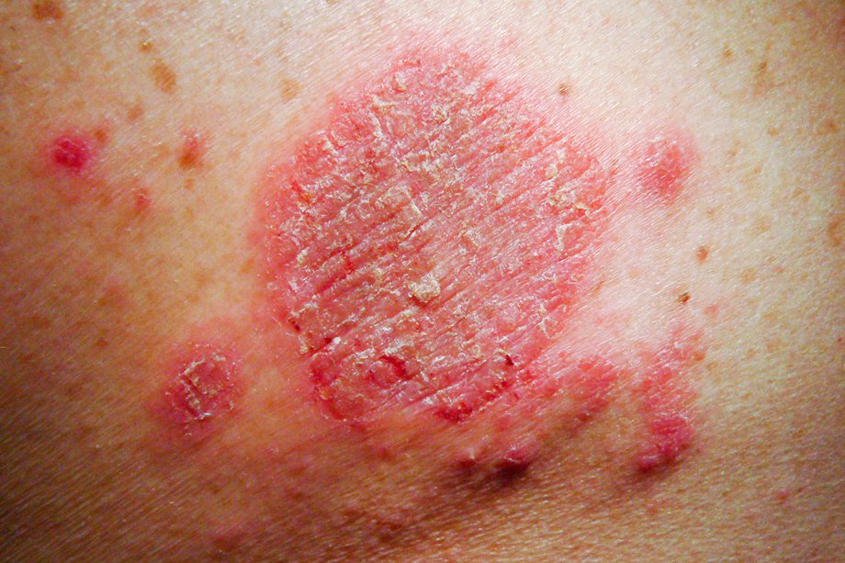

**Figure 1.** Signs of seborrheic dermatitis

In fact, dermatitis usually occurs slowly, does not happen abruptly, so many patients are unable to recognize that they have dermatitis until more severe symptoms appear. The early identification of dermatitis symptoms can be done through the following 4 signs (2). First, redness increases on the skin in the shapes of yellow or white scales. Some types of scales are similar to dandruff, contain a lot of oil and stick to the skin. Second, patients clearly feel more oil on the skin than usual. They may feel itchy when scratching and experience bleeding. Third, the skin is very vulnerable, with patches on the inflamed skin. Fourth, when the weather becomes dry, the skin produces more sebum. The inflammation area can spread to other areas. For example, the forehead area between the eyebrows can spread to the eyebrows or hair, shedding eyebrows, hair loss.

**Methods to support the treatment of dermatitis**

In order to overcome the inflammation of oily dermatitis, patients can choose Western medicine methods, use folk tips or support treatment with Oriental medicine. Each method has certain advantages and disadvantages.

Treating oily dermatitis with Western medicine only resolves “the surface” of disease. With psychological desire to quickly eliminate symptoms, when suffering from dermatitis, many patients tend to look to the pharmacy. Accordingly, patients are often prescribed some drugs by the doctors. For oily dermatitis in the head, patients can use anti-fungal shampoo 2-3 times a week and it can be used for long-term maintenance. In severe cases, a mild anti-inflammatory solution or gel may be applied for 1-2 weeks. If the injury due to oil dermatitis in the face, patients can use anti-inflammatory cream or lotion and apply for 1-2 weeks. The advantage of this the treatment is quick and convenient. However, we cannot solve the causes of disease, but only support to remove external symptoms. When we stop using the drug, there is a high risk of recurrence. In addition, long-term use of topical anti-inflammatory drugs can cause side effects such as stretch marks, acne, vasodilation, skin atrophy, etc.(3).

Treatment of dermatitis at home is also applied by some people even though the risk of infection from raw materials is not guaranteed. In the folk treasure circulated for generations, there have been benign, simple and easy-to-implement remedies that work for patients with acute dermatitis such as fresh lemon, aloe vera or honey. Using lemon peel in combination with white wine, alum, fresh turmeric and fine salt to create a mixture can apply on face and inflamed skin. Using aloe vera gel to rub on lesions of dermatitis with the desire to cool the wound, we can apply it many times a day. Then, using honey to mix with a little water to make face cream is said to reduce swelling and irritation. The first advantage is that the materials are easy to find, simple to implement, easy to apply, cheap. But, these folk remedies have not been verified, moreover, over time the disease has changed quite a lot, probably no longer suitable. Not to mention, time for results from folk tips is rather long.

Traditional medicine remedies often bring long-term effects, reducing the possibility of relapse (4). The remedies are studied and developed based on traditional medicine capable of overcoming the disadvantages of Western medicine is leaving no side effects. Accordingly, the remedy is prepared from more than 100 traditional remedies, a benign herbal medicine with clean herbal ingredients taken from herbal specialized areas across the country. Some ingredients are extracted from turmeric, cnicus japonicus, betel nut,lophatherum gracile, etc. in order to make something like paste. It has effect of drainage, keratosis, scarring and reduce oil secretion, pore ventilation. It also helps to complete disappearance of symptoms of the disease (Fig 2).

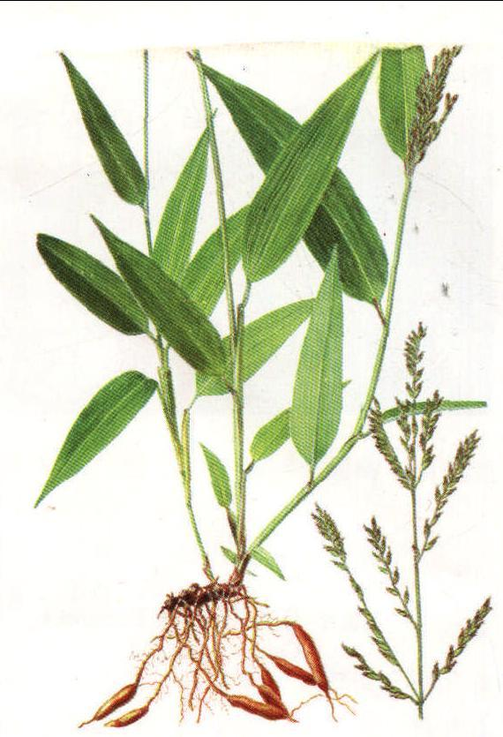

**Figure 2.** The image of lophatherum gracile

The medication in which ingredients including honeysuckle, dandelion, sophora, origan, etc. is used to make in order to help inflammation, cool liver, enhance the detoxification function of the liver and eliminate kidney toxicity. The body completely eliminates the toxins will help prevent the disease for a long time.

# METHODOLOGY AND RESULTS

Thanks to the support of 100 respondents who are presently living in Vietnam, a survey was conducted online at https://surveynuts.com. Using the form of direct interview and method of completing questionnaires, the role of traditional therapy ​​ has clearly affirmed. The paper was also based on the collected data and knowledge of related journals.

Some questions have been designed to help us understand the symptoms and causes of the disease that patients suffer from in order to find out effective solutions to prevent and treat it in a right way. When they get sick, they all find some therapies to cure. According to the result of first question: “What will you do when having seborrheic dermatitis?”, the number of patients seeking treatments is rather equal since they chose either “going to hospital” (43%) or “using traditional therapy” (51%) (Fig 3).

**Figure 3.** Reaction of patients when having seborrheic dermatitis

The second question was designed to better understand patients’reactions to modern therapy: “What will you do when having seborrheic dermatitis?”. In their opinions, one of the quickest ways to effectively treat seborrheic dermatitis is to apply Western medicine. Normally, Western medicine products will be in the form of cream, gel containing Steroid or salicylic acid, Hydrocortison, etc. for the effect of reducing itching, regulating sebum, preventing the formation of new scales (Fig 4).

**Figure 4.** Patient's opinion about treating seborrheic dermatitis by Western therapy

Respondents answered that they used it 2 or 3 times daily and were quite effective. The best way to treat the disease, they said, is to use shampoos (when answered the direct interview questions). Western medicine is rather effective, easy for patients to buy or to choose the right product according to the payment. That is the benefit that many people choose to treat in a fairly busy society today. Only a few (9%) said that the medicine is not good since medicines or shampoos are usually only instantaneous, easily cause drug abuse and have side effects.

Responding to the next issue, most patients expressed satisfaction with the traditional therapy. Most respondents selected the option "Very good" (27%), “Good” (66%), while only no one chose “Not good”. This may take us into deep consideration why they have made their decision like that. When comparing the above questions, it is clear that the patients still believe in traditional therapy. The methods of using herbs are derived from folk tips, with the main source of raw materials close to daily life. Not only is it effective in reducing dermatitis, but it is also helpful in beauty. The effectiveness of the remedy is also assessed by the patient.

**Figure 5.** Patient's opinion treating seborrheic dermatitis by traditional therapy

The methods of using herbs are derived from folk tips, with the main source of raw materials is the leaves close to daily life. Not only is it effective in reducing dermatitis, but it is also helpful in beauty. The effectiveness of the remedy is also assessed by the patient (Fig 5).

Specifically, the majority of patients said that the traditional method was quite good and effective, when asked directly about the side effects of the drugs, they said that they had not encountered side effects during treatment. This is thanks to the medicinal ingredients in the remedy for seborrheic dermatitis by the effective combination of herbs.

**Figure 6.** Time to recover seborrheic dermatitis

The percentage of patients cured by remedies up to 60%. Survey of treatment results on more than 100 patients who used to treat dermatitis who used herbal medicine showed positive results and reactions.

According to them, patience is essential when treating the disease because the drugs take at least 1 month, over 2 months and even more than 6 months to be able to work best (Fig 6).

In fact, there are many elderly people in Vietnam who believe in traditional remedies. Most of them (46/100) believe in the effectiveness of this treatment, while young people still have some anxiety. Although they still believe in traditional remedies (also called folk remedies), busy young people tend to choose advanced Western medications (Fig. 7).

**Figure 7.** The attitude of respondents to present medications

Most of old patients trusted traditional therapy just because they are not reluctant to choose this effective traditional method. Most said that although this method takes time, it can completely cure the disease, this can be verified over time, through the experience of previous generations (6).

# SOME RECOMMENDATIONS

According to medical research, apple cider vinegar, coconut oil and aloe vera are the 3 most commonly used ingredients when treating seborrheic dermatitis.

First is tea tree oil since the minerals in tea tree oil have antibacterial, anti-inflammatory properties, which are good for treating seborrheic dermatitis. Tea tree oil should be diluted with coconut oil or olive oil to dilute the concentration before applying it to the affected skin. “Tea oil shampoo” is also a good way to treat and decrease the symptoms(4,5).

Second is olive oil. Patients can apply an adequate amount onto the palm of their hand, apply to the skin where seborrheic dermatitis appears, massage gently and leave for 1 hour. Then use a soft bristle brush to remove the dandruff scab, scaly skin on the head. Brush gently, thoroughly and then clean the skin with a dedicated shampoo as usual.

Third is coconut oil since it can be combined with many other oils such as strawberry oil, borage or pomegranate seed oil to reduce itching and redness symptoms. Special nutrients from coconut oil have antibacterial ability for skin.

Next is aloe vera due to its effectiveness. The anti-inflammatory properties of aloe vera are very high and this property is rather good for treating seborrheic dermatitis. The essence of aloe vera can prevent the disease from spreading more, reducing the effects of the disease (Fig 8).

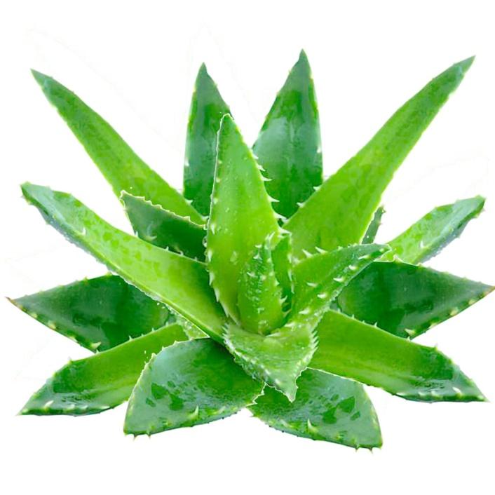

**Figure 8.** The image of aloe vera

Apple cider vinegar is also another choice. It is no stranger to many women, the use of apple cider vinegar is also known more than beauty and skin care. It helps with anti-inflammatory, softening of the skin, providing essential vitamins for the skin. It can be used to treat seborrheic dermatitis by washing your hair. Just rub the apple cider vinegar over your scalp, massage gently for 5 minutes and then rinse with water, persistently apply for a long time to see the results[6].

Besides, patients are also encouraged to eat plenty of suitable foods, drink 2 to 3 liters of water a day. They should limit eating something such as hot spicy food, greasy food, oil seeds (sesame, peanuts) or instant foods. They should also stop drinking beer, alcohol, coffee, tobacco and stimulants(7). “Dietary changes” are beneficial in the treatment and Tamer (2018) mentioned that patients should eat foods rich in vitamin B, salmon, vegetables and fruits(1).

In addition, patients need to maintain a healthy lifestyle, exercise daily, go to bed early, avoid stress. Patients should avoid fried foods, greasy fast foods that easily cause elevated liver enzymes, gastrointestinal disorders thereby aggravating the condition. Eating too much starchy or sugary foods like bread, carbonated soft drinks can easily cause insulin changes that cause inflammation. Excessive use of alcohol and drugs will harm the liver and kidneys and convert food into harmful substances. This makes the area of ​​infection more likely to spread (1,7).

One thing rather important is to do exercise regularly and gently. Patients should avoid dust and wind blowing directly into the affected area. They should not abuse the air-conditioned environment and avoid staying up late or working too hard (8).

When there is dermatitis, there are a few things that patients should avoid to minimize the possibility of recurrence of seborrheic dermatitis, which requires the patient to combine medication and adhere to the diet. abstinence and rational living. The addition of many foods rich in vitamins A, E, C to improve the skin, eliminate toxins from the body is quite necessary. Patients should also use a variety of foods such as greens, cherries, blueberries, olives, and sweet potatoes. Foods containing omega-3 help prevent and treat from the inside, mainly in foods such as salmon, tuna, etc.

# CONLUSION

In sum, the incidence of skin diseases in general, seborrheic dermatitis in particular has a high increasing trend in recent years. Until now, modern medicine has not been able to unify the cause of the discomforting disease. For people who suffer from this disease, the new studies mainly directly affect the areas of temporary relief and symptoms of temporary discomfort, but have not been able to fully cure the disease. Oriental remedy for treating this disease has really shown its high efficiency that patients should use for better health.

# ACKNOWLEDGMENTS

Our thanks to respondents as well as the support of FPT University

# REFERENCES

1. Tamer F. Relationship between diet and seborrheic dermatitis. 2018. *Our Dermatology Online/Nasza Dermatologia Online.* 9(3).
2. Dessinioti C, Katsambas A. 2013. Seborrheic dermatitis: etiology, risk factors, and treatments:: facts and controversies. *Clinics in dermatology.* 31(4):343-51.
3. Borda LJ, Wikramanayake TC. 2015. Seborrheic dermatitis and dandruff: a comprehensive review. *Journal of clinical and investigative dermatology.* 3(2).
4. Bhadoriya Y. 2017. Seborrheic Dermatitis Causes , Symptoms and Treatment : Homeopathic Perspective. 3(5):237–9.
5. Clark GW, Pope SM, Jaboori KA. 2015. Diagnosis and treatment of seborrheic dermatitis. *American family physician.* 91(3).
6. Parvizi MM, Heydari M, Namazi MR. 2017. Successful Treatment of Chronic Scalp Seborrheic Dermatitis Using Traditional Persian Medicine: A Case Report and Literature Review. *Galen Medical Journal.* 6(2):157-9.
7. Tran HK, Azizan NZ, DallʼOglio F, Gabriel MT, Torsekar RG, Ungpakorn R, et al. 2016. Treatment of Seborrhoeic Dermatitis in Asia: A Consensus Guide. *Ski Appendage Disord*. 1(4):187–96.
8. Cheong WK, Yeung CK, Torsekar RG, Suh DH, Ungpakorn R, Widaty S, Azizan NZ, Gabriel MT, Tran HK, Chong WS, Shih IH. 2015. Treatment of seborrhoeic dermatitis in Asia: a consensus guide. *Skin appendage disorders.* 1(4):187-96.