Mental Health Resources for Students in Higher Education: A Case Study of

the Student Support Centre at Manipal, India

Authors: Kangkana Bhuyan, Debasmita Phukan, Shafeer KV, Bhavishya Kalyanpur,

Suma T Udupa, Avinash G Kamath, Gayathri Prabhu

Higher Education and Mental Health Ecosystems:

It is widely recognized that the campaign for mental health resources for the age group of 18-29 years has to move onto a second stage—for the first stage (awareness of the seriousness of the problem), has been established (1). The World Health Organization has run sustained drives to draw attention to the occurrence of half of mental illness before the age of 14, and three quarters by mid-20s (2). This being acknowledged, the second stage then is to identify and create resources that segment and support, for not all population strata either suffer equally, or need the same tools. This is particularly complicated in a country such as India with its uneven resources wherein only 0.3 psychiatrists, 0.12 nurses, 0.07 psychologists and 0.07 social workers are available to cater to every 100,000 people (3) and poised to host the highest number of young people in the world – 34.33% share of youth in its total population by 2020 (4). A recent survey conducted by the National Institute of Mental Health and Neuro Sciences (NIMHANS) estimated the current prevalence of mental disorders in the age group of 18-29 years at 7.39 per cent (excluding tobacco use disorder) and lifetime prevalence at 9.54 per cent (5). While this is a valuable epidemiological data and insight to the demographic group, ultimately a bridge has to be built towards individual sites where these issues have to be negotiated and comprehended. This sentiment has also been reflected in recent case studies and policy reviews (6-7). Chadha rightly notes that any strategies aimed at improving the mental health of the youth needs to target the areas of service gaps, and educational institutes are the primary sites of such changes (6). This paper is a case study of one such site: a campus-town, Manipal in Southern India, with approximately 28,000 students enrolled in undergraduate, graduate and doctoral studies in various disciplines.

One of the preliminary questions to address is whether young people are receiving treatment in proportion to the rising number of mental health issues. Even with recent surge in help-seeking behaviors, untreated mental health disorders are highly prevalent in students. A study found that only 24% of students diagnosed with depression received treatment (8). Of these, fewer than half diagnosed with mood disorders, and less than 20% of those diagnosed with anxiety disorders, received treatment (9-10). Notably, college students with alcohol and drug related disorders were less likely to receive treatment as compared to their counterparts who were not attending any college (9). However, there is an almost total absence of evidence regarding how campus-level interventions, policies, and resources affect help seeking in students in India (11).This is in spite of there being a plethora of articles urgently seeking help in bridging this gap (12-14).

Cognizant of the widely prevalent distress in this age-group, the Manipal Academy of Higher Education (MAHE) set up a dedicated mental health resource – the Student Support Centre (SSC) in April 2017 – to provide psychotherapy, psychiatric consultations and mental health outreach to all students on campus. In the two academic terms since the Centre has been functional, it has catered to 953 unique individuals (between April 2017 – July 2019). This is a distinct initiative in India and perhaps one might even make a global claim, for its model of linking psychotherapy, psychiatric consultations and student-centric outreach/advocacy programs towards a cohesive mental health ecosystem in higher education. Equally significant, this is the first cache of detailed data of mental health concerns – both quantitative and qualitative, within higher education in India. This article seeks to present in some detail the model that has been attempted with the Student Support Centre in Manipal and some of the patterns that have emerged that might be helpful for further research, policy-formation, and implementation.

Re-imagining the Wheel of Mental Health Support:

The Student Support Centre (SSC) was designed as a confidential service devoted to supporting the emotional wellbeing of students. It took about six months of preparatory work from initial approvals to its first day of functioning, and was made possible by the involvement and support of several stakeholders and administrative officials. As the project began to fall into place, there were three initial considerations, all with equal weightage:

1) The Physical Space: The location and design of the physical space was to take into consideration the ethos (a progressive approach to mental health) of the Centre. Phelps et al observed that “A poorly designed counselling area may reduce the quality of the interaction between patient and counsellor . . . Making efforts to provide a less clinical environment may have benefits for all”(15). Multiple studies have highlighted barriers to students seeking help including lack of time, concerns for privacy and confidentiality, stigma and lack of openness (16-19). These factors were prioritized in establishing a space for SSC. The founding team reflected on the importance of prioritizing environment and design in creating spaces that support a positive frame of mind. SSC is located in a quiet, residential area modified to ensure privacy and accessibility (Fig 1). As represented by the images accompanying this article, SSC’s physical space has three configurations: the therapy and consultation rooms (Fig 2) , shared areas such as the waiting lounge (for clients) and work-stations (for staff) (Fig 3), and areas for community activities such as the discussion hall and an open pavilion for those seeking quiet time (Fig 4). The original architecture of the buildings that included features characteristic of the region, such a wood rafters, red-oxide floors and tiled roof, were retained to keep the space welcoming and organic in design. Similarly, the interiors were planned to extend the same warmth, with open conversation spaces, wall art by student artists, thoughtfully compiled bookshelves and inviting seating arrangements. In a conscious effort to avoid discussions “across a table” all the therapy rooms have an open design plan, without the barricades of furniture, where every effort is made for the client to feel welcome, safe and comfortable.

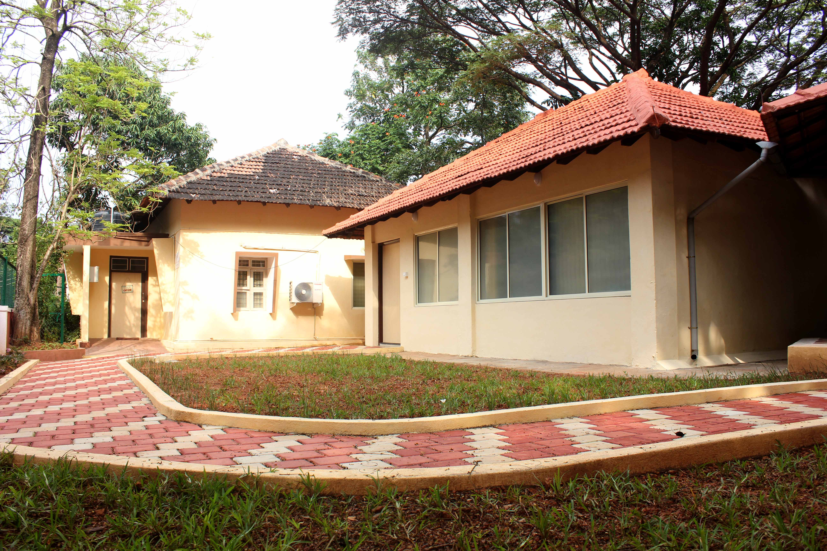

Fig 1

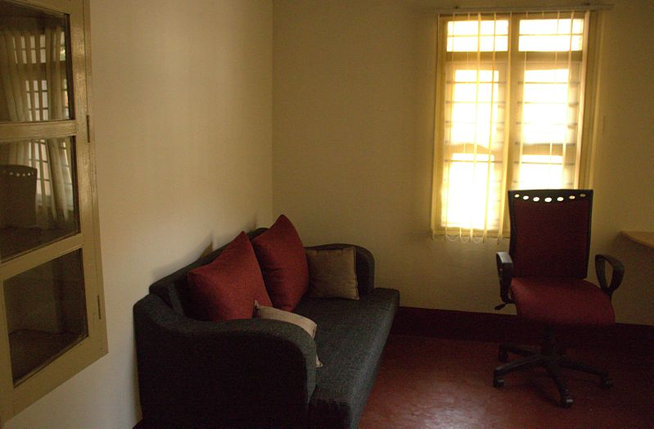

Fig 2

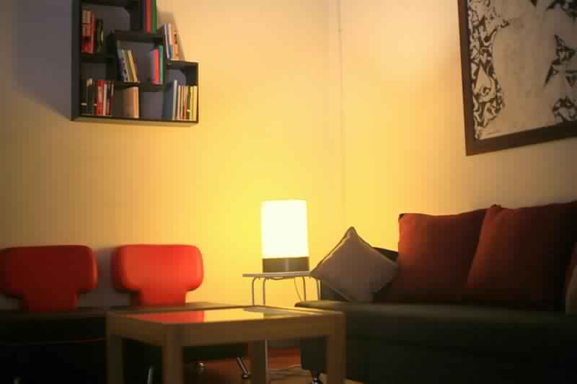

Fig 3

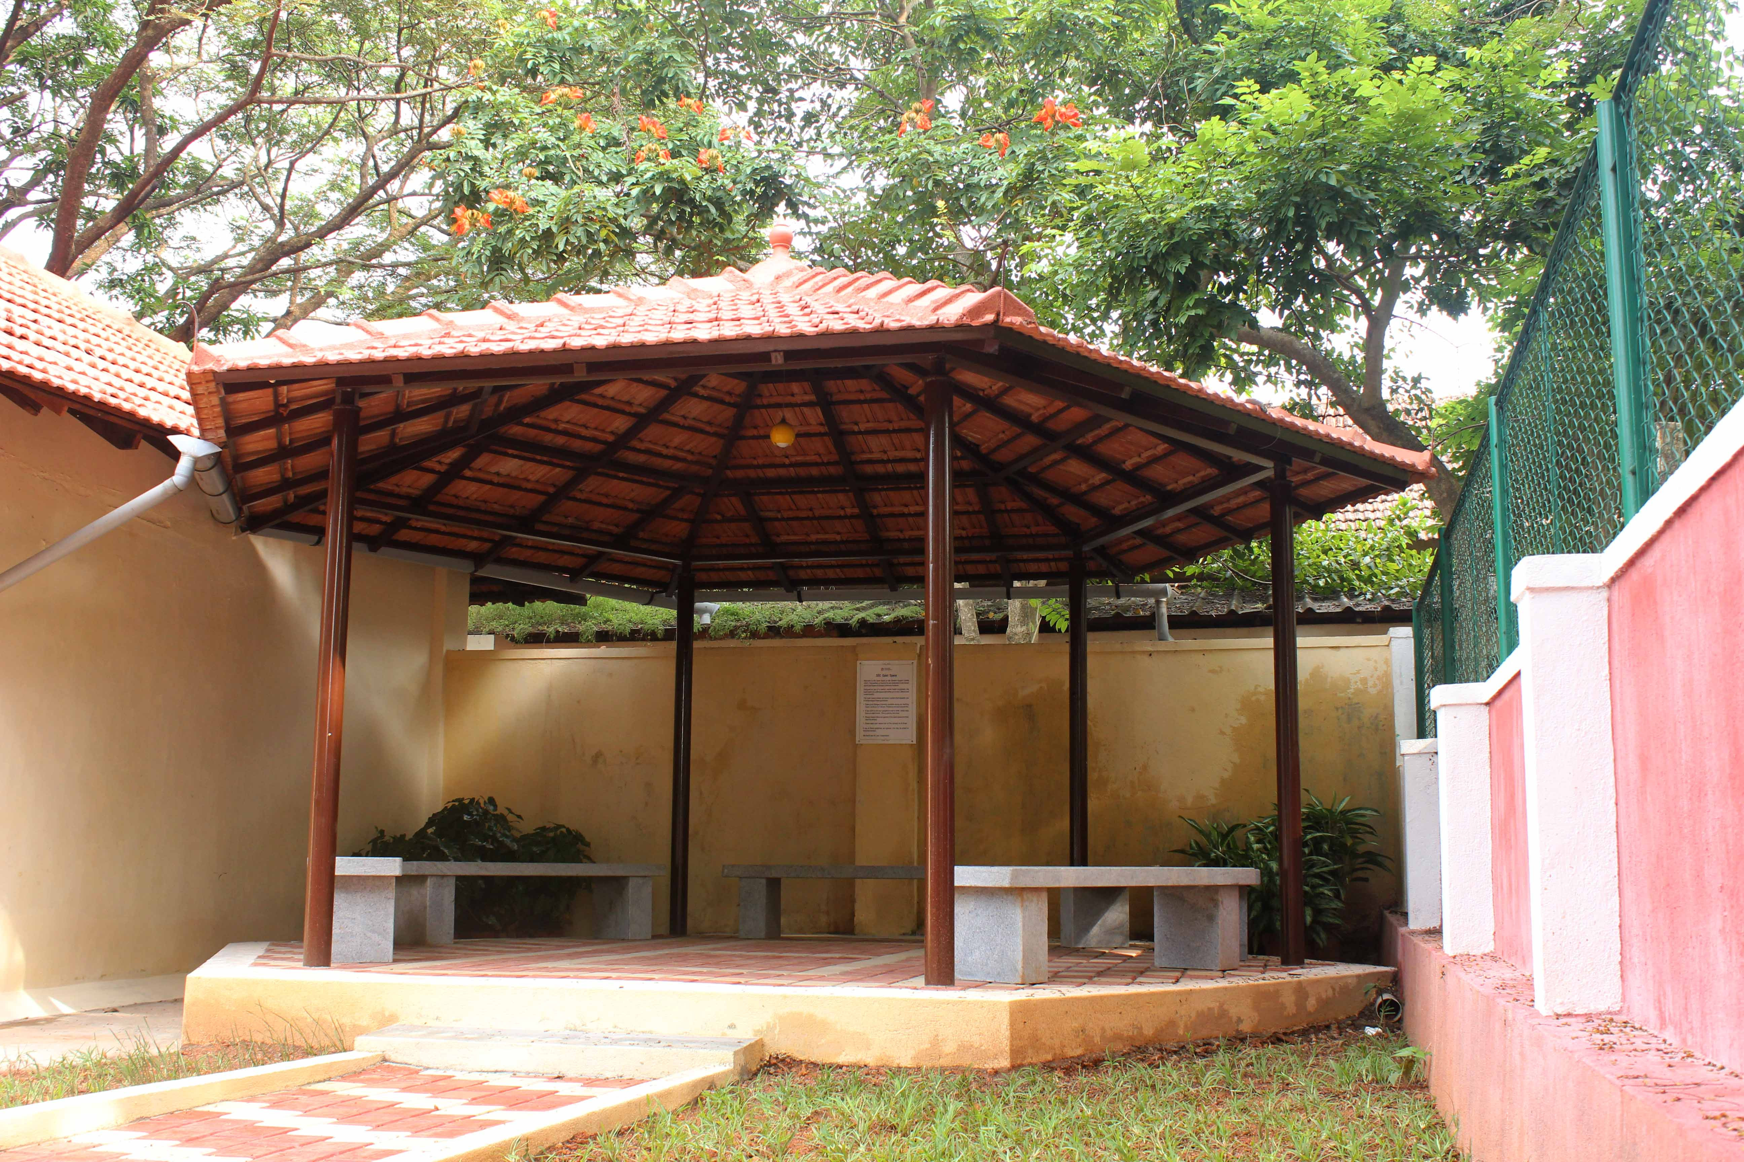

Fig 4

2) Health Professionals: The qualification, aptitude, interests of the mental health professionals and the services that would be offered is necessarily a crucial consideration. The setting up of a Centre that caters to a fixed demographic (students in higher education) poses both advantages and challenges. The appointments were largely oriented towards clinically trained psychologists who were particularly committed to working with this age-group and who were willing to take up the challenges of working within the exigencies of a campus town. While the main work conducted at the Centre remains psychotherapy, this was extended to psychiatric consultations made possible by the support of the psychiatric department of Kasturba Medical College and Hospital, Manipal. Three psychiatrists generously offered their time for fixed evenings every week to see SSC clients, based on the willingness of the client and following a detailed assessment/referral by their therapist at the Centre.

3) Operations: The processes for the daily functioning of the Centre was designed keeping in mind the unique requirements of its clientele. Prior to the setting up on SSC, student volunteers and administrators working closely with students held several rounds of discussions on what a student-centric approach to a mental health centre might entail. There was largely a consensus on working towards the following: assured anonymity and privacy (unless the client wished otherwise, or was at risk of harm to self or others), delinking of the therapy and treatment records from both hospital and academic records, no charge to students (nominal billing to existent student insurance where possible), and regular sessions and events to involve students in mental wellness projects. In seeking to foster this larger mental health eco-system, SSC set up a Student Advisory Board comprising of young mental health advocates in the student community, several of the members having been clients of SSC as well. Since its early days, SSC has presented its space as not just a place to seek help or helpful conversation, but also a place for celebrating creativity, initiative and community spirit. Among the events organised thus far have been art exhibitions, music concerts, poetry recitations, reading circles, painting sessions and so on. An important practice at the centre is also the collection of regular anonymous feedback from on-going and former clients that has offered a range of insights and possibilities of improvement.

Mapping Initial Data Patterns:

As one of the first such collations of data in this demographic (young people in higher educational institutions), the following findings are being released in the hope of offering an overview and select insights that can be researched further –

A. Socio-demographic details:

All students supported by SSC, Manipal, are enrolled in a higher education degree, from undergraduate to postgraduate, an age group that ranges from 17 to 42 years (Mean=20.8, SD=2.39). Of the total 953 new registrations since April 2017, 570 are women (60%) and 383 are men (40%) (Table 1). This follows the trend of help-seeking behaviors between genders that has been observed in psychotherapy in the general population—one not restricted to a campus setting. A report by the World Health Organisation on Gender and Mental Health noted that women are consistently more likely to use out-patient mental health services than men (20). Another study had a similar finding wherein men were less likely to seek help than women (21). Majority of the students (N=378) were from the Pure and Applied Science disciplines such as engineering, architecture, geology etc. These were closely followed by students from Medical Sciences (N=231). It is worth noting that students from these disciplines also constitute the majority of the student population in Manipal. The rest of the student-clients were from Allied Health Sciences (N=121), Humanities & Liberal Arts (N=120) and Management courses (N=104) respectively.

Table 1: Socio-demographic details

|  |  |  |  |
| --- | --- | --- | --- |
|  | Categories | Frequency | Percentage |
| Sex | Male | 383 | 40 |
| Female | 570 | 60 |
| Course/ discipline | Medical Sciences | 231 | 24% |
| Allied Health | 121 | 13% |
| Pure & Applied Science | 378 | 40% |
| Humanities & Liberal Arts | 120 | 13% |
| Management and Administration | 104 | 11% |
| Relationship status | Single | 205 | 22% |
| In a Relationship | 657 | 69% |
| Unknown | 91 | 10% |
| Country | India | 859 | 90.13% |
| Other | 94 | 9.86% |

B. Mode of referral:

The data collected for referrals indicate that the most common was the initiative taken by individuals to reach out to the Centre (50%) followed by referrals from other SSC clients (20%)(Fig. 5). Students learned about the Centre from college brochures and pamphlets distributed during the admission process, from faculty members during college orientations, and through social media platforms. Coverage of SSC events by student-run local media also helped spread the word.

Teaching faculty referred 8% of the registered clients. Psychiatrists and Student Counsellor referred 2% and 3% of the students respectively. Outreach programs by the Centre garnered another 3% of the referrals. The Department of Student Affairs (DSA), MAHE, a body that oversees students’ welfare and grievances referred 1% of the students. Finally, the rest of the 8% of the referring sources were friends and family members. It is significant that the most noticeable initiative in seeking support from mental health professionals has been by students themselves.

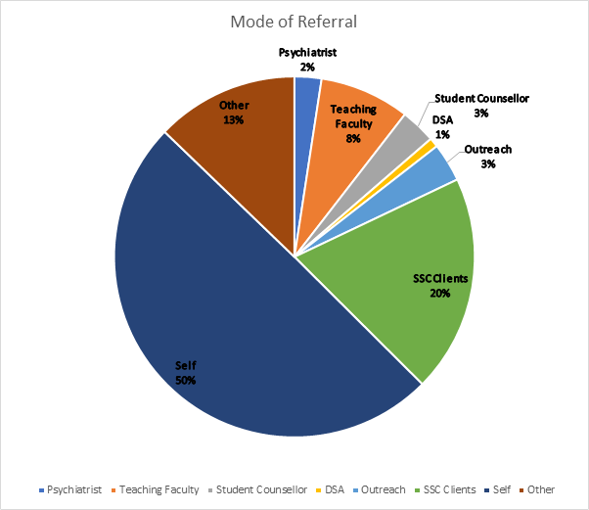

Fig 5

C. Clinical Variables:

These variables compose of the nature of presenting complaints that the students sought help for, the precipitating factors, and the level of perceived distress on the first session (Table 2):

Table 2: Clinical Variables

|  |  |  |
| --- | --- | --- |
| **Presenting Complaints** | Biological Functioning | 289 |
| Intrapersonal | 776 |
| Interpersonal | 466 |
| Academic | 208 |
| Other | 5 |
| **Precipitating Factors** | Interpersonal Issues | 272 |
| Academic | 69 |
| Trauma | 28 |
| Major Life-events | 72 |
| Multiple factors | 24 |
| Other | 47 |
| Undifferentiated | 437 |
| **Level of distress on first session** | Low | 250 |
| Moderate | 501 |
| High | 202 |

Presenting complaints are the symptoms stated *by the clients* as reasons to seek help e.g., feeling low, difficulty focusing on tasks, crying spells, etc. Based on the nature of the complaints, five categories have been made. The clients typically had a combination of two or more categories of complaints. Intrapersonal issues were noted to be issues related to oneself, as well as one’s relation to others (families, friends, college instructors). These include difficulties related to self-esteem or self-concept, mood symptoms (like “feeling low”), anxiety, experience of stress etc. Such intrapersonal issues were reported by 776 clients. 446 of the clients reported inter-personal issues like difficulty making friends, difficulties in romantic relationships, issues in family, difficulties in peer relationships etc. 289 clients also reported difficulties in biological functioning like sleeping too much or too less, loss or increase in appetite, fatigue, pain and other unexplainable physical symptoms etc. 208 clients reported difficulties in academic functioning like loss of motivation, keeping up with academic responsibilities, not having their expectations met in terms of academic goals, not being a good fit in the course, cognitive difficulties etc.

Precipitating factors are usually the immediate causes or events that act as triggers. Amongst those for whom such triggers were identified, 272 people had difficulties in interpersonal relationships like break of a romantic relationship, discord in families, difficulties in peer relationships and so on. Major life events like change of places, separation or divorce in families, incarceration of a family member, death or loss of a loved one etc. contributed as precipitating factors for 72 of them. Academic stressors acted as triggers for 69 of them. Traumatic events like accidents, assaults of physical and sexual nature etc. were significantly reported as triggers by 28 clients. For a large portion of clients, the triggers were often overlapping or undifferentiated, i.e., a single causal factor was not identified (N=437).

Level of distress is generally described as unpleasant feelings or emotions one may have which generally gets in the way of one’s functioning—these could be social, academic or biological. The client’s level of distress was assessed by the therapist. On the first date of consultation a moderate level of distress was reported by 501 (53%) clients. 250 (26%) clients reported low level of distress and 202 (21%) reported a high level of distress respectively.

D. Therapeutic Variables:

These variables are related to the process of therapy such as number of sessions, status and outcome of therapy. During the study period, 6014 individual sessions have been logged with an average of 6.3 sessions per client and a median of 3 sessions (SD=7.68). Of these, 159 (17%) clients were still in therapy by the end of the study period (Table 3). Successful termination of therapy sessions was reported for 344 (36%) of clients. The therapy termination was based on successful resolution of presenting complaints, subjective reports of improvement by clients and achievements of goals set in the beginning of therapy. This also includes clients for whom therapy had to be concluded due to the end of their academic course. This rate is however considerably lower than the 50%-75% termination rate noted across other studies and settings (22-23).

Unplanned termination consists of clients dropping out of therapy before a formal discussion of termination. Among contributing factors were loss of contact with the client, clients’ unwillingness to continue, and resolution of distressing symptoms prior to termination. Unplanned termination was significantly high at 44% (N=424) of the total registrations. This trend of premature termination of therapy initiated by clients follows the 47%-50% rates noted across other studies and contexts, including therapists’ theoretical orientations, level of education and even years of experience (24-26). A small percentage of clients (N=26, 3%) were referred out due to the presenting issue being a grievance (referred to the Directorate of Student Affairs) or the client not being a current student of MAHE (they were referred to in-campus hospital or other sources).

The outcome is a resultant effect of therapy which is generally intended to be a positive one. Based on the resolution of distressing symptoms and subjective reports of betterment, an improved outcome was noted for 454 (48%) clients. This matches the well-documented meta-analysis by Lambert who estimates the range of improvement to be between 35% and 70% (27). No changes in symptoms were noted for 153 (16%) of the clients. Our findings are fortunately much lower than the current rates of 30%-50% of individuals reporting no significant benefits from therapy (28). A small percentage of clients (N=12, 1%) reported worsening of symptoms. This corresponds with findings in other studies which estimates that 3%-10% of adult clients leave treatment worse off than before they began treatment (29-30). For a significant number of clients, 334 (35%), the outcome could not be documented reliably due to their discontinuation of therapy or lack of reports of progress.

Table 3: Therapeutic Variables:

|  |  |  |  |
| --- | --- | --- | --- |
|  |  | Frequency | Percentage |
| **Status of Therapy** | Ongoing | 159 | 17% |
| Unplanned | 424 | 44% |
| Planned | 344 | 36% |
| Referred (O) | 26 | 3% |
| **Outcome of Therapy** | Improved | 454 | 48% |
| Static | 153 | 16% |
| Deteriorated | 12 | 1% |
| Unknown | 334 | 35% |

E. Psychiatric Referrals:

A select portion of clients (N=169, 17.7%) were also referred for psychiatric consultations based on the level of distress and impairment in functioning. Some clients also specifically requested for a consultation with a psychiatrist and the same was arranged for them. (Table 4).

Table 4: Data for psychiatric referrals

|  |  |  |  |  |  |
| --- | --- | --- | --- | --- | --- |
| **Psychiatric Consultations** |  | 2017-18 | 2018-19 | 2019-20 | Total |
| Number of Psychiatric Visits | 103 | 98 | 26 | 227 |
| Number of new clients referred | 88 | 65 | 16 | 169 |
| Total number of Psychiatric consultations (including follow-ups) | 209 | 298 | 79 | 586 |

18% of the clients have been referred for psychiatric consultations (N=169) with a total of 586 registered sessions which includes follow-up with clients.

F. Feedback from Clients:

Systematic feedback from clients to their psychotherapists ensures that the quality of the service provided is maintained. Lambert and Shimokawa have emphasized the need for the same as a way of understanding what is working and more importantly, what is not working (31). Keeping up with the standards of modern ethical, clinical practice, SSC has made efforts to collect feedback from clients about the service. Anonymity of the clients is ensured. Overall, 174 responses were collected. Some of the key findings from the feedback have been tabulated below (Table 5):

In addition, the clients were also asked about the ease of scheduling appointments. 77% of respondents felt that they found it somewhat or very easy to schedule appointments. The 15% respondents who were not in agreement (either fully or partially) expressed their concern with the wait time in the comment section of the questionnaire. The SSC team has also identified the difficulty of balancing the inflow of new clients with ongoing clients, particularly during the middle or end of a semester, and this has been addressed again later in the paper when we address the challenges for such services.

When asked about the atmosphere of SSC, 82% of respondents strongly agreed that they found it warm and comfortable, while 15% said they somewhat agreed, which reinforces the core team’s decision to focus on the importance of design of the premises where mental health services are provided.

The therapist’s conduct in the sessions was deemed largely in a favorable light. Therapy sessions were found either helpful or somewhat helpful by majority of the respondents (Fig. 6 & Fig. 7)

Fig. 6

Fig. 7

Significant and moderate improvement was reported by 25% and 41% of the respondents respectively, wherein 6% reported no improvement at all (Fig 8 & Fig 9)

Fig. 8

Fig. 9

Fig. 10

Fig. 11

The feedback also had an open section for comments and some of the common concerns were not having enough therapists (“*As the demand for counseling has increased, it gets difficult to get quick appointments... suggest that more counsellors be hired to satisfy the demand*”), not getting appointments with ease (“*Availability of appointment was an issue that I had faced while trying to continue the sessions”*) and longer waiting time. There was also a suggestion for the availability of an immediate appointment slot so that people in high distress can be seen as soon as possible. This was taken into consideration and SSC now has a slot reserved each day for such clients. However, from the beginning, the SSC has made it clear to the adminstration and clientele that it is not equipped to deal with emergency situations—if anyone contacts SSC under such situations, they are redirected to the hospital.

Challenges and Future Directions:

One of the leading challenges for the SSC team has been to ensure regular and thorough gathering of feedback. Several methods have been tried since inception to ensure feedback from all clients, initially through anonymous surveys sent through email. Only 174 out of 953 had filled the feedback form sent via email. To get more responses SSC is now using an electronic tablet for clients to fill the feedback form when they visit the Centre for their sessions. Care if taken to ensure that clients have necessary privacy and don’t feel pressurised during the process.

Another difficult has been the maintainance of continuity of sessions due to the long breaks when students go home for breaks between semesters. This may also explain the high drop-out rate as many do not return for therapy after the breaks. Equally, this may be one of the reasons for the low rates of successful therapy termination. This is a factor that would require further study and redressal.

A recurrent feedback provided by clients has been how difficult it is for students (including ongoing clients) to schedule appointments due to long waiting periods. Although this is a common problem across the country due to the dearth of mental health professionals, it is also possible that a contributory factor for SSC is high number of unused appointments owing to clients cancelling appointments without prior notice or "no-shows". While students not being charged may have encouraged them to seek help, it is likely that this may have reduced a sense of responsibility on their part to maintain appointments. In the future, it would be desirable to establish a uniform cancellation policy (32). It is understandable that clients would like to see their therapists more often (with a smooth process toward a slot of their choice), yet the reality for the Student Support Centre is that it has to accommodate a fast growing demand for mental health support from a sizeable student population. In recent months (following the study period of this paper) SSC has started to conduct group therapy sessions as well. The ratio of therapist to clients may become an increasingly critical challenge in the future.

One of the chief innovations of the Student Support Centre has been making it possible for 1) students undergoing psychotherapy to have access to psychiatric consultations at the same location 2 ) organically extend the centre’s work into advocacy and allied activities that support overall mental wellbeing. This has been possible because of the commitment of the administration to offer resources of space, personnel and outreach activities. More importantly, it has highlighted two strong ethos in the framework that is worth retaining as a possible model for other such ventures – first, ensuring the autonomy of the centre in its daily functioning and record keeping; second, highlighting the moral responsibility that any insititution (family, state, college) bears towards the holistic mental growth of its young popoulation by keeping it student-centric, and remaining sensitive to the swiftly evolving ground realities and pressures of higher education in India .

NOTE: Trend in help seeking behavior

References:

1. Christensen, H., Reynolds 3rd, C.F. and Cuijpers, P., 2017. Protecting youth mental health, protecting our future. *World Psychiatry*, *16*(3), p.327.

2. https://www.who.int/maternal_child_adolescent/topics/adolescence/mental_health/en/

3.Mental health in India, World Health Organisation. Available from: http://www.searo.who.int/india/topics/mental_health/about_ mentalhealth/en/

4.Youth in India 2017.Central Statistics Office https://www.thehinducentre.com/multimedia/archive/03188/Youth_in_India-201_3188240a.pdf

5. Gururaj, G., Varghese, M., Benegal, V., Rao, G.N., Pathak, K., Singh, L.K., Mehta, R.Y., Ram, D., Shibukumar, T.M. and Kokane, A., 2016. National Mental Health Survey of India, 2015-16: prevalence, patterns and outcomes. *NIMHANS Publication*, (129), pp.90-121.

6. Chadda, R.K., 2018. Youth & mental health: Challenges ahead. *The Indian journal of medical research*, *148*(4), p.359.

7. Roy, K., Shinde, S., Sarkar, B.K., Malik, K., Parikh, R. and Patel, V., 2019. India’s response to adolescent mental health: a policy review and stakeholder analysis. *Social psychiatry and psychiatric epidemiology*, *54*(4), pp.405-414.

8. American College Health Association, 2008. American college health association–national college health assessment: reference group data report, spring 2008. *Baltimore, MD: American College Health Association*, pp.477-488.

9. Blanco, C., Okuda, M., Wright, C., Hasin, D.S., Grant, B.F., Liu, S.M. and Olfson, M., 2008. Mental health of college students and their non–college-attending peers: results from the national epidemiologic study on alcohol and related conditions. *Archives of general psychiatry*, *65*(12), pp.1429-1437.

10. Eisenberg, D., Golberstein, E. and Gollust, S.E., 2007. Help-seeking and access to mental health care in a university student population. *Medical care*, *45*(7), pp.594-601.

11. Hunt, J. and Eisenberg, D., 2010. Mental health problems and help-seeking behavior among college students. *Journal of adolescent health*, *46*(1), pp.3-10.

12.<https://thewire.in/health/indias-colleges-universities-need-to-mind-students-mental-wellbeing-too>

13.<https://www.youthkiawaaz.com/2018/05/mental-health-situation-in-indian-colleges/>

14.<http://www.healthcollective.in/2018/07/mental-health-college-students/>

15. Phelps, C., Horrigan, D., Protheroe, L.K., Hopkin, J., Jones, W. and Murray, A., 2008. “I wouldn’t classify myself as a patient”: the importance of a “well-being” environment for individuals receiving counseling about familial cancer risk. *Journal of genetic counseling*, *17*(4), pp.394-405.

16. Givens, J.L. and Tjia, J., 2002. Depressed medical students' use of mental health services and barriers to use. *Academic medicine*, *77*(9), pp.918-921.

17. Eisenberg, D., Downs, M.F., Golberstein, E. and Zivin, K., 2009. Stigma and help seeking for mental health among college students. *Medical Care Research and Review*, *66*(5), pp.522-541.

18. Komiya, N., Good, G.E. and Sherrod, N.B., 2000. Emotional openness as a predictor of college students' attitudes toward seeking psychological help. *Journal of counseling psychology*, *47*(1), p.138.

19. Mowbray, C.T., Mandiberg, J.M., Stein, C.H., Kopels, S., Curlin, C., Megivern, D., Strauss, S., Collins, K. and Lett, R., 2006. Campus mental health services: Recommendations for change. *American Journal of Orthopsychiatry*, *76*(2), pp.226-237.

20. World Health Organization, 2002. Gender and mental health.

21. Oliver, M.I., Pearson, N., Coe, N. and Gunnell, D., 2005. Help-seeking behaviour in men and women with common mental health problems: cross-sectional study. *The British Journal of Psychiatry*, *186*(4), pp.297-301.

22. Barkham, M., Connell, J., Stiles, W.B., Miles, J.N., Margison, F., Evans, C. and Mellor-Clark, J., 2006. Dose-effect relations and responsive regulation of treatment duration: The good enough level. *Journal of consulting and clinical psychology*, *74*(1), p.160.

23. Schaeffer, J.A. and Kaiser, E.M., 2013. A structured approach to processing clients’ unilateral termination decisions. *American journal of psychotherapy*, *67*(2), pp.165-183.

24. Wierzbicki, M. and Pekarik, G., 1993. A meta-analysis of psychotherapy dropout. *Professional psychology: research and practice*, *24*(2), p.190.

25.Joyce, A.S., Piper, W.E., Ogrodniczuk, J.S. and Klien, R.H., 2007. Termination in psychotherapy: A psychodynamic model of processes and outcomes.

26. Schwartz, B. and Flowers, J.V., 2010. *How to fail as a therapist: 50+ ways to lose or damage your patients*. Impact Publishers.

27. Lambert, M.J., 2013. Outcome in psychotherapy: The past and important advances.

28. Lambert, M.J., 2017. Maximizing psychotherapy outcome beyond evidence-based medicine. *Psychotherapy and psychosomatics*, *86*(2), pp.80-89.

29. Lambert, M.J. and Ogles, B.M., 2004. The efficacy and effectiveness of psychotherapy. In, MJ Lambert (Ed.) Bergin and Garfields handbook of psychotherapy and behavior change (pp. 139-193).

30. Berk, M. and Parker, G., 2009. The elephant on the couch: side-effects of psychotherapy.

31. Lambert, M.J. and Shimokawa, K., 2011. Collecting client feedback. *Psychotherapy*, *48*(1), p.72.

32.https://www.researchgate.net/publication/232603330_The_missed_session_A_neglected_aspect_of_psychodynamic_psychotherapy