Book reviews:

Sunil Pandya

________________________________________________________________

Rimpi Gupta (Editor): *C M Francis Medical Ethics as per revised MCI curriculum*. 4th edition. New Delhi: Jaypee Brothers Medical Publishers (P) Ltd. 2020 Paperback. 210 pages. Price not stated. ISBN 978-93-89188-62-2

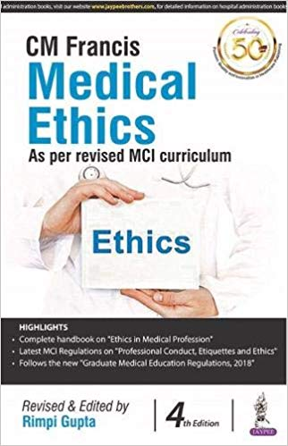

Timms Olinda: *Biomedical Ethics* *AETCOM companion for medical students.* 2nd edition. New Delhi: Elsevier – RELX India Pvt. Ltd. 2019. Paperback. 284 pages. Price not stated. ISBN 978-81-312-5965-8

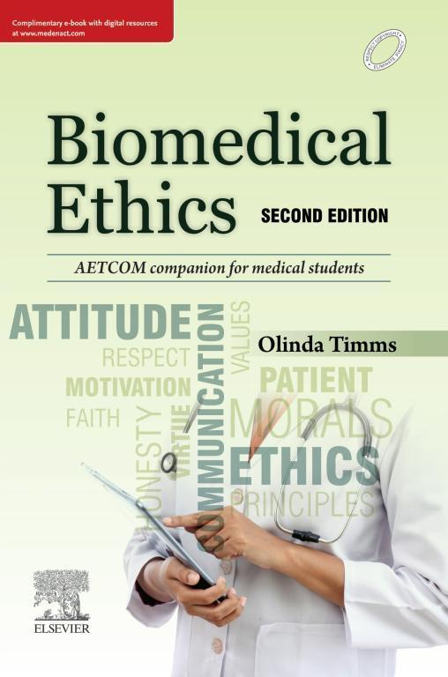

… and a brief note on AETCOM.

________________________________________________________________

**AETCOM**

In 2018, the Medical Council of India issued its 85 page volume entitled *Attitude, ethics and communication* with the acronym AETCOM. Dr. Jayshree Mehta, President of the Council termed this a ‘*competency based curriculum* that has been proposed by the Medical Council of India (that) would definitely serve a larger cause in the domain of *quality centricity*.’ In the next paragraph, we learn that ‘The *Conative domain* which hitherto was not appropriately incorporated and structured in the curriculum has been specifically dispensed of by providing a definitive model for the same titled AETCOM - Attitude, Ethics and Communication Model.’ She expressed the hope that this curriculum ‘would go a long way in creating an Indian Medical Graduate to realistically turn out to be an International Medical Graduate capable of catering to the cause and requirement of health care delivery across the boundaries all over the Globe.’

She was appreciative of Dr. Vedprakash Mishra, chairman of the academic team that produced this document.

In his foreword, Dr. Mishra tells us that ‘Health Professions and practice is a complex interplay of Knowledge, Clinical Skills & Acumen, Communication, Attitude, Inter-Professional behavior and is largely dependent on strong Ethical values.’ He summed up the purpose of the curriculum thus: ‘The entire concept of AETCOM module lies on the fundamental principle that changing a person's attitude can change his or her behavior. The Cognitive components of attitudes are more fundamental and constant over time and more closely connected to basic values.’

There is much more along these lines in the segment preceding the document itself.

A ‘hybrid PBL model’ was suggested as ‘one of the most effective ways for students to explore the various facets of *real life issues* that will confront them in their careers.’

Case discussions, assessment of skills related to attitude, ethics, communication and learning modules for each professional year follow. Queries such as ‘What does it mean to be a doctor?’, ‘What does it mean to be a patient?’ and topics such as the doctor-patient relationship, the foundations of communication, the cadaver as the first teacher of the medical student, the foundations of bioethics etc. are dealt with.

The books under review are new editions of earlier works modified to incorporate the AETCOM guidelines.

_______________________________________________________________

***C M Francis: Medical Ethics as per revised MCI curriculum***

Dr. C. M. Francis, author of the original work, also wrote on HIV, law and ethics; conflicts and confluence - ancient and modern medical ethics in India; hospital administration and health policy of the church in India. Educated in medicine at the Madras Medical College, he studied physiology in Cambridge, England and headed the department of physiology at St. Johns Medical Institute in Bangalore. He later served as the Dean of this institute. The tribute paid to him (2007;4(Suppl):S13) and the obituary by Dr. Ravi D’Souza (2009;6:168) in this journal deserve study.

Dr. Rimpi Gupta is an assistant professor in the department of anatomy at Kalpana Chawla Government Medical College, Karnal, Haryana. She is also the nodal officer of the body donation program of her institution. Her key area of interest is anatomy. I was unable to find papers on medical ethics by her.

The first three editions of the book under review were brought out by Dr. Francis in 1993, 2004 and 2008. The first edition was reviewed in this journal by Dr. Amar Jesani (1994;2:8).

Dr. Rimpi makes her appearance with this 4th edition. She has reproduced Dr. Francis’ preface to the first edition and added one of her own.

Since I have access to the second edition, I shall attempt to compare its contents with those of the volume under review.

Whilst chapter 1 remains almost unchanged, we see changes from Chapter 2 onwards. Brief notes have been introduced in some chapters to bring in the concepts highlighted in the AETCOM document.

Some chapters have been realigned. Chapters 7 (autonomy and informed consent) and 8 (rights of patients) in the second edition are now chapters 6 and 7.

Most of Dr. Francis’ text has been reproduced verbatim. Even errors are reproduced as in the original text. (An example: ‘The geneal assembly…’ on page 39 of edition 2 and on page 36 of the 4th edition.)

Little attempt has been made to update information. As in 2004 (2nd edition, page 76), so in 2019 (page 71), we read: ‘The new Indian Medical Council (professional conduct, etiquette and ethcis) Regulations 2002 are more explicit:’ The spelling mistake ‘ethcis’ is also reproduced verbatim.

We continue to read of ‘ICMR guidelines proposed’ and the report on these proposed guidelines from *The Times of India* dated September 2002 (pages 82-83 in the 4th edition).The draft *Assisted Reproductive Technology (Regulation) Bill* 2010 finds no mention. We also do not find any mention of *Rented Womb: An Assessment of Assisted Reproductive Technologies (Regulation) Bill*, 2013 or the recent debates on commercial surrogacy or on post-mortem retrieval of sperm for assisted reproduction.

Chapter 12 deals with care of the terminally ill in both the 2nd and 4th editions. I could not find any significant differences in the two versions except on page 95 of the present edition where there is a reference to Aruna Shanbaug and the permission granted by the Supreme Court of India in 2018 to withdraw life support in specified instances. However, though this Court did allow us to draw up living wills, we continue to read ‘The living will is not legal here and not binding on the doctors’ (page 92) as we did on page 99 in the 2nd edition.

Suicide is termed a crime in Chapter 13 (page 102 of edition 4 as on page 111 in edition 2). There is no reference to the passage of the Mental Healthcare Bill of 2016 that decriminalised suicide and provided for mental healthcare and services for persons with mental illness.

As we turn to Chapter 22 (Clinical Trials) towards the end of the book, we see, once again, reproduction of the text from the second edition without any attempt at providing up to date information. Whilst the chapter continues to refer to guidelines published in 1996 and the Declaration of Helsinki in 2001, there is no reference to or details from such documents as the *National Ethical Guidelines For Biomedical And Health Research Involving Human Participants* (published by ICMR in 2017) or later documents.

Whilst some references are provided in the text, there is no list of references at the end of each chapter or at the end of the volume. None of the references are provided as recommended by the International Committee of Medical Journal Editors.

The Annexure does contain the text of the regulations of the Medical Council of India updated to October 2018 (as against March 2002 in edition 2).

Dr. Rimpi Gupta has lost a golden opportunity. She could have updated Dr. Francis’ book to advantage, not only to incorporate the schedules suggested in the AETCOM guidelines but also to correct errors and include the significant amount of information that is relevant to India since the publication of editions 2 and 3 and now freely available in documents. The reliance on publications in foreign publications could have been improved upon by replacing many of them with texts in numerous books from and on India and such journals as *Indian Journal of Medical Ethics* and publications by the *Medico-Friends Circle*. The experiences of non-governmental organisations working for the welfare of the poor, downtrodden and tribals provide ample material that could have been used to enthuse medical students.

It is also important to remind students on what medicine can and cannot achieve, the difficulties in treating patients and staying true to medical ethics in the current milieu and the need to strive towards high ideals despite the odds against them.

_______________________________________________________________

**Timms Olinda: *Biomedical Ethics AETCOM companion for medical students***

I had reviewed the first edition of this book in this journal (2016;1(NS):256-267). In that review I had provided some background information on Dr. Timms.

The preface to the second edition points out, that in addition to the AETCOM modules, there is scope for providing background reading material and content for faculty and students.

This book proceeds to do so and also provides case studies and resource material.

Excerpts from the works of such pioneers as Charaka (this is the spelling used in this book), Susruta and Kashyapa are accompanied by commentaries on what we can continue to learn from ancient Indian medicine. Excerpts and quotations from leaders of thought elsewhere in the world are also provided at appropriate places.

The original format has fortunately been retained. Each chapter is divided into sections. Chapter 1 entitled *Introduction to medical ethics* has the following sections: *Why do we need medical ethics*? *Who is a professional*? *History of medical ethics* and *Indian tradition in medical ethics: a legacy*.

A quotation that stimulates thought leads to an outline of the chapter that follows and what it aims to achieve as learning objectives. The case study provided at the start of each chapter is left unanswered at the end of the chapter but pointed questions are posed so that using the information provided in the chapter the student can proceed to formulate a solution to the dilemma highlighted in the case study.

The reader is also encouraged to put on the thinking cap in other ways. Discussing whether ethics and morality in general can be absolute, we are given the example: *Killing another human may be considered morally wrong; however, killing another human in battle may not*.

Relatively uncommon topics are explained fluently. The theories of morality are an example. As physicians untrained in formal philosophy, we balk at terms such as *Virtue ethics*, *deontology* and *teleology*. The text on pages 20-23 will put us at ease and enable the usage of these and other terms with confidence. Likewise, the principles of medical ethics (pages 23-27) provide definitions, quotations from individuals as varied as Hippocrates and John Rawls, agencies formulating codes of ethics and references for further study in addition to the usual explanatory notes.

Short summaries of important landmarks in medical ethics are to be found throughout the book. Chapter 6 (*Ethics at the end of life)*, for instance, has notes on Dr. Jack Kevorkian (called Dr. Death as he promoted euthanasia), Dr. Nigel Cox (who caused the death of an elderly woman in 1992 to relieve her of pain from crippling rheumatoid arthritis), the case of Terri Schiavo (persistent vegetative state) and that of Aruna Shanbaug at the K. E. M. Hospital in Mumbai). In each boxed note, references are provided for further study. This chapter also provides information on the philosophy on euthanasia and death in Hinduism, Buddhism, Sikhism, Islam and Christianity. The discussion on the pros and cons of euthanasia includes a discussion of the slippery slope that led to the Nazi atrocities.

There is much to stimulate young minds. Let me quote from the section *Who is a professional?* in chapter 1.

‘There can be differing perceptions of a medical career, depending on our personal goals and values:

* Medical practice as an *occupation*: We could consider our medical work as a means to be *gainfully occupied* and earn a living. At this level, the practice of medicine is merely an occupation like any other: engineering, fashion design, or flight pilot.
* Medical practice as a *profession*: The next level would be medical practice as a profession where we attribute social significance to our work and its impact on human life. There is also adherence to the standard of conduct expected by the peer group.
* Medical practice as a *vocation*: At the highest level, the chosen career is a vocation. It is a life calling, expressed by the highest level of commitment and dedication. Doctors who dedicate their life to medical practice at remote locations or who work under challenging conditions are examples that would fall into this category.

Not every doctor may consider medical practice as a vocation, although some of the best doctors of all time have been driven by passion for their work and service to others. However*, it is expected that every graduate will practice medicine as a profession*. Anything less will undermine the traditional respect accorded to doctors and their work in society.’

There can be no quarrel with the sentences in the last paragraph. (Incidentally, interested readers may also benefit from Justice Tuttle’s stirring definition of a professional. [Elson Charles M: Remembering Judge Elbert Tuttle. Sr. *Cornell Law Review* 1996;82:15-18 ] )

New terms are defined wherever they are used for the first time. Here is an example:

*Bioethics* is a newer term, first coined by Fritz Jahr in 1927 but popularized by the American biochemist V.R. Potter since 1971. The definition by Warren Reich in 1995 was “the systematic study of the moral dimensions—including moral vision, decisions, conduct and policies—of life sciences and healthcare, employing a variety of ethical methodologies in an interdisciplinary setting.”[4](https://www.medenact.com/FPbookreader/GetXHTMLPage.aspx?AccountId=1&JobId=64123&PageName=page0010a.xhtml&iFrameContainerWidth=1153&iFrameContainerHeight=1130&renditionLayout=&PageNumber=11&UserId=1#bib0025),[5](https://www.medenact.com/FPbookreader/GetXHTMLPage.aspx?AccountId=1&JobId=64123&PageName=page0010a.xhtml&iFrameContainerWidth=1153&iFrameContainerHeight=1130&renditionLayout=&PageNumber=11&UserId=1#bib0030)

I learnt a new term on page 21: *Universalizability*. (Dr. Timms explains that the term was used by Immanuel Kant (1724-1804). The dictionary tells me that this term, used as a noun in ethics, enunciates the principle that the only morally acceptable [maxims](https://en.wikipedia.org/wiki/Maxim_(philosophy)) of our actions are those that could rationally be willed to be universal law.)

Academics and researchers, is particular, must study Chapter 13 – Publication ethics. The quotation at the beginning of this section is from Dr. Edmund Pellegrino (1920-2013): ‘Many of our habits as physicians and what we consider *good* medicine are traceable to imitation or rejection of some teacher’s example.’ It is especially apt as the Case Study that follows pertains to the all-too-familiar demand by the head of the department that his name be included as an author in a paper or chapter to be published, even though he had played no role in the work being described.

A list of references is provided at the end of each chapter. Appendix C contains additional references listed against each chapter as suggested reading. These are different from those provided at the end of the relevant chapter. The references to chapter 1 in this appendix date from 1803 to 2015 whilst those at the end of Chapter 1 date from 1949 to 2011. Where available, links are provided for access to references on the internet.

Appendix D also provides lists of relevant movies, between 3 and 14 movies being listed against each chapter. These movies date from 1939 (*Dark Victory)* to 2013. Western films and those from India are included. Access to the movies is not provided and the reader must seek them elsewhere. Doubtless, you will have your own preferences. Should you know of important films not included here, could you write to this journal, providing details? This will benefit other readers.

Appendix B deals with the practical implementation of the AETCOM approach and provides answers to such questions as ‘How can medical ethics be included seamlessly into the curriculum without needing additional teaching hours?’ ‘Who will teach ethics?’ ‘What should be taught?’ Practical tips to avoid disconnecting ethics from clinical practice and make the former come alive as part of teaching in clinics and wards are provided. A detailed list of suggestions for enabling these is to be found on pages 266-269 and includes such subheads as Preclinical years, various subjects (Anatomy, Physiology…); Clinical years, Forensic Medicine and Community Health Medicine. Under Obstetrics and Gynaecology; for example, we have topics such as Ethical issues related to abortion, Medical Termination of Pregnancy Act, Sterilization Camps, Assisted reproduction techniques, Ethical issues with surrogacy, Prenatal diagnostic tests and PCPNDT Act. The section also offers suggestions on how well students have understood what has been conveyed can be assessed. The references at the end of this chapter include papers on teaching medical ethics by experts such as Dr. Edmund Pellegrino.

I was sorry to see some eminences referred to in the text missing from the index. Sir William Osler (referred to in the text on page 21) has been excluded. He was an exemplar of ethical medical practice and taught it effectively. He is in good company for Aristotle and Plato (referred to on page 20) also fail to find mention in the index.

Purchasers of the book are provided access to the online edition of the book. Once one has registered, access to the full text of the book and its various sections is easy. Notes can be added to any section and relevant text can be highlighted with one of five colours. The search facility is primitive and not very helpful.

As Dr. Francis’ book, there is much in common as regards contents in the two editions. In Dr. Timms’ book, I could not help wishing that the lists of references and that of films had been brought up to date.