**Title: Publications after conference presentations: A systematic review of published studies**

**Abstract:**

**Background and aims:** Conferences present an opportunity to present findings to an audience of experts in the field and get feedback for putting the research in context. Since conference proceedings provide limited space for presenting the findings, research publications are able to provide a better platform for the wider reach, scrupulous peer evaluation, and temporal consolidation of the medical scientific material. This review attempts to collate the studies which have evaluated the abstract publication ratio of the conference presentations.

**Methods**: The systematic review and meta-analysis included peer reviewed publications which quantitatively reported the publication rate of conference presentations.

**Results**: A total of 28 studies were included, with sample sizes ranging from 82 to 1897 abstracts (total 17172 abstracts). The publication rate ranged from 3.8% to 78.0%, with weighted mean publication rate of 41.8% (95% confidence interval of 34.1% to 49.5%). Oral presentations had a greater chance of being published as compared to poster presentations (odds ratio of 2.693, 95% confidence intervals of 1.285 to 5.646). There was high degree of heterogeneity in the findings.

**Conclusions**: A small proportion of the conference presentations are published. Efforts should be made to improve the abstract publication ratio, to improve the wider dissemination of the available research.

**Keywords**: Abstracts, Conferences, Oral, Poster, Publication

**Introduction**

Conference presentations are an important step in the process of dissemination of scientific findings. These presentations are able to provide a glimpse of the current topical research of interest to the field, and also provide an opportunity for discussion and deliberation of the findings.1Conference presentations also provide a platform for the younger researchers to showcase their work, and get familiar with the process of dissemination of scientific insights. However, the natural corollary of conference presentations would be publication in a peer-reviewed journals.2 Publication of the material of conference presentations in journals helps to make the material available in a more rigorous manner to a wider audience. The process of peer review during the publication phase provides critical, unfettered inputs for putting the findings in context and spelling out the inaccuracies and limitations.

Despite publication being a preferred outcome of conference presentations, not all such presentations are published. There could be several reasons for non-publication, including the waning interest of the researchers, difficulties in securing a reasonable outlet for the publication, and/or the presentations being of limited academic value. Yet, knowing the extent to which research presentations are published would give an estimate of the ‘translation’ of the conference presentation to publication. Hence, this systematic review and meta-analysis attempts to collate to what extent the research presentations are published.

**Methods:**

The present systematic review utilized PubMed database to identify the studies. Additional studies were identified using the Google Scholar database. The keywords used for the searches in varying combinations were “Conference Proceedings”, “abstracts”, “publication rate”, “abstract publication ratio”, “publication ratio”, and “publication”. The inclusion criteria for being included in this systematic review were English language articles published in peer reviewed medical journals which evaluated with publication rate of conference presentation and presented their data in usable quantitative format. Those studies which did not numerical data of rate of conference presentations being published were excluded. The search was carried out in the month of March 2019.

To be included in the metanalysis, the studies were required to be presenting data of abstract publication ratio, i.e., providing data about the number of abstracts presented in a conference, which were subsequently published. Studies just reporting about the content of the abstracts and other related topics were excluded.

Information was extracted from the included studies by two of the authors (SG and ND). Information was extracted using a pre-determined proforma and the information regarding the author name, name of the conferences, years of the conferences, number of abstracts evaluated, time lag allowed, search engines and strategies used to identify publications and publication rate. Where available, the publication rate of oral and poster presentations was extracted. The extracted data was analysed using OpenMetaAnalyst software. The effect sizes were generated using the proportions method of the software. Weighted mean effect sizes of the entire sample along with the 95% confidence intervals were computed to generate the pooled publication rate. A random effects model was used for computing the overall publication rate. I2 test of heterogeneity was used to ascertain the heterogeneity of the included studies and their effect sizes. Separate analysis was run to find differences in the publication rate of oral presentations and poster presentations by generating pooled odds ratios and their confidence intervals. Meta-regression was used to see whether the duration of ascertainment of the publication status (i.e. whether waiting for a longer duration after the conference to assess whether abstract was finally published) had an impact on publication rate.

**Results**

Initial search yielded 479 studies, abstracts of which were screened, of which 28 were found to fulfil the criteria for the metanalysis and these studies were included (Table-1 and Figure-1). The number of abstracts in the included studies ranged from 82 to 1897, and total number of abstracts included in all the studies, cumulatively accounted to 17,172. The publication rate ranged from 3.8% to 78%, with weighted mean publication rate of 41.8% (95% confidence interval of 34.1% to 49.5%), as shown in Figure 2. Four studies had explicitly compared publication rates of oral and poster presentations. Oral presentations had a greater chance of being published as compared to poster presentations (odds ratio of 2.693, 95% confidence intervals of 1.285 to 5.646) (Figure-3).

Time frame for assessment of publication was available for 23 studies, and ranged from 2 years to 8 years. Meta-regression was used to ascertain whether greater duration in the time frame of assessment was associated with greater publication rate. However, the duration of time frame available did predict the publication rate in the present study (coefficient – 0.010, 95% confidence intervals -0.043 to 0.024, p = 0.576). Also, publication year did not have a significant impact on the publication rate (coefficient – 0.004, 95% confidence intervals -0.012 to 0.004, p = 0.343).

Table 1: Summary of the studies

|  |  |  |  |  |  |  |
| --- | --- | --- | --- | --- | --- | --- |
| Authors | Name of the conferences | Years of the conferences | Number of abstracts evaluated | Time lag allowed | Search Engines & strategies used to identify publications | Publication rate (i.e., published as full articles) |
| Gorman &Oderda et al, 19903 | American Association of Poison Control Centers, The American Academy of Clinical Toxicology, The American Board of Medical Toxicology and the Canadian Association of Poison Control Centers | 1984 and 1986 | 296 |  | MEDLARS | Total: 49.8% |
| Scherer et al, 19944 | Association for Research in Vision and Ophthalmologyor the American Academyof Ophthalmology annual meetings | 1988, 1989 | 149 | 3 years | MEDLINE | 66% of the confirmed RCT abstracts published |
| Jeffrey et al., 19995 | North American Spine Society (NASS), Scoliosis Research Society (SRS), and International Society for the Study of the Lumbar Spine (ISSLS). | NASS 1990 to 1992, SRS 1991 to 1993, and ISSLS 1991 to 1993 | 1186 | NASS: 8 years;SRS &ISSLS: 7 years | Melvyl Medline Plus | Overall: 43.5%  (NASS: 40%  SRS : 47 %  ISSLS: 45%) |
| Roy et al., 20016 | Otorhino-laryngological Research Society meetings, UK | 1978 to 1995 | 660 | 456 | MEDLINE | Total. 69.09% |
| Sprague et al., 20037 | Meeting of the American Academy of Orthopaedic Surgeons. | 1996 | 465 | Not known | MEDLINE, PubMed | Total: 15.48% |
| Arrive et al, 20048 | Radiological Society of North America | 1995 | 1897 | 1-5 years | MEDLINE | Total: 33% |
| Miguel-Dasit et al., 20069 | European Congress of Radiology | 2000 | 1020 | 5 years | MEDLINE | Total: 47% |
| Secil et al., 200610 | European Society of Gastrointestinal and Abdominal Radiology (ESGAR) meetings | 2000,2001 | 276 | 4 years | MEDLINE, PubMed | Total: 39.5% |
| Macmillan et al., 200711 | British Association of Emergency Medicine and the Faculty of Accident and Emergency Medicine | 2001,2002 | 404 | 3 years | Ovid | Total: 30%  (Oral papers: 57%  Posters: 14%) |
| Ho Ha et al., 200812 | Annual meetings of the Korean Radiological Society (KRS) and abstracts presented by Korean investigators at the annual meetings of the Radiological Society of North America (RSNA) and European Congress of Radiology (ECR) | 2001, 2012 | 1,097 | 7.6 years | PubMed, Korean Medical Database | Total: 27.4%  (KRS: 23.6%  RSNA: 35.4%  ECR: 50.5%) |
| Kottachchi et al., 201013 | Randomized Clinical Trials in Inflammatory Bowel Disease Presented at Digestive Disease Week | 1998-2003 | 82 |  | MEDLINE, PubMed , EMBASE, Google Scholar | Total: 78% |
| Donegan& Kim, 201214 | American Academy of Orthopaedic Surgery (AAOS) | 2001 | 756 | 5 years | PubMed, MEDLINE, | Total: 49%  (Poster  presentations :47%  Podium presentations: 52%) |
| Winnik et al., 201215 | European Society of Cardiology Congress | 2006 | 1020 | 4 years |  | Overall: 31%  (38% for accepted papers and 24 % for rejected papers) |
| Yoon et al., 201216 | Urological Society of Australia and New Zealand (USANZ) Annual Scientific Meeting | 2005 to 2009 | 614 | 3 years | PubMed | Total: 29.8% |
| Walsh et al., 201317 | North American medical education conferences (Research in Medical Education Conference [RIME] and the Canadian Conference on Medical Education [CCME]) | 2005 & 2006 | 449## | 6.3 years | MEDLINE, EMBASE, ERIC, Google Scholar | Total: 34.7% |
| Jorgens et al., 201418 | European Association of studies of Diabetes | 2004 | 493# | 4 years | MEDLINE  Authors contacted by email | Total: 42.4% (51.1% for accepted abstracts and 26.7% for rejected abstracts) |
| Mutlu et al., 201519 | National Congress of Child and Adolescent Psychiatry (NCCAP), Turkey | 2005-2008 | 214$ | 5 years | PubMed, Google Academic databases | Total 25.2% |
| Elliott et al., 201620 | Annual meeting of the Congress of Neurological Surgeons, Canada, 2005 | 2005 | 754 | 5. 3 years | MEDLINE, Scopus, Google Scholar | Total: 50.8% |
| Memon et al., 201621 | American Shoulder and Elbow Surgeons’ (ASES) annual meetings | 2005–2010 | 266 | 5 years | PubMed, Ovid, EMBASE | Total: 49.2% |
| Shergill et al., 201722 | Cardiovascular and Interventional Radiology Society of Europe (CIRSE) and the Society of Interventional Radiology (SIR). | 2012 | 421 | 3 years | PubMed and  Google Scholar | Total: 44.9% |
| Hosseini-Zijoud, 201723 | First International Congress of Nephrology and Urology, Tehran, Iran, 2015 | 2015 | 210 | 1 year | Scopus, PubMed  ISC (for Persian language published  papers) | Total: 23.3%  Oral papers: 41.3%  Posters: 15.6% |
| Orr et al., 201724 | Society of Military Orthopaedic Surgeons (SOMOS), USA | 2009–2013 | 592$$ | 2 years | PubMed | Total: 58.6% |
| Hoelscher et al., 2017 25 | AACAP Annual Meeting, USA | 2012- 2013 | 658 | Not known | PubMed, Google Scholar | Total: 46% |
| Basu et al., 201726 | American Academy of Pediatrics, Pediatric Academic Societies, and Society of Critical Care Medicine national meetings. | 2007-2011 | 267$$$ | 5 years | PubMed search | Total: 41% |
| Nwachukwu et al., 2018 27 | International Society for Hip Arthroscopy (ISHA) | 2011- 2014 | 674 | 3 years | PubMed, MEDLINE, Google Scholar | Total: 46. 85%  Podium presentations: 53.6%  Poster presentations: 40.1% |
| Egloff et al., 201728 | Society of General Internal Medicine 2009 Annual Meeting. | 2009 | 578 | 5 years | MEDLINE | Total: 47.4 % |
| Komagamine&Yabuki, 2018 29 | Japan Primary Care Association Annual Meetings | 2010-2012 | 1003 | 5 years | MEDLINE | Total: 3.8 % |
| Raudenbush et al., 201830 | North American Spine Society (NASS) | 2009 to 2011 | 671 | 4 years | PubMed | Total: 51% |

# Evaluated 493 out of the 2008 submitted abstracts, of which 1306 were accepted for the conference

## Six were excluded (4 withdrawn, 1missing, 2 published before abstract deadline)

$ Included only poster presentation

$$ Excluded poster presentation

$$$Only pediatric critical care medicine abstracts were included

**Discussion**

The two major findings of this metanalysis are that a substantial proportion of the conference presentations may not find an outlet as subsequent publication; and that oral presentations are more likely to be published as compared to poster presentations. Several factors can explain these findings. One, there was considerable heterogeneity across the studies. There were differences in methodology of ascertainment, the duration of follow-up for publication, and the search engines utilized. Yet, even in the best case scenario, there were several presentations (more than 20%) that were not published. Thus, it is possible that the authors either are not interested in publication, or are not able to secure a suitable journal for publication of their presented material. It is also possible that the presentation was of preliminary material which the authors knowingly withheld publication pending the conduct and publication of the full study. Furthermore, sometimes presentations are opportunities for younger members in research team to present a piece of the entire work, while the more comprehensive results are published together. Hence, while some presentations not being published can be intentional, others may be unintentional.

Oral presentations being published more frequently can also be ascribed to several factors. Scientific committees of conferences generally allocate better and more impactful studies into oral presentations.31 Also, oral presentations give more focussed and intense feedback through the discussion during the presentation process. This may provide a first line of peer review for the work under consideration. Furthermore, it can be speculated that those who are less likely to publish the findings per se (due to the preliminary nature of findings or a small part of the entire project) are likely to prefer poster presentation as the choice of presentation.

Publication of conference presentations can be a useful method to enrich the scientific field. The presentation abstract gives leads to researchers working in the field about work done on a particular topic. Access to further details through a scrutinized report in the form of publication can help in planning better research, avoiding the pitfalls experienced previously by others, and developing on the theoretical construct. Thus, encouragement of research publication from the conference presentations is desirable. Yet, one of the important functions of academic conferences is facilitation of the meeting and inter-mingling of a variety of experts in the field, and organizers may be practically constrained for accommodating a range of presentations with myriad inclinations. Hence, expecting all presentations to be duly published might a utopian desire.

Though the present systematic review and meta-analysis aims to present forth the publication rate of conference proceedings, some limitations need to be highlighted. The review included only English language papers and excluded those studies where quantification of the publication rate could not be done. Also, there was one study with fair weight but low publication rate which could have skewed the findings.29 Additionally, we did not look for publication biases or use a structured instrument for assessment of risk of bias. Despite the limitations, the present review presents a collation of findings of the publication of rate of presentations made in conferences.

Figure 1: Inclusion of studies (Fill the numbers approximately)

Records identified through database searching   
(n = 479)

**Screening**

**Included**

**Eligibility**

Identification

Records identified through other sources searching   
(n = 32)

**Identification**

**(n = 511)**

Additional records identified through other sources : None  
(n = )

Records after duplicates removed   
(n = 8)

Records screened  
(n = 475 )

Records excluded   
(n = 447)

Full-text articles assessed for eligibility   
(n = 28)

Figure 2: Forest plot of included studies

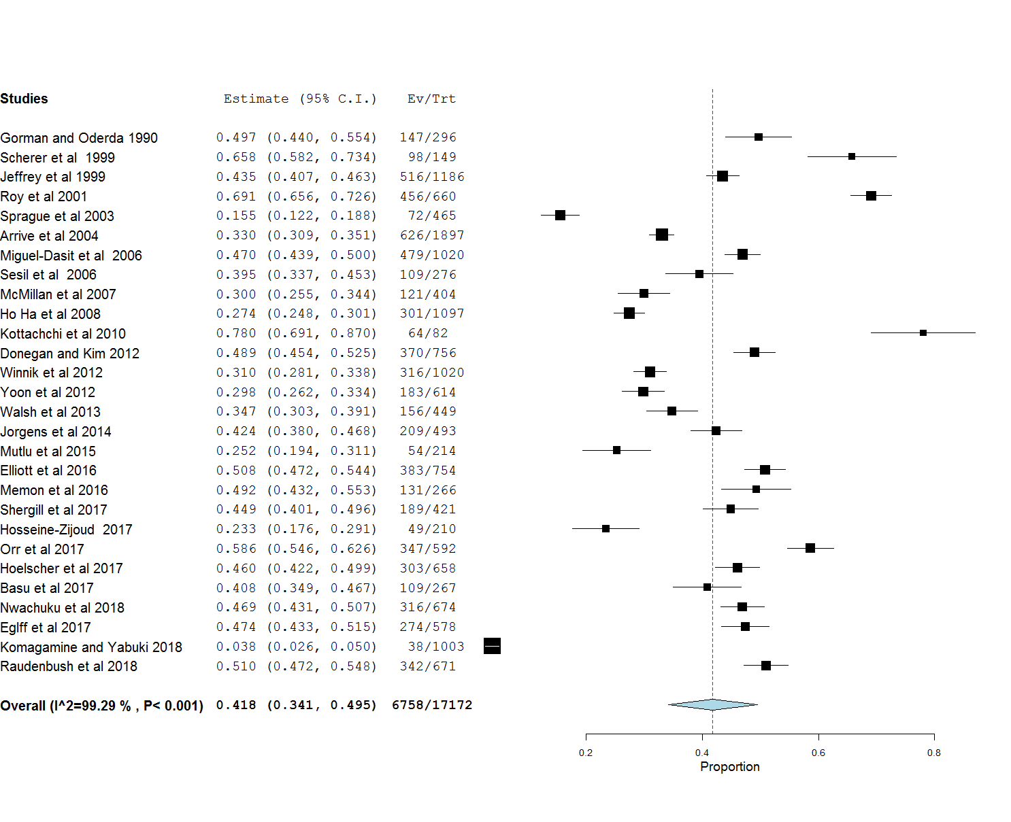

Estimate refer to the proportion of abstracts published

Figure 3: Forest plot of studies with oral and poster presentations

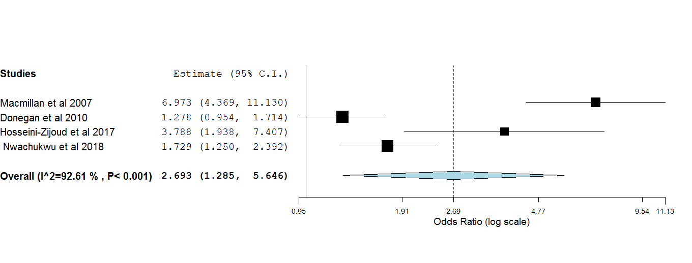

Estimates refer to the odds of publication of oral presentations vis a vis poster presentations

**References:**

1. Strickland, T. Conference presentations with confidence. *Case Manag.***10**, 68–70 (1999).

2. Turale, S. Turning conference presentations into publications. *Int. Nurs. Rev.***62**, 3 (2015).

3. Gorman, R. L. & Oderda, G. M. Publication of presented abstracts at annual scientific meetings: a measure of quality? *Vet. Hum. Toxicol.***32**, 470–472 (1990).

4. Scherer, R. W., Dickersin, K. & Langenberg, P. Full publication of results initially presented in abstracts. A meta-analysis. *JAMA***272**, 158–162 (1994).

5. Wang, J. C., Yoo, S. & Delamarter, R. B. The publication rates of presentations at major Spine Specialty Society meetings (NASS, SRS, ISSLS). *Spine***24**, 425–427 (1999).

6. Roy, D., Sankar, V., Hughes, J. P., Jones, A. & Fenton, J. E. Publication rates of scientific papers presented at the Otorhinolarygological Research Society meetings. *Clin. Otolaryngol. Allied Sci.***26**, 253–256 (2001).

7. Sprague, S. *et al.* Barriers to full-text publication following presentation of abstracts at annual orthopaedic meetings. *J. Bone Joint Surg. Am.***85-A**, 158–163 (2003).

8. Arrivé, L. *et al.* Subsequent publication of orally presented original studies within 5 years after 1995 RSNA Scientific Assembly. *Radiology***232**, 101–106 (2004).

9. Miguel-Dasit, A., Martí-Bonmatí, L., Sanfeliu, P. & Aleixandre, R. Scientific papers presented at the European Congress of Radiology 2000: publication rates and characteristics during the period 2000-2004. *Eur. Radiol.***16**, 445–450 (2006).

10. Secil, M., Ucar, G. & Dicle, O. Scientific papers presented at the 2000-2001 European Society of Gastrointestinal and Abdominal Radiology (ESGAR) meetings: publication rates during the period 2000-2004. *Eur. Radiol.***17**, 2183–2188 (2007).

11. Macmillan, C. D., Moore, A. K., Cook, R. J. & Pedley, D. K. Abstract-to-publication ratio for papers presented at scientific meetings: a quality marker for UK emergency medicine research. *Emerg. Med. J. EMJ***24**, 425–426 (2007).

12. Ha, T. H. *et al.* Publication rates for abstracts presented by Korean investigators at major radiology meetings. *Korean J. Radiol.***9**, 303–311 (2008).

13. Kottachchi, D. & Nguyen, G. C. Quality and publication success of abstracts of randomized clinical trials in inflammatory bowel disease presented at Digestive Disease Week. *Inflamm. Bowel Dis.***16**, 993–998 (2010).

14. Donegan, D. J., Kim, T. W. & Lee, G.-C. Publication rates of presentations at an annual meeting of the american academy of orthopaedic surgeons. *Clin. Orthop.***468**, 1428–1435 (2010).

15. Winnik, S. *et al.* From abstract to impact in cardiovascular research: factors predicting publication and citation. *Eur. Heart J.***33**, 3034–3045 (2012).

16. Yoon, P. D., Chalasani, V. & Woo, H. H. Conversion rates of abstracts presented at the Urological Society of Australia and New Zealand (USANZ) Annual Scientific Meeting into full-text journal articles. *BJU Int.***110**, 485–489 (2012).

17. Walsh, C. M., Fung, M. & Ginsburg, S. Publication of results of abstracts presented at medical education conferences. *JAMA***310**, 2307–2309 (2013).

18. Jörgens, V., Grüsser, M., Schürmann, P. & Müller, U. A. Fate of abstracts submitted to the 2004 EASD Annual Meeting in Munich. *Diabetologia***57**, 1997–1999 (2014).

19. Mutlu, C., Mutlu, E. K., KILIÇOĞLU, A. G. & Yorbik, Ö. From poster presentation to publication: National Congress of Child and Adolescent Psychiatry. *Nöro Psikiyatri Arş.***52**, 111–6 (2015).

20. Elliott, C. A., Mehta, V., Poon, C., Oliver, M. & Gourishankar, S. The fate of abstracts presented at the annual meeting of the congress of neurologic surgeons. *Open J. Mod. Neurosurg.***6**, 1–8 (2016).

21. Kay, J. *et al.* Five-year publication rate of clinical presentations at the open and closed American shoulder and elbow surgeons annual meeting from 2005-2010. *J. Exp. Orthop.***3**, 21 (2016).

22. Shergill, R., Kaka, H., Kennedy, S. A. & Baerlocher, M. O. Publication rates of abstracts presented at major interventional radiology conferences. *Diagn. Interv. Radiol. Ank. Turk.* 435–440 (2017). doi:10.5152/dir.2017.16499

23. Hosseini-Zijoud, S.-M., Barzi, F., Lotfiazar, A. & Einollahi, B. Fate of Abstracts Presented at the First International Congress of Nephrology and Urology, Tehran, Iran, 2015. *Nephro-Urol. Mon.***9**, e42541 (2017).

24. Orr, J. *et al.* Publication Rate and Impact Factor for Society of Military Orthopedic Surgeons. Annual Meeting Presentations, 2009–2013. *Mil. Med.***182**, e1992–e1996 (2017).

25. Hoelscher, A. M., Checketts, J. X. & Vassar, M. An Evaluation of the Publication Rate of AACAP Annual Meeting Presentations From 2012-2013. *J. Am. Acad. Child Adolesc. Psychiatry***56**, S297 (2017).

26. Basu, S. & Pollack, M. M. Outcome of Pediatric Critical Care Medicine Abstracts Presented at North American Academic National Meetings. *Pediatr. Crit. Care Med. J. Soc. Crit. Care Med. World Fed. Pediatr. Intensive Crit. Care Soc.* 795–799 (2017). doi:10.1097/PCC.0000000000001194

27. Nwachukwu, B. U. *et al.* What is the fate of scientific abstracts presented at the International Society for Hip Arthroscopy meetings? *J. Hip Preserv. Surg.***5**, 157–161 (2018).

28. Egloff, H. M. *et al.* Publication Rates of Abstracts Presented at the Society of General Internal Medicine Annual Meeting. *J. Gen. Intern. Med.* 673–678 (2017). doi:10.1007/s11606-017-3990-5

29. Komagamine, J. & Yabuki, T. Full-text publication rate of abstracts presented at the Japan Primary Care Association Annual Meetings (2010-2012): a retrospective observational study. *BMJ Open***8**, e021585 (2018).

30. Raudenbush, B. *et al.* Publication Rate of Podium Presentations From the North American Spine Society Annual Meetings. *Glob. Spine J.***8**, 273–278 (2018).

31. Uhl, E., Steiger, H. J., Barth, C. & Reulen, H. J. Evaluation of abstracts submitted for the annual meeting of the German Neurosurgical Society 1999--unravelling a mystery. *Zentralbl. Neurochir.***60**, 196–201 (1999).