**The Differential Expression Of Mincle In Human Leukocytes**

Shuping Li1,2#, Xiaohua Wang1,2#, Keping Wu1,2#, Dengyang Zhang3, Jinhong Li1,2, Zhiguang Chang3, Yuming Zhao3, Yiqing Zhang1,2, Yan Lei1,2, Wenqian Xu1,2, Na Li 1,2, Zhizhuang Zhao3, Yun Chen3* and Zhihua Zheng1,2*

Department of Nephrology1, Center of Nephrology and Urology2, [Scientific](C:/Users/li%20shuping/AppData/Local/youdao/dict/Application/8.4.0.0/resultui/html/index.html#/javascript:;) [Research](C:/Users/li%20shuping/AppData/Local/youdao/dict/Application/8.4.0.0/resultui/html/index.html#/javascript:;) [Center](C:/Users/li%20shuping/AppData/Local/youdao/dict/Application/8.4.0.0/resultui/html/index.html#/javascript:;)3, The Seventh Affiliated Hospital, Sun Yat -Sen University, Shenzhen, China.

Correspondence to:

Dr. Zhihua Zheng

Department of Nephrology1, Center of Nephrology and Urology2, The Seventh Affiliated Hospital, Sun Yat -Sen University, Shenzhen, 518107, China.

Telephone: +86 13922298682

E-mail:  zhihuazheng@126.com/ zhihuazheng163@163.com

Dr. Yun Chen

Scientific Research Center3, The Seventh Affiliated Hospital, Sun Yat-Sen University, Shenzhen, 518107, China.

Telephone: +86 13756913560

E-mail: [cheny653@mail.sysu.edu.cn](mailto:cheny653@mail.sysu.edu.cn)

|  |  |
| --- | --- |
| Shuping Li | scorpiolishuping@163.com |
| Xiaohua Wang | dr_wxh@163.com |
| Keping Wu | Wukp@mail2.sysu.edu.cn |
| Dengyang Zhang | epazhang@outlook.com |
| Jinhong Li | lijinhong0414@hotmail.com |
| Zhiguang Chang | 34162917@qq.com |
| Yuming Zhao | zym9307@163.com |
| Yiqing Zhang | zhangyq85@sysu.edu.cn |
| Yan Lei | hsxr8308@126.com |
| Wenqian Xu | xuwq28@mail2.sysu.edu.cn |
| Na Li | linamu90@163.com |
| Zhizhuang Zhao | zhizhuang.zhao@outlook.com |
| Yun Chen | cheny653@mail.sysu.edu.cn |
| Zhihua Zheng | zhihuazheng@126.com |

**A statement of competing interests and funding support**

The authors declare no conflict of interest.

This work was supported by 100 Top Talents Program of Sun Yat-sen University, National Natural Science Foundation of China (NSFC, Grant No. 31871400) and Shenzhen Science and Technology Innovation Committe Guangdong Province of China (Grant No. JSGG20180703155802047).

**Non-structured abstracts**

The manuscript is entitled as “The Differential Expression Of Mincle In Human Leukocytes”. In this study, we detected the expression of Mincle in human leukocytes from peripheral blood and cell lines representing myeloid and lymphoid cells by flow cytometry. Subsequently, we found that the expression of Mincle was high in human myeloid cells but was low to negative in human lymphoid cells. In addition, its expression was significantly higher in monocytes than granulocytes of the same donors. The indication from our data is considered as final conclusion that Mincle as a vital participant in the process of innate immunity mediated by myeloid cells, especially monocytes.

**Abstract**

Mincle is a C type lectin receptor that recognizes lipidic species from damaged/altered self and foreign organisms. It is expressed on immune cells to support the initiation of innate immune responses to infections. Mincle is also involved in allergies, acute kidney injury, neuropathic pain, and autoimmune diseases due to the recognition of various esterols including cholesterol. Studies show that the immune function of Mincle is tightly associated with its expression levels on cell surface. However, the relative expression levels are undetermined on immune cells. Due to the emerging importance of Mincle in human diseases, we aimed to explore the expression pattern in leukocytes from human peripheral blood in the present study. We used flow cytometry to evaluate the expression of Mincle in leukocytes from 8 health donors. The results showed that lymphocytes had low to negative expression in all cases. In contrast, high expression of Mincle was found in 37.5% of granulocytes (3/8) and 100% of monocytes (8/8). Furthermore, the overall expression in monocytes was significantly higher than granulocytes. Our data suggest a potentially important role of Mincle in monocytes due to its significantly high expression, which may contribute to immune responses to infections and autoimmune diseases.

[Key Words]: Mincle; Flow cytometry; Human peripheral blood; Monocytes

**Introduction**

Mincle is one of transmembrane C-type lectin receptors (CLRs) which are predominantly expressed by macrophages and are pivotal in tailoring immune response against pathogens(1), providing the capacity to recognize a broad range of self and foreign molecules as a part of innate immune sensing(2). It is a type-II transmembrane molecule with an extracellular carbohydrate-recognition domain (CRD), cholesterol and protein interaction sites, and a short cytoplasmic tail(3). CRD and cholesterol and protein interaction sites could recognize a wide range of ligands including lipidic species from bacteria, fungi, and mammals(4), as well as the self-ligands including sterols (e.g. cholesterol), β-glucosylceramides, and protein SAP130 released upon cell death(2). Upon binding to ligands, Mincle activates signals through immune receptor tyrosine activation motif (ITAM) of FcγR to mediate immune responses for host defense or autoimmune diseases(5-8).

Mincle was found initially as the transcriptional target of NF-IL6. Subsequently, Matsumoto and colleagues cloned Mincle by using NF-IL6-deficient macrophages. It is also known as a lipopolysaccharide-induced NF-IL6-dependent molecule since it was found up-regulated after *Candida albicans* infection in macrophages.(9, 10) Mincle is mainly expressed in macrophages, but also found to be expressed in neutrophils, dendritic cells, a part of B lymphocytes and other immune cells.(9, 11, 12) After binding to its ligands, Mincle inhibits cholesterol efflux and mediates signals by ITAM of FcγR to activate Syk-Card9-Bcl10-MALT1 and nuclear factor kappa light-chain enhancer of activated B cells (NF-κB) signaling pathways.(13) It induces Syk-mediated endoplasmic reticulum stress response and activates NF-κB signaling to release inflammatory factors including TNFα、IL-6、G-CSF、IL-1, CXCL1, CXCL2.(14, 15) Studies show that the signaling of Mincle is tightly correlated with the expression level on cell surface(16), but the relative expression levels in different immune cells are highly heterogenous that require further investigation. In the present study, we used flow cytometry to explore the distribution of Mincle in lymphocytes, granulocytes, and monocytes from human peripheral blood.

**Materials & Methods**

*Peripheral Blood specimens*

Blood samples were collected from donors at the Seventh Affiliated Hospital of Sun Yat-sen University who provided written informed consent using a protocol approved by the Institutional Review Board of Sun Yat-sen University in accordance with the Declaration of Helsinki. Leukocytes were isolated from fresh peripheral blood. Red cells were removed by using a red cell lysis buffer (0.16 M NH4Cl, 10 mM KHCO3, 0.5 mM EDTA).

*Cell lines*

MV-4-11, HL60, U937, Jeko, and THP1 were from ATCC (VA, USA). MEC1 was from DMSZ (Braunschweig, Germany). All cells were cultured in RPMI medium supplemented with 10% FBS in a humidified atmosphere at 37 °C with 5% CO2.

*Flow Cytometry*

Flow cytometry analysis was performed as described.(17, 18) Anti-CD11b-APC was from BD Biosciences (CA, USA). Anti-Mincle-Alexa488 was from Santa Cruz Biotechnology (TX, USA). Alexa488 Mouse IgG1 κ Isotype Control was from BD Biosciences. Flow cytometry was performed by using a CytoFlex XL flow cytometer (Beckman Coulter, USA) at Scientific Research Center of the Seventh Affiliated Hospital of Sun Yat-sen University. The data were analyzed by using FlowJo 10 (FlowJo, LLC, USA).

*Statistical Analyses*

Data are presented as the mean ± SD. Differences between two groups were determined by 2-tailed Student's t test. Correlation between two groups was determined by Pearson correlation coefficients. Significance was analyzed by GraphPad Prism 6.0 (GraphPad Software Inc., CA, USA) and p values of less than 0.05 was considered significant.

**Results**

*Mincle is expressed predominantly in myeloid cells*

We used flow cytometry to detect the expression of Mincle in human leukocytes from peripheral blood. The expression of Mincle was high in myeloid cells (CD11b+) but was low to negative in lymphoid cells (CD11b-) as comparison with control (Figure 1A). We also detect Mincle in cell lines representing myeloid and lymphoid cells (Figure 1B). HL-60 is a promyelocytic cell line. U937 and THP1 are monocytic cell lines. Jeko represents human mantle cell lymphoma. MEC1 represents human chronic lymphocytic leukemia. MV-4-11 was derived from human biphenotypic B-myelomonocytic leukemia.

*Monocytes express higher Mincle than granulocytes*

We further measured the expression of Mincle in lymphocytes, granulocytes, and monocytes gated by CD11b and side scatter (SSC) in peripheral blood from 8 healthy donors. We found high expression of Mincle (ΔMFI > 1000) in 100% of monocytes (8/8) and 37.5% of granulocytes (3/8)(Figure 2C). Lymphocytes expressed low to negative Mincle that is consistent with our previous data. Furthermore, the expression of Mincle was significantly higher in monocytes than granulocytes(Figure 2A and Figure 2B). We also collected clinical features including age, red blood cell count, hemoglobin, white blood cell count, and platelet count of donors involved in this study (Table 1) and analyzed their correlation with the expression of Mincle in granulocytes and monocytes. However, we did not find any correlated feature to the expression of Mincle in this study.

**Discussion**

In the present study, we found that Mincle was expressed predominantly in myeloid cells both in peripheral blood and cell lines. Monocytes expressed significantly higher Mincle than granulocytes, but the expression levels of Mincle were not correlated with age or blood cell count.

The C-type lectin receptor family of innate immune pattern recognition receptors (PRRs) is mainly expressed on myeloid cells and recognizes both carbohydrate and lipid moieties.(19) As a member of the family, Mincle mediates inflammatory responses in antigen-presenting cells via the nonreceptor tyrosine kinase Syk and the CARD9 pathway.(20, 21) There is a wide range of self and external ligands(22) that could bind to Mincle, including lipids, sugar lipids, SAP130, and other kinds of self-antigens, so Mincle is involved in both anti-exogenous microbial infection, autoimmune disease(5),which affect millions worldwide(23), acute kidney injury(6), mycobacterial infection(7), and neuropathic pain(8).

Monocytes and granulocytes are major components of the innate immunity against exogenous microbes.(24, 25) The high expression of Mincle in these cells suggests that Mincle is a vital participant in the process of innate immunity mediated by monocytes and granulocytes. Monocytes differentiate into macrophages when migrating from peripheral blood to various tissues. The binding of Mincle to ligands leads secretion of a large number of inflammatory factors to fight microbial infections.(9) The high expression of Mincle in monocytes is likely to contribute to similar functions in macrophages. We also detected Mincle in cell lines representing myeloid and lymphoid cells. We did not find Mincle expression in cells with lymphoid features, including MV-4-11, Jeko, and MEC1. HL60, THP1, and U937 are myeloid cells that expressed Mincle, which agrees with our data in peripheral blood. The monocytic cell line THP1 had the highest expression of Mincle, which may serve as an excellent cell model to study functions and related mechanisms of Mincle in innate immunity in the future. In conclusion, we explored the distribution of Mincle in the peripheral blood cells and cell lines, which laid the foundation for the role of Mincle in immune response mediated by various types of cells.

**Authorship Contributions**

Shuping Li1,2#, Xiaohua Wang1,2# and Keping Wu1,2#,share the co-first author as equal contribution.

Zhi-Hua Zheng1,2* and Yun Chen3*, share the co-responders author as equal contribution.

**References**

1. Devi S, Rajakumara E, Ahmed N. Induction of Mincle by Helicobacter pylori and consequent anti-inflammatory signaling denote a bacterial survival strategy. Scientific reports. 2015;5:15049.

2. Williams SJ. Sensing Lipids with Mincle: Structure and Function. Front Immunol. 2017;8:1662.

3. Balch SG, McKnight AJ, Seldin MF, Gordon S. Cloning of a novel C-type lectin expressed by murine macrophages. J Biol Chem. 1998;273(29):18656-64.

4. Lu X, Nagata M, Yamasaki S. Mincle: 20 years of a versatile sensor of insults. International immunology. 2018;30(6):233-9.

5. Lee EJ, Brown BR, Vance EE, Snow PE, Silver PB, Heinrichs D, et al. Mincle Activation and the Syk/Card9 Signaling Axis Are Central to the Development of Autoimmune Disease of the Eye. J Immunol. 2016;196(7):3148-58.

6. Tan RZ, Liu J, Zhang YY, Wang HL, Li JC, Liu YH, et al. Curcumin relieved cisplatin-induced kidney inflammation through inhibiting Mincle-maintained M1 macrophage phenotype. Phytomedicine : international journal of phytotherapy and phytopharmacology. 2019;52:284-94.

7. Zhang Q, Lee WB, Kang JS, Kim LK, Kim YJ. Integrin CD11b negatively regulates Mincle-induced signaling via the Lyn-SIRPalpha-SHP1 complex. Experimental & molecular medicine. 2018;50(2):e439.

8. Ishikawa A, Miyake Y, Kobayashi K, Murata Y, Iizasa S, Iizasa E, et al. Essential roles of C-type lectin Mincle in induction of neuropathic pain in mice. Scientific reports. 2019;9(1):872.

9. Matsumoto M, Tanaka T, Kaisho T, Sanjo H, Copeland NG, Gilbert DJ, et al. A novel LPS-inducible C-type lectin is a transcriptional target of NF-IL6 in macrophages. J Immunol. 1999;163(9):5039-48.

10. Wells CA, Salvage-Jones JA, Li X, Hitchens K, Butcher S, Murray RZ, et al. The macrophage-inducible C-type lectin, mincle, is an essential component of the innate immune response to Candida albicans. J Immunol. 2008;180(11):7404-13.

11. Flornes LM, Bryceson YT, Spurkland A, Lorentzen JC, Dissen E, Fossum S. Identification of lectin-like receptors expressed by antigen presenting cells and neutrophils and their mapping to a novel gene complex. Immunogenetics. 2004;56(7):506-17.

12. Behler F, Maus R, Bohling J, Knippenberg S, Kirchhof G, Nagata M, et al. Macrophage-inducible C-type lectin Mincle-expressing dendritic cells contribute to control of splenic Mycobacterium bovis BCG infection in mice. Infect Immun. 2015;83(1):184-96.

13. Yamasaki S, Ishikawa E, Sakuma M, Hara H, Ogata K, Saito T. Mincle is an ITAM-coupled activating receptor that senses damaged cells. Nat Immunol. 2008;9(10):1179-88.

14. Patin EC, Orr SJ, Schaible UE. Macrophage Inducible C-Type Lectin As a Multifunctional Player in Immunity. Front Immunol. 2017;8:861.

15. Clement M, Basatemur G, Masters L, Baker L, Bruneval P, Iwawaki T, et al. Necrotic Cell Sensor Clec4e Promotes a Proatherogenic Macrophage Phenotype Through Activation of the Unfolded Protein Response. Circulation. 2016;134(14):1039-51.

16. Vijayan D, Radford KJ, Beckhouse AG, Ashman RB, Wells CA. Mincle polarizes human monocyte and neutrophil responses to Candida albicans. Immunol Cell Biol. 2012;90(9):889-95.

17. Chen Y, Guo Y, Zhao W, Tina Ho WT, Fu X, Zhao ZJ. Identification of an orally available compound with potent and broad FLT3 inhibition activity. Oncogene. 2016;35(23):2971-8.

18. Guo Y, Chen Y, Xu X, Fu X, Zhao ZJ. SU11652 Inhibits tyrosine kinase activity of FLT3 and growth of MV-4-11 cells. J Hematol Oncol. 2012;5:72.

19. Dambuza IM, Brown GD. C-type lectins in immunity: recent developments. Curr Opin Immunol. 2015;32:21-7.

20. Ostrop J, Jozefowski K, Zimmermann S, Hofmann K, Strasser E, Lepenies B, et al. Contribution of MINCLE-SYK Signaling to Activation of Primary Human APCs by Mycobacterial Cord Factor and the Novel Adjuvant TDB. J Immunol. 2015;195(5):2417-28.

21. Schoenen H, Bodendorfer B, Hitchens K, Manzanero S, Werninghaus K, Nimmerjahn F, et al. Cutting edge: Mincle is essential for recognition and adjuvanticity of the mycobacterial cord factor and its synthetic analog trehalose-dibehenate. J Immunol. 2010;184(6):2756-60.

22. Zelensky AN, Gready JE. The C-type lectin-like domain superfamily. FEBS J. 2005;272(24):6179-217.

23. Pepelyayeva Y, Amalfitano A. The role of ERAP1 in autoinflammation and autoimmunity. Human immunology. 2019;80(5):302-9.

24. Hellebrekers P, Vrisekoop N, Koenderman L. Neutrophil phenotypes in health and disease. Eur J Clin Invest. 2018;48 Suppl 2:e12943.

25. Varga G, Foell D. Anti-inflammatory monocytes-interplay of innate and adaptive immunity. Mol Cell Pediatr. 2018;5(1):5.

|  |  |  |  |  |  |  |  |  |
| --- | --- | --- | --- | --- | --- | --- | --- | --- |
| Table 1 Routine blood test andΔMFI of Mincle from healthy donors’ peripheral blood cells | | | | | | | | |
| SampleID | Age | RBC  (*109/L) | Hb  (g/L) | WBC  (*1012/L) | PLT  (*109/L) | ΔMFI Lymphocytes | ΔMFI Granulocytes | ΔMFI Monocytes |
| 1 | 35 | 6.85 | 5.5 | 158 | 210 | 373 | 2337 | 3357 |
| 2 | 24 | 5.55 | 5 | 137 | 278 | 429 | 413 | 1947 |
| 3 | 38 | 3.76 | 4.1 | 127 | 172 | 252 | 1433 | 2643 |
| 4 | 40 | 5.06 | 5.1 | 151 | 213 | 524 | 1195 | 4914 |
| 5 | 28 | 5.09 | 4.8 | 147 | 280 | 286 | 674 | 2472 |
| 6 | 33 | 6.01 | 4.3 | 135 | 242 | 179 | 490 | 1754 |
| 7 | 35 | 5.8 | 5.5 | 164 | 263 | 316 | 196 | 3102 |
| 8 | 45 | 7.2 | 5.3 | 160 | 248 | 344 | 379 | 1462 |
|  | | | | | | | | |

Figure 1

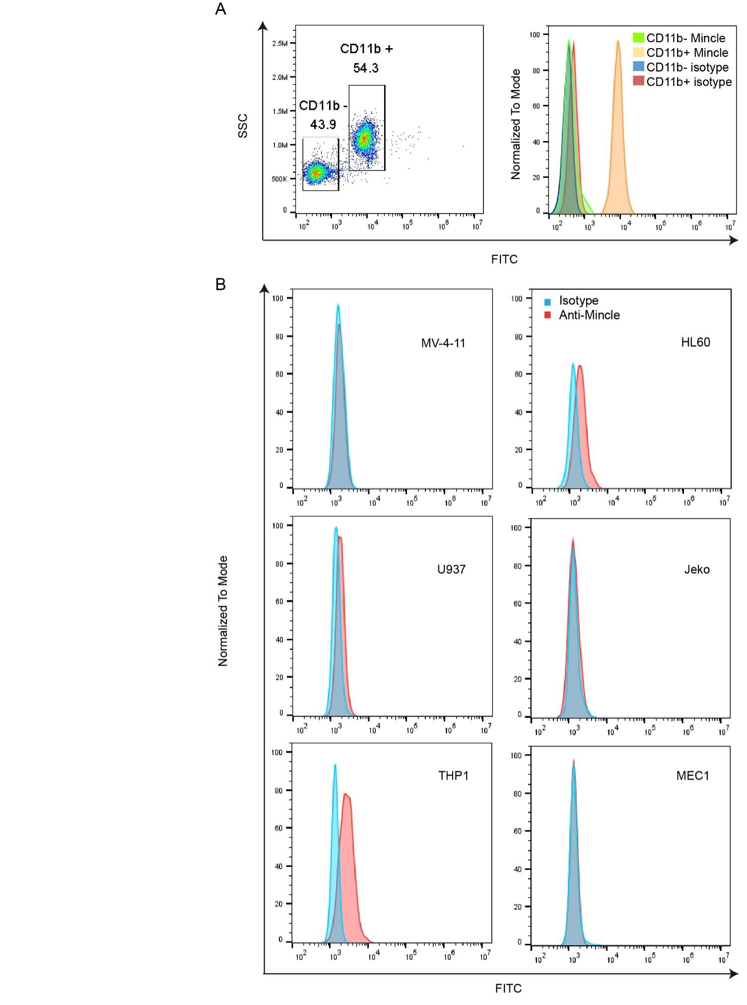

Figure 2

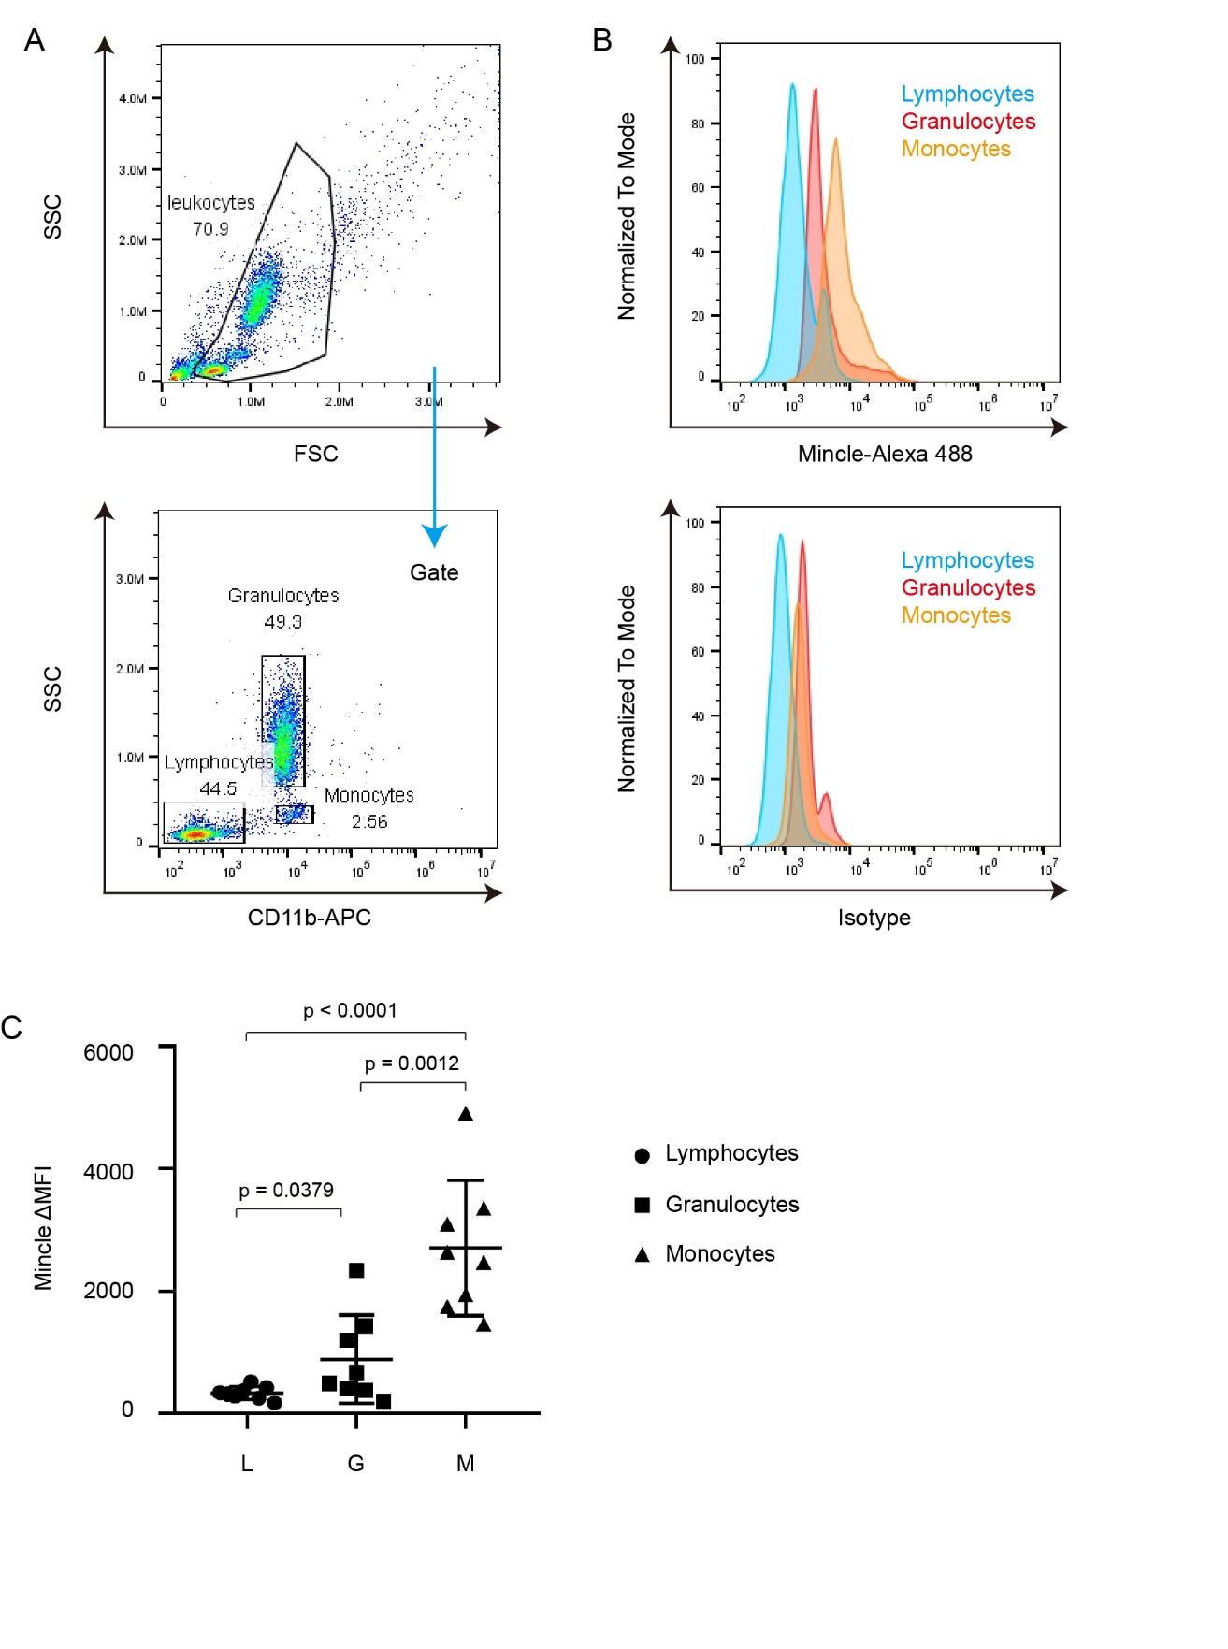

**Figure Legends**

Figure 1. Mincle is expressed predominantly in myeloid cells. A. Flow cytometry analysis of Mincle in CD11b+ and CD11b- leukocytes from peripheral blood. B. Flow cytometry analysis of Mincle in MV-4-11, U937, THP1, HL60, Jeko, and MEC1.

Figure 2. Monocytes express higher Mincle than granulocytes. A. Lymphocytes, granulocytes, and monocytes were gated by CD11b and SSC. B. Flow cytometry analysis of Mincle in lymphocytes, granulocytes, and monocytes. C. Dot figure representing expression levels of Mincle in lymphocytes, granulocytes, and monocytes from 8 donors. Error bars denote standard deviation.