**A SMART APPROACH TO IDENTIFY THE COVID-19 VICTIMS**

**K.SUTHENDRAN**

Associate Professor & Head, Department of Information Technology

Kalasalingam Academy of Research and Education, India

Email:k.suthendran@klu.ac.in

**Abstract:**

Corona virus disease 2019 (COVID-19) influence the others in a speedy way rooted by means of [severe acute respiratory syndrome coronavirus 2](https://en.wikipedia.org/wiki/Severe_acute_respiratory_syndrome_coronavirus_2) (SARS-CoV-2) [1] [2]. During December 2019, it was sensed in [Wuhan](https://en.wikipedia.org/wiki/Wuhan), Chaina and within 3 months, it has increased to more than 200 countries in the world, resulting more than 1,00,000 deaths; ensuing in the enduring [2019–20coronavirus pandemic](https://en.wikipedia.org/wiki/2019%E2%80%9320_coronavirus_pandemic) [3] [4] . The major indication of the existence of this virus includes an abnormal high body temperature, expulsion of air from the lungs with a sudden sharp sound and [small inhalation or exhalation](https://en.wikipedia.org/wiki/Shortness_of_breath) [5].In addition, extreme tiredness, muscle aches, [diarrhea](https://en.wikipedia.org/wiki/Diarrhea), [painful throat](https://en.wikipedia.org/wiki/Sore_throat), [low sense of smell](https://en.wikipedia.org/wiki/Loss_of_smell) and stomach pain [6][7][8] are reported as symptoms. Now, this becomes the paramount challenge for all governments to identify the covid19 victims, offer required treatment and protect other public from this life threatening disease. This article presents a suitable idea to the government, for identifying the COVID 19 victims in smart and fast manner.

Keywords: Corona Virus, Social Spread,Pandemic.

**Introduction:**

  Corona Virus belongs to the family of RNA virus and it can be quarantined in non identical animal species. In humans, these viruses are able to cause sickness varying from the ordinary sneeze to many rigorous infections such as MERS and SARS. In February 2020, the WHO gave the cautionary notice toward the CoV outbreak as "very high" level [9]. During April 2020, the COVID-19 cases has increased to many times outside China and this disease infected more than 200 countries  with more than 17,77,515 cases and over 1,08,862 deaths, WHO announced the COVID-19 as a pandemic [1]. The world administration is searching for the suitable solution and countermeasures to protect their people. Many governments have announced funding scheme to find the solutions. Researchers are working with great effort and energy to offer novel solutions to diagnose and treat the victims. The sad part is doctors, nurses and scavengers who are handling COVID 19 victims are also getting affected by this disease. The governments are struggling to scan their public because of the lacuna in the medical facilities. Our contribution here is to offer best solution to identify COVID 19 victims. Once a person is found with disease then using his mobile phone it is easy to find his travel history with the help of google maps timeline service [10]. Scanning other people in identified location will enable us to identify the victims in early stage so that saving their life becomes easy and further, the social spread can be avoided. In micro level, with help of mobile phone service providers it is easy to track which mobiles were in active at particular location with COVID affected person mobile phone.

**Existing System**

Pertaining to COVID-19, the government has started scanning of passengers in airport , railway station and other places using thermal scanners as shown in fig. 1. If any of them found with abnormal body temperature then they are taken in to further level of diagnosis to ensure that whether they are having disease infection or not. But, this method may not produce 100% result. Because, if the infected person takes some fever tablet means then there is a chance to escape from thermal scanning.

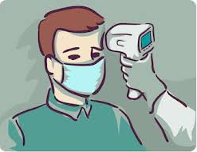

Fig.1 Thermal Scanning Process

In other way, the government has given public announcement that if any of them finds the disease symptom then they are informed to undergone the further diagnosis process at government and selected hospitals in their location. Here, the problem is some of them are hiding themselves on fear and not meeting doctors even if they have disease symptoms. This act leads to the social spread. To overcome this issue, the government has initiated verification process home by home on the high risk areas. This involves huge manpower and consumes more time and thus leads some untoward situations. In this scenario, our suggestion helps the government to quickly identify the new victims. Therefore the disease spread may be prevented.

**Proposed System:**

These days, most of the human beings are having and using android mobile phones for their day to day communication activities. In that majority of them are having installed gmail accounts for quick communication in their mobile phones. Therefore, it is proposed to use the existing google maps timeline service to identify the location history and travel history of infected person on day basis using their android mobile phones. The detailed procedure is presented here as follows.

Step: 1 Get the disease affected person mobile phone with installed gmail accounts in which his/her mobile phone is linked.

Step 2: open www. google.com

Step 3: Search Google Maps timeline [10] as shown in fig. 2.

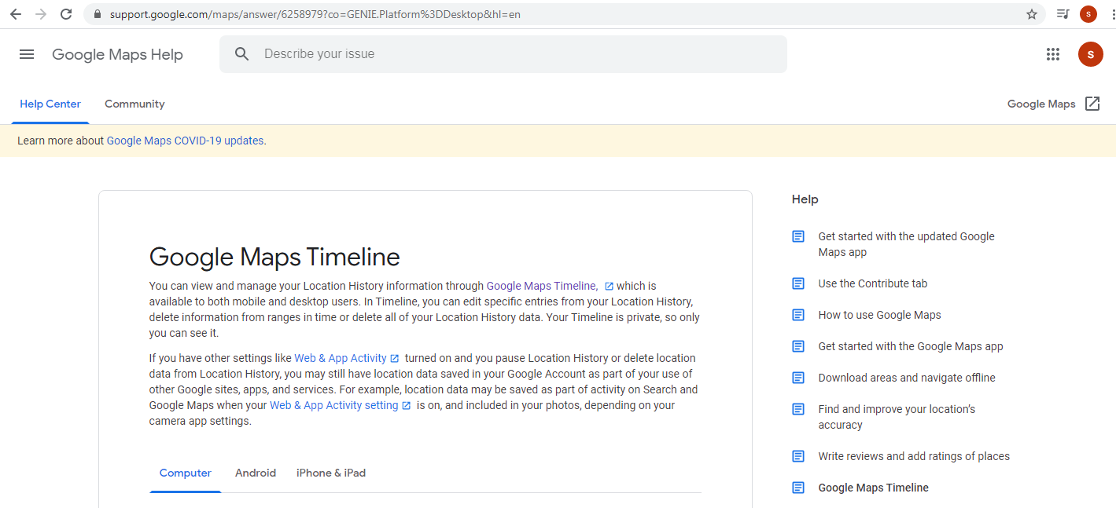

Fig 2. Google maps timeline webpage

Step 4: At the bottom of this page find the keyword “Timeline” under the caption “Turn on or pause Location History” as shown in fig. 3 and click it [10].

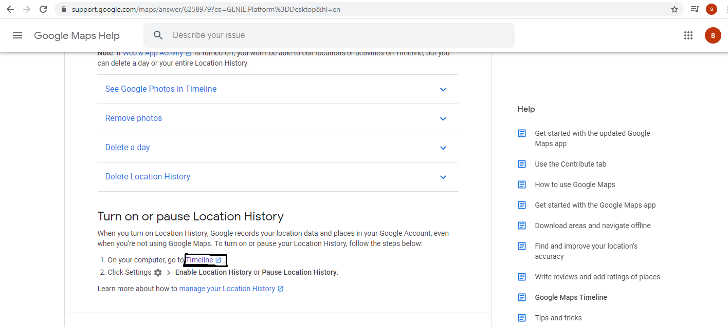

Fig 3 . The timeline option

Step 5: It shows the location history of the person. The red dots represent the location where the user has travelled in the past shown fig. 4.

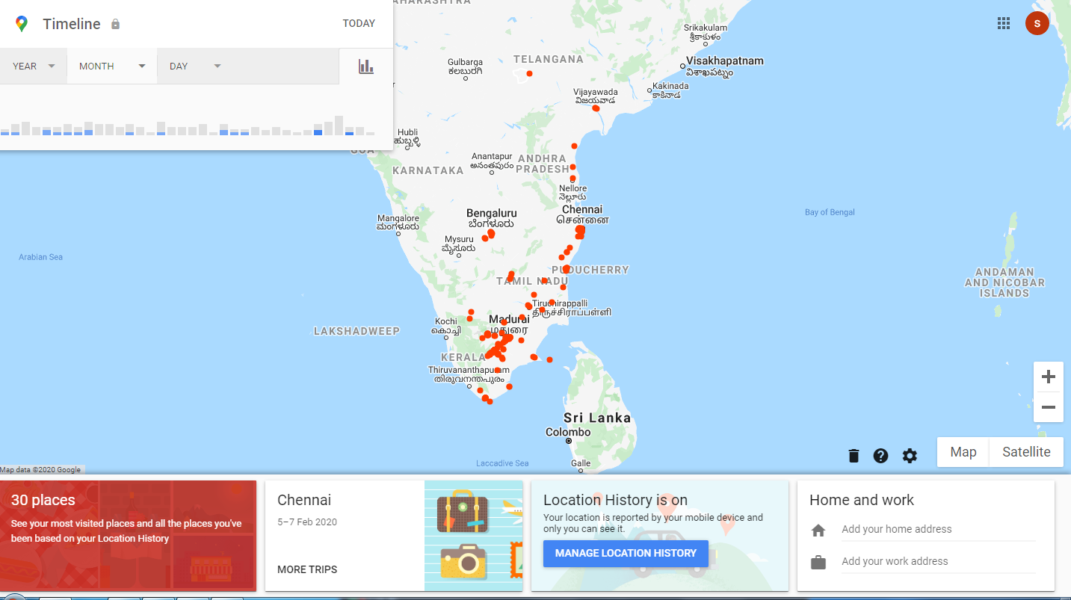

Fig. 4. Travel history of individual user

Step 6: Select the required year, month and date details from the time line caption on the top left corner. Figure 5. shows the travel history of that person on that selected date.

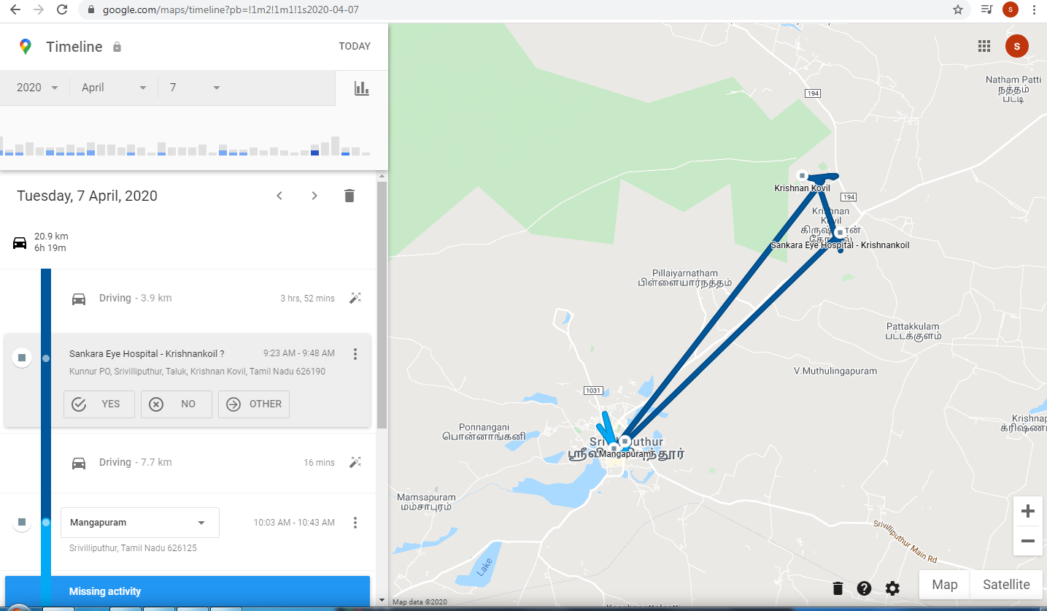

Fig. 5. The travel map of individual user

This also shows how long duration the user has spend his time during the travel at each location. This information is sufficient for the government to do scanning procedure. Further, with the help mobile service providers it is easy locate the other mobile users in that particular area in that particular time interval. All identified other mobile users may be taken for further scanning procedure which will provides effective result.

**Conclusion:**

This article offers one of the smart approaches to identify the COVID 19 victims with help of available google maps timeline service and mobile phone service providers. It also helps the government to save their people from the dangerous disease and also stops the social spreading.

**Acknowledgement:**

The author thankful to the google maps timeline service.

**References**:

[1] <https://en.wikipedia.org/wiki/2019%E2%80%9320_coronavirus_pandemic>

[2] "Coronavirus disease 2019". World Health Organization. Retrieved 15 March 2020.

[3] "Statement on the second meeting of the International Health Regulations (2005) Emergency Committee regarding the outbreak of novel coronavirus (2019-nCoV)". World Health Organization. 30 January 2020. Archived from the original on 31 January 2020. Retrieved 30 January 2020.

[4] "WHO Director-General's opening remarks at the media briefing on COVID-19—11 March 2020". World Health Organization. 11 March 2020. Retrieved 11 March 2020.

[5] Politi, Daniel, "WHO Investigating Reports of Coronavirus Patients Testing Positive Again After Recovery", 2020.

[6] “Coronavirus COVID-19 Global Cases by the Center for Systems Science and Engineering (CSSE) at Johns Hopkins University (JHU)". ArcGIS. Johns Hopkins CSSE. 2020.

[7] Feng and Emily, "Mystery In Wuhan: Recovered Coronavirus Patients Test Negative ... Then Positive". NPR, 2020.

[8] Spychalski, Piotr, Błażyńska-Spychalska, Agata, Kobiela, Jarek ,"Estimating case fatality rates of COVID-19". The Lancet Infectious Diseases. doi:10.1016/s1473-3099(20)30246-2. PMID 32243815

[9] Marco Cascella, Michael Rajnik, Arturo Cuomo,Scott C. Dulebohn,Raffaela Di Napoli, “Features, Evaluation and Treatment Coronavirus (COVID-19)”, StatPearls Publishing LLC,2020

[10] <https://support.google.com/maps/answer/6258979?co=GENIE.Platform%3DDesktop&hl=en>