April 17, 2020

Dear Editor,

This is to confirm that the article entitled “Burnout Among Healthcare Providers During COVID-19 Pandemic: Challenges and Evidence-based Interventions” submitted to the Indian Journal ofMedical Ethics is original and has been co-authored by the undersigned. All authors have participated in the work sufficiently to meet the ICMJE guidelines for authorship. All  
have read and approved the manuscript.

The submission is not under consideration for publication in any other journal.  
We give consent to Dr. Abida Sultana to act as the author for correspondence.  
Details of sponsorship or relevant competing interests, financial or otherwise: None.

We have read the terms and conditions of authorship of IJME and accept them.  
Contact details (mailing address, email id) and affiliation of all authors:  
a) Dr. Abida Sultana MBBS, Gazi Medical College, Khulna, Bangladesh. Email: [a.sultana21@outlook.com](mailto:a.sultana21@outlook.com)

b) Dr. Rachit Sharma MBBS MPH, The INCLEN Trust, New Delhi, India. Email: [drrachitsharma09@gmail.com](mailto:drrachitsharma09@gmail.com)

c) Dr. Md Mahbub Hossain MBBS MPH, Texas A&M School of Public Health, TX 77843, USA. Email: [mhossain@tamu.edu](mailto:mhossain@tamu.edu)

d) Dr. Sudip Bhattacharya MBBS MD, Department of Community Medicine, HIMS, Dehradun, India. Email: [drsudip81@gmail.com](mailto:drsudip81@gmail.com)

e) Dr. Neetu Purohit PhD, The IIHMR University, Jaipur, Rajasthan, India. Email: [neetu@iihmr.edu.in](mailto:neetu@iihmr.edu.in)

*Signatures of all authors:*

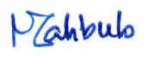

*Dr. Abida Sultana Dr. Rachit Sharma Dr. Md Mahbub Hossain*

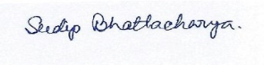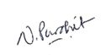

*Dr. Sudip Bhattacharya Dr. Neetu Purohit*