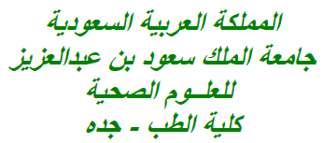

Dated: 22nd of January, 2020

Place: Jeddah, KSA

**Manuscript for Consideration**

Dear Editor,

Kindly find enclosed the manuscript entitled “*Knowledge, awareness and attitude of Health Professions Students of KSAU-HS towards End of Life Patient care*”

The aim of this study was to assess the knowledge, awareness and attitude of Health Professions Students (HPSs) about the bioethics of EOL medical care in King Saud bin Abdulaziz University for Health Sciences (KSAU-HS), Jeddah, Saudi Arabia.

A total of 522 students responded positively to the dispensed survey, of them, 290 (55.6%) were males, while 232 (44.4%) were females with a ratio of 1:1.25. Also, 226 (43.3%) of the respondents were from College of Medicine (COM), 142 (27.2%) from College of Health Professions (COSHP), 86 (16.5%) from College of Applied Medical Sciences (CAMS) and 68 (13.0%) from College of Nursing (CON). The analysis of showed that among the four colleges, COM & CON students’ bioethical knowledge & awareness about end-of-life care was higher than that of CAMS and COSHP. The awareness about the bioethical concepts of EOL care was fairly good among the Health Professions Students of KSAU-HS however this study identifies a need of introducing the bioethical concepts related to palliative care within the curriculum for the early exposure and benefit of students.

I may further add that the manuscript has been seen and approved by all listed authors, all of whom have contributed significantly to the work and there is no conflict of interest between the authors.

The contributing Author has no financial or any non-financial competing interests.

Thanking you in advance.

With regards,

**Dr. Syed Sameer Aga** (MSc, PhD)

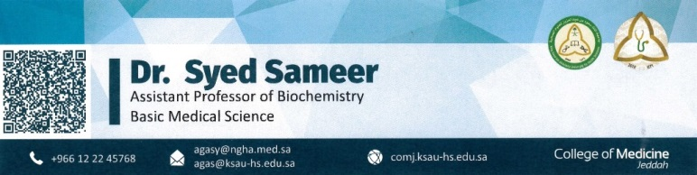

**Knowledge, awareness and attitude of Health Professions Students of KSAU-HS towards End of Life Patient care**

Aga Syed **Sameer1**

1**Department of Basic Medical Sciences & Quality Unit**, College of Medicine, King Saud Bin Abdulaziz University for Health Sciences, 1King Abdullah International Medical Research Centre (KAIMRC), Jeddah, KSA

**\*Corresponding Author:**

**Dr. Syed Sameer A.**

Telephone: +966 12 2246666 Ext. 45768 || Official Email: agasy@ngha.med.sa

**ABSTRACT:**

Objectives: Provision of ethical medical care is the totem pole of the health care system and to make appropriate decisions while providing the end-of-life (EOL) care is essential for all practicing physicians. The aim of this study was to assess the knowledge, awareness and attitude of Health Professions Students (HPSs) about the bioethics of EOL medical care.

Methods: This cross-sectional study was carried out in all Colleges of King Saud Bin Abdulaziz University for Health Sciences (KSAU-HS), Jeddah Campus was conducted from September 2019 through December 2019. A predesigned questionnaire written in English containing essential elements about end of life patient care was adopted to achieve the purpose of the study.

Results: A total of 522 students responded positively to the dispensed survey, of them, 290 (55.6%) were males, while 232 (44.4%) were females with a ratio of 1:1.25. Also, 226 (43.3%) of the respondents were from College of Medicine (COM), 142 (27.2%) from College of Health Professions (COSHP), 86 (16.5%) from College of Applied Medical Sciences (CAMS) and 68 (13.0%) from College of Nursing (CON). 44.9% of the males and 52.6% of females had a disagreement with the statement that patient has the right to end his or her own life of which 24.8% of COM, 27.9% of CAMS, 35.3% of CON and 26.85% of COSHP Strongly Disagreed (P<0.001). Additionally, most of the HPSs of all colleges agreed to that terminally ill patients can die peacefully at home of which 69.9% were of COM, 46.5% of CAMS, 41.2% of CON and 46.5% of COSHP students (P<0.001). Also, the analysis of showed that among the four colleges, COM & CON students’ bioethical knowledge & awareness about end-of-life care was higher than that of CAMS and COSHP.

Conclusions: The awareness about the bioethical concepts of EOL care was fairly good among the Health Professions Students of KSAU-HS however this study identifies a need of introducing the bioethical concepts related to palliative care within the curriculum.

Keywords: Quality of Life; Student’s; Health Professions; Medicine; Palliative Care; COM; KSAU-HS