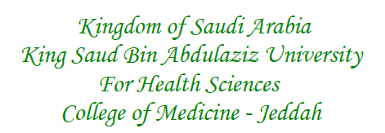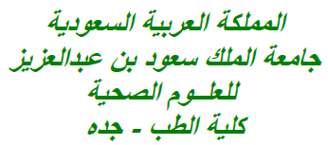

Place: Jeddah, KSA

Kindly find enclosed the manuscript entitled “*Knowledge, awareness and attitude of Health Professions Students of KSAU-HS towards End of Life Patient care*”

**Acknowledgments:**

I would like to express their deep gratitude towards all students of the KSAU-HS, Jeddah campus who pro-actively participated in this study. A million thanks are due also to Dr. Anwar A Khan, Department of Medical Education, COM-J, KSAU-HS for the analysis of the collected data. I also acknowledge the help of Mr. Abdul Rehman in dispensing the survey to various leaders of KSAU-HS Students for the collection of data.

**Ethical Clearance:**

This study was approved by the Institutional Review Board of King Abdullah International Medical Research Centre (KAIMRC), a research wing of KSAU-HS, Jeddah (***Reference No: SP19-127-J; Dated: 03/11/2019***).

**Author Contributions:**

**SSA** conceptualized the project, designed the study questionnaire in its final form, analyzed the collected data and wrote the entire manuscript.