**To 26th April 2020**

**The Editor**

**Indian Journal of Medical Ethics**

Respected Sir ,

Please find enclosed the article titled” entitled “**India fights the invisible: A saga of Strategies, Hope and Resilience”** for consideration for publication as a comment/view point in your esteemed journal. Sir, While COVID19 has had a powerful impact on out physical health, it has left us with a significant emotional and mental impact. It is apt that we transform our life by changing our lifestyle. India has learnt its lessons well and strategically moving ahead to contain this pandemic.

This article summarizes the unique strategy that India has followed in management of this pandemic.

This is to confirm that the article entitled “**India fights the invisible: A saga of Strategies, Hope and Resilience**” submitted to the *Indian Journal of Medical Ethics* is original and has been co-authored by the undersigned. All authors have participated in the work sufficiently to meet the ICMJE guidelines for authorship. All have read and approved the manuscript.

The submission is not under consideration for publication in any other journal.

We give consent to Dr Mohit D Gupta to act as the author for correspondence.

Details of sponsorship or relevant competing interests, financial or otherwise: None

We have read the terms and conditions of authorship of IJME and accept them.

Contact details (mailing address, email id) and affiliation of all authors:

1. Prof Mohit D Gupta: A1, White House, 6 Jamuna Road, Civil Lines, Delhi 54:

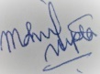

1. Dr Shweta Goswami B63 Ground floor, Dayanand colony, lajpat Nagar 4, New Delhi 110024

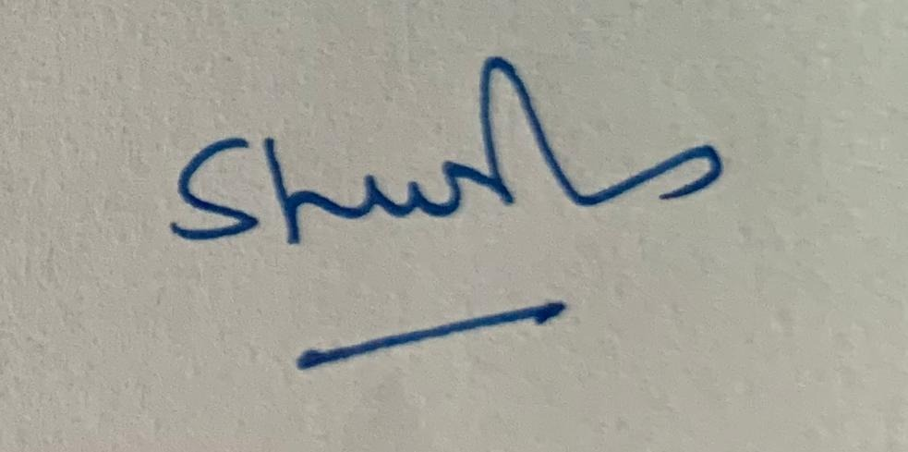

1. Dr Vishal Batra : Room 129, Academic Block, GB Pant Hospital, New Delhi

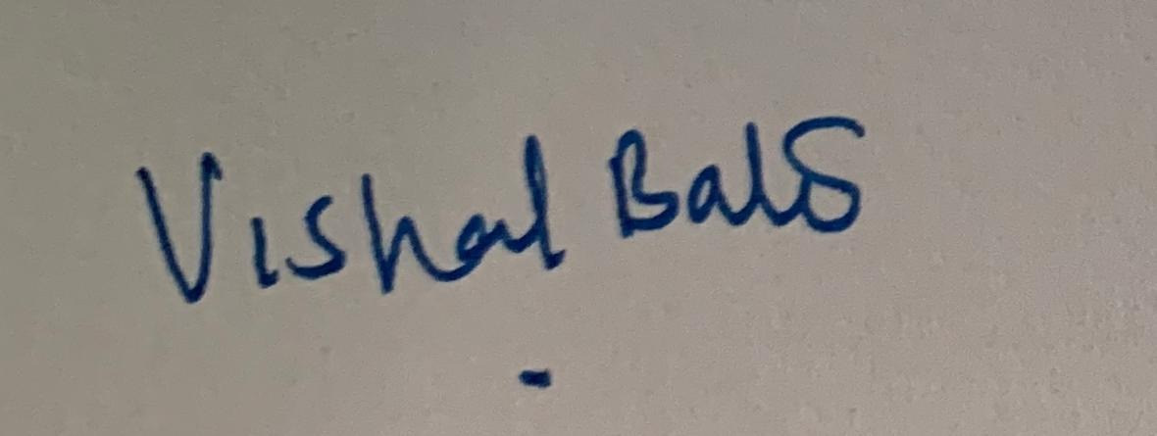

1. Dr Girish MP: Room 125, Academic Block, GB Pant Hospital, New Delhi

