**Genotoxic and Cytotoxic Biomonitoring in patients exposed to Panoramic Dental Radiography: Comparison between 5 different age groups.**

**Abstract**

**Background:** Radiography is an inseparable tool in dentistry and they go hand in hand for diagnosis and planning of treatment. X- rays are very well noted for their mutagenic effect. Radiation can induce DNA damage as well as cellular damage. Hence, this study is done to estimate the genotoxicity and cytotoxicity following Panoramic Dental Radiography.

**Objectives:** To estimate the genotoxicity and cytotoxicity in buccal mucosal exfoliated cells before and after taking OPG. To compare the result between 5 different age groups.

**Study Design:** The study group consisted of 60 patients. They are divided into 5 different groups with 12 in every single group.

**Materials and Methods:** Buccal mucosal smears were extracted from the participants of the study group before X‑ray exposure and duration of about 10 days after radiation exposure. The collected smears were stained using PAP method and PAS method. It was evaluated for genetic and nuclear abnormalities. They were compared with 5 age groups.

**Results:** The mean of nuclear alterations representing cytotoxicity after taking OPG were significantly increased (P < 0.05). Though there was an increase in micronuclei expression, no statistically significant difference was evidenced (P > 0.05).

**Conclusions**: The result of our study reveals that OPG might not cause any chromosomal damage, but it is capable of inducing cytotoxicity in buccal mucosal cells in all age group. The study has to be performed with a larger sample size at multicentric level to validate the result.

**Keywords:** Genotoxicity, Cytotoxicity, Micronucleus, OPG

**Introduction**

An eminent fact says, “Oral cavity is like a mirror which reflects one’s systemic health”. In the modern era, dentistry cannot be performed without radiology. Radiology aids in the envisioning of deeper structures and pathologies which naked eye cannot detect. With the evolution of radiology, we are able to see the structure as it is, using 3D imaging technologies. However, anything with merits will also have demerits. It is preferable to compare the risk with the benefits and use it wisely.

Any carcinogen or hazardous agent will initially contact the oral mucosa which acts as the first barrier. After penetrating this barrier and its entry into the cell, they become genotoxic. Genotoxins are mutagens; they trigger changes resulting in mutation. Genotoxicity is described as damaging impact on a cell's hereditary material (DNA, RNA) by altering its integrity.[1]

X- Rays are very well known for their mutagenic effect. They can cause aberration in chromosome and mutation in gene. They damage DNA directly as well as indirectly.[2] It breaks the single stand or double strands of DNA, causing cross links in its protein which eventually result in death of the cell. In view of the strong association between cancer formation and DNA damage, it will be beneficial if we know the level of genetic and cellular damage which resulting from X rays.[3]

X Rays can cause cytotoxicity as well. Genotoxicity induced apoptosis may stimulate proliferation of cells resulting in cytotoxicity. It is essential to study about cytotoxicity while studying about genotoxicity because the incidence of the nuclear abnormalities indicating cytotoxicity was similar or greater than that of genotoxity in oral cavity.[4]

Since X rays are extensively used for diagnostic purpose in dental as well as medical field, we should have a reliable biomarker to evaluate the extent of damage like genotoxicity and cytotoxicity caused.

A biomarker is a reliable tool for assessing the risk factor associated with various diseases. Before diagnosis is made it can aid in screening as well as risk assessment. During diagnosis it helps in staging and choosing the appropriate treatment. The ideal features of biomarker include safety, specificity for a disease, sample collection and analysis simplicity. [5]

Though many studies have monitored the genotoxic and cytotoxic effects in human using peripheral lymphocytes, they areinappropriate for monitoring effects owing to dental x- rays.[6] The buccal mucosa is under direct exposure to dental X- rays. Thus, buccal cell micronucleus assay is an excellent and most apt biomarker for assessing these effects due to dental x rays.[7]

The detrimental effects of radiation vary with age. Children are more vulnerable to such toxic agents compared to adults. The have higher chance of exposure to radiation throughout their lifetime, and the accumulation which ultimately results in nuclear alteration and thus mutation.[8] On the other hand, progressing age is naturally associated with genomic instability which results in decreased probabilities of cellular and DNA repair resulting in phenotypic changes to both cellular and nuclear structure. Pertaining to the current study, most reference studies on buccal cell micronucleus assay failed to demonstrate their influence on age. Hence, this study was done to assess and compare the cytotoxic and genotoxic effect of radiation in buccal mucosal exfoliated cells owing to Panoramic Dental Radiography in different age groups.

**Aim and Objectives**

**AIM:**

1. Genotoxic and Cytotoxic biomonitoring in patients exposed to Panoramic Dental Radiography as demonstrated on buccal mucosal cells and comparison among five different age groups.

**OBJECTIVES:**

1. To evaluate the genotoxicity and cytotoxicity in exfoliated buccal mucosal cells before and after taking OPG.

2. To compare the result between 5 different age groups.

**Materials and Method**

**Materials:**

Materials used in this study were

1. Wooden Spatula for cell collection
2. Slides for smear preparation
3. Slide box for storage of slides
4. Rapid PAP Stain kit for staining
5. PAS Stain reagent for staining
6. X Mind Trium Acteon OPG Machine for taking radiograph
7. Light Microscope for observing cellular changes

**Method:**

**Study Design**

The present study was performed in the department of Oral Medicine and Radiology, SRM Dental College, Ramapuram after getting approval from the Institutional Ethical Committee and written informed consent from the patients. The study group includes 60 patients who require OPG for their dental treatment and they were not exposed solely for this study purpose. Participants were recruited for the study after satisfying the exclusion and inclusion criteria. They were divided into 5 groups based upon the age with 12 in each group.

**Inclusion Criteria**

**Group 1:** Normal, healthy participants having good oral hygiene with age between 6-11years (children). n=12

**Group 2:** Normal, healthy participants having good oral hygiene with age between 12-18years (Adolescence). n=12

**Group 3:** Normal, healthy participants having good oral hygiene with age between 19-39years (Young Adulthood). n=12

**Group 4:** Normal, healthy participants having good oral hygiene with age between 40-60years (Middle adulthood). n=12

**Group 5:** Normal, healthy participants having good oral hygiene with age above 60years (Late adulthood). n=12

**Exclusion Criteria**

1. Smokers.

2. Any Systemic or Genetic Disease.

3. Carcinoma patients.

4. Acute Dental Infection.

5. Maxillofacial Trauma.

6. Pregnancy.

7. Clinically Visible Oral Lesions.

**Collection of the cells:**

Participants were requested to rinse the oral cavity with normal water to eliminate any debris or food particles which will hinder during the analysis. With a moist wooden spatula exfoliated cells were collected by gently scraping the buccal mucosa in a rolling motion and it was immediately smeared on to the centre of the slide. Then the slide is coded. Smears were dried in air and then fixed with 80% ethanol. For every participant, 2 slides were prepared (One slide for PAP stain and another is stained with PAS Stain).

Now, the participants were subjected to OPG.

The panoramic dental radiographs were performed with X Mind Trium Aceton equipment, system 65—79 kV/ 8mA/10s.

After which the participants were recalled for the second collection of cells within 7-10 days. The participants were requested not to get exposed to any kind of medical radiation in this period.

**Scoring Principles:**

Cells were viewed with the help of the light microscope under optimal condition at 40x to evaluate cytotoxicity as well as genotoxicity. Tolbert’s criteria [4] was applied for scoring of the micronucleus. The count of micronucleus was taken into consideration for evaluating genotoxity while the incidences of karyolysis, pyknosis as well as karyorrhexis were evaluated for estimating the cytotoxicity. Both the PAP Stain [Figure 1] and PAS Stain [Figure 2] were observed using the same procedure for assessment of genotoxicity as well as cytotoxicity. The slides were evaluated by an experienced oral pathologist. The observer was blinded with the time of collection of samples and the demographic details. The values were plotted on the table and statistical analysis was performed to extract the results.

Though Feulgen stain is opted by many investigators due to its unique feature of DNA specificity it has practical difficulties like lengthy staining procedure, technique sensitive and higher chances for under scoring of micronuclei. Hence, we had used PAP Stain and PAS Stain in this study.[9] Pap stain is a nuclear stain and also has a counter stain which aids in better visualisation during scoring. Ethyl alcohol (95%) was used as a fixative which has numerous advantages like bactericidal effect, infiltrates the cells quickly and preserves the morphological structure. It permits the dyes to pass through cellular boundaries and facilitates adhesion of cell onto the slide.[10]

**Statistical Analysis:**

All statistical analysis was performed using SPSS, version 17. Descriptive statistics were submitted as numbers and percentages. The data were depicted as Mean and SD. Wilcoxon Signed Ranks test was used within groups. Kruskal Wallis test was used for continuous data. A two-sided p value < 0.05 was considered statistically significant.

**Results:**

In PAP group, while comparing pre-exposure with post-exposure smears, there was an increase in the mean value of micronuclei from 9.73 to 9.85, pyknosis increased from 35.17 to 45.67, karyolysis increased from 11.17 to 22.00 and karyorrhexis increased from 19.00 to 32.33 respectively. Though there was an increase in the incidence of micronuclei it was not statistically significant with a P value of 0.925 indicating absence of genotoxicity. The P value for pyknosis was 0.001, karyorrhexis was 0.000 and karyolysis was 0.000. These values were statistically significant indicative of cytotoxicity. [Table 1] [Figure 3]

To analyse the influence of age each parameter like micronucleus, karyolysis, pyknosis and karyorrhexis were compared between 5 different groups. The p value for micronucleus was 0.427, pyknosis was 0.394, karyolysis was 0.133 and karyorrhexis was 0.489. These values were statistically not significant which showed that age does not influence genotoxic and cytotoxic changes following OPG. [Table 2] [Figure 4]

Similarly, In PAS group, while comparing pre-exposure with post-exposure smears, there was an increase in the mean value of micronuclei from 5.42 to 6.60, pyknosis increased from 22.17 to 31.67, karyorrhexis increased from 16.50 to 25.50 and karyolysis increased from 6.50 to 19.00. Though there was an increase in the incidence of micronuclei it was not statistically significant with a P value of 0.192 indicating absence of genotoxicity. The P value for pyknosis was 0.004, karyorrhexis was 0.000 and karyolysis was 0.000. These values were statistically significant suggestive of cytotoxicity. [Table 3] [Figure 5]

To analyse the influence of age each parameter like micronucleus, karyolysis, pyknosis, and karyorrhexis were compared between 5 different groups. The p value for micronucleus was 0.432, pyknosis was 0.505, karyolysis was 0.500 and karyorrhexis was 0.200. These values were statistically not significant which showed that age does not influence genotoxic and cytotoxic changes following OPG. [Table 4] [Figure 6]

**Discussion**

Oral cavity serves as an initial contact medium for numerous toxic agents. It imparts initial defence against pathogens. It has been said that epithelium gives rise to 90% of malignancies among all different types of cells. Epithelium is noted for its proliferative capacity that permits persistent cell division for maintaining constant population of cells. However, this typical feature makes it vulnerable to DNA and cellular damage. 60% of oral epithelium is composed of non-keratinized stratified squamous cells which permits easy uptake of stain, in turn facilitating exact evaluation of morphological changes of the nuclei. Hence in this study OPG radiation related changes were observed in oral cavity epithelial cells.[5]

Biomonitoring studies in humans have been used widely in the field of research for identifying the aetiology, managing and preventing exposure to toxic agents. Till date there is a wide variety of analyses for human biomonitoring which includes the evaluation of DNA damage and cell damage. The major drawbacks of the traditional methods include they need skilled technicians, time consuming and laborious. Because of these facts micronucleus test for studying genetic damage is greatly encouraged. It has numerous advantages over those techniques which utilize lymphocyte for micronucleus evaluation.[11]

Buccal cell micronucleus assay is simple, accurate, not invasive, painless, quick, affordable and easy to perform. Compared to any other part of the body it can be effortlessly collected from the mouth in a non-invasive manner and repeated sampling can be done.[12]

Holland et al stated that after ionizing radiation exposure, expression of micronucleus in buccal mucosal cells takes minimum of about 5-7 days to maximum of 21 days.[13] Riberio et al said that the turnover time for the oral cavity epithelial cells is 7 – 16 days and highest number of micronucleus was anticipated from 1 week to 3 weeks time after a genetic insult. Taking these factors into consideration a time interval of about 7 to 10 days was given for second collection. [14]

Pan yang et al stated that the radiation sensitivity of the various cells in oral cavity like exfoliated cells of buccal mucosal, tongue and gingiva had no statistically significant difference. [15] Sunitha kesidi et al stated that after taking full mouth radiographs, the mean incidence of micronucleus and other nuclear changes were elevated in exfoliated cells of buccal mucosa when compared to gingival epithelial cells. Keratinized mucosa has higher resistance to any trauma when compared to non-keratinized mucosa. Non keratinized epithelium has rapid turnover which make them more prone to damage.[16] In this study we had taken buccal mucosal cells which have rapid turnover and non-keratinized mucosa for observing genetic and cytologic damage.

Mohan et al concluded in their study that the genetic damage caused by IOPA is higher compared to OPG. The cellular damage resulted due to OPG was higher compared to that of IOPA.[2] Naveena Preethi et al study showed that Bitewing radiograph result in three times rise in micronuclei level. Similarly, digital OPG result in two times rise in micronuclei level. Even though both the OPG and bitewing result in elevation of micronuclei they stressed the fact that increase in exposure time of radiation and decrease in scattered radiation result in the formation of more micronuclei.[17] Sandhu et al compared the genotoxicity caused during obtaining conventional and digital OPG radiographic examination and found out that higher genotoxity was resulted due to conventional OPG.[18]

Gang Li et al studied the changes in the oral mucosa due to amount of absorbed dose and concluded that there exists a strong association between these two. The results of their studies showed that there was no evidence of changes except for karyolytic cells when the radiation was less than 1mGy. Similarly, there exists a significant change in the level of micronuclei, pyknotic and karyolytic cell when the absorbed dose was higher. [19]

Raj et al studied about the association between the dose and presence of micronuclei and other interrelated nuclear abnormalities in patients undergoing radiotherapy for oral cancer and concluded that it can be effectively used as a biomarker for evaluating radiosensitivity of the cell. Micronuclei act as the most dependable structure for evaluating the damage in the cancer cells due to radiation. [20]

Current study revealed an increase in the level of micronuclei after OPG exposure, but the value is not statistically significant which was similar to the result of Eman A El-Ashiry[21], Popova[22],Poonam Agarwal[23], and Madhavan[24]. On contrary few studies like Mohan[2], Arora[9], Sandhu[18], Naveena Preethi[17], Antonia[8] showed statistically significant rise in the micronuclei mean value after exposure to OPG. Studies done by Angelieri [25], Lorenzoni[26], Ribeiro[3], Haghgoo[27], Ribeiro[14] showed no change in the level of micronuclei after exposure to radiation. In numerous studies although there is elevation in cytotoxicity, the level of micronuclei shows no significant elevation. In this study the reason for statistically insignificant expression of micronuclei could be due to the loss of the cells with micronuclei also during cytotoxicity [16].

Antonio et al said that occurrence of micronuclei depends upon the dose, radiation type and sensitivity of that tissue to radiation. Even small amount of radiation can result in DNA breakage and not compulsorily all should end up in micronuclei formation. Notable difference was not found in micronuclei level probably due to cytotoxic damage which cause cell death of even those cells with micronuclei by apoptosis.[8] Upsurge in the incidence of micronuclei will not inevitably result in the appearance of new premalignant lesion or cancer yet it indicates the genotoxic nature of that particular agent.[15]

With regards to cytotoxicity there exists a statistically significant change consistent with the study of Poonam Agarwal[23], Haghgoo[26], Mohan[2], Antonia[8], Angelieri [25], Eman A El-Ashiry[21], Lorenzoni[26], Madhavan R[24].

In this study, comparative assessment of genotoxicity and cytotoxicity in OPG between 5 different age groups was carried out. The results of our study show no difference between 5 age groups which was in the same way as the result of the study done by cerqurie[15], gang li [19], Haghgoo [27]. Arora et al concluded in their study that only in gingival epithelial cells there exists a correlation of age with genotoxicity & cytotoxicity.[9]

This study helps in the better understanding of genotoxic and cytotoxic changes induced by OPG among five different age groups. In the present study effect of OPG on buccal mucosal cells was only evaluated but the effect of other radiographs on epithelial cells from different sites were not evaluated which is beyond the perspective of this study. Further studies are needed to explore age effects on different epithelial cells of the oral cavity caused by different types of dental X Rays

The major drawback in our study is the altered expression of micronucleus which could be attributed to the population, methodologies applied like sites from where they had collected, type of cells collected, type of stain adapted, total number of cells checked, criteria for scoring they had employed.The present study employed only one observer, inter observer variability can be assessed when more observer is used.

This is one among the few studies reported in the literature that correlates the influence of age on genotoxic and cytotoxic damage induced by OPG. Moreover, to our knowledge this is the first study to be carried out in a wider age range and a larger sample which will act as evidence in future results.

**Conclusion**

The results of this study will aid in better understanding of radiation induced changes on the buccal mucosal cells after OPG among different age groups. Buccal cell micronucleus assay can be used effectively as a biomarker to study about genotoxic and cytotoxic damage in the oral cavity. Though there is absence of genotoxicity, there is evidence of cytotoxicity. Dental X Rays must be taken only when it was extremely needed obeying ALARA principle. Age has no influence on genetic and cytotoxic damage caused by OPG. To generalize our results further studies must be performed with a larger sample at multicentric level.

Acknowledgement:

I am grateful to **Dr. P.H. Raghuram,** **Dr. M.S. Anandhi** and **Dr.R. Kanmani** for their ever willingness to help and for being a source of inspiration for successful completion of this study.

It is with great privilege and honour that I convey my sincere and heartful gratitude to **Dr.R. Ramya,** **Dr.A. Ramesh Kumar and Dr. Swarnalatha** under whose guidance, mentoring made it possible to complete my dissertation.

**References:**

1. Shah SU. Importance of Genotoxicity & S2A guidelines for genotoxicity testing for pharmaceuticals. IOSR Journal of Pharmacy and Biological Sciences. 2012;1(2):43-54.
2. Mohan N, Ravikumar PT, Madhumitha C. Genotoxic and cytotoxic effects following dental and panoramic radiography. Indian Journal of Oral Sciences. 2016 May 1;7(2):92.
3. Ribeiro DA, De Oliveira G, De Castro GM, Angelieri F. Cytogenetic biomonitoring in patients exposed to dental X-rays: comparison between adults and children. Dentomaxillofacial Radiology. 2008 Oct;37(7):404-7.
4. Tolbert PE, Shy CM, Allen JW. Micronuclei and other nuclear anomalies in buccal smears: methods development. Mutation Research/Environmental Mutagenesis and Related Subjects. 1992 Feb 1;271(1):69-77.
5. Torres-Bugarín O, Zavala-Cerna MG, Nava A, Flores-García A, Ramos-Ibarra ML. Potential uses, limitations, and basic procedures of micronuclei and nuclear abnormalities in buccal cells. Disease markers. 2014;2014.
6. Fenech M, Bonassi S. The effect of age, gender, diet and lifestyle on DNA damage measured using micronucleus frequency in human peripheral blood lymphocytes. Mutagenesis. 2011 Jan;26(1):43-9.
7. Fenech M, Bolognesi C, Kirsch-Volders M, Bonassi S, Zeiger E, Knasmuller S, Holland N. Harmonisation of the micronucleus assay in human buccal cells--a Human Micronucleus (HUMN) project (www. humn. org) initiative commencing in 2007. Mutagenesis. 2007 Jan 1;22(1):3.
8. Antonio EL, Nascimento AJ, Lima AA, Leonart MS, Fernandes Â. Genotoxicity and cytotoxicity of x-rays in children exposed to panoramic radiography. Revista Paulista de Pediatria. 2017 Sep;35(3):296-301.
9. Arora P, Devi P, Wazir SS. Evaluation of genotoxicity in patients subjected to panoramic radiography by micronucleus assay on epithelial cells of the oral mucosa. Journal of dentistry (Tehran, Iran). 2014 Jan;11(1):47.
10. Ayyad SB, Israel E, El-Setouhy M, Nasr GR, Mohamed MK, Loffredo CA. Evaluation of Papanicolaou stain for studying micronuclei in buccal cells under field conditions. Acta cytologica. 2006;50(4):398-402.
11. Carlin V, Artioli AJ, Matsumoto MA, Filho HN, Borgo E, Oshima CT, Ribeiro DA. Biomonitoring of DNA damage and cytotoxicity in individuals exposed to cone beam computed tomography. Dentomaxillofacial Radiology. 2010 Jul;39(5):295-9.
12. Yadav AS, Jaggi S. Buccal micronucleus cytome assay-a biomarker of genotoxicity. Journal of Molecular Biomarkers & Diagnosis. 2015 Jan 1;6(3):1.
13. Holland N, Bolognesi C, Kirsch-Volders M, Bonassi S, Zeiger E, Knasmueller S, Fenech M. The micronucleus assay in human buccal cells as a tool for biomonitoring DNA damage: the HUMN project perspective on current status and knowledge gaps. Mutation Research/Reviews in Mutation Research. 2008 Jul 1;659(1-2):93-108.
14. Ribeiro DA. Cytogenetic biomonitoring in oral mucosa cells following dental X-ray. Dentomaxillofacial Radiology. 2012 Mar;41(3):181-4.
15. Yang P, Hao S, Gong X, Li G. Cytogenetic biomonitoring in individuals exposed to cone beam CT: comparison among exfoliated buccal mucosa cells, cells of tongue and epithelial gingival cells. Dentomaxillofacial Radiology. 2017 Jul;46(5):20160413.
16. Kesidi S, Maloth KN, Reddy KV, Geetha P. Genotoxic and cytotoxic biomonitoring in patients exposed to full mouth radiographs–A radiological and cytological study. Journal of Oral and Maxillofacial Radiology. 2017 Jan 1;5(1):1.
17. Preethi N, Chikkanarasaiah N, Bethur SS. Genotoxic effects of X-rays in buccal mucosal cells in children subjected to dental radiographs. BDJ open. 2016 Mar 25;2:16001.
18. Sandhu M, Mohan V, Kumar JS. Evaluation of genotoxic effect of X-rays on oral mucosa during panoramic radiography. Journal of Indian Academy of Oral Medicine and Radiology. 2015 Jan 1;27(1):25.
19. Li G, Yang P, Hao S, Hu W, Liang C, Zou BS, Ma XC. Buccal mucosa cell damage in individuals following dental X-ray examinations. Scientific reports. 2018 Feb 6;8(1):2509.
20. Raj V, Mahajan S. Dose response relationship of nuclear changes with fractionated radiotherapy in assessing radiosensitivity of oral squamous cell carcinoma. Journal of Clinical and Experimental Dentistry. 2011 Jul 1;3(3):e193-200.
21. El-Ashiry E, Abo-Hager E, Gawish A. Genotoxic effects of dental panoramic radiograph in children. Journal of Clinical Pediatric Dentistry. 2010 Sep 1;35(1):69-74.
22. Popova L, Kishkilova D, Hadjidekova VB, Hristova RP, Atanasova P, Hadjidekova VV, Ziya D, Hadjidekov VG. Micronucleus test in buccal epithelium cells from patients subjected to panoramic radiography. Dentomaxillofacial Radiology. 2007 Mar;36(3):168-71.
23. Agarwal P, puttalingaiah Vinuth D, Haranal S, Thippanna CK, Naresh N, Moger G. Genotoxic and cytotoxic effects of X-ray on buccal epithelial cells following panoramic radiography: A pediatric study. Journal of Cytology/Indian Academy of Cytologists. 2015 Apr;32(2):102.
24. Madhavan R, Kumaraswamy M, Kailasam S, Kumar SM. Genetic Damage in exfoliated cells from oral mucosa of individuals exposed to X-rays after panoramic radiograph: A cross-sectional study. Journal of Indian Academy of Oral Medicine and Radiology. 2012 Apr 1;24(2):102.
25. Angelieri F, Carlin V, Saez DM, Pozzi R, Ribeiro DA. Mutagenicity and cytotoxicity assessment in patients undergoing orthodontic radiographs. Dentomaxillofacial Radiology. 2010 Oct;39(7):437-40.
26. Lorenzoni DC, Fracalossi AC, Carlin V, Ribeiro DA, Sant'Anna EF. Mutagenicity and cytotoxicity in patients submitted to ionizing radiation: a comparison between cone beam computed tomography and radiographs for orthodontic treatment. The Angle Orthodontist. 2012 Jun 1;83(1):104-9.
27. Haghgoo R, Sedaghat R, Ahmadvand M, Ogaghi Z. Cytological changes of oral mucosa following lateral cephalometry and panoramic radiograph. International Journal of Dental Clinics. 2014 Sep 30;6(3).

Figure 1: Micronucleus, Pyknosis, Karyolysis and Karyorrhexis in PAP Smear

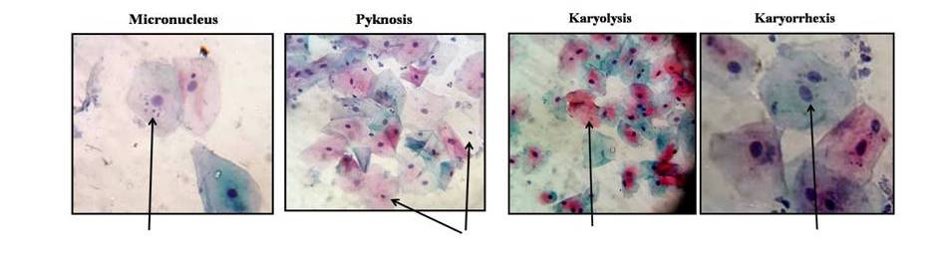

Figure 2: Micronucleus, Pyknosis, Karyolysis and Karyorrhexis in PAS Smear

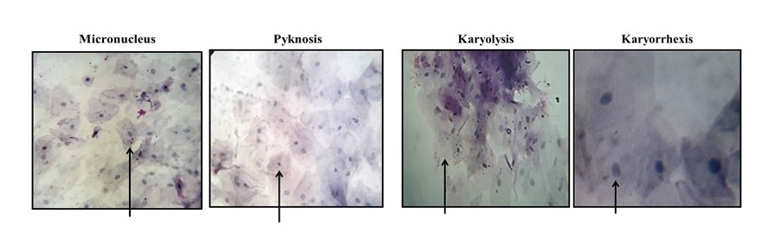

Figure 3: Graphical representation of comparison between pre exposure and post exposure values in PAP Smear.

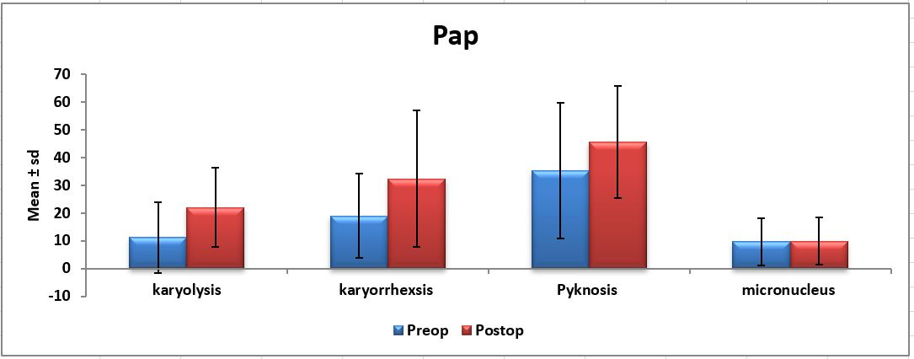

Figure 4: Graphical Representation of the comparison of karyolysis, karyorrhexis, pyknosis and micronucleus among different age groups in PAP smear.

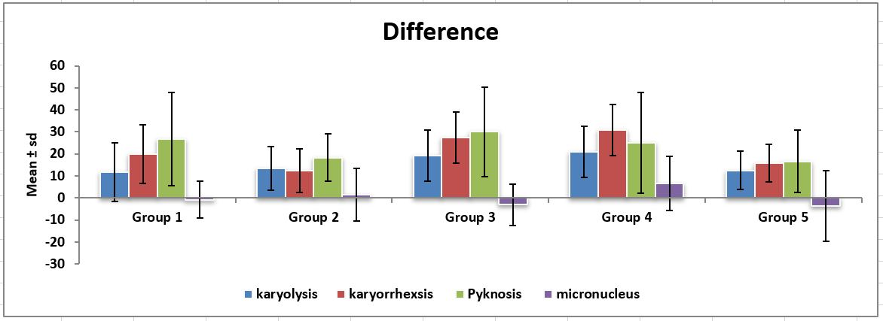

Figure 5: Graphical representation of comparison between pre exposure and post exposure values in PAS Smear.

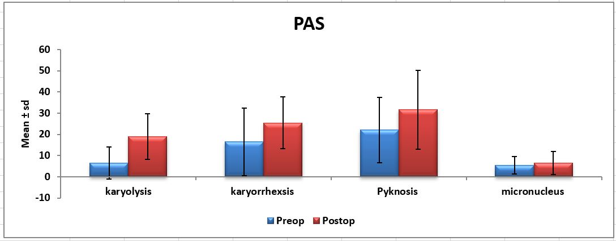

Figure 6: Graphical Representation of the comparison of karyolysis, karyorrhexis, pyknosis and micronucleus among different age groups in PAS smear.

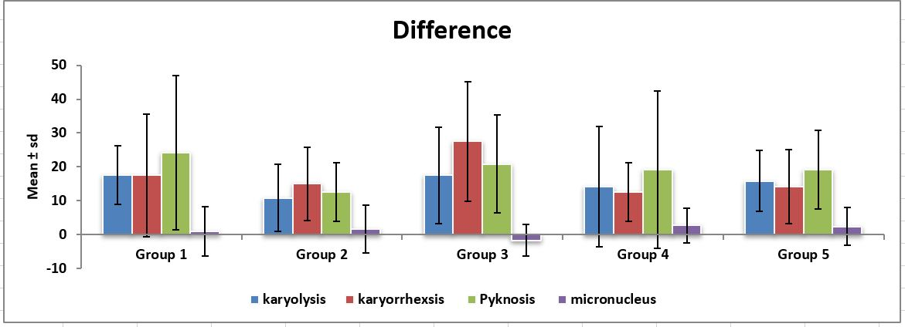

Table 1: Comparison between pre exposure and post exposure values of PAP Smear group using Wilcoxon Signed Ranks test

|  |  |  |  |  |  |  |  |
| --- | --- | --- | --- | --- | --- | --- | --- |
| PAP Group | | n | Mean | SD | SEM | z | P |
| Micronucleus | Pre | 60 | 9.73 | 8.457 | 1.092 | -0.094a | .925 |
| Post | 60 | 9.85 | 8.479 | 1.095 |
| Pyknosis | Pre | 60 | 35.17 | 24.460 | 3.158 | -3.392a | .001* |
| Post | 60 | 45.67 | 20.241 | 2.613 |
| Karyolysis | Pre | 60 | 11.17 | 12.635 | 1.631 | -4.285a | .000* |
| Post | 60 | 22.00 | 14.238 | 1.838 |
| Karyorrhexis | Pre | 60 | 19.00 | 15.260 | 1.970 | -3.780a | .000* |
| Post | 60 | 32.33 | 24.589 | 3.174 |

a -Based on negative ranks *-statistically significant

Table 2: Kruskal Wallis test for comparison of the variable between groups in PAP Smear

| **Kruskal-Wallis Test** | | | |  |  |  |
| --- | --- | --- | --- | --- | --- | --- |
|  | Group | N | Mean Rank | Chi-Square | df | Asymp. Sig |
| karyolysis - difference | Group 1 | 12 | 24.04 |  |  |  |
| Group 2 | 12 | 27.92 |  |  |  |
| Group 3 | 12 | 34.88 |  |  |  |
| Group 4 | 12 | 39.50 | 7.050 | 4 | 0.133 |
| Group 5 | 12 | 26.17 |  |  |  |
| Total | 60 |  |  |  |  |
| karyorrhexsis - difference | Group 1 | 12 | 31.79 |  |  |  |
| Group 2 | 12 | 24.54 |  |  |  |
| Group 3 | 12 | 32.21 | 3.429 | 4 |  |
| Group 4 | 12 | 36.29 |  |  | 0.489 |
| Group 5 | 12 | 27.67 |  |  |  |
| Total | 60 |  |  |  |  |
| Pyknosis - difference | Group 1 | 12 | 33.17 |  |  |  |
| Group 2 | 12 | 27.83 | 4.089 | 4 | 0.394 |
| Group 3 | 12 | 37.17 |  |  |  |
| Group 4 | 12 | 30.17 |  |  |  |
| Group 5 | 12 | 24.17 |  |  |  |
| Total | 60 |  |  |  |  |
| micronucleus - difference | Group 1 | 12 | 29.38 |  |  |  |
| Group 2 | 12 | 31.21 |  |  |  |
| Group 3 | 12 | 26.83 | 3.845 | 4 | 0.427 |
| Group 4 | 12 | 38.63 |  |  |  |
| Group 5 | 12 | 26.46 |  |  |  |
| Total | 60 |  |  |  |  |

Table 3: Comparison between pre exposure and post exposure values of PAS Smear group using Wilcoxon Signed Ranks test

|  |  |  |  |  |  |  |  |
| --- | --- | --- | --- | --- | --- | --- | --- |
| PAS Group | | n | Mean | SD | SEM | z | P |
| Micronucleus | Pre | 60 | 5.42 | 4.155 | 7.278 | -1.305a | .192 |
| Post | 60 | 6.60 | 5.478 | 7.072 |
| Pyknosis | Pre | 60 | 22.17 | 15.414 | 1.990 | -2.844a | .004* |
| Post | 60 | 31.67 | 18.610 | 2.403 |
| Karyolysis | Pre | 60 | 6.50 | 7.552 | .975 | -5.184a | .000* |
| Post | 60 | 19.00 | 10.688 | 1.380 |
| Karyorrhexis | Pre | 60 | 16.50 | 15.926 | 2.056 | -3.495a | .000* |
| Post | 60 | 25.50 | 12.272 | 1.584 |

a -Based on negative ranks *-statistically significant

Table 4: Kruskal Wallis test for comparison of the variable between groups in PAS Smear

| **Kruskal-Wallis Test** | | | |  |  |  |
| --- | --- | --- | --- | --- | --- | --- |
|  | Group | N | Mean Rank | Chi-Square | df | Asymp. Sig |
| karyolysis - difference | Group 1 | 12 | 35.54 |  |  |  |
| Group 2 | 12 | 25.21 |  |  |  |
| Group 3 | 12 | 32.79 | 3.354 | 4 |  |
| Group 4 | 12 | 26.50 |  |  | .500 |
| Group 5 | 12 | 32.46 |  |  |  |
| Total | 60 |  |  |  |  |
| karyorrhexis - difference | Group 1 | 12 | 28.92 |  |  |  |
| Group 2 | 12 | 28.58 | 5.983 | 4 | .200 |
| Group 3 | 12 | 40.67 |  |  |  |
| Group 4 | 12 | 25.88 |  |  |  |
| Group 5 | 12 | 28.46 |  |  |  |
| Total | 60 |  |  |  |  |
| pyknosis - difference | Group 1 | 12 | 33.88 |  |  |  |
| Group 2 | 12 | 23.83 | 3.327 | 4 | .505 |
| Group 3 | 12 | 33.54 |  |  |  |
| Group 4 | 12 | 27.88 |  |  |  |
| Group 5 | 12 | 33.38 |  |  |  |
| Total | 60 |  |  |  |  |
| micronucleus - difference | Group 1 | 12 | 31.29 |  |  |  |
| Group 2 | 12 | 29.21 |  |  |  |
| Group 3 | 12 | 22.75 |  |  |  |
| Group 4 | 12 | 34.92 | 3.812 | 4 | .432 |
| Group 5 | 12 | 34.33 |  |  |  |
| Total | 60 |  |  |  |  |