**COVER LETTER**

Dear Editor,

This is to confirm that the article entitled, “**Knowledge Level on Patient rights at Selected Hospital, Puducherry**” submitted to the Indian Journal of Medical Ethics is original and has been co-authored by the undersigned. All authors have participated in the work sufficiently to meet the ICMJE guidelines for authorship. All have read and approved the manuscript.

The submission is not under considered for publication in any other journal.

We give consent to Mr. Prakash.P to act as author of correspondence.

Details of sponsorship or relevant competing interest, financial or otherwise: Nil

We have read the terms and conditions of authorship of IJME and accept them.

Contact details (mailing address, email id) and affiliation of all authors:

1. Mr. P. Prakash, Asst. Professor, Dept. Of Mental Health Nursing, College of Nursing, Pondicherry Institute of Medical Sciences, Puducherry. Address – No.4, S.P.D Ramasamy Street, Panruti, Cuddalore District. Pin code – 607106. email: [prakash.lalitha88@gmail.com](mailto:prakash.lalitha88@gmail.com), Ph:8903615913, 8015100710.
2. **Ms. Sulu Kuruvilla, Registered Nurse. Address – Puthiyaparambil (H), Manarcad P.O. Kottayam, Kerala Pin code -686019 Email id -** [**sulukuruvilla@gmail.com**](mailto:sulukuruvilla@gmail.com)**. Ph: 9994987622**
3. **Ms. Ranjani R., Registered Nurse. Address- No.6, Appavu Naiker Street, Mudaliyarpet, Puducherry – 605014. Email id-** [**ranjaniramesh6991@gmail.com**](mailto:ranjaniramesh6991@gmail.com) **Ph. 8428658081**

Signature of all authors:

1. E:\CERTIFICATES- P. PRAKASH ON 1.6.13\Sign.jpg
2. 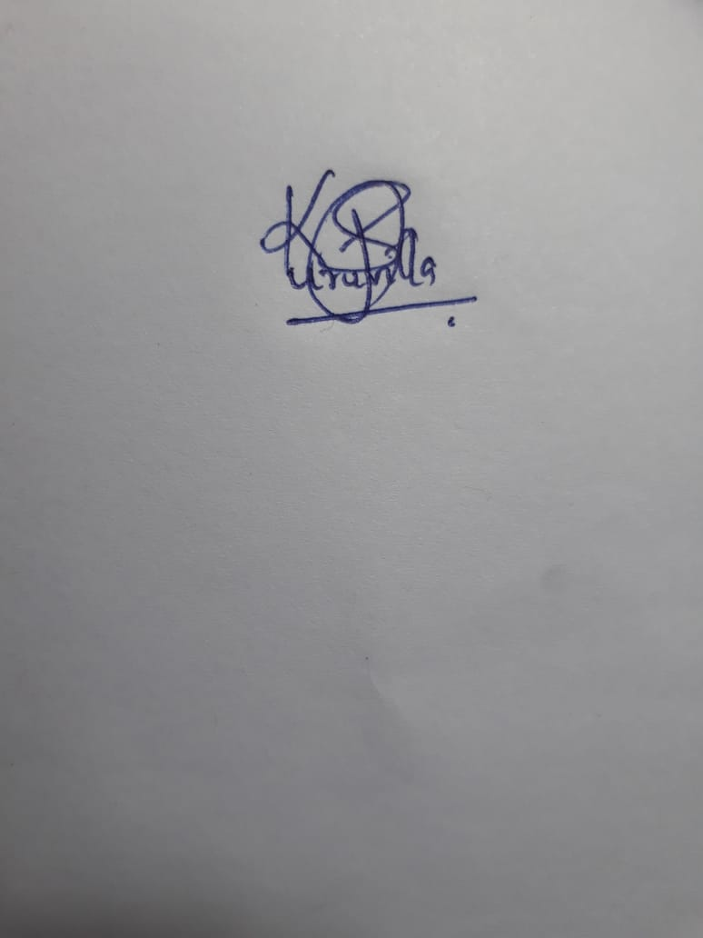
3. 