Figure 1: Higher rate of forecasting confirmed and death cases through Auto ARIMA method

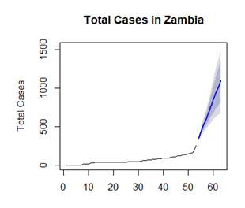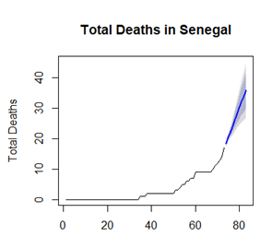

1. Confirmed cases (b) Death cases

Figure 2: Lower rate of forecasting confirmed and death cases through Auto ARIMA method

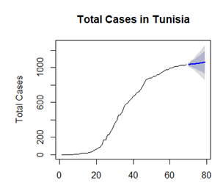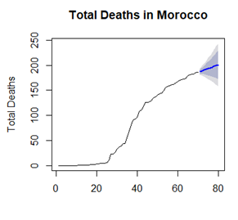

1. Confirmed cases (b)Death cases