**COVID-19: Averting the Crisis of–A Case of Bhilwara Model from India**

**Abstract**

Novel Coronavirus disease (COVID-19) has become a major health challenge worldwide. The disease has affected 210 countries and territories, and have claimed 92,798 lives as of 10th April 2020. The growth of the disease has been relatively low in India. One of the reasons being cited for this slow growth is the early embracing of countrywide lockdown, a social distancing strategy. This study reviews the effect of various lockdown strategies on the progression of COVID-19 in India and worldwide. The study further illustrates the results of lockdown strategies implemented in the Bhilwara town of Rajasthan, a frontier state of India. The success of the implementation strategy in Bhilwara coined the term Bhilwara Model being followed in other parts of the country. The strategy executed with clockwork precision, immaculate coordination and extreme efficiency under able leadership made Bhilwara the first district in the country to stop new infections within less than two weeks. The study also maps the approach followed by Bhilwara administration with a four-step symmetrical model of crisis management (FSMCM) used for crisis communication. This study documents the case of lockdown implementation in Bhilwara town and hence theoretically contributes to the existing literature on crisis management in public health. The findings of the study will be helpful for public health professionals and policymakers in the effective implementation of social distancing.

Keywords: COVID-19, Crisis Management, Post COVID-19, Lockdown, Bhilwara Model

**Introduction**

Novel Corona Virus Disease (COVID-19) has become a major healthcare challenge in recent times. Current detailed knowledge on the biology and transmission of this virus is limited (Chen et al,2020). More than 209 countries and territories worldwide are affected by the disease and the World Health Organization has declared it as a pandemic. According to the World Health Organization (WHO) COVID-19 situation dashboard, on 10th April 2020, there were 1,521,252 confirmed cases and 92,798 deaths due to the disease. The US has reported the highest number of confirmed cases of 425,889 while the maximum number of deaths has been reported in Italy as 18,281 (WHO,2020). Figure 1 depicts the pictorial representation of the COVID-19 outbreak (darker circle represents the higher confirmed cases). The number of reported confirmed cases in India to date is 6,412 while the number of reported deaths has been 199. There are various theories behind the low number of confirmed cases in India. Some experts associate it with less number of the test being carried in the country, while others relate it with timely implementation of countrywide lockdown.

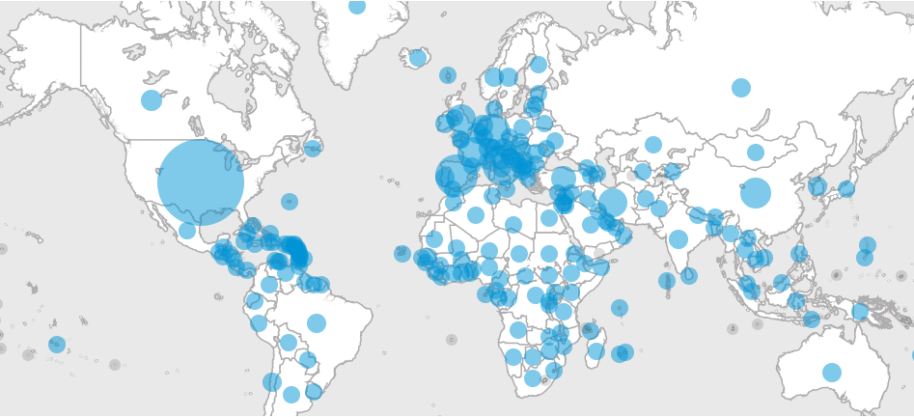

Figure 1: Pictorial Representation of COVID-19 Outbreak (Source: WHO)

There are different measures to contain COVID-19 infections and reduce interaction between unidentified infected and non-infected individuals. Wilder Smith and Freedman (2020) in their recent study list different actions in detail, ranging from the quarantine of confirmed cases and suspected cases to community containment with travel restrictions outside of the defined areas.

Lockdown is an emergency protocol that usually prevents people or information from leaving an area. A pre-emptive lockdown gives a healthcare system time to prepare itself to address an unusual scenario like an outbreak of a pandemic. Mitigation efforts can help to reduce the number of daily cases and to reduce the pressure on the healthcare system. This phenomenon is called flattening of curve Figure 2. During COVID-19 outbreak the term lockdown was used for actions related to mass quarantines. It limits the movements in the community and only activities related to the supply of basic needs are allowed.

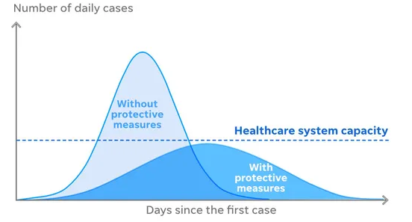

Figure 2: Flattening of the Curve (Source: Centre for Disease Control (CDC))

The lockdown in Hubei province of China significantly decreased growth rate and increased doubling time of COVID-19 cases. Chinese hospitals overflowing with COVID-19 patients a few weeks ago now have empty beds. China has ended its more than 10-week-long lockdown of Wuhan — the city where the coronavirus is believed to have originated, and spread to 209 countries and territories across the globe. Other countries can learn a lesson from China that stringent confinement of people in high-risk areas seems to have the potential to slow down the spread of COVID-19. The experts also warn about the human rights costs of the most severe measures imposed by China's authoritarian government: massive lockdowns and electronic surveillance of millions of people.

**COVID-19 in India**

India reported the first case of COVID-19 on 30th January 2020. As of 12th April 2020, the Ministry of Health and Family Welfare has confirmed 8,447 cases,765 recoveries and 273 deaths in the country (MHA,2020). The state of Maharashtra is most severely hit by the COVID-19 and have reported 1,761 cases till date, while Delhi is the second most affected state with 1,069 reported cases. India is taking stringent measures to reduce the number of infected people and hence patients needing hospitalisation. India scored a “100” on the stringency index developed by the researchers at Oxford University because of its strict measures taken, including the nationwide lockdown, to curb the spread of coronavirus (University of Oxford,2020).

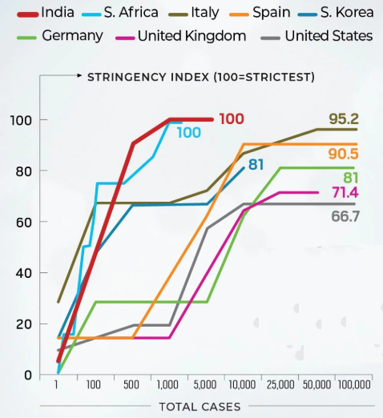  
Figure 3: Stringency Index of Different Countries (Source: India Today)

The experts believe that country’s healthcare system is not ready to face the situation if things go bad as it happened in countries like the US, Italy, and Spain. The prime minister of the country requested for a 14-hour self-imposed curfew on 22nd March 2020. The country imposed a countrywide lockdown on 24th March 2020 and experts are in favour to extend this lockdown till 3rd May 2020.

**Bhilwara Model**

Rajasthan is a frontier state of India known for its historical places, which attract tourists from Indian as well as overseas. Bhilwara is a city in the state of Rajasthan known for its textile industry and tourism destinations. The popular textile town reported its first COVID-19 case on 19th March 2020 and then quickly emerged as a hotspot, reporting 27 cases, becoming the worst-affected district in Rajasthan. With the potential to become an epicentre of coronavirus spread, the city was touted as Italy of India (BBC,2020). The city took stringent measures to combat the progression of the disease and have not reported any new case since 31st March 2020.

**Methodology**

This paper uses a case study method for analysis of the Bhilwara model. The data was collated from various newspaper articles available on online portals like Business Standards, Indian Express, and Economic Times. The data was arranged in chronological order to understand various stages of the Bhilwara Model implemented in a crisis.

A crisis is an unpredictable process or event, which can cause damage to a negative impact on an organization and its stakeholders (Pearson & Clair,1998). Crisis management is the approach adopted by an organization in a crisis (Pearson & Mitroff,1993). There are three common elements in a crisis: a threat to the organization, the element of surprise, and short decision time. There are four different stages of the crisis life cycle is depicted in Figure 3. If timely intervention is taken the crisis might not reach the growth and maturity stage. The management can avoid the crisis even before it is born. This approach is called crisis killing. In another scenario, management can limit the growth of the crisis or shorten the life cycle of the crisis this approach is called crisis control (Herrero & Pratt,1996).

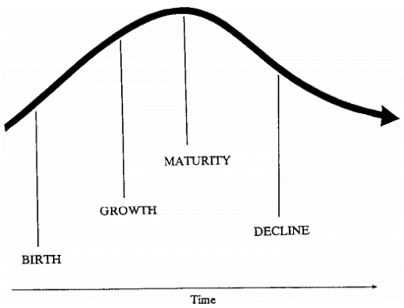

Figure 3: The Crisis Life Cycle

This paper maps the Bhilwara model with crisis management model proposed by Herrero and Pratt (1996) for managing crisis in an organization. In their seminal paper, they have proposed an integrated four-step symmetrical model for the effective management of crises. This approach has four main steps (1) issues management, (2) planning-prevention, (3) crisis, and (d) post-crisis Figure -4.

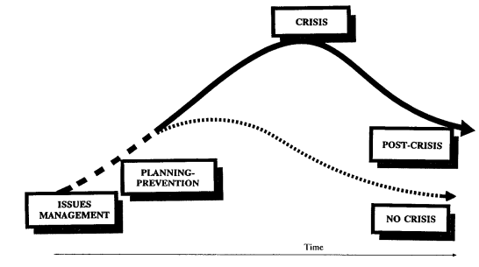

Figure 4: Four-Step Symmetrical Model for Crisis Management

This paper analyses the Bhilwara model from lenses of this four-step symmetrical model of crisis management (FSMCM) used for crisis communication. The study uses a focus group of four doctors and two healthcare professionals for input in the mapping of Bhilwara model with FSMCM. The details of the various steps of FSMCM is listed in Table 1.

Table 1: Various Steps of Develop FSMCM

|  |  |
| --- | --- |
| Steps of (FSMCM) | Detail of Activities |
| Issue Management | Scan the environment, Collect the Data, Identifying the threatening issue, Develop Strategy |
| Planning Prevention | Set Proactive Policy, Develop Contingency Plan, Delegate the work, Clear Communication Plan |
| Crisis | Evaluate the organization’s response to the crisis, pre-empt the negativity, Communicate the message to the appropriate audience |
| Post Crisis | Continue to monitor, Continue to inform stakeholders, Evaluate how the crisis plan worked, Develop a long term communication strategy |

**Research Objective**

1. The objective of this study is to list the approach adopted by the city administration in Bhilwara to combat the spread of COVID-19 in the city.
2. The paper maps the Bhilwara Model with Crisis Management Model

**Case: Bhilwara Model**

The Bhilwara Model is referred to as the approach adopted by administration in Bhilwara district to contain the spread of the disease after it emerged as a hotspot for coronavirus positive cases. This section further explains the chronology of the events and the major steps taken by the administrator of the city.

On 22nd March 2020, the Indian government requested for nationwide 14 hours self-imposed curfew. This exercise was a dressed rehearsal of more stringent combating measures the government was going to take in the coming days. Meanwhile, the situation in Bhilwara was getting tense and war-like. The international media like the British Broadcasting Corporation (BBC) has feared the textile city to become an epicentre of the corona outbreak in India. The district collector (DC) of the city Mr Rajendra Bhatt was running out of the time. His action was going to shape the future of Bhilwara and India up to some extent.

**19th March 2020:**

A couple who have returned from Italy was tested positive for COVID-19 in Jaipur. The first case of Coronavirus was found in Bhilwara on the same day. The state government directed all cities to impose article 144 and prohibited the assembly of five or more people in a public place.

**21st March 2020:**

There was a sense of desperation seeping into the administration after the realisation that almost half of the 20 odd cases in [Rajasthan](https://www.business-standard.com/topic/rajasthan)were in Bhilwara. The district collector issued the directions of closing down all industries, factories, offices and other establishments in which more than 10 workers were employed. Meanwhile, a doctor returned from Saudi Arabia was tested positive along with five other medical staffs who had worked close to him at Brijesh Bangar Memorial Hospital (BBM Hospital). The possibilities of infection to patients who were treated by them was a possibility. These patients may have infected many more people.

**22nd March 2020**

All public transports including buses, taxis, auto-rickshaws, and commercial vehicle were banned. The hotels were asked to reserve at least five rooms for medical purpose. These measures were taken to prepare quarantine centres if needed. The district officials were asked to draw the route chart of every zone to provide the essential supply. It was ensured that essential supply reaches every resident of the city otherwise there was fear that people will not follow the lockdown.

**23rd -24th March 2020**

It was the fourth consecutive days which reported the rise in cases. The police department took stringent measures to ensure that the lockdown is followed in its true spirit. The barricades were erected within the district and its borders to restrict the intra and inter-district movements. These barricades were manned by the police around the clock and food, tent and drinking water was supplied to these check posts. The administration requisitioned for quarantine facilities with at least 6,000 beds in various places. The guest houses of big industries were used for keeping the healthcare professional. The hostel rooms of the various educational institution were used as quarantine facilities. The food was distributed in the quarantine centres by a non-government organization (NGO) Akshay Patra.

**25th March 2020**

The district administration was getting concerned about the situation at BBM Hospital. Out of the 19 cases reported to date, the majority of them were medical professionals. The hospital was identified as a hotspot of the coronavirus. The 63 patients admitted in the ICU of the hospital and their relatives were screened for coronavirus. The number of tests at the government-owned Mahatma Gandhi hospital (MGH) was increased from 200 to 300 a day.  A 24-hour war room was created, which was manned by three teams working in eight-hour shifts every day. They were tasked with monitoring every aspect of tracing, testing, quarantine and lockdown in the district.

**26th-28th March 2020**

More than 6000 people were tested and were quarantined. The district administration took control of five private hospitals along with their staff and medical equipment. All patients admitted at BBM Hospital were moved into quarantine facilities. The results of the first door-to-door medical screening done on 21st March 2020 were known by 28th March 2020. The list contained names and addresses of all symptomatic people displaying signs of COVID-19 infection. The relatives of the people included in this list were done. The screening of the fist list and suspects and their family member was done within 24 hours.

**29th -30th March 2020**

The second list of the suspects was prepared by the 29th March 2020. Two thousand teams were commissioned to screen 2.2 million people – 92 per cent of the district’s entire population. Special teams were formed in every village of the district which included Accredited Social Health Activists (ASHA), Anganwadi workers and other local officials. The duty of these teams was to ensure that people asked for self-quarantine didn’t come out of their homes. These teams sent the status reports to the war-room formed in district collector’s office. To guarantee the smooth supply of essential goods, sanitisers, and masks, police ensured against the black marketing of these products. The strict directions were given by the administration to confirm that the essential medical products not sold above the maximum retail price (MRP).

**31st March 2020**

The last case was recorded in the city and the infection reached its peak at 27. In the line of nationwide lockdown, the city administration tightens the movement further till 15th April 2020. The door-to-door delivery of milk and other essential being ensured in the city.

The success of the Bhilwara Model didn’t go unnoticed. The other states have followed the suit. On 8th April 2020, another state Uttar Pradesh in a bid to prevent community spread sealed the affected areas or 'hotspots' in 15 districts across the state till 15th April 2020 In the similar lines, Delhi government announced the sealing of hotspots in various part of the state.

**Mapping Bhilwara Model**

This section maps the Bhilwara model with the four-step symmetrical model of crisis management.

Table 2: Mapping Bhilwara Model with FSMCM

|  |  |
| --- | --- |
| Steps of (FSMCM) | Inputs from Bhilwara Model |
| Issue Management | * The administration timely assessed the situation that Bhilwara may emerge as a hotspot of the corona infection. * All school, colleges and companies were closed * They took timely measures and locked down the city completely. Article 144 was imposed in the city and * Movement of the public and the private vehicle was prohibited. |
| Planning Prevention | * Five private hospitals including BBM were taken over by administration. * All patients from BBM hospital and their relatives were scanned for COVID-19 * 92% of the population of Bhilwara was tested for the infection * Hostels of institutions and guest houses of big companies were converted into quarantine centres. * Supply of the essential goods was ensured * Black marketing of the essential goods and medical supplies prohibited in the city * War-room was created to monitor the situation |
| Crisis | * The last case of the COVID-19 was recorded in the city on 31st March 2020. The number of infection peaked at 27 and then decreased. Thus a major crisis was averted due to effective crisis management by the administration. |
| Post Crisis | * The city is in lockdown and social distancing is being maintained. * The situation in the city is being monitored * Guidelines for social distancing and behaviour modification are issued |

It can be debated that the effective crisis management in the city averted a possible crisis but that again depends on the definition of the crisis. The city has not reported any new case for the last two weeks, but the administration should not get complacent of the situation. They need to be alert and keep monitoring the situation so that it doesn’t get out of control.

**Conclusion**

This study uses a case of Bhilwara Model to establish an approach for crisis management. The study maps the Bhilwara model with a four-step symmetrical model of crisis management (FSMCM). The study also shows that if the issue management and planning prevention steps are implemented impeccably the crisis life cycle follows a different path. If managed effectively, the crisis proceeds to no crisis stage after the planning prevention step. In the case of COVID-19, the crisis is ongoing and containment doesn’t mean than crisis will not come back again. If we want to return to the normalcy, a vaccine of the disease is required which may take another six months or so. This makes the post-crisis steps very important in the management of COVID-19 in a city. This study documents the case of lockdown implementation in Bhilwara town and hence theoretically contributes to the existing literature on crisis management in public health. The findings of the study will be helpful for public health professionals and policymakers in the effective implementation of social distancing.

**Acknowledgement**

The infrastructural support provided by FORE School of Management, New Delhi is greatly appreciated.

**Reference**

Chen, N., Zhou, M., Dong, X., Qu, J., Gong, F., Han, Y., ... & Yu, T. (2020). Epidemiological and clinical characteristics of 99 cases of 2019 novel coronavirus pneumonia in Wuhan, China: a descriptive study. *The Lancet*, 395(10223), 507-513.

World Health Organization, COVID-19 situation dashboard, [www.who.int](http://www.who.int) retrieved on 10th April 2020.

Wilder-Smith, A., & Freedman, D. O. (2020). Isolation, quarantine, social distancing and community containment: pivotal role for old-style public health measures in the novel coronavirus (2019-nCoV) outbreak. *Journal of Travel Medicine*, 27(2).

Lau, H., Khosrawipour, V., Kocbach, P., Mikolajczyk, A., Schubert, J., Bania, J., & Khosrawipour, T. (2020). The positive impact of lockdown in Wuhan on containing the COVID-19 outbreak in China. *Journal of Travel Medicine*.

Kupferschmidt, K., & Cohen, J. (2020). Can China's COVID-19 strategy work elsewhere? *Science,*367(6482), 1061-1062

Ministry of Health and Family Welfare, <https://www.mohfw.gov.in/>,Retrieved on 12th April 2020.

Oxford COVID-19 Government Response Tracker, [https://www.bsg.ox.ac.uk/research/ research-projects/oxford-COVID-19-government-response-tracker](https://www.bsg.ox.ac.uk/research/%20research-projects/oxford-covid-19-government-response-tracker), Retrieved on 12th April 2020

India scores high on COVID-19 response tracker made by Oxford University, https://www.indiatoday.in/india/story/india-scores-high-on-covid-19-response-tracker-made-by-oxford-university-1665573-2020-04-10, Retrieved on 13th April 2020

Soutik Biswas, Coronavirus: Is this textile city set to be India’s Italy? <https://www.bbc.com/news/world-asia-india-51997488>, Retrieved on 24th March 2020.

Pearson, C. M., & Clair, J. A. (1998). Reframing crisis management. Academy of management review, 23(1), 59-76.

Pearson, C. M., & Mitroff, I. I. (1993). From crisis-prone to crisis prepared: A framework for crisis management. Academy of Management Perspectives, 7(1), 48-59.

Coombs, W. T. (1998). An analytic framework for crisis situations: Better responses from a better understanding of the situation. Journal of public relations research, 10(3), 177-191.

Herrero, A. G., & Pratt, C. B. (1996). An integrated symmetrical model for crisis-communications management. Journal of Public Relations Research, 8(2), 79-105.