COVER LETTER FORMAT

Dear Editor,

This is to confirm that the article entitled “**The barriers to observing professional ethics in the practice of nursing care from nurses' viewpoints**” submitted to the *Indian Journal of Medical Ethics* is original and has been co-authored by the undersigned. All authors have participated in the work sufficiently to meet the ICMJE guidelines for authorship. All have read and approved the manuscript.

The submission is not under consideration for publication in any other journal. We give consent to **Raziye Iloon Kashkouli** to act as the author for correspondence.

Details of sponsorship or relevant competing interests, financial or otherwise: **Approval for this study was obtained by the Islamic Azad University of Firoozabad, Fars, Iran. This study did not get a specific grant. The authors declare no competing interests.**

We have read the terms and conditions of authorship of IJME and accept them.

Contact details (mailing address, email id) and affiliation of all authors:

**Marzieh Azadian**

Department of Nursing, Firoozabad Branch, Islamic Azad University, Firoozabad, Iran.

Department of Nursing, Faculty of Nursing and Midwifery, Tehran Medical Science, Islamic Azad University, Tehran, Iran.

**Email:** [s.azadian@yahoo.com](mailto:s.azadian@yahoo.com); phone number: 00989171391242

**Azar Rahimi**

Department of Nursing, Firoozabad Branch, Islamic Azad University, Firoozabad, Iran.

**Email:** med.sums.ac.ir@gmail.com; phone number: 00989173052069

**Mohammad Mohebbi**

Namazi Hospital, Shiraz University of Medical Sciences, Shiraz, Iran.

**Email:** [mohammadmohebi990@gmail.com](mailto:mohammadmohebi990@gmail.com); phone number: 0098990615870

**Raziye Iloon Kashkouli**

School of Nursing and Midwifery, Shiraz University of Medical Sciences, Shiraz, Iran.

Shahid Beheshti Hospital, Social Security Organization, Shiraz, Iran

**Email:** [iloonraziye@gmail.com](mailto:iloonraziye@gmail.com); phone number: 00989171882381

**Abbas Mardani**

Nursing Care Research Center, School of Nursing and Midwifery, Iran University of Medical Sciences, Tehran, Iran.

**Email:** [mardani.a@iums.ac.ir](mailto:mardani.a@iums.ac.ir); phone number: 00989191430541

* Corresponding Author: Raziye Iloon Kashkouli, School of Nursing and Midwifery, Shiraz University of Medical Sciences, Shiraz, Iran. Phone number: 00989171882381, Fax number: 0098 88201978, Email: iloonraziye@gmail.com

Signatures of all authors:

**Azar Rahimi Abbas Mardani**

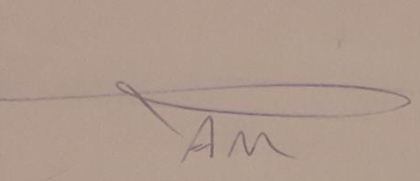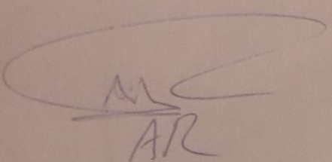

**Mohammad Mohebbi Marzieh Azadian**

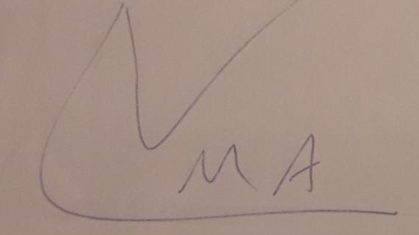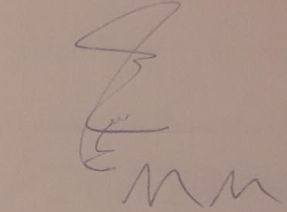

**Raziye Iloon Kashkouli**