**Outbreak of novel corona virus disease (COVID-19): An Indian report from first case to current**

Pragati S Dubey

Ph.D. Scholar

Faculty of Dental Science,

Institute of Medical Sciences, Banaras Hindu University, Varanasi

Email: [ruchidubey008@gmail.com](mailto:ruchidubey008@gmail.com)

ORCID ID: http:// orcid.org/ 0000-0002-2914-5444

Contact: 8866636569

Dr. Neelam Mittal

M.D.S, B.D.S

Professor

Faculty of Dental Science,

Institute of Medical Sciences, Banaras Hindu University, Varanasi

Email: [dr.neelammittal@gmail.com](mailto:dr.neelammittal@gmail.com)

Dr. Prabhat Chandra

B.D.S

I.T.S Dental College, Hospital & Research centre, Greater Noida

Email: [dentalsap01@gmail.com](mailto:dentalsap01@gmail.com)

**ABSTRACT:**

The current spread of COVID-19 has affected entire community worldwide as a consequences major public health situation arises. Outbreak of this disease is still on high rise in the whole world. SARS COV-2 is a kind of Zoonotic infection, which allegedly originated from Bats or Pangolins and further transmitted to humans. In human body corona virus is present in nasopharynx and in salivary secretion. Mostly this virus affects the upper respiratory tract which eventually leads to pneumonia in both lungs. Novel corona virus occupies the same receptor Angiotensin converting enzyme (ACE) as that for SAR-COV-2 which results in more affected area such as lung, kidney and heart. It is transmitted through close contact with infected person or by infected area. COVID-19 is a kind of life threatening infection so the transmission of this disease causes extensive problem for heath care practitioner to reduce the symptoms of infected patients. There is no evidence based treatment available till date so this situation causes high impact of severity on human life. Prevention against this disease is important for all of us until researchers make any specific vaccine. Sanitization and healthy life style is necessary to avoid the occurrence of this disease. The main objective of this study to provide brief overview of novel corona virus, its types, pathogenesis, symptoms, transmission, diagnosis, treatment options and preventive measures for this disease.

**Keywords:** Novel Corona virus, Pathogenesis, Symptoms, Culture, Preventive measures.

**BACKGROUND:**

According to the World Health Organization (WHO) reports, in early December 2019, world identified its first cluster case of Pneumonia origin from Wuhan, capital of Hubei Province, China. Afterward an enveloped RNA, β-corona virus commonly known as Severe Acute Respiratory Syndrome Corona Virus-2 (SARS COV-2) has been reported by WHO. In Jan 2020, WHO set up IMST (Incident Management Supported Team) to put organization on emergency for dealing with this outbreak, at that time WHO declared there was cluster of pneumonia cases – with no deaths – in Wuhan, Hubei Province.1 Then on fifth day of January, WHO published in social media our first disease outbreak news on novel virus. On tenth day, WHO issued an online package with advice to all countries how to detect, test and manage potential cases, based on what was identified at that time. The control guidance was published to protect the health workers, social distancing, caring of patients and airborne precaution by sanitization. On twelfth day of January, China publicly shared genetic sequence.2 On 13 January, officially confirmed case of COVID-19 in Thailand, outbreak outside China has been reported. On 14th January, WHO reported there may have been human to human transmission of Corona virus (analyzed by 41% confirmed cases in world). Further on 22nd January, evidence of human to human transmission in Wuhan was investigated by WHO experts. Then after 8 days, 30th January, there was large number of Pandemic cases were reported with total number of 7818 worldwide, with majority of these cases in China and 82 cases were reported outside China.3

On the day of 30th January, India also identified its first case of COVID-19 which was originated from China. Further there was no significant rise in case in month of February 2020 in India.4 Afterward 14 infected members from Italian tourist group was reported, resulted in 22 new cases came to light on 4th March 2020. On 15th March 2020, India has reported its overall 100 confirmed cases. Cases rises to 1000 on 28th March, then 5000 till 7th April, 10,000 till 14th April, 20,000 cases till 22nd April and 30,000 till 29th April. Till now on 25th May 2020, more than one lakh seventy three thousand seven hundred sixty three cases have been reported in India.

Then transmission of novel COVID-19 has been increases rapidly during March with low death rate (3.3%). In India first death was reported on 12th March which was a 76 years old man who had returned from Saudi Arabia. On first April, the death toll crossed 50 in India, 100 deaths till 5th April, 500 deaths till 19th April, 10,000 deaths till 29th April. Till now 4,980 deaths has been reported in India on 25th May 2020 with death rate of 2.9%.

**WHAT IS COVID-19?**

Severe acute respiratory syndrome corona virus-2 (SARS COV-2) is kind of Zoonotic infection which may be caused by Bats and Pangolins and further transmitted in humans. The nomenclature of COVID-19 is originated from its crown like spike on rounded surface. It is divided into four subgroups – alpha, beta, gamma and delta.5

**TYPES OF COVID-19:**

Till now there are total seven types of Corona virus has been reported as follows6:

1. Alpha Corona virus (α-COVID) – 229E
2. Alpha Corona virus (α-COVID) – NL63
3. Beta Corona virus (β-COVID) – OC43
4. Beta Corona virus (β-COVID) – HKU1
5. Middle east respiratory syndrome- MERS- Corona virus
6. Severe acute respiratory syndrome- SARS- Corona virus
7. Novel Corona virus COVID-19 (SARS-COV-2)

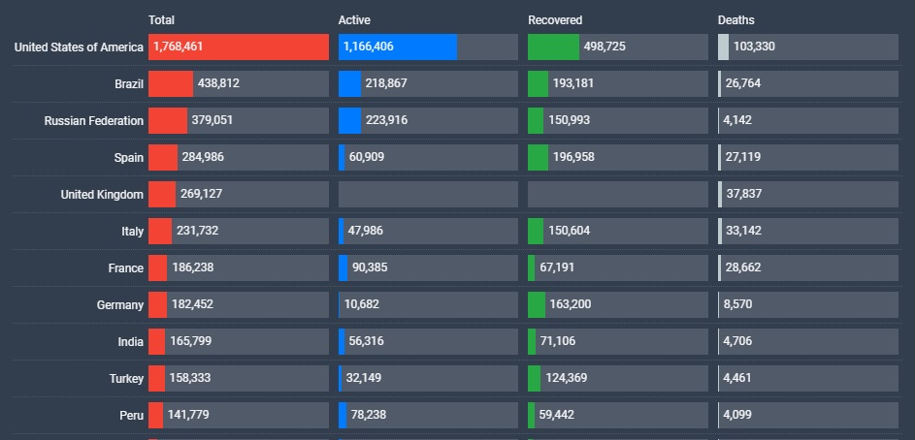

**Figure 1:** Data of infected people with novel corona virus worldwide

**STRUCTURE OF COVID-19:**

COVID-19 is originated from Latin word where coron means crown. So structure of novel corona virus seems like crown shaped, single strain ribonucleic acid (RNA) virus, which is wrapped in an envelope with large number of glycoprotein spike(s). It may also change its structure from person to person.7

Among all seven types of Corona virus, serious infection and fatalities occurs by β- strain. α- strain may be asymptomatic or sometime symptomatic. β- Strain encode with four structural protein: spike protein (S), a protein film (SM), layered glycoprotein (M) and nucleon capsid protein (N). The entire genome of bat COV is 96% similar with novel COVID-19.7, 8

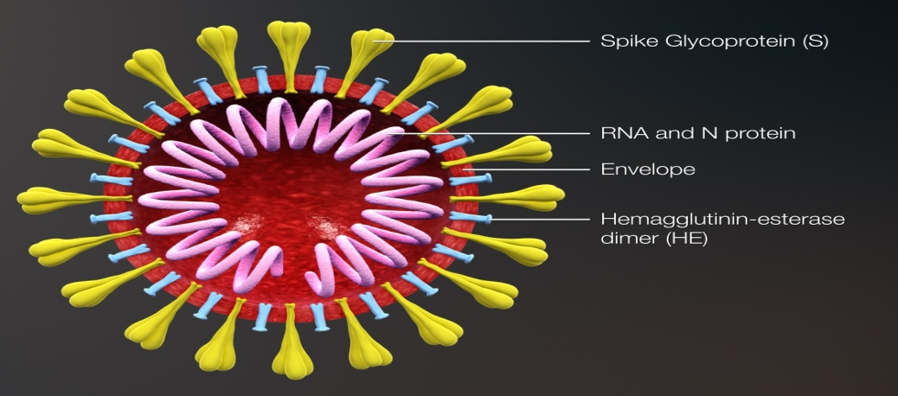

**Figure 2:** Structure of Corona Virus

**INCUBATION PERIOD:**

The mean hatching time of novel corona virus is around 2-14 days. On February 21, JAMA investigation has been done on 5 cases of COVID-19 and reported incubation time is of 19 days for corona virus. Also, on February 22, a case has been reported from government of Hubei, Province which stated that incubation period of COVID-19 in that case is around 27 days. 9

**CULTURING & ISOLATION: 10, 11**

The culturing of COV was done by Tyrrel and Bynoe in 1965 from human tracheal organ. The sample are collected from nasal, sputum, oropharengeal region by using culturing kit (e.g. UTMTM Kit) containing 1ml of viral transport media on 7th day of illness. Afterward sample gets cultured at 37 0C in 5% carbondioxide atmosphere. After 3 days of blind passage, growth of monolayer Vero cells culture observed; after 5 days of blind passage cytopathic effect in culture supernatant observed and matured cultured virus cells with crown like spikes will observe after 10-14 days. Further cutting is done of this virus particle on ultra microtone slide at 65nm and afterwards staining of Vero cell culture with saturated 4% uranyl acetate and 1% lead citrate is done to observe the spherical particle with crown like structure ranging from 66-81 nm in diameter under Electron microscope. This way by using QIA amp viral kit, extraction and isolation of whole genome sequences of single strain RNA occurs.

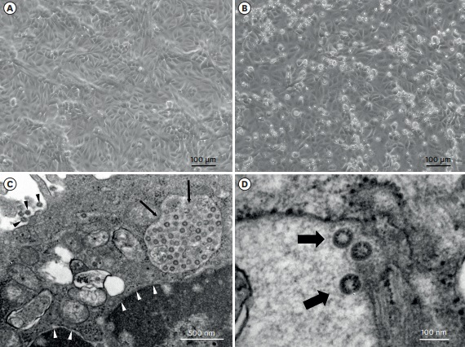

**Figure 3:** Image cytopathic effect of SARS COV-2 under electron microscope. (A): no cytopathic effect till 3 days. (B): Growth of monolayer Vero cell observed. (C): Cytopathic effect observed by rounding and detaches Vero cell culture. (D): Matured crown like spikes of SARS COV-2 under electron microscope observed.

**ETIOLOGY:**

Corona viruses are common in several species of animal such as cattle, camels, etc. Etiology is unclear, but there was still there were some suggestions that it came from sea foods and animals marketed in Wuhan.12

**LIFE CYCLE OF CORONA VIRUS: 13, 14**

Life cycle of novel corona virus with host cell has been given in five steps as follows:

Attachment

STAGE 1

Penetration

STAGE 2

Biosynthesis

Maturation

STAGE 3

Release

1. Attachment of virus with host cell or receptor.
2. Virus penetrates into endocytosis by membrane fusion.
3. Afterwards, viral RNA replicates itself into host cells through mRNA; this stage shows biosynthesis of corona virus into host cells.
4. Then replicate virus gets mature and develop inside host cells.
5. Release of mature novel corona virus into new host cell.

**PATHOGENESIS: 15- 17**

1. Stage 1: Asymptomatic stage (initial 1-2 days of infection)

SARS-COV-2 binds with epithelial cells in nasal cavity and starts replicating. The main receptor for SARS-COV and SARS-COV-2 is Angiotensin converting enzyme (ACE). ACE shows high expression in lungs, heart, ileum, kidney and bladder. At this stage virus can be detected by SWAB test. After binding with ACE receptor the steps are given in flow chart as follows:

COV-2 spike protein undergoes protease cleavage

Activation of SARS-COV-2 at S1 site by ACE

Activation of MERS-COV-2 at S2 site

Activates the spike for fusion in irreversible manner

S1 stabilize the epithelial membrane

Binds host cells with receptor

1. Stage 2: Upper and conducting airway responses

The virus migrates from epithelial cell to the lungs. Here CXCL10 (or some other cytokine) shows responsive effects to the gene and this also considered as a useful marker to detect the corona virus. At this stage SWAB test and SPUTUM test are use to detect the infection in patient. It is most symptomatic stage, about 80% of infected patient detected at this stage. At this stage patient shows restriction to upper and conducting airway of lungs due to which shortness of breath occur.

1. Stage 3: Hypoxia, ground glass infiltrates and progression of ARDS

About 30% of patient shows hypoxia at this stage and develops severe disease with pulmonary infiltrates. End result shows increase in pulmonary toxins which consist of viral particles. Acute respiratory disease syndrome (ARDS) occurs due to which cells undergoes apoptosis and die.

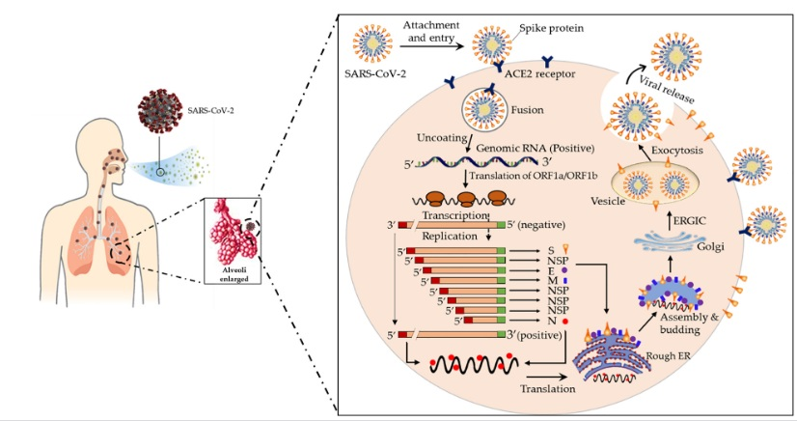

**Figure 4:** Pathogenesis of COVID-19

**TRANSMISSION OF CORONA VIRUS IN HUMAN: 18**

1. When one infected people get close contact with healthy people (with 5-6 feet range).
2. When infected COVID-19 people breathe out or having cough or sneeze, tiny droplet releases which will infect another person.
3. If virus contain droplets land on nearly surfaces or objects and that virus can picked up with any person by touching these surfaces or objects, then this way infection spreads when same person touches their nose, eyes or mouth.

**SIGN AND SYMPTOMS: 19, 20**

After 2-14 days present of corona virus in person, symptoms may occur as follows:

* Fever
* Cough and Cold
* Shortness of breathe
* Pneumonia in both lungs
* Headache
* Muscle soreness
* Fatigue

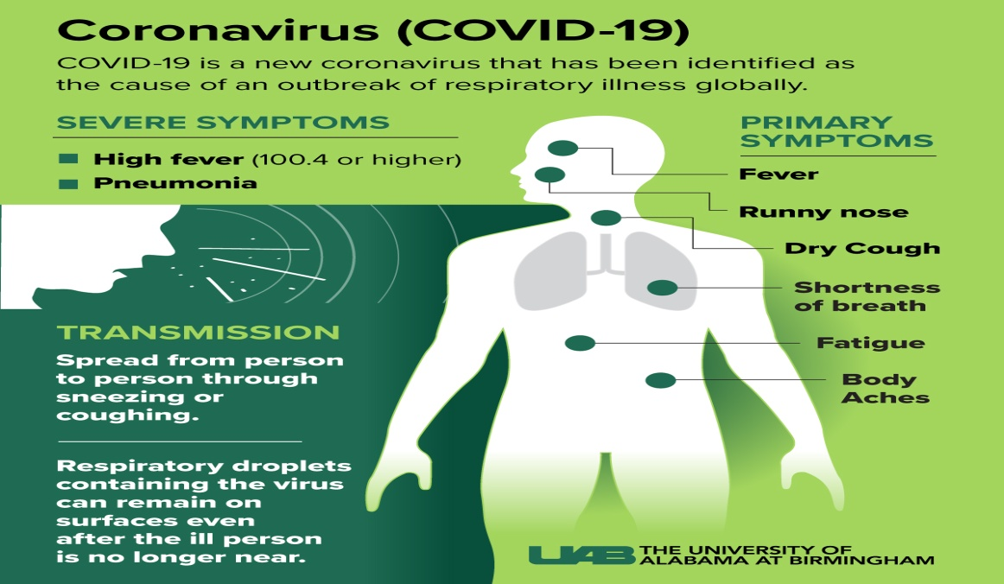

**Figure 5:** Symptoms of Corona virus and its transmission

**PANDEMIC REPORT IN INDIA: 21**

India’s fatality rate is lower at 2.9% as per 29th May, 2020. Five cities of India are mainly affected by this outbreak such as Mumbai, Delhi, Ahmadabad, Chennai and Pune. No case has been reported till 29th May in two regions of India named as Sikkim and Lakshadweep. India’s overall report has been given as (as per 29th May):

* Confirmed cases: 1, 73,763
* Active cases: 86,156
* Death: 4,980
* Recovered: 82,627

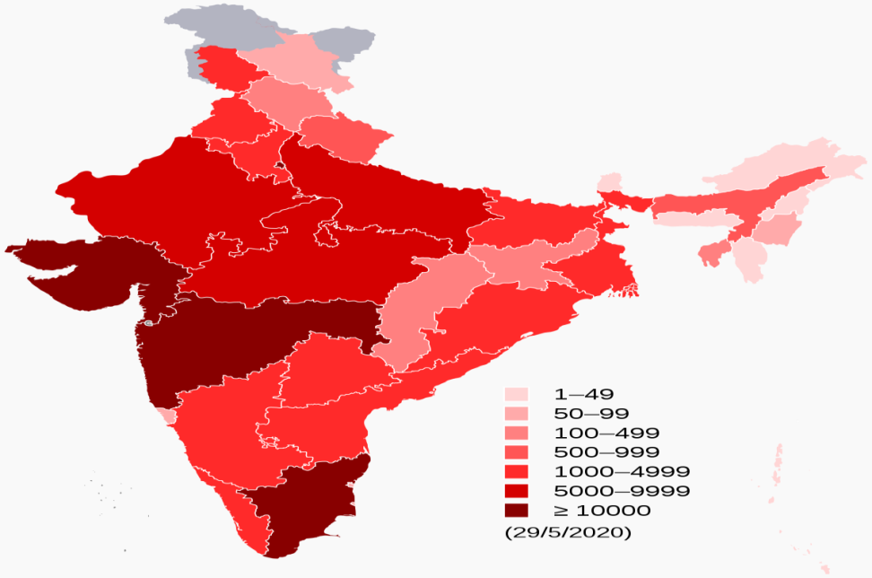

**Figure 6:** Confirmed cases of COVID-19 in India

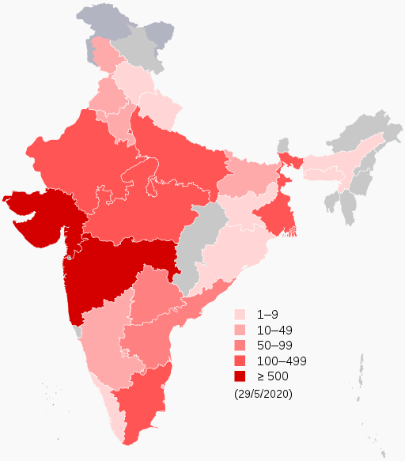

**Figure 7:** Death map of COVID-19 in India

**DIAGNOSIS: 22, 23**

The laboratory methods by which corona virus gets tested as:

* SWAB TEST: Samples can be taken from the nostril or throat of infected patient, by swiping the special type of swab heath professional takes the sample.
* NASAL ASPIRATE: Injection of saline solution into the nasal of infected patients and then collects the sample by removing the solution with suction.

* TRACHEAL ASPIRATE: In this test the sample gets collected with bronchoscope by inserting it inside mouth of patient or may be to the lungs by health professionals.

* SPUTUM TEST: For this test the health professionals collects the sample of coughing in cup or in special type of swab by infected patients.
* BLOOD TEST: Blood samples get collected for detection of antigen antibody reactions in body. This test is used worldwide for detection of COVID-19 in approved laboratories.

More widely used test of COVID-19 is “Rapid test kit” which is approved by Food and Drug Administration (FDA). This method is fast, accurate and approved in all laboratories throughout the world for detection of novel corona virus.

**PREVENTIVE MEASURES: 24-26**

People should follow the CDC rule on regular basis to avoid Infection against virus. Government of India has also published many posters or guidelines for prevention against virus as follows:

* Do not touch your nose, mouth and eyes.
* Do not come in contact with infected person.
* Do not travel unless it is more necessary.
* Stay at home when you are unwell.
* Cover your mouth and nose while sneezing or coughing with tissue and throw it in dustbin.
* Clean and sanitize the gadgets which come in contact with infected person.
* Washing hands with soap properly fro 10-20 seconds and use sanitizer having 70% alcohol.
* Avoid sharing dishes, glasses, bedding and other household gadgets when you are ill.
* Wear mask and gloves while travelling.
* Keep social distancing of 6-7 feet with any person.
* Avoid shaking hand with any person.
* Drink as much as water to increase immunity.
* Drink “Ayush kadha” daily to improve your immunity.
* Do not eat raw or uncooked food or meat.
* Avoid touching live or street animals.
* One should wear personal protective care (PPE) kit for better safety while travelling.

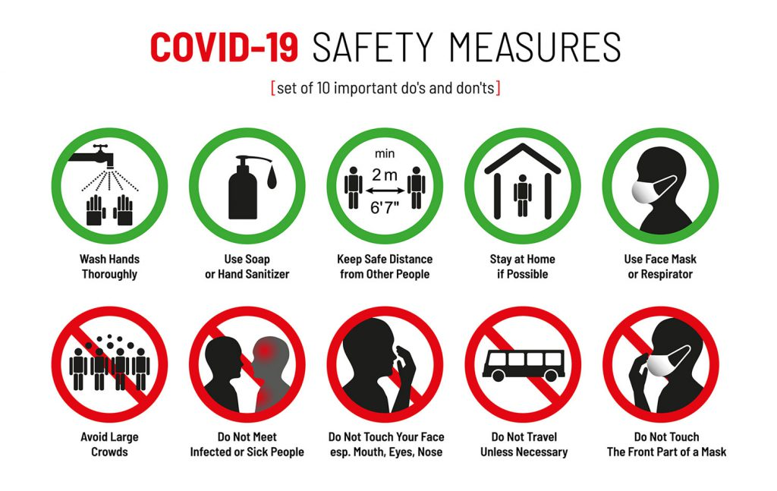

**Figure 8:** Preventive measures during COVID-19

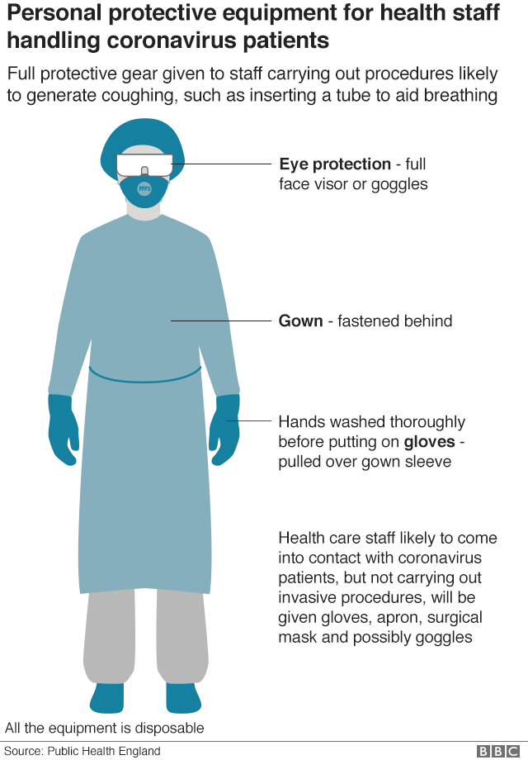

**Figure 9:** Personal protective equipment (PPE) kit

**TREATMENT OPTIONS: 27, 28**

There is no specific treatment for treating outbreak of Corona virus in patients. Also treatments are under investigation in different countries. People with COVID-19 should receive proper supportive care which helps to relieve symptoms. To relieve the symptoms several drugs options are there to relieve the symptoms of this corona virus as:

1. Anti-malarial drug like Hydroxychlorquine
2. Anti viral drugs like Remedsivir, Lopinavir, Rotinavir, Ganciclovir
3. NSAIDS like Ibuprofen, Aceclofenac
4. Neuraminidase inhibitors
5. RNA synthesis inhibitors
6. Combination therapy

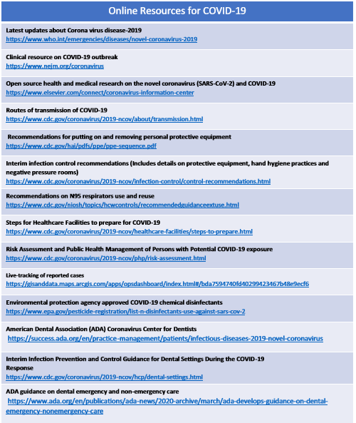

**Figure 10:** Online resources for update of Corona Virus

**REFERENCES:**

1. WHO. Statement on the second meeting of the International Health Regulation (2005) Emergency committee regarding the outbreak of novel corona virus (2019-nCoV). 2020. <https://www.who.int/news-room/detail/30-01-2020-statement-on-the-second-meeting-of-the-international-health-regulations-(2005)-emergency-committee-regarding-the-outbreak-of-novel-coronavirus-(2019-ncov)>. Accessed on 1 February 2020.
2. CDC; 2019 Novel corona virus; Wuhan, China. 2020. <https://www.cdc.gov/coronavirus/2019-nCoV/summary.html>. Accessed on 1 February 2020.
3. WHO. Novel Corona virus- China; 2020. <https://www.who.int/csr/don/30-january-2020-novel-coronavirus-china/en/>. Accessed on 1 February 2020.
4. “Situation Report- 28”. World Health Organization, 2020. <https://www.who.int/csr/don/12-january-2020-novel-coronavirus-situation28/en/>. Accessed on 17 February 2020.
5. National Centre of Immunization and Respiratory Diseases (NCIRD), Division of Viral diseases. http:// https://www.cdc.gov/coronavirus/types.html.
6. Gralinski LE, Menachery VD. Return of the Corona virus; 2019-nCoV. Journal of Viruses; 2020; (12): 135.
7. Zhu N, Zhang D, Wang W, Li X, et al. A novel corona virus from patients with pneumonia in China, 2019. Novel England Journal of Medicine. 2020; 1(2): 1-5.
8. J.C. Juri and M.K. Sen. Pandemic in India- Indian experience. Lung India. 2020; 28(1): 2-4.
9. Corona Incubation could be as long as 27 days, Chinese provisional government says- Reuters, February 22, 2020.
10. Wan Boem Park, Nak-Jung Kuan, Su Ji koi, et al. Virus Isolation from the First Patient with SARS-COV-2 in Korea. Japan Korean Medical Sciences. 2020; 35(7): 1-5.
11. Puja Mehta, Daniel F Mcauley, et al. COVID-19: Considered cytokine storm syndrome and immunosuppression. The Lancet; 2020; 395 (10229): 30-35.
12. Sarbjeet singh, Navneet Kaur and Mandeep Kaur. A review on Corona virus. Journal of Endocrinology and Metabolism Research. 2020; 1(1); 1-11.

1. Vareille M, Keinieiger E, Edeawds MR, Regamay N. The airway epithelium virus soldier in the fight against respiratory Virus. Clinical Microbiological Review. 2011; 24(1); 210-299.
2. Hussain A Rothan, Siddappa N. Byrareddy. The epidemiology and pathogenesis of Corona virus disease (COVID-19) outbreak. Journal of Autoimmunity; 2020; 109 (102433): 1-4.
3. Angela Ceribelli, Francesca Motta, Maria De Santis, et al. Reccommendation for corona virus infection in rheumatic disease treated with biological therapy. Journal of Autoimmunity. 2020; 109(102442); 1-4.
4. Peiris JS, Guan Y, Yuen K. Severe acute respiratory syndrome. Nature Medicology Journal. 2018; 18 (3): S88-S97.
5. Koichi Yuki, Miho Fujiogi and Sophia Koutsouginnaki. COVID-19 Pathophhisiology- A Review. Clinical Immunology (ORLANDO, FLA). 2020; 215(108427): 1-13.
6. Arksey H, O’ Malley L. Scoping studies: Towards a methodological framework. International Journal of social and research methodology. 2005; 8: 19-32.
7. M. Cevik, C.G.G. Bamford and A. Ho. COVID-19 Pandemic- A focused review on Clinicals. Clinical Microbiology and Infection.
8. Mallok Bhatacharjee. 2020. COVID-19: India in a Pandemic situation- Daily Updates. THE HINDU TIMES. 25 May 2020: 1. <https://www.thehindutimes.com/news/national/covid-19-india-in-Pandemic-situation-Dailyupdates/article31610865.ece>
9. Team TNCPERE. 2020. The epidiological characterstics of an outbreak of 2019 novel corona virus disease. (COVID-19)- China. <http://weekly.chinacdc.cn/fileCCDCW/journal/article/ccdcw/newcreate/COVID-19.pdf>.
10. Zhu N, Zhang D, Wang W, et al. A novel corona virus from patient with pneumonia in China, 2019. National England Journal of Medicine. 2020; 382: 727-733.
11. Wang D, Hu C, Zhu F, et al. Clinical characteristics of 138 Hospitalized patient with 2019 novel Corona virus- infected pneumonia in Wuhan, China. JAMA. 2020; 323(1): 1061-1069.
12. Yan Rong Guo, Quing-Dan-Cao, Yung-Yang-Tan, et al. The origin, transmission and clinical therapies of novel Corona virus disease (COVID-19) - An outbreak and update on situation. Military Medical Research. 2020; 7: 11-16.
13. Lidia Morowska and Junji Cao. Airborne transmission of SARS-COV-2: World should face the reality. Environmental International. 2020; 3(105730): 1-6.
14. Eric Hill, Cristopher Crokket, Ryan W, et al. Introducing the “corona curtain”, an innovative technique to prevent airborne COVID-19 exposure during emergent intubation. Patient Safety Surgery. 2020; 14: 22.
15. James M, Marguerite L, Tomazs D, et al. Pharmacological treatment for Corona virus disease (COVID-19)- A Review. JAMA. 2020; 323(18): 1824-1836.
16. Phulen Sharma, Manisha Prajapat, Pramod Avti, et al. Therapeutic option for treatment of novel corona virus: An evidence-based approach. Indian Journal of Pharmacology. 2020; 52(1): 1-5.

**CONFLICT OF INTEREST:** Nil.