Title Page:

**Type of manuscript: Original article**

**Title of the article: Knowledge and awareness of Ethics among 1st year undergraduate medical students- Appraising the role of Foundation course.**

**Running title:** **Knowledge and awareness of Ethics**

**Authors**

1. Dr. Deepti Chopra

Associate Professor,

Department of Pharmacology,

Government Institute of Medical Sciences, Greater Noida, Uttar Pradesh, India- 201310

drdeeptichopra@yahoo.co.in

1. Dr. Bharti Bhandari

Associate Professor,

Department of Physiology,

Government Institute of Medical Sciences, Greater Noida, Uttar Pradesh, India- 201310

[drbhartibhandari@yahoo.co.in](mailto:drbhartibhandari@yahoo.co.in)

1. Dr. Jaspreet Kaur Boparai

Tutor,

Department of Pharmacology,

Government Institute of Medical Sciences, Greater Noida, Uttar Pradesh, India- 201310

[jaspreetkaurboparai@gmail.com](mailto:jaspreetkaurboparai@gmail.com)

1. Dr. Surjit Singh

Additional Professor,

Department of Pharmacology,

All India Institute of Medical Sciences, Jodhpur, India- 342001

[sehmby_ss@yahoo.com](mailto:sehmby_ss@yahoo.com)

1. Dr. (Brig.) Rakesh Gupta

Director & Professor ,

Government Institute of Medical Sciences,

Greater Noida, Uttar Pradesh, India- 201310

[colrgupta@gmail.com](mailto:colrgupta@gmail.com)

**Corresponding author:**

Dr. Deepti Chopra

Associate Professor,

Department of Pharmacology,

Government Institute of Medical Sciences, Greater Noida, Uttar Pradesh, India- 201310

[drdeeptichopra@yahoo.co.in](mailto:drdeeptichopra@yahoo.co.in)

Ph no. 09818710237

Total number of pages:

Total number of photographs: Nil

Word counts- for abstract- 252 , Text- 2819

Total number of tables/figures : 5

Sources of support- Nil

Presentation in a meeting- Nil

Conflicts of interest- The authors declare no Conflicts of interest

**Knowledge and awareness of Ethics among 1st year undergraduate medical students- Appraising the role of Foundation course.**

Abstract

Increasing incidences of disconnect between doctors and patients in India make it imperative to teach principles of ethics to medical graduates. The New CBME based undergraduate curriculum encompasses teaching ethics at the beginning. The study assessed the knowledge and awareness of Ethics among 1st year undergraduate medical students. A standard questionnaire was administered at the beginning of the foundation course and after 40 hours of ethics training. There was a significant increase in the knowledge regarding some of the items like “patient’s wishes must always be adhere to”. There was improvement in the students’ knowledge on practice of ethics. The students agreed that awareness of ethics is important and should be an integral part of MBBS curriculum. To prevent ethical erosion, ethics education should be introduced early during the undergraduate years, and its continuous reinforcement is vital. We should strive to promote discussions about real occurrences directly involving students.

Keywords: ethics, CBME, foundation course, ethics education, practice of ethics, teaching

**Introduction:**

Ethics is the rigorous and systematic consideration of moral values and the application of the moral judgments and actions. Medical ethics relates to the application of these fundamental principles. The purpose of education in ethics is to allow students to recognize and deal with challenging circumstances in a rational and ethical way. It helps students of medicine consider and evaluate moral concepts and develop their own beliefs [1]. Students need to build a logical approach to address the ethical dilemmas they will face in day-to-day patient care roles. Doctor’s lack of regard for patient’s wishes and widespread rise in unethical practices has tainted their reputation in society. Medical practice has become more and more commodified globally. Advancements in medical research have also raised the ethical concerns related to healthcare [2].

Evidence of unethical activity by medical students, resident doctors and nurses has been documented in different settings [3]. The four fundamental principles of medical ethics (autonomy, justice, beneficence and non-maleficence) form the basis for health care professionals to direct and determine the activities and interventions in clinical settings which are ethical [4]. Hippocratic oath, Nuremberg code and Declaration of Helsinki are the key healthcare ethics documents on which these fundamental ethical standards are based [3]. The future doctors and nurses are expected to know and adhere to these ethical standards and documents in their professions as early as possible.

With the implementation of Competency Based Medical Education (CBME) curriculum, major focus is on attitude, ethics and communication. Measures are needed for improving awareness of ethics among health‑care providers for a healthy doctor‑patient relationship. In an attempt to prepare the students for the challenges they will face throughout their professional careers, ethics in medical education has been incorporated early during foundation course. This study is planned to assess the awareness of ethics and knowledge about practice of ethics among 1st year MBBS students after teaching ethics to them during foundation course. The importance of teaching of medical ethics to medical undergraduate students has also been considered.

This study has been planned to assess the knowledge and awareness of health care ethics among 1st year undergraduate medical students and secondarily to help the students develop critical thinking skills for the analysis of ethical and medico-legal issues.

**Methods:**

It is a Cross-sectional study including the 1st year medical students who volunteer to participate. The study was approved by the Institutional Ethics Committee. All students were briefed on the study’s purpose and invited to participate. In recognition of students’ vulnerability at the start of their courses, every attempt was made to ensure that students did not feel beleaguered to participate. Students were assured that confidentiality would be maintained. Informed verbal consent was taken from those who chose to participate. At the commencement of the academic year 2019, in the beginning of the foundation course, the validated modified questionnaire in the paper form was distributed to the students and they were asked to fill it [5, 6]. The modified questionnaire consisted of 35 items, classified into four sections, the first section of the questionnaire covered demographic information like age and sex. The second section consisted of 12 items about their knowledge and awareness of ethics, third section consisted of items 13-24, which explored their knowledge about practice of ethics (including issues such as consent and confidentiality, privacy) and the last section with items 25-34 dealt with the importance of teaching of Medical Ethics. For initial 33 items, the participants were asked to select from a Likert scale 5-point rating: “strongly disagree”, “disagree”, “neutral”, “agree” and “strongly agree.” Question 34 options included “Not at all”, “Some-what important”, “Important”, “Very important” and “Extremely important”. Question 35 enquired the students about the source of their knowledge.

After the baseline, students were exposed to the sessions on Professionalism and ethics. In the newer CBME based curriculum, 40 hours have been allotted for this topic, which are to be covered during the foundation course of 1-month duration. The aim of this introductory course was to introduce the students to the central importance of ethical principles in medical practice at the very first month of the undergraduate medical programme. The topics covered in Ethics and professionalism during foundation course as per MCI CBME curriculums are listed in Table 1 [7].

**Table 1**

**Topics covered under Professionalism and Ethics during Foundation Course of MBBS Training**

|  |  |  |
| --- | --- | --- |
| S.No. | Topics | Teaching /learning method |
| 1. | Concept of Professionalism and Ethics | Lecture, Group presentation and discussion, Video clippings |
| 2. | White coat Ceremony | Ceremony |
| 3. | Professional behavior and altruistic behavior (compassion, altruism, integrity, duty, responsibility and trust) | Lecture, group discussion, role play |
| 4. | Working in a health care team (Discuss the value, honesty and respect during interaction with peers, seniors, faculty, other health care workers and patients) | Lecture |
| 5. | Disability competencies | Lecture, small group discussion |
| 6. | Cultural competence (understanding and respect of cultural diversities) | Lecture, small group discussion |
| 7. | Stress management | Guest lecture, small group discussions |
| 8. | Time management | Guest lecture, small group discussions |
| 9. | Interpersonal relationship (importance of interpersonal relationship while working in a health care team) | Lecture, small group discussion |
| 10. | Learning (collaborative learning, self directed learning, group learning) | Small group discussion |

After the completion of the foundation course the questionnaire was again administered to the students.

Statistical analysis was done for the nominal data using SPSS version 21 (IBM Corp., Armonk, NY, USA). Fischer’s Exact test was applied for finding the level of significance between categorical data. A p-value of less than 0.05 was considered to be statistically significant.

**Results**

Eighty-two students participated in the study. Out of the total, 30 were girls. The mean age of the students on entry to the course was 18 ± 0.8 years. Table 2 shows the items in the pre-validated questionnaire.

**Table 2**

**Pre-validated Questionnaire on the knowledge, attitude and practice of Ethics**

|  |  |  |  |  |
| --- | --- | --- | --- | --- |
| **S.No.** | **Items** | **Agree %** | | **P-value** |
|  |  | **Pre-course** | **Post-course** |  |
| **I** | **Knowledge and awareness about Ethics** | | | |
| 1 | Patient`s wish must always be adhered | 43.4 | 65.1 | 0.004 |
| 2 | Patient should be always informed of wrong doing by anyone involved in his/her treatment. | 85.5 | 94 | 0.061 |
| 3 | Confidentiality is not an important aspect of treatment. | 9.6 | 3.6 | 0.105 |
| 4 | Doctor should do best for the patient irrespective of patient`s opinion. | 30.1 | 41 | 0.097 |
| 5 | Close relatives should always be told about patient condition. | 25.3 | 28.9 | 0.364 |
| 6 | Children should never be treated without consent of patient. | 77.1 | 88 | 0.050 |
| 7 | Doctors and nurses should refuse to treat a violent patient. | 9.6 | 10.8 | 0.500 |
| 8 | If law allows abortion, doctors cannot refuse to do abortion. | 54.2 | 41 | 0.060 |
| 9 | If there is disagreement between patients/families and health care professionals about treatment decisions, doctor’s decision should be final. | 68.7 | 61.4 | 0.208 |
| 10 | During clinical teaching it is important to follow certain guidelines for intimate examinations of the patient like informed consent, maintaining confidentiality. They should be followed even for anesthetized or sedated patients. | 90.4 | 90.4 | 0.603 |
| 11 | Privacy of one patient may be ignored for the benefit of the larger group. | 10.8 | 18.1 | 0.135 |
| 12 | Patients, who refuse to be treated on religious or other grounds, should be told to find another doctor or accept the treatment offered | 63.9 | 49.4 | 0.042 |
| **II** | **Knowledge about practice of Ethics** | | | |
| 1 | Ethical aspect is important only to avoid legal action. | 19.3 | 12 | 0.140 |
| 2 | It is very difficult to keep confidentiality so it should be abandoned. | 13.3 | 9.6 | 0.310 |
| 3 | In your opinion do you think that doctors receiving income from referring patients for medical tests is unethical. | 51.8 | 72.3 | 0.005 |
| 4 | Consent is required only for operations and not for tests and medications. | 15.7 | 13.3 | 0.410 |
| 5 | Copying answers in degree examinations is bad/sin. | 65.1 | 78.3 | 0.04 |
| 6 | Writing nervous system examination as normal or BP as normal when it is not done is acceptable because it is important for documentation. | 14.5 | 12 | 0.41 |
| 7 | If a patient wishes to die, he or she should be assisted in doing so. | 12 | 9.6 | 0.40 |
| 8 | In your opinion do you think that doctors influenced by drug companies’ inducements, including gifts is unethical. | 53 | 75.9 | 0.002 |
| 9 | To prevent transmission of TB, disclosure of TB positive status to neighbors should be done. | 61.4 | 47 | 0.04 |
| 10 | Given a situation, a male doctor needs to examine a female patient and female attendant is not available. In your opinion is it ethical to refuse the patient? | 37.3 | 30.1 | 0.21 |
| 11 | Do you think doctors and nurses must serve in hard to reach areas and underserved population. | 81.9 | 89.2 | 0.14 |
| 12 | Certain medical practitioners charging more from rich patients to compensate for treating the poor is a good practice. | 56.6 | 44.6 | 0.08 |
| **III** | **Importance of teaching of Medical Ethics** | | | |
| 1 | I have interest in learning healthcare ethics | 89.2 | 91.6 | 0.39 |
| 2 | Ethics as a part of syllabus should be taught in every medical and nursing teaching institutions. | 90.4 | 94 | 0.28 |
| 3 | Medical ethics teaching for medical students is an important aspect of medical education. | 91.6 | 94 | 0.38 |
| 4 | Medical ethics education in a formal course is crucial to good patient care. | 85.5 | 94 | 0.06 |
| 5 | Medical ethics teaching should not be integrated within the medical curriculum. | 16.9 | 15.6 | 0.50 |
| 6 | I have a general interest in learning more about medical ethics. | 69.9 | 84.3 | 0.02 |
| 7 | The medical ethics topics are relevant to me. | 80.7 | 94 | 0.009 |
| 8 | Medical ethics education made me more aware of the complexity of the practice of medicine. | 74.7 | 84.3 | 0.08 |
| 9 | Medical ethics teaching would neither influence the attitude and behavior of doctors nor improve doctor-patient relationship. | 9.6 | 8.4 | 0.50 |

Overall it was observed that after the sessions on Ethics and Professionalism during foundation course, there was an increase in the students’ level of knowledge and awareness regarding ethics. Their knowledge regarding the practice of Ethics also improved. Similarly more students realized the importance of teaching ethics during undergraduate medical training.

The responses with regard to knowledge and awareness of ethics among doctors have been shown in Figure 1.

**Figure 1**

**Percentage of response (agree) in pre- and post-course assessment with regard to items assessing knowledge and attitude of ethics. Values above the bars depicting each item are p-value for Fischer’s Exact test**

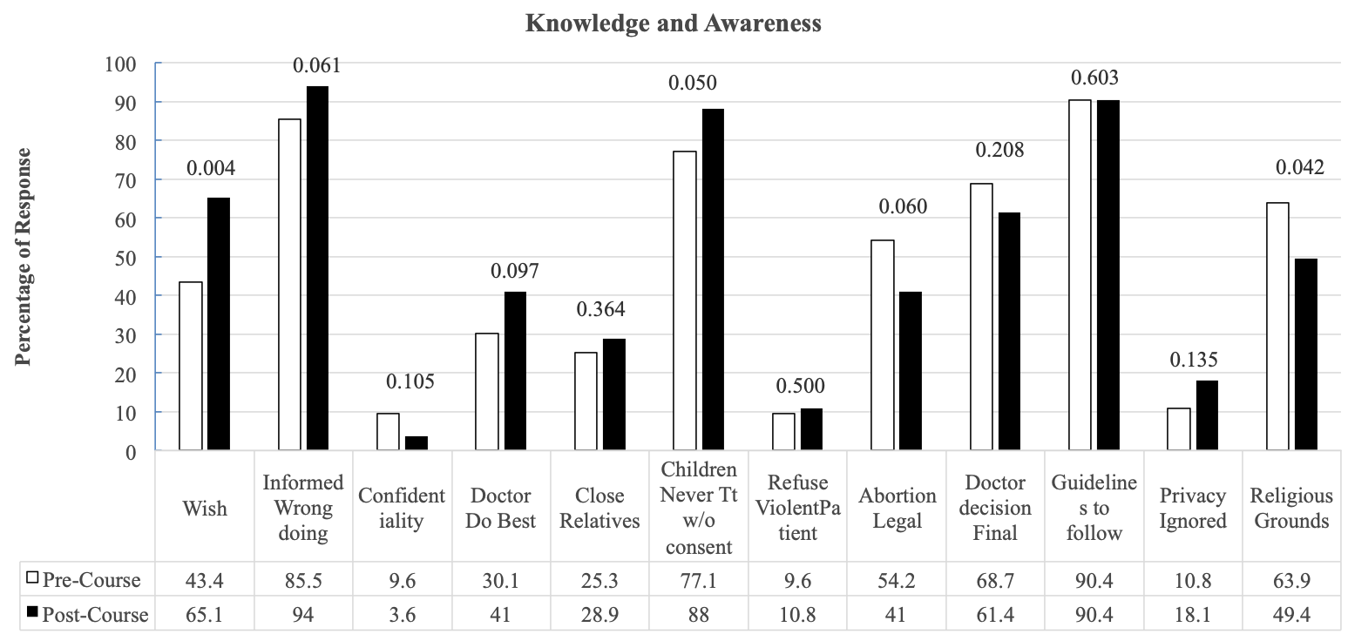

There was a significant increase in some of the items regarding the knowledge and awareness of Ethics (Figure 1). After the sessions, the students’ felt that patient’s wishes must always be adhere to (43.4 to 65.1%), children should not be treated without consent (77.1 to 88%). Pre-sessions, 63.9% believed that if the patient refuses to be treated on religious grounds, they should be instructed to find another doctor, however after the sessions the percentage of students who agreed with the statement significantly decreased to 49.4.

The response related to practice of ethics is depicted in Figure 2. In response to the item “Copying answers in degree examinations is bad/sin’, 65.1% students agreed before the sessions, however after the sessions, the percentage significantly increased to 78.3 %. Before the foundation course, only 51.8% of the students agreed to the statement “In your opinion do you think that doctors receiving income from referring patients for medical tests is unethical”, however after the course, the percentage of students agreeing to this item increased to 72.3%. After the sessions, the percentage of students who believed that doctors getting influenced by drug companies’ inducements, including gifts is unethical increased from 53% to 75.9%. A significant decrease was observed in the percentage of students (61.4 to 47%) who believed that “to prevent transmission of TB, disclosure of TB positive status to neighbors should be done”.

**Figure 2**

**Percentage of response (agree) in pre- and post-course assessment with regard to items on ethical practices. Values above the bars depicting each item are p-value for Fischer’s Exact test**

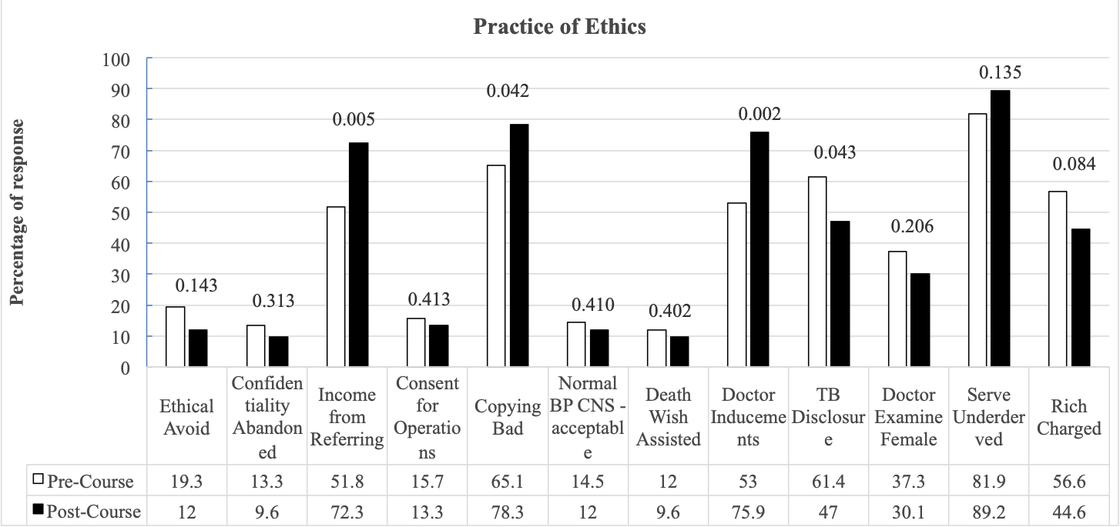

Figure 3 depicts the responses with regards to the importance of teaching medical ethics. The general interest in studying Ethics increased significantly after the course (69.9 to 84.3%). Pre-course, only 80.7% students found the topics related to Ethics in the new curriculum to be relevant, however after the sessions, this significantly increased to 94%.

**Figure 3**

**Percentage of response (agree) in pre- and post-course assessment with regard to items on ethical practices. Values above the bars depicting each item are p-value for Fischer’s Exact test**

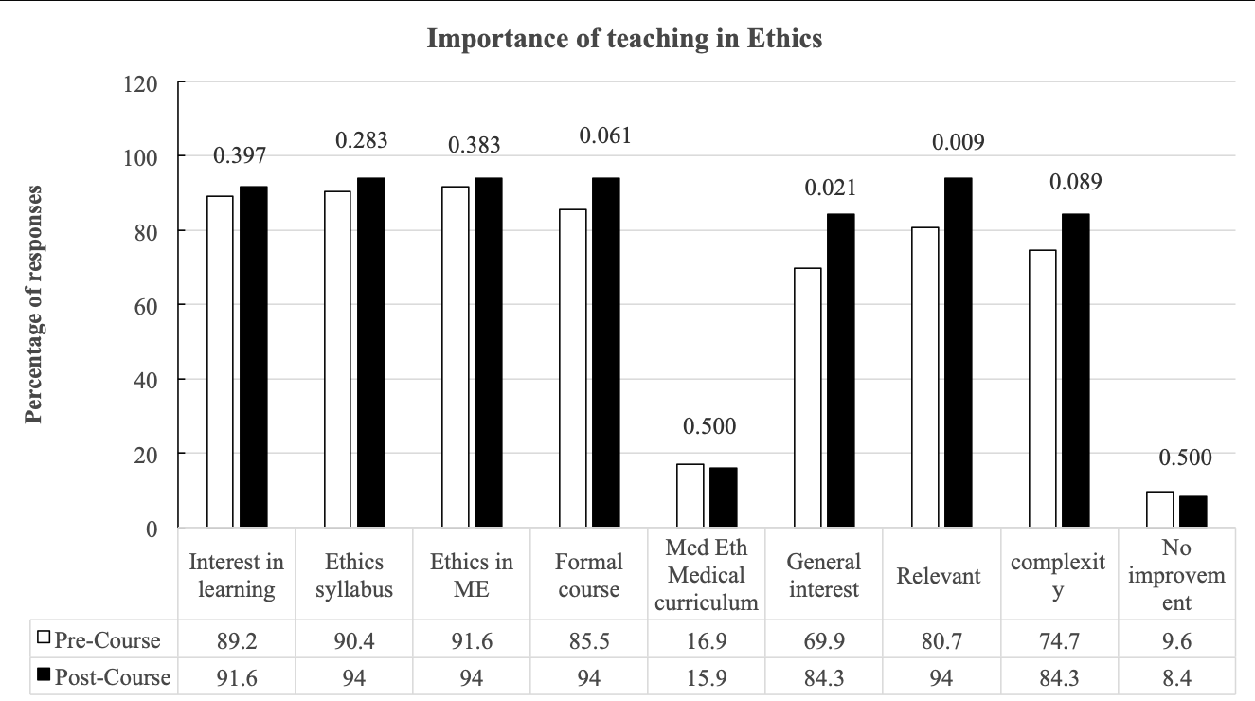

Almost all the students stated that the topics on Ethics covered during foundation course were helpful. The sources of knowledge of Ethics among the students before the sessions were newspaper and television. However, after the sessions, lectures notes were the primary source of ethics knowledge.

**Discussion**

Medical ethics is an essential component and an indispensable aspect of healthcare. With the changing times, the doctors are now coming across increased number of litigations against them, most of which are linked to ethical issues. In view of the current level of the distrust that has start off between the doctors and the patients and worsening of the doctor patient relationship, it has become important that doctors are professionally sound with all required competencies. It is expected that while the doctors are dealing with patients, their attendants, relatives, they practice ethical behavior with relevant competencies [8]. It is very crucial for the physicians to recognize the importance of being sensitive to ethical issues which they can face during clinical practice and develop in them the aptitude to effectively tackle ethical concerns [8]. The new medical undergraduates should understand and possess high personal & professional values, and also comprehend the ethical and legal issues they can face [9]. They need to provide care to their patients, respecting their autonomy and maintaining their self-esteem [10]. Therefore integration of medical ethics into the medical curriculum to provide opportunities for understanding, analysing ethical dilemmas, and guide students in making thoughtful ethical clinical decisions was considered important [11, 12].

The General Medical Council (GMC) United Kingdom, affirmed that medical ethics and law should constitute one of the essential components of medical curriculum [13]. The World Health Organization (1995) also suggested that medical ethics should be an essential part of medical education [12].

Evidence from literature demonstrates that many of the doctors when interviewed felt inadequately prepared for common ethical problems [14]. Study by Jacobson et al showed residents from internal medicine residency programs indicated an interest in expanded teaching about medical ethics [15]. Similarly, the present study showed that the students are in favor of integrating medical ethics within the medical curriculum. It has been also realized that formal teaching of medical ethics, however, continues to be limited by the lack of clearly defined goals for such teaching [14]. Nevertheless, teaching of medical ethics is a part of routine curriculum in many countries and the programs are running successfully since past many years, so as to endow medical students with the required knowledge, and understanding of the ethical challenges [16, 17].

Considering great need for the topic of medical ethics, recently in India a special Ethics module has been introduced in the undergraduate curriculum, with the educational objectives of primarily arousing interest, internalizing the concepts and understanding the applications of Ethics. The aim of the first stage of the module is to introduce ethics in the early phase medical of training, within a month of joining the medical graduation programme [7].

There are a limited number of studies on the effectiveness of teaching medical ethics in undergraduate medical education and there is no recognized single best model for delivering medical ethics education [18, 19]. Learning ethics in small groups is widely accepted and is practiced in some universities [20, 21, 22, 23, 24]. Taking this fact into consideration we used different teaching /learning methodologies for sensitization of the students to this topic.

Through these sessions, the students were sensitized to the ethical principles and consequences of unethical practices. In the present study before the sessions 43.4 % agreed with the statement that “Patient`s wish must always be adhered”, this shows a lack of knowledge of the basic principle of medical ethics (patient’s autonomy should be respected). Although the percentage increased significantly to 65% post sessions but still nearly one third of the students were not able to comprehend the concept of autonomy clearly.

Ethics education must, in addition, to the traditional values seek to nurture present-day cultural sensibilities in medical students [25]. Walround et al found that students had uncertainties on how to deal with religious differences in treating patients, on the information to be given to relatives, and how violent patients should be treated [26].

Results showed that before the course, more than half (63.9%) of the students agreed with the statement “Patients, who refuse to be treated on religious or other grounds should be told to find another doctor or accept the treatment offered”, the percentage decreased (49.4%) after the sessions which is a positive sign. Similarly, Chatterjee and Sarkar reported that 55.9% of the medical students agreed that they will refer the patient to another doctor for religious conflict situations [27].

The results of the present study showed before the course, only 25.3 % of students wanted that “Close relatives should always be told about patient condition”, after the course, the percentage increased to 28.9%. Contrary to this Chatterjee and Sarkar found that 86% of the students would tell the truth to the “close relatives” [27]. Singh et al reported 68.2 % of consultants and majority (80.8%) of the residents agreed with the statement that “Close relatives should always be told about patient condition” [5]. Brogen et al also showed that majority 82.9 %, 89.4% of junior doctors and faculty respectively were in favor of the above statement [28].

In the present study, pre-course, 9.6% of the students were in favor of the statement that “Doctors and nurses should refuse to treat a violent patient”, the percentage increased to 10.8% after the sessions. Chatterjee and Sarkar found 21.7% of the students were of the opinion to refuse violent patients [27]. Hariharan et al found 7% of the physicians were in favor to refuse violent patients [29]. Brogen et al found 28.7% of junior doctors were more likely to be in favour of not negotiating with, or treating, uncooperative patients [28]. Singh et al also reported 16.4% of the senior resident and 11.4% of the consultants were in favor of the above statement [5]. The evidence from literature shows a trend towards more of junior doctors in favor of refusing violent patients as compared to the consultants.

In the present study, pre-session 10.8% of the students agreed with the statement that “Privacy of one patient may be ignored for the benefit of the larger group”, the percentage of students agreeing increased to 18.1% after the sessions. In contrast to this, Chatterjee and Sarkar reported that around half of the students (55.9%) agreed with the above statement [27]. Reason for this could not be explained as the response to this statement is very subjective, varying with the prevailing condition or situation.

Around 19% students believed that ethical aspect is important only to avoid legal action, however this decreased after the sessions. While Chatterjee and Sarkar found that 37.8% of the students agreed to the above statement [27]. Singh et al reported 20.5% of the residents and 11.5% of the consultants agreed with the above statement [5].

Integrity is a necessary attribute of medical profession. Evidence from literature shows that students showing academic dishonesty during student days are more likely to indulge in unethical practices later on [30]. It is also documented that explaining to students what is acceptable behavior is an important step when trying to reduce dishonesty [31, 32]. In the present study, pre-sessions 65.1% students agreed with the question that copying answers in degree examinations is bad/sin. However, their response changed significantly after the session and more students now believed that engaging in dishonest behavior is bad.

It was upright to observe that 85.5% of the students disagreed with the statement “Writing nervous system examination as normal or BP as normal when it is not done is acceptable”. The numbered increased further to 88% after the session. Eighty eight percent students before the sessions disagreed with the opinion that physicians must aid patients who wish to die, regardless of the illness, which further increased to 90.4% after the session. Similarly, Chatterjee and Sarkar found 64% of the students disagreed to the suggestion of euthanasia [27].

The present study showed that not only there was an increase in the knowledge level of the students but also in a change in their attitude after nominal teaching. Similarly, Ypinazar and Margolis study also demonstrated that first year students were able to identify medical ethical issues in a clinical setting after minimal instruction [33]. Study by self and collegues found a significant increase in the level of moral reasoning of the students exposed to the medical ethics course regardless of the format of teaching (lectures, case discussions) [34]. Similar to this other studies from India have also shown increase in knowledge of students after training [35].

Students recognized the importance of teaching ethics and were passionate to bring about a change in their behavior towards patients. Literature reveals that the teaching of ethical principles and professional codes are welcomed by both teachers and students [36]. Indian studies also showed that students and faculty recognize the importance of medical ethics in their professional life [27, 35].

**Limitations**

The limitation of the present study is the brief nature of the introductory session, and the fact that students are still inexperienced (as they were exposed at the very beginning of their medical training). Hence, for improving the performance and effectiveness of programme, continuing education with reinforcement is recommended.

**Conclusion**

Need of the hour is to give attention to the important issue of teaching of medical ethics early within the undergraduate curriculum and its reinforcement throughout the MBBS course. There should be a continuum between practice and education. In India now, teaching medical ethics has been formally included within the medical curriculum. Doctors must recognize situations as an ethical dilemma, possess the relevant knowledge of norms, laws and policies at an impressionable age so that it become easy for them to handle more complex issues later during their clinical practice. Ethics should become a way of thinking, we should expand our horizons a bit beyond our own cultures and at least listen to other voices and try to cultivate these values in our students.

**Acknowledgement:** None

**Conflict of interest:** The authors declare no conflict of interest

References

1. Iswarya S, Bhuvaneshwari S. Knowledge and attitude related to medical ethics among medical students. International Journal Of Community Medicine And Public Health 2018;5(6):2222-2225.

2. Chopra M, Bharadwaj A, Mitha P, Sign A, Siddiqui A, Rajesh PR. Currnt status of knowledge, attitude and practices towards healthcare ethics among doctors and nurses from north India-A multicentre study. JKIMSU. 2013;2:102-7

3. Adhikari S, Paudel K, Aro AR, Adhikari TB, Adhikari B, Mishra SR. Knowledge, attitude and practice of healthcare ethics among resident doctors and ward nurses from a resource poor setting, Nepal. BMC Medical Ethics. 2016;17(1):68.

4. Summers J, Morrison E. Principles of healthcare ethics. Health Care Ethics. 2nd ed. Sudbury: Jones and Bartlett Publishers; 2009. p. 41–58.

5. Singh S, Sharma PK, Bhandari B, Kaur R. Knowledge, awareness and practice of ethics among doctors in tertiary care hospital. Indian Journal of Pharmacology 2016;48:S89-93.

6. Jatana S K, Soe H H K, Phyu K L, Lwin H, Than N N. A Survey on Knowledge and Attitudes towards Medical Ethics among Undergraduate Medical Students. Education 2018, 8(3): 48-53.

7. Medical Council of India. Foundation Course for the Undergraduate Medical Education Program, 2019: pp 1-46.

8. World Health Organization, Regional Office for South-East Asia. (‎2009)‎. Module for teaching medical ethics to undergraduates. WHO Regional Office for South-East Asia. <https://apps.who.int/iris/handle/10665/205534>

9. General Medical Council. 2009. Tomorrow's doctors: outcomes and standards for undergraduate medical education. London: General Medical Council.

10. Stirrat GM, Johnston C, Gillon R, & Boyd K. Medical ethics and law for doctors of tomorrow: the 1998 Consensus Statement updated. Journal of Medical Ethics 2010; 36:55–60.

11 Beigy M, Pishgahi G, Moghaddas F, Maghbouli N, Shirbache K, Asghari F & Abolfat-h Zadeh N.. Students' medical ethics rounds: a combinatorial program for medical ethics education. Journal of Medical Ethics and History of Medicine 2016, 9:3.

12. Henderson H, Ballard I, Alsuwaidi L, Thomas R, Ezimokhai M. Simulation: Teaching Medical Ethics to First Year Medical Students within the United Arab Emirates MedEdPublish Available from https://doi.org/10.15694/mep.2018.0000016.1.

13. General Medical Council. 2015. Outcomes for Graduates. London: General Medical Council.

14. Forrow L, Arnold RM, Frader J. Teaching clinical ethics in the residency years: preparing competent professionals. The Journal of Medicine and Philosophy 1991;16:93-112.

15. Jacobson JA, Tolle SW, Stocking C, Siegler M. 'Internal medicine residents' preferences regarding medical ethics education'. Academic Medicine 1989; 64: 760-764

16. Ali I. Al-Haqwi and Ali M. Al-Shehri. Medical students’ evaluation of their exposure to the teaching of ethics. J Family Community Med 2010; 17: 41-5.

17. Moodley K. Teaching medical ethics to undergraduate students in postapartheid South Africa. 2003–2006. J Med Ethics 2007; 33: 673–677.

18. De La Garza S, Phuoc V, Throneberry S, Blumenthal-Barby J, McCullough L & Coverdale J. Teaching Medical Ethics in Graduate and Undergraduate Medical Education: A Systematic Review of Effectiveness. Acad. Psychiatry 2017 ;41:520-525. doi: 10.1007/s40596-016-0608-x

19. Eckles RE, Meslin EM, Gaffney M & Helft PR. Medical Ethics Education: Where Are We? Where Should We Be Going? A Review. Acad. Med 2005; 80: 1143-1152.

20. Claudot F, Alla F, Ducrocq X, et al. Teaching ethics in Europe. J Med Ethics 2007; 33(8): 491–5.

21. Mattick K, Bligh J. Teaching and assessing medical ethics: where are we now? J Med Ethics 2006; 32(3): 181–5.

22. Roff S, Preece P. Helping medical students to find their moral compasses: ethics teaching for second and third year undergraduates. J Med Ethics 2004; 30(5): 487–9.

23. Wrage S. Teaching ethics at a military academy. Int Stud Perspect 2012; 13: 21-5.

24. Kolb JA, Lin H, Frisque DA. Teaching ethics in a multicultural classroom. Teaching Ethics 2005; 5(2): 13-30.

25. Voo TC, Braddock III CH, Chin J, Ho A..Ethics and attitudes in: Dent J, Harden RM, Hunt D, (Eds). A Practical Guide for Teachers. China: Elsevier Ltd, 2017; p. 195-202.

26. Walrond ER, Jonnalagadda R, Hariharan S and Moseley HSL. Knowledge, Attitudes and Practice of Medical Students at the Cave Hill Campus in relation to ethics and law in healthcare. West Indian Med J 2006; 55(1): 42-47.

27. Chatterjee B and Sarkar J. Awareness of medical ethics among undergraduates in a West Bengal medical college. Indian Journal of Medical Ethics 2012; 9(2): 93-100.

28. Brogen SA , Rajkumari B, Laishram J, Joy A. Knowledge and attitudes of doctors on medical ethics in a teaching hospital,Manipur. Indian Journal of Medical Ethics 2009; 6: 194-197.

29. Hariharan S, Jonnalagadda R, Walrond E, Moseley H. Knowledge, attitudes and practice of healthcare ethics and law among doctors and nurses in Barbados. BMC Medical Ethics 2006, 7:7

30. Gitanjali B Academic dishonesty in Indian medical colleges. J Postgrad Med 2004;50:281-4

31. Baldwin DC , Daugherty SR, Rowley BD, Schwarz MD. Cheating in medical school: a survey of second­year students at 31 schools. Acad Med 1996;71:267­73.

32. Wagner RF. Medical student academic misconduct: implications of recent case law and possible institutional responses. Acad Med 1993;68:887­9.

33. Ypinazar V A, Margolis SA. Western medical ethics taught to junior medical students can cross cultural and linguistic boundaries. BMC Medical Ethics 2004, 5:4 doi:10.1186/1472-6939-5-4

34. Self D J, Wolinsky F D & Baldwin D C. (). The effect of teaching medical ethics on medical students' moral reasoning. Acad Med 1989; 64: 755–759. https://doi.org/10.1097/00001888-198912000-00014

35. Kaur G, Singh J, Bhutani K, Delmotra N J, Goyal A. Development of Module on Medical Ethics in Patient Care to MBBS Students. Int J Med Res Prof.2019 Mar; 5(2); 22-27.

36. Ercan Avci Learning from experiences to determine quality in ethics education. International Journal of Ethics Education 2017; 2:3–16