COVER LETTER

Dear Editor,  
This is to confirm that the article entitled “Relationship between Professional Ethics and Spiritual Wellbeing in Iranian Nurses” submitted to the Indian Journal ofMedical Ethics is original and has been co-authored by the undersigned. All authors have  
participated in the work sufficiently to meet the ICMJE guidelines for authorship. All  
have read and approved the manuscript.  
The submission is not under consideration for publication in any other journal.  
We give consent to Dr Efat Sadeghian to act as the author for correspondence.  
Details of sponsorship or relevant competing interests, financial or otherwise: --------------  
We have read the terms and conditions of authorship of IJME and accept them.  
Contact details (mailing address, email id) and affiliation of all authors:

Yousef Yazdandoust : MSc of Psychiatric nursing, Department of Nursing and Midwifery, Hamadan University of Medical Sciences, Hamadan, Iran, [yosef.yasna1362@gmail.com](mailto:yosef.yasna1362@gmail.com)

Farshid Shamsaei :Associate Professor, Behavioural Disorders and Substance Abuse Research Centre, Hamadan University of Medical sciences, Hamadan, Iran, [shamsaei68@yahoo.com](mailto:shamsaei68@yahoo.com)

Lilei Tapak: Assistant Professor, Department of Biostatistics, School of Public Health Sciences Research Center ,Hamadan University of Medical Sciences, Hamadan, Iran. [l.tapak@umsha.ac.ir](mailto:l.tapak@umsha.ac.ir)

Efat Sadeghian: Assistant Professor, Chronic Diseases (Home Care) Research Centre, Hamadan University of Medical Sciences, Hamadan, Iran, [sadeghianefat@gmail.com](mailto:sadeghianefat@gmail.com)  
Signatures of all authors:

Efat sadeghian : 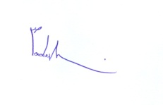

Yousef Yazdandoust, 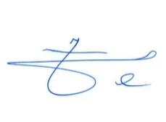

Farshid Shamsaei 

Lilei Tapak 