Biases of the peer review in the debate about the safety and efficacy of CQ/HCQ for Covid19 infection

**Alberto Boretti 1,\***

1Prince Mohammad Bin Fahd University, ‎Al-Khobar 31952, Saudi Arabia

*Email: [a.a.boretti@gmail.com](mailto:a.a.boretti@gmail.com)

**Abstract**

In late May 2020, The Lancet published a work claiming CQ/HCQ was unsafe and not efficient for Covid19 infection. Despite this work was immediately used by the World Health Organization to call for a ban of the specific use of CQ/HCQ, the work was openly flawed. Additionally, it was based on an unrealistic dataset that was unavailable for review. The scientific community highlighted these issues, and the paper was eventually withdrawn after the author failed to provide data to permit an independent assessment of the claims. To date, no comment has been published highlighting the flaws of the study. This occurrence, and other similar, cast doubts about the rigor of the peer review of works covering sensitive subjects that are welcomed or unwelcomed by global governance and mainstream media.

**Keywords:** Ethics in publishing; biases of the peer review; political and economic interference in science

**Biases in the peer-review process of works dealing with CQ/HCQ**

The recent retrospective study [1], published May 22, 2020, immediately employed to call for an end to the use of CQ/HCQ for Covid19 infection by the World Health Organization [2], was openly flawed. If the data could have been reliable, nevertheless the conclusions will not have been warranted.

This retrospective study was only an examination of carefully selected registries, in the vast majority from selected hospitals in the United States of America (66% of total). For completely unclear reasons, somewhere patients were given one specific option in one specific hospital in one specific state or one specific country. Which were the reasons that guided the choice of the selected hospitals and patients were not known.

This was not a double-blinded, placebo new study where patients were randomly given the option to use CQ, CQ+ macrolide, HCQ, HCQ+macrolide, or placebo, as claimed necessary to evaluate safety and efficacy of CQ/HCQ use for Covid19 infection. This was a selection of registry.

This study only considered severe cases, and not prophylaxis or mild/medium cases, that are otherwise the best opportunities offered by CQ/HCQ. This paper should not have impacted on the other uses, as the use of CQ/HCQ on mild/medium cases or prophylaxis was not covered.

While parameters under CQ/HCQ administration (for example zinc or vitamin C or D) must be controlled, there was no mention these parameters were monitored and controlled. CQ/HCQ should be used “giving no contraindication applies” and are suggested not to be used simultaneously with other medications There was no mention these guidelines were followed.

Finally, the main author was reporting personal fees from pharmaceutical companies and the database was claimed to be funded by a corporation, with the opportunity of conflict of interest impact judgment. In our opinion, people having a conflict of interest should be prevented from taking a position on a subject in which they may have vested interests and reap profit or gain power from one outcome vs. the other.

Most importantly, there were also doubts about the reliability of the data [3], [4]. For example, no Australian health official confirmed the sharing of Covid19 data with a tiny corporation that is claimed to have collected and analyzed the huge amount of data [4]. How this company could have collected and analyzed all these tens of thousands of patient records from hundreds of hospitals worldwide was unclear. Data and code were not made available upon submission.

Many independent researchers immediately wrote to the Lancet raising the flag about this work. I was one of them, and my comment was rejected many weeks after the paper was retracted following public outcry in the general press. This paper was retracted because the company that purportedly analyzed the raw data won’t allow their validity to be independently validated [5]. Possibly because this unrealistic data set does not exist.

None of the many comments submitted to The Lancet got published. Opposite, one minor flaw was commented by the editors [6] on May 30, 2020. Then the editors published an expression of concern [7] on June 3, 2020. Finally, 3 of the 4 authors published a retraction on June 5, 2020 [8]. Since then, the original paper only reports the “retracted” word in front of the title, and the word retracted across the text.

Not my comment, nor the comments by others got published. The paper [1] has been cited so far 424 times (Google scholar), with most of the citations neglecting the fact the work was flawed and it has been withdrawn.

The failure to address the major flaws during the peer review, and also the similarly improper post-publication review of the work, namely the commenting and citation processes, casts serious doubt about the reliability of the peer review process strangled by the conflict of interest.

Much different treatment is now reserved for late works supporting the use of CQ/HCQ for Covid19 infection. For example, the review paper [9] was proposing an objective review of papers in favor or again the use of CQ/HCQ for Covid19 infection, also mentioning the conflict of interest issue, and concluding CQ/HCQ were very likely helpful in some circumstances, and opposite even negative in others, very well established in the literature. The acceptance communicated July 17, 2020, was then transformed in rejection on the way to production by July 27, 2020, likely because of the politically incorrect conclusion as well as the mention of the evident conflict of interest biasing the assessment.

As soon as the claims of the work [1] were demystified, immediately the preliminary results of the RECOVERY trials were proposed to the mainstream media to permit enforcement of the ban by the WHO [10]. In this case, the RECOVERY (Randomised Evaluation of COVid-19 thERapY) was suggesting higher fatalities for those treated with CQ/HCQ, however the result of using much higher than reasonable doses for those not intended to receive these doses [10], demonstrating absolutely nothing against the proper uses of CQ/HCQ.

As the University that supported the RECOVERY trials is also deeply involved into the development of a Covid19 vaccine, and similarly supportive of a Covid19 vaccine is the “charity” that is the first and foremost supporter of the WHO, directly and indirectly through the GAVI vaccine alliance, with the present director-general of the WHO a former board director of GAVI, it is clear as the improper peer review of [1] is only part of an unacceptable political and economic interference in the science of the Covid19 pandemic.

As a matter of fact, there are now 53 studies published in the literature that show positive results of the use of CQ/HCQ in Covid19 infection, especially mild to medium severity cases and prophylaxis. Then, there are 14 studies that show neutral or negative results. 10 of these 14 refer to patients in the late stage of Covid-19 infection, where there CQ/HCQ same of every other known antiviral is not supposed to do that much. The remaining 4 papers suffer of major flaws, including papers that should have been retracted, or papers that have been retracted such as the work [1]. Without interference by mainstream media, the verdict could only be that CQ/HCQ are very likely helpful in Covid19 infection when properly used.

If corruption in global health is the open secret [11], the use of Covid19 for political and economic reasons especially in the United Kingdom, the European Union and the United States is a not less evident issue of potentially devastating consequences through containment measures exceeding the damage of the viral infection itself.

Covid19 had so far a much higher number of fatalities in the supposed to be more advanced countries, believed to enjoy a better health system, for example, the United Kingdom, Belgium or the United States, than in poorer countries, for example, Africa, Figure 1. Belgium has been the country with the world's largest fatality, at 850 per million. New York is the megacity with the largest fatality, at 2,500 per million [12]. In the United States, states with a democrat as the governor have almost double the fatality rate of states with a republican as governor [12]. These are clear indications the Covid19 is being used to serve other agendas. A properly working peer review, that must be independent of political and economic powers to be trustworthy, is needed more than ever before in the world of globalism. The mainstream media should report, not decide, of matters of science.

**Conflict of interest**

The author received no funding and has no conflict of interest to declare.

**Authors contribution**

Single author manuscript.

**References**

[1]  [Mehra, M.R., Desai, S.S., Ruschitzka, F. and Patel, A.N., (2020). Hydroxychloroquine or chloroquine with or without a macrolide for treatment of COVID-19: a multinational registry analysis,](https://www.thelancet.com/lancet/article/s0140673620311806) The Lancet*;* DOI: 10.1016/S0140-6736(20)31180-6.

[2] RT.com, (2020). WHO SUSPENDS trials of Trump-chosen hydroxychloroquine drug over SAFETY RISKS for Covid-19 patients. [www.rt.com/news/489724-who-drops-hydroxychloroquine-risks/](https://www.rt.com/news/489724-who-drops-hydroxychloroquine-risks/)

[3] The Guardian, (2020). Surgisphere: governments and WHO changed Covid-19 policy based on suspect data from tiny US company. [www.theguardian.com/world/2020/jun/03/covid-19-surgisphere-who-world-health-organization-hydroxychloroquine](http://www.theguardian.com/world/2020/jun/03/covid-19-surgisphere-who-world-health-organization-hydroxychloroquine)

[4] Medicine (UN) censored, (2020). A Study Out of Thin Air. [www.medicineuncensored.com/a-study-out-of-thin-air](http://www.medicineuncensored.com/a-study-out-of-thin-air)

[5] Piller, C., and Servick, K., 2020. Two elite medical journals retract coronavirus papers over data integrity questions. [www.sciencemag.org/news/2020/06/two-elite-medical-journals-retract-coronavirus-papers-over-data-integrity-questions](http://www.sciencemag.org/news/2020/06/two-elite-medical-journals-retract-coronavirus-papers-over-data-integrity-questions)

[6] Department of Error, 2020. Department of Error. doi.org/10.1016/S0140-6736(20)31249-6

[7] The Lancet Editors, Expression of concern: Hydroxychloroquine or chloroquine with or without a macrolide for treatment of COVID-19: a multinational registry analysis. The Lancet, Vol. 395, No. 10240, e102

[8] Mehra, M.R., Ruschitzka, F, and Patel, A.N., 2020. Retraction—Hydroxychloroquine or chloroquine with or without a macrolide for treatment of COVID-19: a multinational registry analysis. The Lancet, Vol. 395, No. 10240, p1820

[9] by Albert, 2020. Inconvenient Covid19 works are censored in the scientific peer review. WHO knows why? qualityassuranceofclimatestudies.wordpress.com/2020/08/01/inconvenient-covid19-works-are-censored-in-the-scientific-peer-review-who-knows-why/

[10] Fordham, E. (2020). The Marx Brothers do science. conservativewoman.co.uk/the-marx-brothers-do-science/

[11] García, P.J., 2019. Corruption in global health: the open secret. *The Lancet*, 394(10214), pp.2119-2124.

[12] by Albert, 2020. Data of Covid19 fatalities for the US – 530 per million in states with a democratic governor and 289 per million in states with a republican governor. qualityassuranceofclimatestudies.wordpress.com/2020/08/03/data-of-covid19-fatalities-for-the-us-530-per-million-in-states-with-a-democratic-governor-and-289-per-million-in-states-with-a-republican-governor/

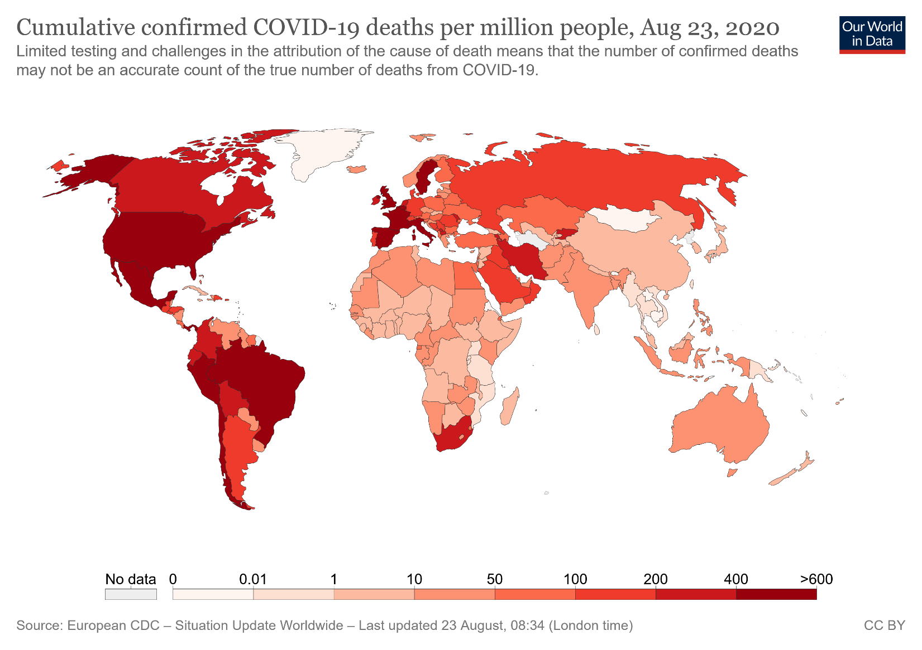

Figure 1 – Covid19 fatality per million across the world.