**Safeguarding the frontier Covidians during the Covid-19 pandemic: Scuffles and proposed strategies**

*Vijay VR*, Nadiya Krishnan, Alwin Issac, Jaison Jacob, Shine Stephen, Rakesh VR, Harmeet Kaur Kang, Manju Dhandapani*

1. **Vijay VR\*** (Corresponding author)

College of Nursing,

All India Institute of Medical Sciences, Bhubaneswar, India

(An Institute of National importance under Ministry of Health and Family Welfare, India)

[vijayvrpgi@gmail.com](mailto:vijayvrpgi@gmail.com)

1. **Nadiya Krishnan**

College of Nursing,

All India Institute of Medical Sciences, Bhubaneswar, India

1. **Alwin Issac**

College of Nursing,

All India Institute of Medical Sciences, Bhubaneswar, India

1. **Jaison Jacob**

College of Nursing,

All India Institute of Medical Sciences, Bhubaneswar, India

1. **Shine Stephen**

College of Nursing,

All India Institute of Medical Sciences, Bhubaneswar, India

1. **Rakesh VR**

College of Nursing,

All India Institute of Medical Sciences, Bhubaneswar, India

1. **Harmeet Kaur Kang**

Chitkara School of Health Sciences

Chitkara University, Punjab, India

1. **Manju Dhandapani**

Post Graduate Institute of Medical Education & Research, Chandigarh, India

**Funding sources: None**

**Abstract**

The outrageous consequences of COVID-19 had brought the nastiest state of affairs for the entire world, and now India is alarmingly crippling in the midst of the pandemic crisis. The health care professionals (HCPs) in the country endures multiple stressors and swift psychosocial turmoil during this ongoing battle due to changing working environments, physical and psychological grievances, unattended concerns, and undue job demands by the disease outbreak, where they carry the expectations of nearly 1.36 billion people. This article analyses the challenges and menaces faced by the HCPs during the fight against COVID-19 in India. We also propose a model to portray the threats faced by HCPs during COVID and the action strategies required to deal with it. The model emphasizes a delicate interplay between various factors that determine the efficiency of a HCP in COVID times. It would be a complex task for these COVID warriors to outweigh a handful of perceived threats inherent in the pandemic to succeed through the strategic network that demands collective sustained actions from governmental, societal, institutional, and individual levels. History has proved that mankind is capable of amazing resilience and health care is not an exception.

**Keywords:** Covid-19, Coronavirus, Pandemics, challenges, safeguarding, health care professionals

**Introduction**

As of July 31, the tally of COVID-19 cases in India has crossed 1.5 million of which 35,747 people succumbed to infection. (1) The burden of multiple stressors ranging from a shortage of personal protective equipments (PPEs) to unattended concerns and undue work demands coupled with pessimistic public attitudes of social stigma, physical attacks instigate lasting moral injury on health care professionals (HCPs). (2), (3). Governmental and institutional strategies to address psychosocial wellbeing and mitigate these negative gestures from society are suboptimal in our country with diverse socio-cultural and regional disparities. Here the authors have thoroughly searched the literature and official websites to shed light on various problems faced by HCPs during this pandemic and put forward a strategic model to overcome these tussles.

**The unprecedented facets of threats**

India's COVID-19 workforce is battling the disease in the middle of diverse threats. With a humongous population of 1.36 billion, every doctor and nurse in India caters to 1,457 and 483 people respectively and the estimated shortage is of around 600,000 doctors and 2 million nurses. (4) (5)The scarcity of workforce and COVID-19 pandemic has put undue pressure on HCPs. In addition to the Coronavirus, HCPs in India are fighting another insidious threat-Stigma. The incidents of eviction, ostracism, and mental harassment on HCPs are repeatedly reported. (6) Fearing HCPs as vectors of the novel Coronavirus, there have been incidents of mob attack, rape threats, verbal spat, and exhibitionism towards them. Despite risking their lives to tame the virus, they are hurled with stones, evicted from rented apartments, and stranded on the roads with nowhere to go. (7) The petrifying phenomenon is that now health professionals have been perceived as "an impending risk, as opposed to being a solution" to COVID-19.

Health care professionals are at high risk of having a moral injury and mental health problems when dealing with challenges of the COVID-19 pandemic. (8) Owing to the immense challenge of caring for patients amidst critical circumstances, the HCPs are exposed to burnout, mental trauma, and depression. Hectic working hours, lack of protective gears along with seclusion from the family has emerged as the major factors contributing towards disturbed mental health. (8)

**Good Samaritan strategies for health care professionals (Fig: 1)**

An overburdened and crumbled healthcare system cannot manage an expanding pandemic if HCPs fall sick or surrender to moral injury. We propose a model to depict the threats to HCPs during COVID and the strategies to deal with it. The model emphasizes a delicate interplay between various factors that determine the efficiency of a HCP in COVID times. The HCPs must get gratification and the feel of attachment from their work. Similarly, they must feel safe and secure and socially respected. Their morality and self-esteem should be high for good efficient work performance.

The model further depicts the factors threatening the efficiency of HCP (Left wheel-Fig: 1). The threats can be broadly grouped as physical, psychological, social, and environmental. Physical stressors like excessive physical exertion due to long working hours in PPE, working in severe staff constraints due to staff leave or huge patient load, physical attacks from patients, patient relatives, and public, lack of adequate rest and sleep, etc drain the energy out of the HCPs and cause bodily damage to the worker. Psychological threats include existing low morale, stress, and anxiety induced by sub-optimal working conditions and the fear of infecting self or family and community. The arduous task of triaging and ensuring equitable distribution of care to all the deserving patients is very stress-inducing, as it may come in direct conflict with ethical, moral, and religious principles of HCPs. Long working hours and separation from loved ones can induce further stress and contribute to burnout syndromes in people. Added to this are social factors like the stigma faced by the very society they chose to serve. The evictions and stone-pelting and the media coverage associated with these events and the mounting number of HCPs infected induce a state of being ostracized leading to a lack of self-esteem. Disrupted family time and stress-induced family conflicts also add to the stress. Among the environmental factors, poor working conditions with huge patient overload and lack of supplies and unsafe conditions exaggerate an already strained HCP. The rampant loss of livelihood among non- health sectors and the threat faced by many even in healthcare sectors of loss of job put an impact on the HCPs.

Coming to strategies to compact the threats, there can be a four-pronged approach. At the governmental level, the prime focus should be on enacting, implementing, and putting in place a system that has zero tolerance on the attack against the health care workforce. Also, it is in the government's capacity to ensure a smooth supply of equipment and well-validated clear protocols to be followed to ensure transparency. These can be done by increasing investments in the health care sector and contingency funding. Incentivizing and insuring HCPs can boost morale and zeal in the workforce.

Society has a pivotal role to play by being responsible and vigilant to the rules and regulations and by being empathetic to the HCPs. There should be mutual trust and confidence-building measures to elicit cooperation and respect towards the HCPs. Institutions have impactful roles in providing job security and staff protection by ensuring optimal working conditions and making working environment as flexible as possible by diverting priority attention and resources to COVID care though not compromising attention to other emergent cases. Proper staff training, good communication to the ground level workers from the management, and ensuring adequate supplies and facilities can make staff in an institution feel part of the system and ensuring the change management demanded by COVID times.

On top of all these, a testing time like the present epidemic calls for a lot of effort at the personal level on the HCPs. These may include stress adaptation and change management strategies, openness to learn and contribute, and a high state of accountability and responsibility by HCPs. They must take it as a challenge and their moral duty to contribute to the society to take up this call for action. It will require a lot of personal preparedness to face the task in terms of making themselves physically and emotionally strong to deal with the patient surge. It will require moving out of their routines and comfort zones and moving into an unknown, uncertain realm. They will have to endure a lot of change in long-held beliefs and systems and adapt to the situation at hand.

**Conclusion**

These are testing times and the smooth passing of this time requires great sacrifices and strategies. But time and again history has proved that mankind is capable of amazing resilience and health care is not an exception to it, albeit with support from the governmental, institutional, and societal systems. None of the strategies can exist in isolation; each one must turn to be the 'Cape of Good Hope' through collaboration by giving priority to society. Such intersectoral and collaborative strategies can yield fruitful results and may facilitate a hassle-free system where HCPs can work with pride and safety.

**Acknowledgment**

The authors would like to express sincere gratitude to all health care professionals who are involved in caring for COVID patients.

**Funding:** None

**Authorship contribution**

Conceptualization: VVR, NK. Data curation: AI, SS. Funding acquisition: None. Visualization: JJ. Writing original draft: VVR, NK, AI, SS, RVR. Writing- review& editing: HKK, MD. All authors agreed with the final content.

**Competing interests**

The authors declare no conflicts of interest

**References**

1. MoHFW | Home [Internet]. [cited 2020 Apr 22]. Available from: https://www.mohfw.gov.in/

2. DelhiMarch 31 RN, March 31 2020UPDATED:, Ist 2020 16:29. Coronavirus in India: Lack of equipment forces doctors to fight Covid-19 with raincoats, helmets [Internet]. India Today. [cited 2020 Apr 22]. Available from: https://www.indiatoday.in/india/story/coronavirus-in-india-doctors-face-equipment-shotages-1661773-2020-03-31

3. Lancet T. COVID-19: protecting health-care workers. The Lancet. 2020 Mar 21;395(10228):922.

4. WHO | Wanted: 2.4 million nurses, and that’s just in India [Internet]. WHO. World Health Organization; [cited 2020 Apr 30]. Available from: http://www9.who.int/bulletin/volumes/88/5/10-020510/en/

5. Metamorphosis of nursing profession: an Indian perspective [Internet]. [cited 2020 Apr 29]. Available from: https://www.ncbi.nlm.nih.gov/pmc/articles/PMC6858989/

6. Covid-19: Health minister says “deeply anguished” at reports of doctors facing eviction from landlords | India News - Times of India [Internet]. [cited 2020 Jul 29]. Available from: https://timesofindia.indiatimes.com/india/covid-19-health-minister-says-deeply-anguished-at-reports-of-doctors-facing-eviction-from-landlords/articleshow/74797873.cms

7. Ravi R. Abused, Attacked, Beaten: Frontline Workers Are Risking Their Lives Everyday In India [Internet]. 2020 [cited 2020 Jul 29]. Available from: https://thelogicalindian.com/news/covid-19-healthcare-workers-attacked-20665

8. Greenberg N, Docherty M, Gnanapragasam S, Wessely S. Managing mental health challenges faced by healthcare workers during covid-19 pandemic. BMJ [Internet]. 2020 Mar 26 [cited 2020 Apr 22];368. Available from: https://www.bmj.com/content/368/bmj.m1211

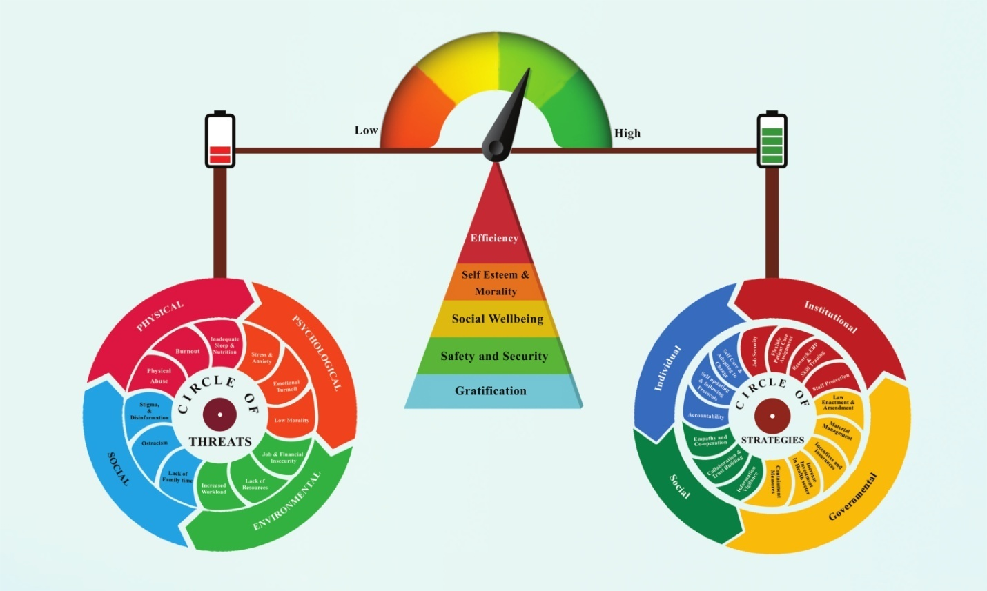

**Fig 1: Strategic model for health care professionals**