**Table 1 lesson plan FC 4.5.1, 4.5.2 AND 4.5.4**

|  |  |
| --- | --- |
| Competency -Indian medical graduate [IMG] role  Description of competency | FC 4.5.1- [Clinician]  Describe disability as per United Nations Convention on the Rights of Persons with Disabilities while demonstrating respect for the differences and capacities of persons with disabilities as part of human diversity and humanity.  FC 4.5.2-[Clinician]  Compare and contrast medical and social model of disability.  FC 4.5.4- [lifelong learner]  Demonstrate awareness of the disabilities included in the Rights of Persons with Disabilities Act,2016 |
| Domain, level | K [knows/cognitive], KH [knows how of Miller’s pyramid] |
| Suggested TLM | Lecture/or panel discussion involving person with disability  Patient narratives in small groups followed by sharing amongst groups  Case histories, incidental reports in small groups followed by sharing amongst groups. |
| Actual TLM | Interactive lecture, student narratives, personal anecdotes by doctor treating PWD, buzz groups, literature search using mobile phones |
| Specific learning objectives[SLO] | FC 4.5.1.1 At the end of the interactive lecture, learner should be able to describe disability as per United Nations Convention on the Rights of Persons with Disabilities accurately.  FC 4.5.1.1 At the end of the interactive lecture, learner should be able to demonstrate respect for the differences and capacities of persons with disabilities as part of human diversity and humanity.  FC 4.5.2.1 At the end of interactive lecture and self-directed learning, learner should discuss the social approach to disability  FC 4.5.2.2 At the end of interactive lecture the learner should compare the social approach with other approaches and explain the evolution of other approaches  FC 4.5.4.1 At the end of interactive lecture and self-directed learning learner should be able to enlist the 21 disabilities included in the Rights of Persons with Disabilities Act,2016. |
| Lesson plan | 1. Set induction: Invoking Lord Ganesha, the deity with a broken tooth. 3 minutes, 1 facilitator 2. Students’ narratives: 2 stories of having a disabled family member, 10 minutes, 1 facilitator 3. Personal anecdotes in treating patients by a facilitator, 10 minutes 4. Definition of disability as per United Nations Convention on the Rights of Persons with Disabilities, 15 minutes, resource material powerpoint slides adapted from The Convention on the Rights of Persons with Disabilities. Training Guide Professional Training Series No. 19 5. Medical and social models of disability: Buzz group formation and sharing of consensus with facilitator and others for solving 4 MCQs, 30 minutes, slides deck adapted from Convention on the Rights of Persons with Disabilities: training package. Module 1 6. Self-directed learning period: literature search for Rights of Persons with Disabilities Act,2016 using their smart phones, 15 minutes 7. Summarizing the salient features of Rights of Persons with Disabilities Act, 2016 by facilitator, 15 minutes, powerpoint slides |
| Challenges | * Diverse faiths of some students. * Some learners expressed a strong view against reservation of medical seats and jobs for PWD based on prior experiences. * Seating arrangement was in lecture theatre and there was a single facilitator. * Possibility of non-judicious use of mobile phones. |
| opportunities | * Encouraging a silent prayer as per their belief systems. [We described Ganesha, a familiar deity with disability in the form of a broken tooth which he used to write an epic.] * Respecting dissent and encouragement to find solutions as it is not necessary to convince the learners. * Movement of the facilitator among the learners allowed interaction. * Trusting the learners while reminding them of their goal. |

**Table 2 lesson plan FC 4.5.6**

|  |  |
| --- | --- |
| Competency -[ IMG role]  Description of competency | FC 4.5.6 – [Professional]  Demonstrate a non-discriminatory behaviour towards patients or caregivers with disabilities |
| Domain | A[Attitudinal/affective] |
| Level | SH[Shows how of Miller’s pyramid] |
| Suggested TLM | Video or simulated encounters or Forum Theatre (Theatre of the Oppressed) Class room Session. |
| SLO | At the end of forum theatre the learner should demonstrate a non-discriminatory behaviour towards patients or caregivers with disabilities |
| Actual TLM | Forum theatre for the oppressed |
| Lesson plan | * Introduction of the concept of the theatre of the oppressed by a facilitator, 5 minutes, * Facilitators’ version of forum theatre 10 min. * Students’ version of forum theatre 15 min.   Resource persons: 6  Setting: classroom |
| challenges | * Concept of forum theatre was new. * There was need for prior training of facilitators. |
| opportunities | * Introducing the concept to facilitators by a trained faculty member. * All facilitators from the same department |

**Table 3 lesson plan FC 4.5.3 and 4.5.5**

|  |  |
| --- | --- |
| Competency –[IMG role]  Description of competency | FC 4.5.3- [Communicator]  Build an understanding on the disability etiquettes while addressing people with disabilities.  FC 4.5.5 Communicator  Demonstrate the use of verbal and nonverbal empathetic communication techniques while communicating with people with disabilities |
| Domain, level | S[Skill]/ A[attitude/affective], SH |
| Suggested TLM | Standardized patients with disabilities in small groups followed by sharing amongst groups/  Clinical patient encounter with guidance in small groups followed by sharing amongst groups. |
| Actual TLM | Role play followed by buzz groups |
| SLO | FC 4.5.3. At the end of the session learner should be able to understand the disability etiquettes while addressing PWD.  FC 4.5.5 At the end of the session learner should be able to demonstrate the use of verbal and nonverbal empathetic communication techniques while communicating with PWD |
| Lesson plan | Role play demonstrating unacceptable disability etiquettes followed by discussion and sharing of observations by group leaders.  Second role play demonstrating acceptable etiquettes  Two Role plays 10 min each=20 min  Discussion and sharing of observations 15 min, Facilitators: 3 |
| challenges | * Need for Prior training of facilitators * Objective of the training could be lost in merriment * FC 4.5.5 needed small groups and simulated or real patient encounter. |
| Opportunities | * Facilitators from the same department * Allowing a certain degree of merriment to reach the objective after the 2ndrole play * Limited by the group size and number of facilitators due to simultaneous teaching programs for other phases. Hence role play adapted. Foundation course is a sensitizing program and the learners would be having real patient encounters later. |

**Table 5 lesson plan FC 4.5.8**

|  |  |
| --- | --- |
| Competency and role | FC 4.5.8, Leader  Advocate social inclusion by raising awareness of the human rights of persons with disabilities. |
| Domain, level | K, KH |
| Suggested TLM | Self-reflection paper/blog ,SDL |
| Actual TLM | Encounter with PWD |
| SLO |  |
| LESSON PLAN | Interview of staff with disabilities by learners, 10 minutes  Students’ perspectives, 5 minutes  Sloganeering ‘*disability is a part of diversity on this planet*’, 3 minutes |
| challenges | Need for Prior training of resource persons.  Lack of perspective of the interviewing students which could embarrass the resource persons |
| opportunities | Introducing the concept by a facilitator and setting the ground rules.  Prior training of the resource persons. Choosing resource persons who could handle students with a positive attitude. |

**Table 4: Table 2 lesson plan FC 4.5.7**

|  |  |
| --- | --- |
| Competency and role | FC 4.5.7, lifelong learner  Have an understanding of accessible healthcare  setting for patients with disabilities, including  Universal design. |
| Domain and level | K [cognitive], KH |
| Suggested TLM | Functioning of NGO or accessible Disability Unit visit or SGD-2 hours |
| Actual TLM | Students survey of the facilities for the PWD in the campus |
| SLO | FC 4.5.7.1 At the end of the sensitizing lecture the learner should be able to enlist the components of universal design  FC 4.5.7.2 At the end of survey of the campus, the learner should identify accessible healthcare for PWD, including Universal design and bring pictures of any 5 infrastructural facilities for PWD. |
| Lesson plan | Introduction of the ‘ramp man,’ 8 min  Awareness of list of accessible equipment Observation and photography of universal design and access facilities in our campus, 30 minutes, using observer checklists |
| challenges | Large group of students who needed to be guided through the campus |
| opportunities | Two groups were made. Penultimate activity. |

Figure 1: New beginning, set induction

Prayer to Ganesha, the God of knowledge who converted his broken tooth [disability] into a tool to scribe the great epic

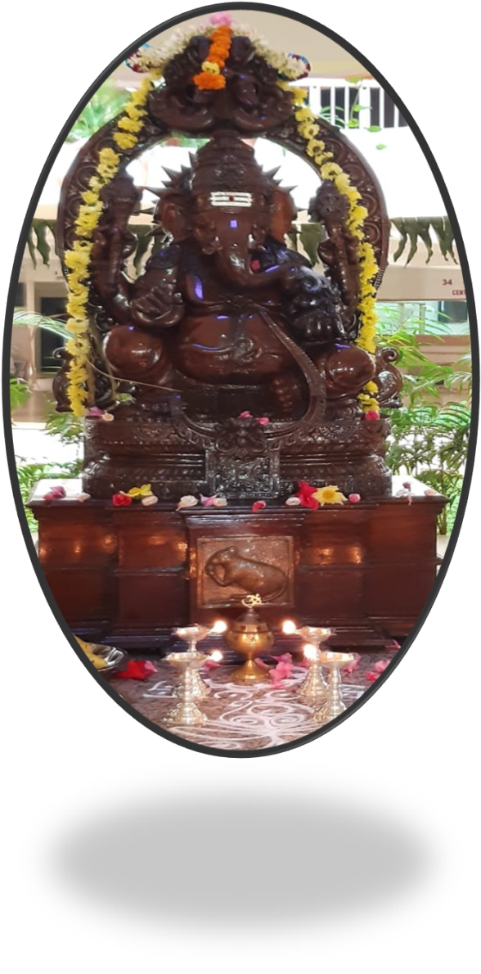

Figure 2a: forum theatre faculty version

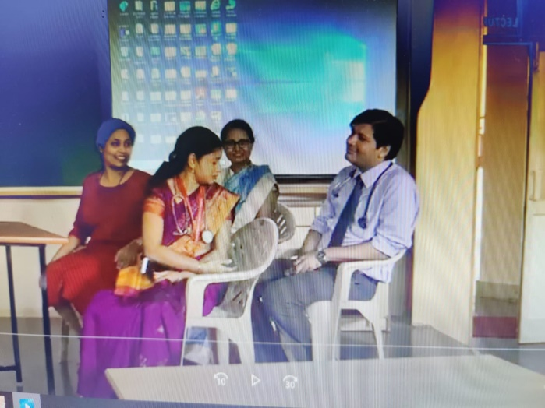

Figure 2b: forum theatre learners’ version

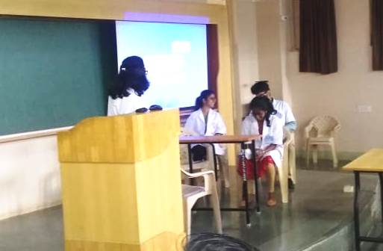

Figure 3 universal design observation activities

