Dear Editor,

This is to confirm that the article entitled “***A review on the ethical reporting of medical information during the Covid19 pandemic***” submitted to the Indian Journal of Medical Ethics, is original and has been co-authored by the undersigned.

All authors have participated in the work sufficiently to meet the ICMJE guidelines for authorship.

All have read and approved the manuscript.

The submission is not under consideration for publication in any other journal.

We give consent to **Dr. Farheen Taha** to act as the author for correspondence.

Details of sponsorship or relevant competing interests, financial or otherwise: **None to declare.**

We have read the terms and conditions of authorship of IJME and accept them.

Contact details (mailing address, email id) and affiliation of all authors:

|  |  |
| --- | --- |
| **Authors** | 1. Dr. Farheen Taha BDS, MDS   Freelance medical writer (not affiliated to any institution).  Abdullah Bukhari Road. Al Aziziyah district.  Jeddah, Saudi Arabia  Phone: 00966 548424019  Fax: 00966 545550970  Email: [dr.farheentaha@gmail.com](mailto:dr.farheentaha@gmail.com)   1. Dr. Chandrashekar Janakiram BDS, MDS, PhD, MS (bioethics)   Professor & Head of the Department  Department of Public Health Dentistry  Amrita School of Dentistry  Amrita Vishwa Vidyapeetham (AIMS)  Ponnekkara, Kochi 682041, Kerala, India  Phone: 00919481789572  Email: [sekarcandra@gmail.com](mailto:sekarcandra@gmail.com)   1. Dr. Joe Joseph BDS, MDS   Professor & Head of the Department  Department of Public Health Dentistry  Sree Mookambika Institute of Dental Sciences  Kanyakumari, Marthandam Pechiparai Road,  Kanyakumari 629161, India.  Phone: 00919142182854  Email: joe.dentist.dph@gmail.com |

Signature of all authors:

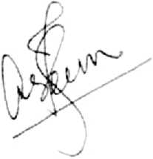

1. Dr. Farheen Taha:

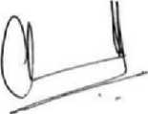

2. Dr. Chandrashekar Janakiram:

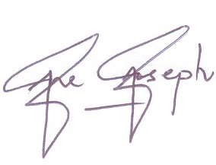3. Dr. Joe Joseph: