**Lay Person Term ‘LPT’ as Sixth Level of Hierarchy in MedDRA: Harmonising Terminologies for Plain Language Summary**

Gaurav Ananda, Mohit Joshia*

aMedical Writing, Tata Consultancy Services, Noida, Uttar Pradesh, India.

*The author was working in TCS at the time of writing this manuscript

**Corresponding author**: Gaurav Anand

**Email**: Gaurav.Anand3@tcs.com

**Abstract**

Presenting a single standardized international ‘lay person term’ (LPT) for medical terminology, which can be used by industry could be a major challenge in the recent future considering plain language summaries will become an important document type for data dissemination. We are proposing a new sixth level LPT that is aligned with MedDRA. This will ease the need to convert data from one terminology to another, uniformly across the globe. Pharmaceutical organizations could always have a look at the MedDRA level LPT, and disseminate trial results to the layman, preventing the loss and/or distortion of data, and allowing savings in terms of resource utilization.

**Introduction**

Data transparency is the one continuing practice in the past one decade that has benefited probably all the stakeholders of a clinical drug development process. The continued efforts of the regulatory and other stakeholders of drug development process has resulted in numerous ways for clinical data to come in the public domain.1 Plain language summary (PLS) is one such recent addition post regulation (EU) No 536/2014 (2014).2 The regulation mandates pharmaceutical companies to provide the clinical trial results in a language that is understandable to a layperson, within the defined timelines. The PLS would be a huge boon to the layman as it will help them to better understand the procedures and the results of the clinical trials so that they can take informed treatment decisions, if required and satisfaction of serving interests of human beings in poor health. Major regulators such as USFDA are also warming‑up towards this initiative and other regulators across the globe will soon follow their footsteps. This presents a new challenge to provide a single standardized international ‘lay person term’ (LPT) for medical terminology which can be used by industry. Thus, we propose that it would be worthwhile to harmonize medical PLS terminology across globe similar to what has been done for MedDRA3 though the International Council for Harmonization of Technical Requirements for Pharmaceuticals for Human Use (ICH). The LPT can be inserted as sixth level off hierarchy in MedDRA along with ‘Lowest Level Terms’ (LLTs), ‘Preferred Terms’ (PTs), ‘High Level Terms’ (HLTs), ‘High Level Group Terms’ (HLGTs), and ‘System Organ Classes (SOCs)’. **Figure** 1 provides an illustration of proposed level of hierarchy using hypotension as PT.

**Figure 1**: Proposed level of hierarchy with respect to lay person term for common terminology

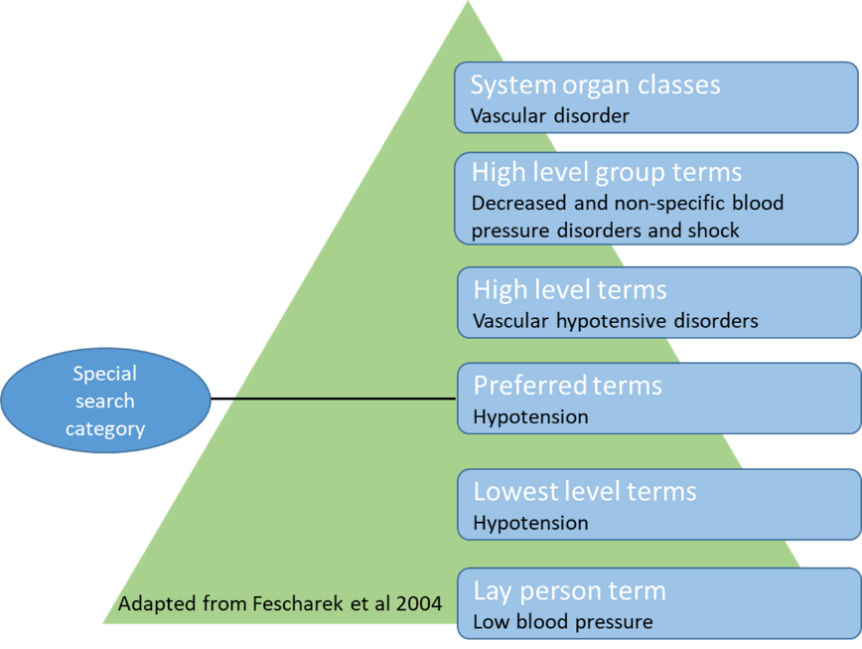

Patient‑friendly term list in MedDRA v21.0 (subset of LLTs derived from AEs reported by patients and consumer in several PV databases) and LLTs can be a starting point for development of this hierarchy level. As PLS is now a regulatory requirement, the LPT should be in-line to MedDRA with a vision to provide a solitary and standardised international medical terminology that can be used both as a regulatory requirement along with evaluation of data pertaining to medicinal products for human use. The LPT thus could prevent various versions created by individual users working on varied document types in different organizations across globe that could lead to loss of standardization.

**LPT as sixth level of hierarchy: Aligning MedDRA vision and present practices with the evolving requirements**

An aligned MedDRA with LPT as sixth level of hierarchy will help pharma companies to document PLS and also help for ICF development, especially for multicentre trials that are spread across various countries and may use different terms for the same indication. Additionally, not all pharmaceutical companies can afford PLS services from KPO. Thus small pharmaceutical organizations can easily and always look at the MedDRA level LPT, and disseminate trial results to the layman at minimal costs using the resources available in the their organization. Academics and health care providers can also access LPT through MedDRA from Maintenance and Support Services Organization (MSSO) at no cost and from Japanese Maintenance Organization (JMO) at a nominal cost. Furthermore, for the regulators that follow USFDA and EMA or for that matter, any other regulatory body that has or will mandate the PLS as an integral document type for data dissemination, mapping CT.gov and EudraCT or other result disclosure websites with a PLS template using LPT will help them to harmonise the medical terminologies that will lead to improvements and ease in assessing quality and timeliness of data available for effective analysis, exchange and decision making. This would be an effective exercise to perform at beginning of this transparency revolution considering the cost and time utilized at a later stage, as was the case similar to development of MedDRA.

**Conclusion**

As stated in the MedDRA vision a standardised terminology with the addition of LPT will help the regulators, and other stakeholders including layman alike in the removal of the need to convert data from one terminology to another, preventing the loss and/or distortion of data and allowing savings in resources. We assume that this intraoperatibility and harmonization will lead to ‘**Vasudhava Kutumbakam’** which literally means "the world is one family”.

**Author contributions**

Both authors were extensively involved in the input, writing and corrections for this paper.

**Conflict of interest**

Authors have no conflict of interest to declare.

**References**

1. Joshi M, Bhardwaj P. Impact of data transparency: Scientific publications. *Perspect Clin Res*. 2018;9(1):31-36.
2. Regulation (eu) no 536/2014 of the European Parliament and of the Council of 16 April 2014 on Clinical Trials on Medicinal Products for Human Use, and Repealing Directive 2001/20/EC. Available from: https://www.gmp-compliance.org/guidelines/gmp-guideline/eu-536-2014-on-clinical-trials-on-medicinal-products-for-human-use-and-repealing-directive-2001-20-ec. [Last accessed on 2018 Dec 14].
3. MedDRA. Medical Dictionary for Regulatory Activities. Available from: <https://www.meddra.org/>. [Last accessed on 2018 Dec 14].