COVER LETTER

Dear Editor,

This is to confirm that the article entitled “**Lay Person Term ‘LPT’ as Sixth Level of Hierarchy in MedDRA: Harmonising Terminologies for Plain Language Summary**” submitted to the Indian Journal of Medical Ethics is original and has been co-authored by the undersigned.

All authors have participated in the work sufficiently to meet the ICMJE guidelines for authorship. All have read and approved the manuscript.

The submission is not under consideration for publication in any other journal.

We give consent to Mr. **Gaurav Anand** to act as the author for correspondence.

Details of sponsorship or relevant competing interests, financial or otherwise: **NA**

We have read the terms and conditions of authorship of IJME and accept them.

Contact details (mailing address, email id) and affiliation of all authors:

Gaurav Anand: [Gaurav.Anand3@TCS.Com](mailto:Gaurav.Anand3@TCS.Com)

Senior Manager, Medical Writing, Tata Consultancy Services

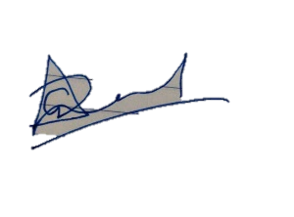

Mohit Joshi: [Joshimohit4@yahoo.in](mailto:Joshimohit4@yahoo.in)

Business Process Lead, Tata Consultancy Services

