**Tables/Figures/Illustrations**

**Illustrations have been made by using BioRender.com**

**Figure 1**

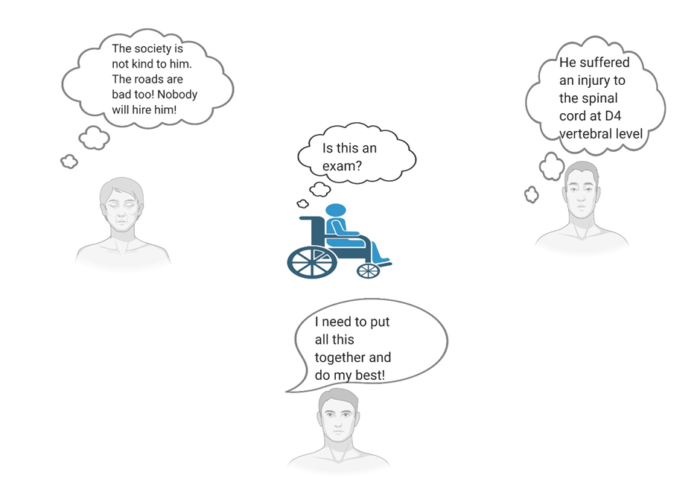

**The medical model and the social model looking at the same problem differently. This is what makes the task of the judge difficult and open to scrutiny by higher courts.**

**Figure 2**

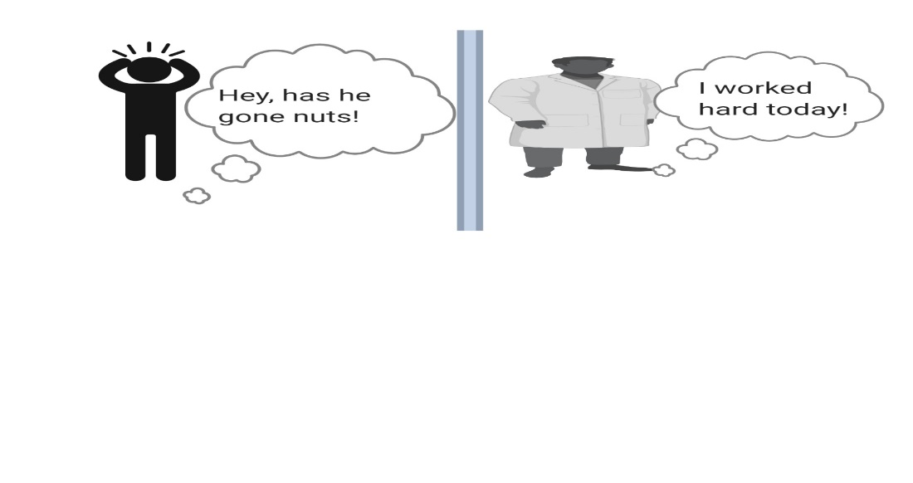

**The population at large views the disability certificate with scepticism due to the jargon that is used in these certificates.**

**Figure 3**

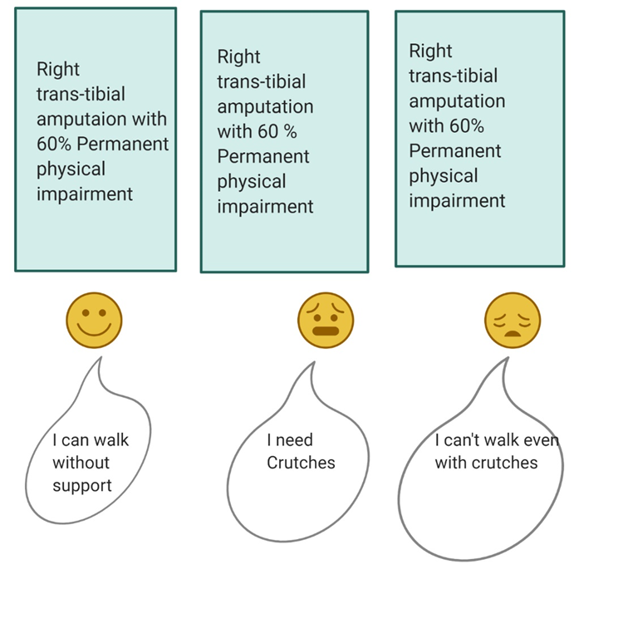

**Exemplification of the shortcomings of the medical model alone: All three patients have the same percentage of impairment and the same diagnosis, however, in reality there is a difference in their respective disabilities. This is because the medical model fails to recognize environmental and social factors which too contribute to disability.**

**Figure 4**

**Case No 1**

**Figure 5**

**Case No 2**

**Figure 6**

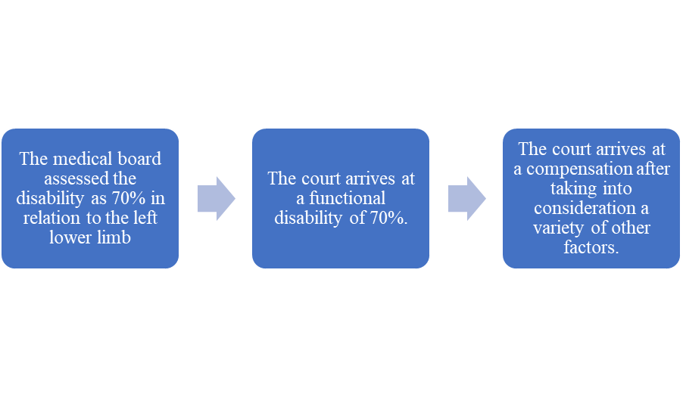

**Case No 3**

**Figure 7**

**Case No 4**

**Table 1**

|  |  |
| --- | --- |
| Pecuniary Losses | Non-Pecuniary Losses |
| Arithmetically calculable and includes:   1. Expenses incurred on treatment 2. Special diet 3. Conveyance cost 4. Expenses towards nursing/attending 5. Loss of income 6. Loss of earning capacity and other material loss, which shall require special treatment or aid for the insured for his rest of his life. | Compensated in terms of money, but includes:   1. compensation for mental, physical shock 2. Pain, suffering 3. Loss of amenities of life 4. Disfiguration 5. Loss of marriage prospects 6. Loss of earning or expected earning of life 7. Inconvenience, hardship, disappointment, frustration, metal stress, dejectment and unhappiness in life and in future 8. Other reasons due to special or additional circumstances depending upon the facts to that particular case. |

**Calculation of pecuniary and non-pecuniary damages**

**Figure 8**

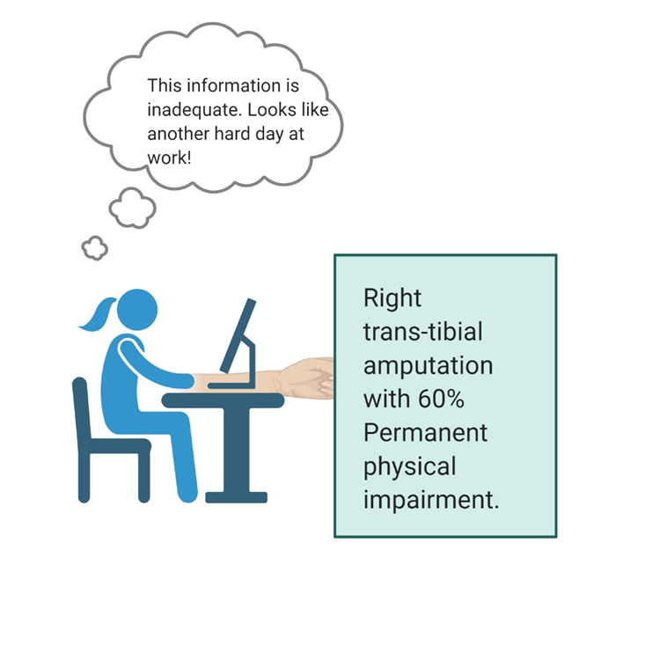

**Calculation of pecuniary and non-pecuniary damages on the basis of the percentage of permanent physical impairment is a backbreaking task.**