**Figure 1: Year wise distribution of medical and nursing students**

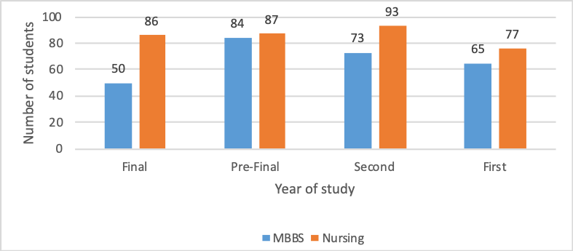

**Figure 2: Distribution of participants who experienced/observed workplace violence**

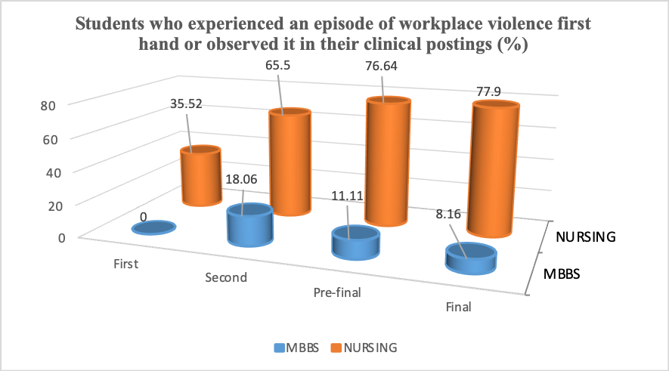

**Figure 3: Responses of participants with respect to question about reporting of WPV**

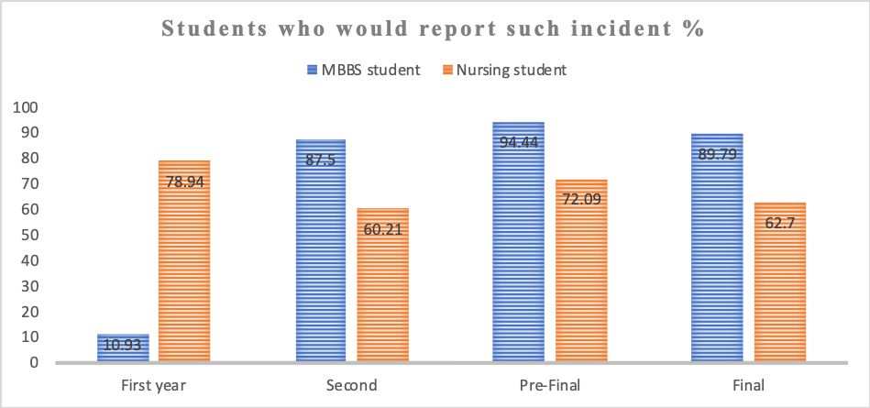

**Figure 4: Response of participants regarding awareness about law against WPV**

**Figure 5: Responses of the MBBS students to the video clip 1 with respect to the person responsible for aggression by relatives**

