**COVID 19 (SARS-CoV-2) – Ethical Practices and its consequences on Health and Economy**

**Abstract:**

The aim of the paper is to investigate the factors associated with the coronavirus outbreak and how this pandemic affected the health, economy and the due ethical practices to be followed by the front line workers while providing services to the public. The only way of reducing the outbreak of Coronavirus infection is through social distancing as vaccines are just becoming available and follow the norms set by the government at the workplace. Complete lockdown approaches have started showing multiple effects in terms of economic crisis and also on the wage earners. This paper is written based on the information available about the COVID – 19, through survey viewpoints collating the most prominent factors responsible for Coronavirus spread and its impact on health and economy as well. The study suggests the direct cost associated with COVID 19 pandemic is less (in the form of illness and death) as compare to indirect losses incurred due to economic crisis. This pandemic has created huge losses to both the public health and economic health. According to the worldwide data, the value chain disruptions and low international demand of products and services have led many countries into recession and consequently the GDP has fallen as had happened in 2009.

**Keywords:**

Coronavirus; Impact on the Economy; Lockdown; Personal Hygiene; Vaccine; Public Health

**Introduction**

The Coronavirus pandemic has created havoc on individuals, societies, businesses and economy as a whole. The Coronavirus which spread through personal contact not an air – borne disease. The ethical practices need to be followed by the practitioners during the pandemic time as mentioned by Council of Ethical committee and Hasting.

This paper is structured in different sections. Section I describes the Introduction of COVID – 19 disease, section II is related to method adopted in this paper, section III is describing the results, data collection and data analysis of the survey results, ethical practices and last section IV is discussions & conclusion, highlighting the findings of the research and then policy implications of the research.

**The Reproduction number of Coronavirus among the Society**

The Scientists have discovered that the rate by which infection spreads among the society is decided by the number called as reproduction number (RO). If the RO < 1 then the number of infection people is not increased and in case if RO = 1, then the rate of infection spread remain constant and if RO > 1 then in that situation the spread increases at a much faster speed.

Most of the evidence suggests that cases of the Coronavirus patients do not show any symptoms initially. It implies that the patients are asymptotic in nature as the Chinese authorities have reported that four in five Coronavirus infections caused no illness (Day, 2020).

Zhing Nanshan, Senior Medical adviser to the Chinese government clearly indicated that the asymptotic patients do not cause major outbreak of COVID – 19 if they are kept in isolation for 14 days. The same fact was substantiated by the officials of WHO that the asymptotic patients are not the major drive of transmission of this disease.

As per the official PLOS blog posted on 31st January 2020, the novel Coronavirus (COVID -19) outbreak is both saddening and concerning to society and Government of each country in the India and World.

(Day, 23rd March 2020) As per Italian patient’s history it is also found that COVID – 19 infected people do not show any symptoms of disease but they can infect others because this disease is visible after 5 days in some cases and in some even after 14 days. Authorities in the Tuscany region has indicated that the 50 – 75 % of the persons were asymptotic, but symbolised a terrible cause of infection.

The paper of Wu Fan, 2020 show that a severe respiratory disease was visible in Wuhan, Hubei Province, China. By 25th January 2020, around 1,975 cases had been informed ever since the first patient was brought in the hospital on 12th December 2019. An investigation of the patient report had suggested that the Coronavirus eruption was connected with seafood market in Wuhan.

A major crisis like situation has propped up, which is approaching world widely, creating a disaster kind of unparalleled quantity, if not managed properly by all governments. The data of our history clearly indicates that Indian government and people have courageously defied all the new and burgeoning communicable disease in recent eras.

As per the study of Baveja, 2020 shows that the problem of COVID – 19 cannot be contained due to lack of protective coordination, eating away the confidence of citizens, business and consumers as well.

Strong vicious cycle (shown in the Figure 2) strengthens this process making the situation worse in the minds of the normal public. This vicious cycle is looping in itself at health front and the consequence of which is visible in economic facade. As per the theory of constraints the breaking down of this vicious cycle by working on the constraints and provide a much impactful solution for this pandemic.

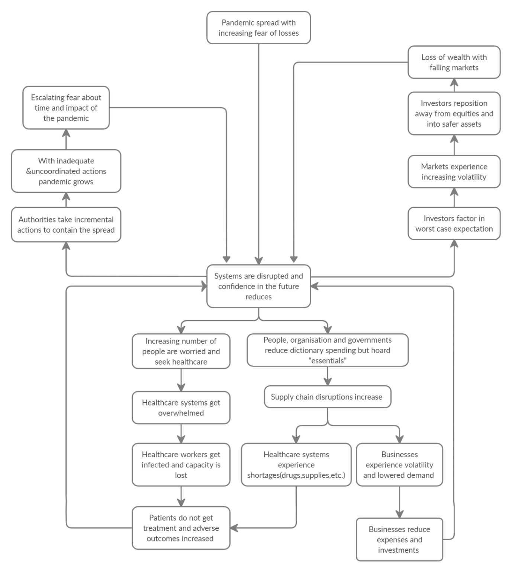

**Figure 1: Showing the crisis of COVID - 19 pandemic through Vicious Cycle**

**(Author’s Viewpoint)**

David Hodes, Founder of Ensemble Consulting Group has indicated that the world faced an unprecedented challenge of COVID – 19 in the past 6 months and crippled the health and economy of each nation. As per the philosophy of Theory of Constraints, the first step is to define the goal. Therefore, in case of COVID 19, the goal is to flattening the curve or in other words, slow down the rate of infection through administration of social distancing. The constraints faced by each country during pandemic is limited intensive care beds. David, 2020, applied theory of constraints in case of Australia’s pandemic. The report said that the 2000 intensive care beds are there in Australia and if the virus multiplied continuously and large population is affected by this disease then there would be 40 people for every bed. So only the younger generation would be able to survive in this crisis time and the older generations may get impacted much more severely in this emergency situation.

**Economic Goal:**

Australian economy is distressed due to the impact on domestic and international tourism. As a consequence of which they have slashed down the international capacity by 90% and domestic capacity by 60% till the May end. It leads to unemployment, restaurant business closed and resulted a severe economic crisis. David has suggested the 5 steps process of theory of constraints to overcome the pandemic prevailing all over the world.

Find the Constraint

Optimize It

Collaborate around it

Uplift System Performance

Start Again

**Figure 2: 5 Step Focus Process of Theory of Constraint (Author’s Viewpoint)**

**The 5 Step Focus Process of theory of constraint is described here:**

**Step 1:** Find the Constraint: As per the present situation, the availability of intensive care beds and ventilators are the constraints in the COVID – 19 pandemic.

**Step 2:** Optimize the constraints: There are only two methods to optimize the constraint, either more capacity of beds is to be build up or by curtailing the increase of COVID – 19 cases, the demand of beds automatically reduced. For increasing the beds capacity, more projects related to creation of beds should be mobilized, the design and production of ventilators process should be ramped up. To curtail the demands of beds, efforts should be put in towards increasing the supply of testing kits, throughput of pathology lab should be ramp up and usage of big data, artificial intelligence must be deployed in order to understand the epidemiology and virology of Coronavirus.

**Step 3:** Collaborate around the constraint: To support the health workers more and more people should voluntarily come forward which is possible through social media like Facebook and WhatsApp.

**Step 4:** Uplift the constraint: Once the vaccine of Coronavirus will be developed, the number of cases would be cured and COVID-19 pandemic will be over. But to achieve this situation, the community and people at large should have sense of hygiene, cleanliness and less wastage during the clinical trials of vaccine.

**Step 5:** Start again: There is a strong conviction that the world after the pandemic would be entirely different and worth living with a quality of life having less pollution, more sensible and responsible society.

As a positive side of this pandemic has resulted that people have adopted strategies working on online mode and leverage their knowledge in much more structured way. Either physically present or remotely one can treat or care can be taken of the diseased person.

As per the study of Trisha, March 2020, highlighted that most of the patients can be managed remotely by providing advice on the symptoms and self - isolation. Even doctors are giving consultations to the patients remotely, but in case of breathlessness, require the physical presence of the doctors or nursing staff. The best way out is to stop the movement of the public except the essential services are running. Banik et al, 2020, authors have analysed the prominent factors which causes the fatality rates across 29 nations.

**Impact of Lockdown on Economy**

As per the report of Dun and Bradstreet’s Country Risk and Global Outlook, which covers the 132 countries, highlights that the global situation remains grave and the global economy will take time to reach its pre–pandemic level not before 2022. The forecasted figures of D&B indicate that the global economy will weaken by 5.2% in 2020, the biggest decline since the World War II and higher than observed (1.7 %) in 2009 during global financial crisis (DST, July 2020).

**COVID 19 – Health Pandemic or Pandemic of World Economy**

As per study, the direct cost associated with COVID 19 pandemic is less (in the form of illness and death) as compare to indirect losses incurred due to economic crisis. According to the worldwide data, the value chain disruptions and low international demand have led many countries into huge setback in the form of recession.

As per the report of UNIDO 2020, 81% of the countries have faced the reduction of 6% on an average in Industrial Production. The Index of Industrial production of India fell by 65% as per the report of April 2020 in comparison March 2019.

Comparing the decline in manufacturing industries, it is clear that “Pharma” companies are the “winners” and the “Motor Vehicles” is the biggest “losers” across the globe (Hartwich, 2020).

**Methodology:**

After extensive literature review, author has found that many researchers have worked for causes and cure for COVID 19 cases but the researches are limited on the COVID 19 and its impact on the World economy.

**Research Issue:**

To increase the know - how and the major factors which are very crucial in COVID 19 cases through mobile apps, various tests and so on so forth, this study was started. This study is helpful in identifying the major factors which are causation reasons of the widespread of Corona among the societies.

**Data Collection:**

To target national and international communities faced this pandemic in their countries descriptive research based on cross–sectional study is used. This study is conducted through structured questionnaire in Western Region of Asia. The scholar has focussed on five causing aspects viz.; underlying the health conditions, host behaviour and number of contacts, social distancing and community consciousness, age, personal hygiene practices, and host defence potential. The objective of this study is to develop a model out of the findings of the empirical work. The model will ultimately help the policy makers to see the major causes of COVID – 19 which are theoretically known but substantiated by the statistical research.

**Results:**

With the help of questionnaire, cross–sectional data have been collected and questionnaire sent through mail to the Industries and Academic Institutes of Western region of Asia. Approximately 250 sample data have been collected and the base of selection of sample was snowball sampling. While doing survey many of the respondents have not replied back and because of which the actual sample size has got reduced from 250 to 211 (84% response rate).

**Data Analysis**

The 211-sample data collected through mail survey was analysed through SPSS. The procedures used for analysis are correlation coefficient to show the relationship of the factors associated with the positive cases of COVID 19. The Table 1 reflects the factors considered for analysis of the positive cases among the community at large.

**TABLE 1: FACTORS OF COVID -19 OUTBREAK IN THE WORLD**

|  |  |  |  |  |  |  |  |
| --- | --- | --- | --- | --- | --- | --- | --- |
| **SN** | **FACTORS** | **10%** | **30%** | **50%** | **70%** | **100%** | **Total** |
| 1 | Underlying health condition | 91 | 25 | 35 | 45 | 15 | 211 |
| 2 | Host behaviour and number of contacts | 48 | 42 | 64 | 32 | 25 | 211 |
| 3 | Social Distancing and community of consciousness | 6 | 10 | 45 | 55 | 95 | 211 |
| 4 | Age | 29 | 22 | 33 | 42 | 85 | 211 |
| 5 | Personal Hygiene practices | 27 | 35 | 31 | 43 | 75 | 211 |
| 6 | Host Defence potential | 32 | 29 | 37 | 33 | 80 | 211 |

Source: Computed by authors

The respondents who have participated in the survey, running the Industries and working in academic institutes located in Asia and other parts of the country. It is clearly visible that most of the industries are in the acute crisis due to pandemic and the forthcoming situation is also gloomy due to downfall in demands in each sector. The data fetched against the COVID – 19 positive cases caused due to various factors are analysed through correlation coefficients as shown in the Table 2.

**TABLE 2: CORRELATION COEFFICIENTS AMONG THE FACTORS**

|  |  |  |  |  |  |  |  |
| --- | --- | --- | --- | --- | --- | --- | --- |
|  | Factor 1 | Factor 2 | Factor 3 | Factor 4 | Factor 5 | Factor 6 | Result |
| Factor 1 | 1 |  |  |  |  |  |  |
| Factor 2 | -0.013 | 1 |  |  |  |  |  |
| Factor 3 | -0.381 | -0.046 | 1 |  |  |  |  |
| Factor 4 | 0.082 | -0.259 | 0.867 | 1 |  |  |  |
| Factor 5 | -0.522 | -0.721 | 0.649 | 0.573 | 1 |  |  |
| Factor 6 | -0.007 | 0.651 | 0.667 | 0.562 | -0.133 | 1 |  |
| Result | -0.459 | 0.207 | 0.964 | 0.743 | 0.478 | 0.791 | 1 |

Source: Computed by Authors

**Abbreviations:**

**Result:** Positive COVID 19 Cases

**Factor 1:** Underlying Health Conditions

**Factor 2:** Host Behaviour and number of contacts

**Factor 3:** Social Distancing and Community of consciousness

**Factor 4:** Age

**Factor 5:** Personal Hygiene Practices

**Factor 6:** Host Defence Potential

From the table above it is clear that Result is having high positive correlation (0.964) with factor 3, with factor 6 (0.769) and with factor 4 (0.74) respectively. While the result is having low positive correlation with factor 5 (0.47). Other factors like 1 and 2 is not having any significant relationship with the result of Positive COVID 19 cases. The world statistics of the Coronavirus infected cases shows the same fact that United States, Italy and Spain have found the highest number of cases in their country.

After considering the Situation Reports (SITREPs – 153) of WHO on COVID – 19, we have found that there are three basic reasons of COVID – 19 cases world over, namely community transmission, cluster of cases and sporadic cases. As per WHO, they have defined community transmission as larger outbreaks of local transmission in that region, while cluster of cases is nothing but when the cases are clustered around time or geographical location or common exposures. The term sporadic cases, when one or more cases are detected locally or imported only.

The values in Table 3, indicates that America has the highest number of cases with 99% are due to community transmission, Europe has got the second highest number of cases with 64% community transmission and 34% cluster of cases. The trend in Eastern Mediterranean is different as it has 62% due to cluster of cases and 33% are because of community transmission.

|  |  |  |  |  |
| --- | --- | --- | --- | --- |
| **TABLE 3: PERCENTAGE OF CONFIRMED CASES DUE TO VARIOUS MODES OF TRANSMISSION** | | | | |
| **Continent** | **Total Number of Cases** | **Reasons of COVID - 19 Cases** | | |
| **Community Transmission (%)** | **Cluster of Cases (%)** | **Sporadic Cases (%)** |
| Africa | 2,25,463 | 93 | 6.0 | 0.0 |
| Americas | 43,95,895 | 99 | 0.2 | 0.0 |
| Eastern Mediterranean | 9,16,378 | 33 | 62.0 | 0.3 |
| Europe | 25,45,540 | 64 | 34.0 | 0.2 |
| South-East Asia | 6,00,781 | 26 | 72.0 | 1.5 |
| Western Pacific | 2,06,230 | 15 | 85.0 | 0.2 |

Source: SITREP – 153 of WHO as on 21st June 2020

**Discussions:**

The outbreak of COVID – 19 has imposed a deep crisis on every front like health care of individual. Due to Coronavirus lot of families have lost their loved ones. If we consider its impact on our students of any class - standards, we found that their studies are equally disturbed due to Coronavirus spread.

If we take into consideration our Indian Industries which has got impact due to complete lockdown everywhere in the World. We have found that those industries which are dependent on China for their raw material procurement supply, going to face a major crisis in the future time.

The COVID -19 has created negative growth rates in many sectors as the worst affected one is financial, real estate and professional services (-17.3%) and the least affected sector is public administration, defence and other services (-0.4%).

On the contrary of it, some sectors are going to get benefits due to this pandemic situation. If we see the health and hospital industry is in great demand due to the patients load on current hospital system in each and every country of World today. Similarly, the pharmaceutical industry is also getting increase in revenue due the demand of medicine in this disaster kind of situation. Not only this the companies which are manufacturing personal care equipment like ventilators, masks, gloves and hand sanitizers are required at a very high pitch.

Further if we consider working population in the offices requiring the internet for completing their time bound tasks, so definitely the telecommunication industry is having a boom sale for its products. The future of E – Commerce companies like Amazon, Flip cart, big basket, Reliance are also bright because seeing the present scenario, and most of the people would be going to prefer online shopping rather offline. Similarly, in Education sector, many educational institutes would be going to launch new online courses of short-term duration and the distance learning model and online teaching would be in higher demand in the coming time period.

Due to the increase in number of COVID – 19 cases every day, it is creating worries to India and other developed countries. In India and other countries have opened the lockdown and started functioning normally because due to this lockdown all the nations have entered into the phase of deeper recession and consequently the GDP has fallen drastically even much higher as had happened in 2009. Each country, facing difficulty in committing social distancing consequently overloaded public health infrastructure, already popular for non – communicable diseases. Although each Government has taken measures to contain the outburst of COVID – 19, but still it is not completely eradicated from the countries. As WHO and medical officials are continuously hampering that social distancing and self – isolation is the only way to curtail down the effect of Coronavirus. In that situation how long one can devoid the public not to come on the roads for earning their livelihood. Despite many companies are trying to develop the vaccine and the process of taking trials is already on a very faster mode but again a pertinent question which remains in the mind of a person that the Coronavirus has crippled the country in two ways, one the suffering due to ill health and second the money crisis and reduction of the jobs in each sector.

**Implications for Policy & Practice:**

**Profitability and Employment:**

Bearing in mind the prevailing situation, the profit is expected to decline by approximately 50% and 20% of the firms are in the process of laying off employees in the year 2020.

The irresistible challenge as described are two i.e. (i) Shrinkage in demand (ii) payment of wages. This scenario is existing specifically to labour intensive industries like textiles and apparel etc. The challenges and problems encountered by the firms varies as per the size of the companies.

As a whole, companies are facing the five major problems viz. fall in demand, payment of wages, difficulty in financing, logistics problems and value chain disruptions.

In order to overcome from the above crisis or issues, firms are demanding reduction in tax rates, utilities cost, financing cost, social benefits along with optimization of export tax (Hartwich, 2020).

**Ethical Practices**

The medical professional has to follow the ethical practice during the COVID – 19 pandemic by keeping both personal and professional demands.

The principles of Nonmaleficence (“do no harm”), Beneficence (“do good”), and Justice (“fairness”) are all the great support to the professionals during the pandemic.

So according to the first principle, the social distancing is to be followed while doing the procedures on the patients, do not run the clinics if they are out of PPE kit as per the second principle and the last principle is implying that each professional should try to do justice with the profession. So, in case, a particular clinic is out of PPE kit then they send the patient to the allies for getting the services in time. (JADA, 2020)

The another approach for ethical practices is mentioned by Hastings Centre's 3 - tier method to a pandemic situation, viz, the duty to plan, the duty to safeguard, and the duty to guide. As per the policy, the providers do not have the right to refuse to treat a COVID - 19 patient, prioritization of the patients, decision-related to a screening of the population due to allocation of the scarce resources and addressing the issues with regards to end - of - life and resuscitate orders. (Jessica B Kramer, D. E., 2020)

**Conclusion:**

**Measures to Overcome the Recession:**

Many countries like Europe have planning to go for recovery plan through transiting their businesses towards Green and digital transitions. The countries are also thing of adopting more robust healthcare system so that dependency on imports of essential items would be less in near future time. The IMF itself is also insisting countries to follow green recovery plans along with the structural reforms essential for macroeconomic development. United States, Germany and Republic of Korea already started efforts for greening the construction sector and pumping in funds to recover from the present system (Hartwich, 2020)

**Use of Innovative Technologies to Fight with Coronavirus**

Policlinico Abano chain of hospitals in Italy, Dr Cristiano Huscher has used robotics and artificial intelligence for disinfection of the room and surgical procedures. Throughout the room, these robots travel autonomously, the DNA in the virus is killed using ultraviolet – C light and also destroyed the viruses with bacteria. Dr Huscher reported that 99.99% of viruses, bacteria and fungal spores are killed by robots.

As a part of strategies used by Italian people to combat the COVID – 19 pandemic, the robots are being utilized for monitoring the social distancing in parks, and the fever is detected by thermal sensor from 10 feet distance (Janet, 2020).

**References:**

(2020, July 10). *Daily Shipping Times, 15*(118), p. 13. Retrieved from www.dst.news

A Baveja, A. K. (2020). Stopping Covid - 19: A Pandemeic Management Service Value Chain Approach. *Annals of Operations Research, 289*(2), 173-184.

Arindam Banik, T. N. (2020). Why Do Covid - 19 Fatality Rates differ Across Countries? An Exploratory Cross - Country Study Based on Select Indicators. *Global Business Review, 21*(3), 607-625.

(2020). *Asian Development Outlook 2020 - What Drives Innovation in Asia.*

(2020). *Coronavirus COVID-19- Economic Impact on India.* Statistica 2020. Retrieved from www.statistica.com/63044/covid-19

(21st June 2020). *Coronavirus Disease (COVID-19) Situation Report - 153 Data.* WHO from National Authorities.

(September 2020). *Coronavirus Panedimc News.* Al Jeera. Retrieved from www.aljeera.com/topics/events/coronavirus-outbreak.html

Day, M. (2020). *Covid-19: Four Fifths of cases are asymptomatic.* China.

Ethical Practice during the COVID-19 pandemic. (2020, May). *JADA, 151*(5), 377-378. Retrieved from https://doi.org/10.1016/j.adaj.202.03.038

F Wu, S. Z. (2020). *A New Coronavirus associated with human respiratory disease.* China.

(2020). *Fighting the Coronavirus with Innovative Tech.* Nytimes.

Frank Hartwich Greenhalgh, A. L. (April 2020). *Coronavirus: the economic Impact - A health Pandemic or Pandemic for the Economy?* United Nations Development Organization.

*https://ensembleconsultinggroup.com/corona-constraints/*. (n.d.).

Jessica B Kramer, D. E. (2020, June). Ethics in the Time of Coronavirus:Recommendations in the COVID-19 Pandemic. *American College of Surgeons, 230*(6), 1114- 1118.

*Ministry of Health and Family Welfare.* (n.d.). Retrieved from htps://www.mohfw.gov.in/

(2020). *Novel Coronavirus (2019 -nCoV) outbreak .* PLOS Blog. Retrieved from https://theplosblog.plos.org/2020/01/novel-coronavirus

T Greenhalagh, G. K. (2020). *Covid-19: A Remote Assessment in Primary Care.*

*World Health Organization .* (n.d.). Retrieved from https://www.who.int/emergencies/diseases/novel - coronavirus-2019