Forensic Dentistry – Awareness and Scope.

Dr. Sneha R. Sharma (Corresponding Author)

Department of Oral Medicine and Radiology, Nair Hospital Dental College, Mumbai Central, Mumbai, Maharashtra, India

Phone no: + 91 9920238676

[sneharajsharma@gmail.com](mailto:sneharajsharma@gmail.com)

Dr. Freny R Karjodkar

Department of Oral Medicine and Radiology, Nair Hospital Dental College, Mumbai Central, Mumbai, Maharashtra, India

Phone no: + 91 9869652213

[fkarjodkar@yahoo.co.in](mailto:fkarjodkar@yahoo.co.in)

Dr. Kaustubh P Sansare

Department of Oral Medicine and Radiology, Nair Hospital Dental College, Mumbai Central, Mumbai, Maharashtra, India

Phone no: + 91 9821237185

[kaustubhsansare@yahoo.com](mailto:kaustubhsansare@yahoo.com)

Dr. Ankit Sharma

Department of Oral and Maxillofacial Surgery, Nair Hospital Dental College, Mumbai Central, Mumbai, Maharashtra, India

Phone no: + 91 8779988513

[drankitsharma2015@gmail.com](mailto:drankitsharma2015@gmail.com)

Dr. Mohd Saalim

Department of Oral Medicine and Radiology, Nair Hospital Dental College, Mumbai Central, Mumbai, Maharashtra, India

Phone no: + 91 9871850160

[mohdsaalim12@gmail.com](mailto:mohdsaalim12@gmail.com)

Dr Samiksha Chavan

Department of Oral Medicine and Radiology, Nair Hospital Dental College, Mumbai Central, Mumbai, Maharashtra, India

Phone no: + 91 9421080625

[samnsak@gmail.com](mailto:samnsak@gmail.com)

Statement of competing interests and funding support - We declare that we have no conflicts of interest to disclose regarding this manuscript and have acknowledged all source of funding if any.

Statement of any submissions of very similar work - We confirm that this manuscript is original, has never been published, or under the consideration for publication elsewhere (in part or in whole).

**Abstract:**

Dental professionals play various roles and forensics is one such area where their role of a dentist is exremely valuable. Even today, there are very few qualified forensic odontologists in India; perhaps because of lack of proper awareness and incomplete understanding. A cross-sectional study was conducted in a sample of 1860 practitioners in western India to scrutinize the awareness, attitude and practice of forensic odontology. The total participants were divided according to age and educational qualification. Even though majority participants maintained dental records in their clinic/workplace, only 13.4% of the practitioners maintaining complete records. The time duration for which patient records should be maintained was not known maximum participants. The role of radiographs in forensics is also very vital. More than half of the participants knew about radiographic methods used for age estimation. Amongst all the participants, the highest responses were noted for the younger age group and student participants.

**Key-words**: Dental practitioners, forensic odontology, forensic dentistry, knowledge, awareness.

**Introduction**:

Forensic dentistry is a challenging and fascinating branch of forensic science that involves the application of dental sciences in the identification of deceased individuals through the comparison of ante- and postmortem records. As previously described by Keiser–Nielson, forensic odontology is a branch of forensic medicine that deals with the proper handling, examination, and presentation of dental evidence in the best interest of justice. Forensic odontology has become an integral and essential part of forensic medicine in the last century. (1) Forensic dental fieldwork requires an interdisciplinary knowledge of dental science. Teeth, with their physiologic variations, pathoses and effects of therapy, record information that remains throughout life and beyond. Recently, forensic odontology has evolved as a new ray of hope in assisting forensic medicine, but, this vital and integral field of forensic medicine is still in a state of infancy in India.(3)

A general dentist apart from having a comprehensive background understanding of general dentistry, must also hold elementary knowledge of the character of the forensic pathologist, approaches used in autopsy, the role of a dentist in the proof of identity of a person, and the significance of preserving dental records of all patients.(1) The imperative applications of forensic odontology comprise documentation of human remains through dental records; in matters of alleged child or adult abuse through bite marks and indentations due to physical injuries; age and gender estimation of the living or deceased and to attest as a proficient witness in court to present forensic dental evidence. Unfortunately, in India there are very few qualified forensic odontologists; perhaps because of the dearth of proper awareness, and an incomplete understanding of the importance of a forensic dentist. (2) Despite the demand for well-educated and experienced forensic odontologists being recognized globally, the progress in forensic odontology in India has been relatively slow. There have been studies done in the past to assess the knowledge and the attitude of dental students, staff and practitioners but they have been mostly done on a smaller sample size. Therefore, the present study was performed on a larger sample size to get a better understanding and appraise the perception of forensic odontology and its practice among Dental Interns, Postgraduates, Teaching Faculty affiliated with Dental Colleges and Private Dental Practitioners in various parts of western India.

**Materials and Methods:**

A questionnaire based cross sectional observational study was conducted amongst the Interns, Post graduate students, teaching faculty of a dental college and private dental practitioners. The questionnaire was pre-tested by giving it to 10 professionals to assess its feasibility, ease of understanding and reliability. The questionnaire consisting of 10 questions was digitally distributed using google forms by a single investigator. Since the participants included were educated and literate professionals the questionnaire was only in English language. Participants were asked to respond to each item in the questionnaire by choosing the most appropriate alternative. Confidentiality and anonymity of the respondents was assured. A Sample Size of 1900 was estimated out of which 1860 participated in the study. The Participant information documented were Age, Gender, Educational Qualification - Intern / Post Graduate dental student/ Faculty of a dental college/ Private Practitioner and Number of Years into Dental practice. [For participants having a private dental practice]

**Results**:

Out of the total 1860 respondents who took part in the survey, there were 1056 females and 804 males. The participants were divided into 5 age groups as described below –

Group 1 – age less than 25 years (639),

Group 2 – age 26 to 35 years (894),

Group 3 – age 36 to 45 years (165),

Group 4 – age 46 to 55 years (87)

Group 5 – age more than 56 years (75).

Considering the variation in the educational qualification and number of years into dental practice, the total sample was also divided into 7 groups [Figure 1]–

Group A - Intern in a dental college

Group B - Post Graduate student in a dental college

Group C – Teaching Faculty of a dental college

Group D - Private Practitioner - less than 5 years

Group E - Private Practitioner - 6 to 10 years

Group F - Private Practitioner -11 to 20 years

Group G - Private Practitioner - More than 20 years

The Comparison of frequencies of categories of variables with groups was done using chi square test.

**Questionnaire and Responses** – [Table 1]

1. Do you maintain Dental records of the patients treated in your department / clinic?

Yes

No

1815 out of 1860 participants maintained dental records and only 45 participants did not maintain any dental records. There was a statistically significant difference seen for the frequencies between the groups [p<0.01, 0.05] with higher frequencies of age group [26 to 35 years] responding to option 1

1. If yes, which of the following do you maintain?
2. Patient details
3. Medical history
4. Family history
5. Clinical finding
6. Study casts 36.82%
7. Photographs 48.76%
8. Radiographs 71.66%
9. Treatment done

Every option [from a to h] was given a score of 1 and multiple responses could be given for this question. Respondents who preserved all records had the highest score of 8. [Figure 2] There was a statistically significant difference seen for the frequencies between the groups [p<0.01, 0.05] with higher frequencies of age group 2 corresponding to score 8 and Group A, closely followed by group B. Out of the 1860 participants, all records were maintained only by 13.4 % participants. Study Casts were maintained by 36.82%, radiographs were preserved by 71.66% and photographs were preserved by 48.76% of the participants.

1. Are you aware of the number of years recommended by the Indian Dental Association (IDA) for maintenance of dental records?

Yes

No

52.5 % of the participants gave a positive response, 34.67% of the participants did not know about the correct response while 12.37% of the participants chose not to answer this question. There was a statistically significant difference seen for the frequencies between the groups [p<0.01, 0.05] with higher frequencies of age group 1 & 2 responding to option 1. [Figure 3]

1. If yes, for how many years ?
2. Upto 1 year
3. 1 to 5 years
4. 6 to 10 years
5. More than 10 years

468 out of 1860 [25.16 %] participants responded to this question. Amongst the 468 participants, 108 [23.07%] opted for option 6 to 10 years. There was a statistically significant difference seen for the frequencies between the groups [p<0.01, 0.05] with higher frequencies of age group 2 responding to option a.

1. Are you aware of the significance of maintaining dental records in identifying the deceased and crime suspects?

Yes

No

72% of the total participants who responded had a positive response with highest number of positive responses being in Group 2 and Group A.

1. Can you estimate the dental age of an individual by examining the teeth?

Yes

No

77.23 % of the total participants had a positive response and said that the dental age of a patient can be estimated by examination of teeth. There was a statistically significant difference seen for the frequencies between the groups [p<0.01, 0.05] with higher frequencies of age group 2 and Group A responding to option 1

1. Can a dental surgeon testify as an expert witness in the court to present forensic dental evidence?

Yes

No

Out of the total respondents, 77.9% gave a positive response, with the highest being in age group 2 and group A

1. Do you know about radiographic methods of estimation of dental age?

Yes

No

A total of 57% of the participants knew about radiographic methods used for age estimation. Higher frequencies being of group 2 and almost equal frequencies in group A and B [Figure 4]

1. Which of the following is the most accurate and sensitive method to identify an individual?
2. Visual identification
3. Finger prints
4. Physical anthropological examination of bones and teeth
5. Serological comparison
6. DNA comparison

52.15 % gave a positive responses that DNA comparison is the most accurate and sensitive method to identify an individual

1. Do you know of any formal training centers for forensic odontology in India?

Yes

No

46.7 % had the knowledge about formal training centers available in India for the field of forensic odontology in India, out of which higher scores were recorded for group 2 and Group A

**Discussion:**

Forensic dentistry involves the application of dental sciences in the determination of age and gender of human and also identification of remains through dental records. Maintenance of patient details, pre and post treatment radiographs, photographs, impressions study casts, etc., is a moral and a legal obligation of the dentist as these play a vital part in forensic dentistry. (3) In the present study there was an excellent positive response with regards to maintaining patient details; as 97% of the total participants maintained dental records. In 2011, in the study done on 322 participants, Preethi et al stated that 79% of dental practitioners maintained dental records, out of which only 12% maintained, complete dental records. (4) In the present study, which was done on a much larger sample size, 97 % of the participants maintained dental records but only 13.4 % of them maintained all records. Also in the same study it was found that 41% of the dental practitioners were unaware of Dental age estimation methods, and 38 % were unaware of the accurate method of individual identification. (4) This number had lowered in the present study where 22.77% of the total respondents were unaware of the fact that teeth examination is helpful in knowing the dental age of the patient. A dental professional working in a clinic or in a hospital should be well versed with the importance of taking accurate and precise dental records and also preserving these records, as they serve as a source of future reference as and when needed as well as can be used as a tool in medicolegal cases. As specified by the law, the patient records should be maintained for a minimum of 7 years to a maximum of 10 years for forensic purposes.

Radiographs are also a vital and essential aspect of forensics as they play a vital role in revealing the identity of an individual majorly through age estimation methods. (5) While, study casts are extremely reliable as they are a duplication of the patient’s natural dentition. There were 71.6% patients maintaining the radiographs of patients while only 36.82% participants maintained study casts of a patient. This was in accordance with Sarode et al who stated more recently in 2017 that 78% of the General dental practitioners in Pune city retained radiographs. (6) In the present study, 57% of the total participants knew about radiographic methods used for age estimation. Regarding the number of years advised by the IDA for maintenance of dental records, only 108 participants out of the total 1860 participants responded accurately with the option of 6 to 10 years. The ideal time recommended by the IDA for preservation and maintenance of dental records is 7 years. Maximum participants chose not to answer this question. This lack of confidence could be attributed either to lack of interest or to lack of seminars and conferences held on the subject.In the present study 72% of the participants responded that they were aware of the significance of maintaining dental records in identifying the deceased.

In a study done in Saudi Arabia in 2015, it was found that dental students are more aware and likely to maintain dental records in a teaching hospital and college as compared to the private dental practitioners. This can be due to the fact that the students are assessed on their skills of history taking and obtaining accurate records which have to be produced to obtain their grades in their examinations. (7) A similar result was also seen in the present study where the highest positive responses were from the participants who belonged to age group 2 [26 to 35 years] and to educational qualification Group A and B [Interns and Postgraduate students] A systematic review in 2016 stated that the knowledge and awareness of the dental community was insufficient, with significantly low attitude and practice scores. The dental practitioners had negligible knowledge about the applied aspects of forensic odontology in clinical practice. (8) In the previous questionnaire studies done by Rathod et al in 2017 and Khare et al in 2013 in India it has been concluded that awareness of forensic dentistry is inadequate mainly due to insufficient formal training. (9, 10) In 2011, Shetty P et al concluded that out of 120 oral pathologists, 28% voiced confidently in handling forensic circumstances. (11)

In the present study, the sample size taken was 1860 participants; much larger than the studies done in the past. Also there was involvement of Interns, Postgraduate student, teaching faculty as well as dental practitioners so as to compare the level of their awareness, interest and knowledge regarding the current concepts and situation of forensic dentistry in the nation. Most of the positive responses had higher frequencies corresponding to the younger age group involving interns and postgraduate students. A reason for this could be that the interns and postgraduate students are in continuous exposure to academics as they are working in a dental college and hospital and are bound to maintain dental records and photographs as a part of their curriculum and also for comparing the pre and post treatment photographs so that they can assess their work. The present study took into consideration involvement of interns as they contribute an integral part to the future of forensics. It was observed that the lack of confidence or lack of knowledge is most likely due to lack of awareness and lack of training opportunities. Dentists who are employed and affiliated to teaching colleges and hospital as academicians are constantly improvising their knowledge through continuing dental education [CDE] programmes, conferences etc., thus their knowledge is generally up to date.

A general practitioner is most likely to encounter and contribute to forensic dentistry through patient records which can be used as a means of comparison [ante mortem v/s postmortem]. So it is the moral and ethical responsibility of the treating clinician to accurately produce, preserve, maintain and release clear patient records as and when required. Forensic odontology is a still in the infancy stage in India, but, can touch the sky if proper awareness and education is rendered. Periodic conferences and seminars if conducted would help the dental practitioners and students enrich their knowledge about forensic odontology. In the present study a larger sample size was taken and hence the data accumulated in this study can serve as an addition for future reference. All the previously conducted questionnaire studies have been done in metro cities or towns and urban areas. Therefore, the authors suggest such similar studies involving dentists in rural settings all over the country should be done so that more valuable information can be added to the existing data.

**References:**

1. Kumar S, Dagli N. Forensic Odontology- An area unexplored. J Int Oral Health. 2014 Feb; 6(1):i. PMID: 24653619; PMCID: PMC3959128.
2. Shamim T. Forensic odontology. J Coll Physicians Surg Pak. 2012 Apr; 22(4):240-5. PMID: 22482381.
3. Devadiga A. What's the deal with dental records for practicing dentists? Importance in general and forensic dentistry. J Forensic Dent Sci. 2014 Jan; 6(1):9-15. PMID: 24695875; PMCID: PMC3970394. doi: 10.4103/0975-1475.127764
4. Preethi S, Einstein A, Sivapathasundharam B. Awareness of forensic odontology among dental practitioners in Chennai: A knowledge, attitude, practice study. J Forensic Dent Sci. 2011 Jul; 3(2):63-6. PMID: 22408322; PMCID: PMC3296376. doi: 10.4103/0975-1475.92145.
5. American Academy of Pediatric Dentistry. Clinical Affairs Committee--Infant Oral Health Subcommittee. Guideline on infant oral health care. Pediatr Dent. 2012 Sep-Oct; 34(5):e148-52. PMID: 23211901
6. Sarode GS, Sarode SC, Choudhary S, Patil S, Anand R, Vyas H. Dental records of forensic odontological importance: Maintenance pattern among dental practitioners of Pune city. J Forensic Dent Sci. 2017 Jan-Apr; 9(1):48. PMID: 28584484; PMCID: PMC5450492 doi: 10.4103/jfo.jfds_1_16.
7. Waleed P, Baba F, Alsulami S, Tarakji B. Importance of dental records in forensic dental identification. Acta Inform Med. 2015 Feb; 23(1):49-52. Epub 2015 Feb 22. PMID: 25870492; PMCID: PMC4384856 doi: 10.5455/aim.2015.23.49-52.
8. Gambhir RS, Singh G, Talwar PS, Gambhir J, Munjal V. Knowledge and awareness of forensic odontology among dentists in India: A systematic review. J Forensic Dent Sci. 2016 Jan-Apr; 8(1):2-6. PMID: 27051215; PMCID: PMC4799514. doi: 10.4103/0975-1475.176954
9. Rathod V, Desai V, Pundir S, Dixit S, Chandraker R. Role of forensic dentistry for dental practitioners: A comprehensive study. J Forensic Dent Sci. 2017 May-Aug; 9(2):108-9 PMID: 29263619; PMCID: PMC5717769. doi: 10.4103/jfo.jfds_93_15.
10. Khare P, Chandra S, Raj V, Verma P, Subha G, Khare A. Status of forensic odontology in metro and in tier 2 city in urban India. J Forensic Dent Sci. 2013 Jul; 5(2):134-7. PMID: 24255563; PMCID: PMC3826042 doi: 10.4103/0975-1475.119783
11. Shetty P, Raviprakash A. Forensic odontology in India, an oral pathologist's perspective. J Forensic Dent Sci. 2011 Jan; 3(1):23-6. doi: 10.4103/0975-1475.85291. PMID: 22022135; PMCID: PMC3190435

**Table and Figure legends –**

Table 1 – Questionnaire and Responses

Figure 1 – Distribution of study participants according to Educational Qualification

Figure 2 – Score for maintenance of dental records.

Figure 3– Response to awareness of the number of years recommended by the IDA for maintenance of Dental Records

Figure 4 – Responses to awareness of radiographic methods of age estimation

**Table 1 – Questionnaire and Responses**

|  |  |  |  |
| --- | --- | --- | --- |
| **No.** | **Question** | **Response** | **Percentage** |
| 1. | Do you maintain Dental records of the patients treated in your department / clinic? | Yes | 97.58% |
| No | 2.42% |
| 2. | If yes, which of the following do you maintain?  [Multiple responses could be given for this question] | Patient details | 93.60% |
| Medical history | 72.79% |
| Family history | 45.21% |
| Clinical Finding | 75.69 |
| Study Casts | 36.82% |
| Photographs | 48.76% |
| Radiographs | 71.66% |
| Treatment done | 83.44% |
| 3. | Are you aware of the number of years recommended by the IDA for maintenance of dental records? | Yes | 52.5% |
| No | 34.67% |
| Unanswered | 12.37% |
| 4. | If yes, for how many years? | Upto 1 year | 41.66% |
| 1 to 5 years | 32.05% |
| 6 to 10 years | 23.07% |
| More than 10 years | 3.2% |
| 5. | Are you aware of the significance of maintaining dental records in identifying the deceased and crime suspects? | Yes | 72% |
| No | 28% |
| 6. | Can you estimate the dental age of an individual by examining the teeth? | Yes | 77.23% |
| No | 22.7% |
| 7. | Can a dental surgeon testify as an expert witness in the court to present forensic dental evidence? | Yes | 77.9% |
| No | 22.1% |
| 8. | Do you know about radiographic methods of estimation of dental age? | Yes | 57% |
| No | 43% |
| 9. | Which of the following is the most accurate and sensitive method to identify an individual? | Visual identification | 6.2% |
| Finger Prints | 23.11% |
| Physical anthropological examination of teeth and bones | 10.91% |
| Serological comparison | 7.52% |
| DNA Comparison | 52.15% |
| 10. | Do you know of any formal training centers for forensic odontology in India? | Yes | 46.7% |
| No | 53.3% |

**Figures and figure Legends –**

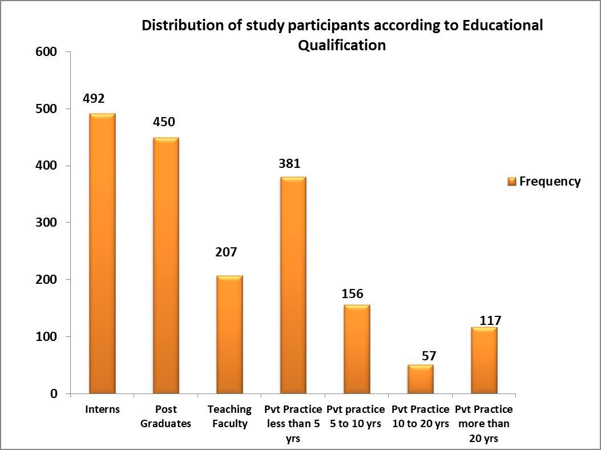

Figure 1 – Distribution of study participants according to Educational Qualification

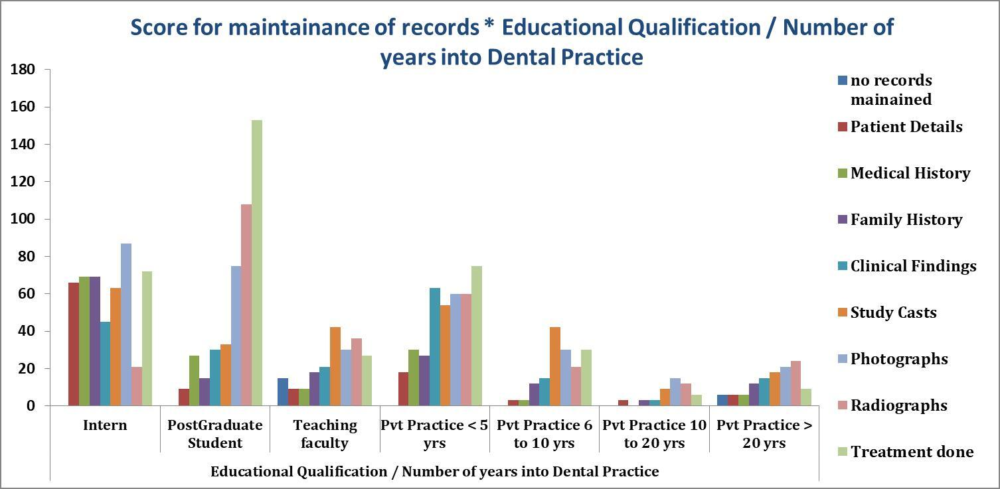

Figure 2 – Score for maintenance of dental records.

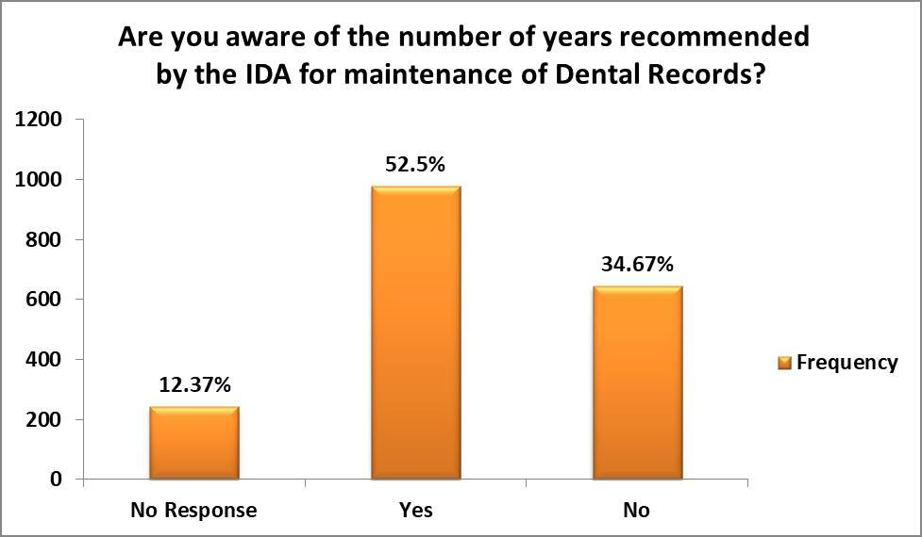

Figure 3– Response to awareness of the number of years recommended by the IDA for maintenance of Dental Records

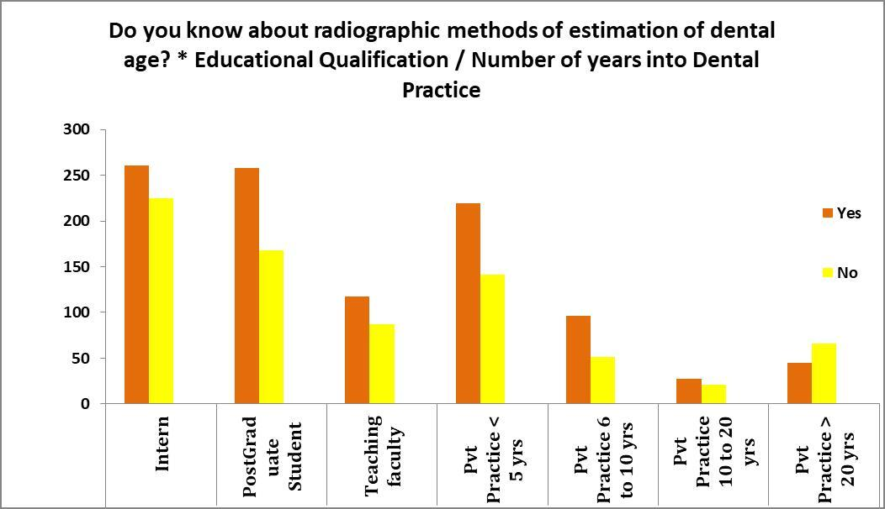

Figure 4 – Responses to awareness of radiographic methods of age estimation