**Assessment of knowledge and attitude among Dentists in India regarding the role of Ethics Committee.**

**Abstract –**

Background: Research activities in dentistry are increased greatly in India during the recent decade, but there is limited of information about the knowledge and attitude of dental faculty about the role of research ethics committee. To assess the knowledge and attitudes of dental faculty of India, this survey was carried out.

Materials and Methods: Through convenience sampling, a questionnaire was sent either via E-mails to 140 dental professionals, while protecting confidentiality and anonymity of all the participants.

Results: Our response rate was 100%. Among surveyed faculties, only 38.1% of total participants were having prior training in research ethics. A large number of participants (48.2%) think that incorporation of research ethics in postgraduate curriculum will be beneficial. There is fair knowledge about informed consent among researchers.

Conclusions: We conclude that there was wide acceptance for the research ethics committee and training in research ethics among dentists. Furthermore, there is need to incorporate research ethics training in undergraduate curriculum.

Key Words: Research ethics, Ethics committee

**Introduction –**

Dental research has been evolving globally. During the past years there have been remarkable advancements in the field of dentistry owing to the development of newer technologies and dental materials. This leads to the encouragement of newer researches being carried out.(1)

Also medical advances led by clinical trials lead to important innovations in patient care over the years with new drugs, devices, and biologics for the promotion of oral health.(2)

In most of the dental institutions, research studies make an integral part of dental curriculum. Majorly post-graduates students and faculty are involved in research projects. Nowadays many dental institutions in India are encouraging undergraduate students to undertake research projects. Most of the dental health care research involves human participants, such research needs to be guided by fundamental ethical principles. This may ensure the protection of the rights, integrity, safety and welfare of research participants. The values of ethics should be inculcated in every dental graduate as a responsibility towards rendering the highest standards of dental health care.(3) Also training in bioethics make dentists aware of patients’ rights, cultural differences and are equipped to resolve ethical dilemmas.(4) Research ethics govern the standards of conduct for scientific researchers.(5)

Dibbern and Wold suggest that medical students’ ethics training is best conducted in a workshop-based format that includes active research, reading, and discussion of ethical dilemmas. Group approaches such as conference and workshop formats can facilitate student interactions.(6)

In summary, to the best of our knowledge, there are few studies regarding the knowledge and ethical considerations about research studies among dentists in India. This study sought to address these questions.

**Materials and Methods –**

A cross-sectional survey was carried out over a period of 3 months from January to March, 2015 with the approval of the Institutional Review Board of the university. All the participants have given their consent for being a part of the study. The study participants included BDS graduates, post graduate students and faculty members from India.

A questionnaire was developed in order to assess the knowledge and attitude of participants regarding the role of ethics committee. The reliability of the questionnaire was validated by two observers independent of the study. The questionnaire was re-evaluated, and minor modifications were made for better understanding.

An internet platform was used to conduct the survey ([www.gforms.com](http://www.gforms.com)). The participants were approached using social media, dedicated mailing lists, and forums like Indian dental Association.

Through convenience sampling, a questionnaire was sent to 140 dental professionals, while maintaining anonymity of all the participants. Each participant signed an electronic informed consent form.

Questionnaire consisted of two parts; first part contains demographic details of participants, second part comprise of set of knowledge and attitude based questions.

A total of 12 questions were asked out of which 5 were knowledge based and 7 questions focused on the attitude of participants regarding the role of ethics committee.

Attitude was assessed on a five-point Likert scale ranging from 1 to 5 points (1 - Strongly agree, 2 - Agree, 3 - Not sure, 4 - Disagree, and 5 - Strongly disagree).

**Statistical analysis –**

The data was tabulated in MS excel sheet ((MS Office version 2007 developed by Microsoft, Redmond, WA) and was subjected to statistical analysis. All the analyses were performed using SPSS 24.0 version and p value less than 0.05 was considered as level of significance. Chi square test was used to analyse the frequency of categorical data.

**Result –**

A total of 140 study participants responded, with a response rate of 100%. A total of 50 respondents were males (63.1%), while 90 were females (36.9%) [Graph 1]. The age group of the study subjects ranged from 21 to 63 years.

The distribution of study subjects based on academic position is shown in graph 2.

A total of 41.3% of MDS faculties, 29% pursuing MDS, 27.5% of BDS graduates and 2.2% of Ph.D holders responded to the survey.

Among surveyed faculties, 61.9% faculties had not attended training in bioethics. Only 38.1% of total participants were having prior training in research ethics. Majority of BDS participants had not attended training in bioethics and the difference was statistically significant. ( p value = 0.003) (Graph 3)

Research participants feel that the incorporation of a bioethics curriculum in initial period of postgraduate programme would be beneficial. (p value = 0.004) (Graph 4)

**Discussion –**

In the recent years, there has been tremendous increase in dental research all over the world. Many institutions make research work as an integral part of dental curriculum. The field of dentistry adheres to same ethical standards embraced by field of medicine. Researcher should be aware of the ethical, legal and regulatory requirements for research involving human subjects.

The present study investigates knowledge and attitude among dentists in India regarding role of research ethics committee.

The surveyed dental faculties were in acceptance for the incorporation of a bioethics in initial period of postgraduate program curriculum.

In the present study, very few participants felt that research studies increases the burden in curriculum among dental students. The opinion was held high among BDS participants. This can be because of lack of prior research ethics training or unfavourable experiences with research ethics committee.

Research participants disagree that review by research ethics committee would delay research. The survey carried out also brings to notice the attitude of dental faculty towards certain practices in research ethics. A large percentage of faculties were aware of the practices regarding confidentiality protection and several aspects of informed consent process. Majority of participants found the need to obtain informed consent for biopsy/blood samples for clinical tests.

The present survey found that majority of BDS participants had not obtained any training in research ethics.The level of knowledge about research ethics was considerably better for participants who had received prior training in research ethics.

The limitations of study include self reported data and the participants may have responded in a socially desirable manner.

**Conclusion –**

The findings of the present study show that there exists some gap in knowledge about research. There was wide acceptance for the research ethics committee and training in research ethics among dentists. Furthermore, there is need to incorporate research ethics training in undergraduate curriculum. Such efforts can lead to enhanced knowledge and acceptance of research ethics principles among investigators.

**References –**

1. Gopinath NM, John J, Senthilkumar E, Nagappan N. Knowledge awareness and attitude about research ethics among dental faculties in India. The journal of contemporary dental practice. 2014;15(5):608–613.

2. Giannobile WV. Improving Clinical Trials in Dentistry. J Dent Res. 2015 Mar;94(3 Suppl):6S-7S.

3. Deolia SG, Prasad KVV, Chhabra KG, Kalyanpur R, Kalghatgi S. An insight into research ethics among dental professionals in a dental institute, India-A pilot study. Journal of clinical and diagnostic research: JCDR. 2014;8(9):ZC11.

4. Janakiram C, Gardens S. Knowledge, attitudes and practices related to healthcare ethics among medical and dental postgraduate students in south India. Indian journal of medical ethics. 2014 Apr 14;11:99–104.

5. Mallela KK, Walia R, TM CD, Das M, Sepolia S, Sethi P. Knowledge, Attitudes and Practice about Research Ethics among Dental Faculty in the North India. J Int Oral Health. 2015;7(Suppl 2):52–6.

6. Berk NW. Teaching Ethics in Dental Schools: Trends, Techniques, and Targets. Journal of Dental Education. 2001 Aug;65(8):744–50.

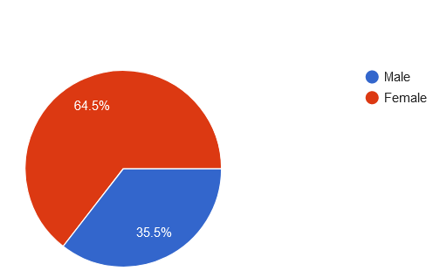

Graph 1- The distribution of study participants according to gender

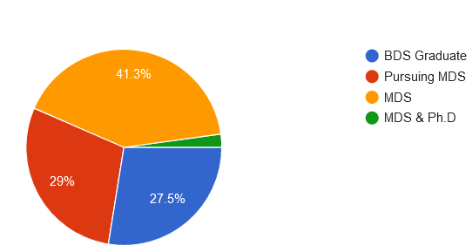

Graph 2- The distribution of study participants based on academic position

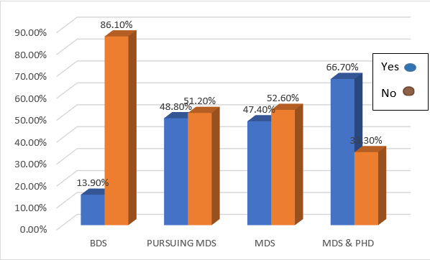

Graph 3 – The distribution of participants who have received training in bioethics

Graph 4 – Response of participants on incorporation of a bioethics curriculum in initial period of postgraduate programme

(1 –Strongly agree, 2- Agree, 3- Not sure, 5- Strongly disagree)

**Figure legends –**

Graph 1 - The distribution of study participants according to gender

Graph 2 - The distribution of study participants based on academic position

Graph 3 - The distribution of participants who have received training in bioethics

Graph 4 - Response of participants on incorporation of a bioethics curriculum in initial period of postgraduate programme