Introduction:

India has the highest burden of tuberculosis in the world; accounting for 26% of global incidence of TB (Tuberculosis).¹ A significantly strengthened RNTCP (Revised National Tuberculosis Programme) is currently operational in India. The whole of India was covered by RNTCP in March 2006.² The development of PMDT (Programmatic Management of Drug Resistant Tuberculosis) is the latest addition in the armoury of RNTCP to fight the menace of drug resistant tuberculosis. The programme, however, needs an ethical introspection as to whether it has provided the best possible treatment over the years to the patients dependent on the programme. For fighting the problem of drug resistant TB, the initial management of all TB cases needs to be the best possible management in line with the existing guidelines. This everlasting update process is extremely important to the success of any programme. However, the current state of TB management in India is reflected by a statement that recently appeared in an editorial in IJMR (Indian Journal of Medical Research), “…Early and effective TB treatment and control is difficult in India with its current tools and systems.” ³ To provide quality healthcare services to the patients is the ethical responsibility and obligation of the system. And, as per the RNTCP, the health system is responsible and accountable for cure, and not the patient.⁴ Drug-resistant tuberculosis is a man-made problem.⁵ If the proportion of this problem is increasing day by day then somewhere something is wrong. One of the important factors in this regards is the treatment received by TB patients.

Recently an XDR TB (Extensive Drug Resistant Tuberculosis) patient was initiated on Regimen for XDR TB at our DOTS Plus site under PMDT. The case is being presented here with an aim to analyse the treatment received by her during her course of illness. The discussion aims to analyse programmatic management of tuberculosis in India by highlighting and discussing the various issues in relation to the management received by the patient. The article further introspects whether the RNTCP, as it stands today, requires inculcation of an ethical aspect to it?

Case Report:

A 19 year old unmarried female college student presented with cough and breathlessness on and off since last six years. There was associated fever, anorexia and weight loss too. She was admitted as a diagnosed case of XDR TB under PMDT programme in India. Her past history of intake of anti tuberculosis drugs was as mentioned in table no. 1. Her DST (Drug Sensitivity Testing) from accredited laboratory under PMDT as per WHO (World Health Organisation) norms was as mentioned in table no. 2. Family history: She had history of tuberculosis contact in the family. Her father had taken category I anti tuberculosis treatment for pulmonary tuberculosis in 2008 and completed its 6 months course irregularly to which there was no clinical response. On 30.03.2009 he was started on category II anti tuberculosis treatment to which his adherence was again irregular and he expired on 7.04.2009 due to his respiratory disease. Her father was a labourer and a chronic alcoholic (consuming approximately 180 ml country liquor /day for 30 years). He was also a smoker, smoking 1 bundle of bidi per day for 30 years. Socioeconomic History: Her socioeconomic status as per the modified kuppuswami socio economic scale was lower middle (III) socio economic class. Personal history: The patient was a college student with no any other medical disease. Examination findings: Her general examination revealed her to be underweight with a body mass index of 13.78 with presence of pallor. Her respiratory system examination revealed features of volume loss on right side and breath sounds were decreased on right side. Investigations: Her sputum smear and culture were positive for tuberculosis. Her culture drug sensitivity testing results were suggestive of XDR Tuberculosis. Her chest X-ray showed right side pleuro- parenchymal fibrosis i.e. her right lung was totally “destroyed”. Thus the salient aspects of this case have been highlighted in table no. 3.

Discussion:

Background of TB programme in India:

Before discussing the various issues related to the case, a brief description regarding the Indian RNTCP programme is presented below so as to enable us to understand the programmatic management received by the patient in a better way.

Indian RNTCP Programme:⁴ RNTCP or the Revised National Tuberculosis Control Program is the state-run tuberculosis control initiative of the Government of India. The two regimes under RNTCP are mentioned in table no. 4.

PMDT (Programmatic Management of Drug Resistant Tuberculosis):⁶ Case definitions: MDR-TB case: A TB patient whose sputum is culture positive for mycobacterium tuberculosis and is resistant in-vitro to Isoniazid and Rifampicin with or without other anti-tubercular drugs based on DST results from an RNTCP-certified culture & DST laboratory XDR TB case: An MDR TB case whose recovered M. tuberculosis isolate is resistant to at least isoniazid, rifampicin, a fluoroquinolone (Ofloxacin, Levofloxacin, or Moxifloxacin) and a second-line injectable anti TB drug (Kanamycin, Amikacin, or Capreomycin) at a RNTCP- certified culture & DST laboratory. MDR TB suspect as per current programme guidelines are mentioned in table no. 5. Thus all retreatment cases, HIV TB cases and new cases which are smear positive at 2 months or later are MDR TB suspects for all practical purposes. The two regimes for MDR TB and XDR TB under PMDT are mentioned in table no. 6. Regimes for MDR TB (previous category IV) is inititated in patients with diagnosed MDR TB or with Rifampicin resistant TB. Patients who fail regimen for MDR TB or whose 4th month culture is positive are investigated for XDR TB. If diagnosed with XDR TB, then the patients may be initiated on regimen for XDR TB.

Issues to be considered in this case:

- The patient was very regular in her antituberculosis treatment and throughout the course of her treatment never deviated from the treatment being provided to her under RNTCP. Thus the patient, through no fault of hers ended up being a case of XDR TB. We are at a loss for words in explaining to such patients why they developed drug resistant tuberculosis, we ourselves being a part of the healthcare system in this country.

- Her father too had taken all his anti tuberculosis treatment from the government sector until his death from the illness while under treatment. Since he was a chronic alcoholic and smoker, his drug adherence and regularity of treatment was questionable and presence of co morbidities like alcoholic liver disease could not be excluded as a contributory factor to his illness. These were also risk factors for development of drug resistance. He was an MDR TB suspect since he was sputum smear positive at the start of the retreatment regime.⁶ Thus our patient, through no fault of hers, was exposed to a patient who was MDR TB suspect and was hence placed at risk of developing drug resistant tuberculosis. Social evils like addiction of smoking and alcohol do have this ugly face and these need to be recognized and tackled. Also inspite of being an MDR TB suspect, her father was never worked up under the RNTCP for the same and also there is currently no provision of isolation of such cases to prevent the chain of transmission. The fact that isolation and segregation practices are currently not advocated in RNTCP, could have led to either one of them contracting the disease from the other since the mode of spread of tuberculosis is aerosol based transmission through the air we breathe.

- Adding a single drug to a failing regime is against the basic principle of tuberculosis chemotherapy⁴ and category II is nothing but adding a single drug added to the failed regime of Category I. Also the patient had, during the course of the illness, received the same category II five times! And she had not responded to it. These are again factors responsible for drug resistance as the patient was given the same regime again and again to which she was not responding, she was probably resistant to the drugs in the regime at this stage.

- Intermittent therapy: The patient had through out the course of her treatment received intermittent chemotherapy with first line anti TB drugs until she was converted to a case of MDR TB. WHO treatment guidelines recommend daily TB chemotherapy instead of intermittent chemotherapy due to high risk of acquired resistance in patients receiving thrice weekly regime as in the RNTCP.⁷ This could be a contributory factor to the development of drug resistant tuberculosis in the patient. In such a scenario, the question that needs to be answered is how far are we ethically and morally correct in referring diagnosed TB patients to a programme (i.e. RNTCP), which has an inbuilt, proven and causative risk factor of acquired drug resistance (i.e. intermittent therapy) ? Aren’t we pushing our patients into the jaws of drug resistant tuberculosis and thereby a more serious form of illness compared to the existing one? These questions need to be thought and answered by us individually as well as collectively, we being an integral part of this healthcare system. The RNTCP programme needs to adapt as early as possible to the daily anti tuberculosis regime. If the programme can provide more number of drugs for a longer duration of treatment for drug resistant tuberculosis on a daily basis, then there shouldn’t be more delay on initiating short course daily chemotherapy with first line drugs based on the current WHO recommendations.^{6,7} There is already a delay of three years since the guidelines first endorsed daily chemotherapy in 2010 and as this delay period goes on increasing, the outcomes aren’t going to be painting any rosy picture either.

- Delay in diagnosis of drug resistant tuberculosis: The patient was MDR TB suspect each time the patient was declared a failure and also each time she was sputum smear positive at the start of a retreatment regime. But the patient was diagnosed as MDR TB as late as 20.10.10 i.e after four years into the course of her illness. She was again diagnosed as XDR TB on 28.06.12 i.e after almost six years into the course of illness. Had all her 1st and second line culture DST been done at an earlier stage when she had become an MDR suspect, probably this delay would not have been there and she could have been diagnosed much earlier leading to an early intervention which could probably have improved her outcome. The issue here is the delayed incorporation of the recommended guidelines by the RNTCP programme in India. The Delayed incorporation of management of drug resistant tuberculosis under RNTCP considering the publications of WHO guidelines on management of drug resistant tuberculosis can be gauged from the following facts: “Guidelines for establishing Dots-Plus pilot projects for the management of multidrug-resistant tuberculosis” were published by the WHO in year 2000.⁸ WHO publication by Toman in year 2004 also had described about category IV regime.⁵ Gujarat was the first state to initiate DOTS Plus services in India in August 2007.⁹ And this was seven years after the WHO had first come out with guidelines on programatic management of drug resistant tuberculosis. An early implementation and decisions based on standard international guidelines thereby keeping a regular update of the management protocols in line with the upcoming evidences is the need of the hour for the RNTCP. May be, if the DOTS PLUS guidelines were implemented at an earlier stage, many such patients as the one in the present case could have been diagnosed and probably been treated accordingly.

- Isolation & other infection control issues: The patient was never advocated isolation throughout the course of her illness. This needs to be analysed if isolation of such drug resistant TB suspects is required. RNTCP does not recommend isolation or sanitorium based on results of the Chennai trial.^{5,10} However it needs to be mentioned here that drug resistant TB cases were excluded in that study and hence the results should not apply to drug resistant TB cases. WHO in its policy on TB infection control recommends that “While culture positive, XDR-TB patients should be isolated at all times, and any person in contact with a culture positive XDR-TB patient should wear a particulate respirator.¹¹ Compulsory isolation or detention is a very difficult decision but health risk to the community at large due to such cases need to be considered. As set forth in the Siracusa principles , this means that such measures must be: in accordance with the law; based on a legitimate objective; strictly necessary in a democratic society; the least restrictive and intrusive means available; and not arbitrary, unreasonable, or discriminatory.¹² Also as per recent WHO guidance on ethics of Tuberculosis Prevention, Care and Control, isolation or detention should be limited to exceptional circumstances when an individual: is known to be contagious, refuses treatment, and all reasonable measures to ensure adherence have been attempted and proven unsuccessful or is known to be contagious, has agreed to ambulatory treatment, but lacks the capacity to institute infection control in the home or is highly likely to be contagious (based on symptoms and evidence of epidemiological risk factors) but refuses to undergo assessment of his/her infectious status.¹³ On all accounts, this ethical issue needs to be thought about to determine the weightage that needs to be give to the patient’s rights vis-a-vis the health risk faced by the community at large, in such cases (due to unrestricted movements of these infective cases).

- Lack of Psycho-socio-economic support to the patuent: Apart from providing free management of Tuberculosis, the programme doesn’t recognise the other needs that the patient faces. Medications can cure Drug Resistant TB only if the patient does not interrupt or abandon the treatment. The management of Drug Resistant TB requires far more than medications. It involves socio-economic and psycho-emotional support to the patients.¹⁴ Some of the problems that this patient is prone to face are as follows:1. Only one earning member in a family of 4 (Her brother is the earning member). 2. Her father’s death due to tuberculosis has the potential to create a fear in her that TB is incurable and ultimately leads to death. The father’s death to TB also has created a void in her life. Being afflicted with the disease for so long also has the potential of developing a thought of her being a burden on her family members. Her studies have been interrupted. Her psycho emotional needs have to be recognised and tackled at the earliest. This requires a proper psychological support system by means of professional psychological counselling and that should be inbuilt in the system. 3. The patient suffering for so long with TB is very often labelled with a social stigma associated with TB. 4. There is no system in the RNTCP to counter social issues like alchoholism ( in patients with TB ) with which her father was afflicted. Increased role of medical social workers is required in the programme. Thus the programme needs to include a strong psycho-socio-economic component in itself to tackle these issues which are very important in the ultimate goal of curing the patient in toto. At present such a component is missing in the programme.

- Urgent need for rapid capacity building of PMDT services: Increased diagnostic and management facilities are urgently required in PMDT.¹⁵ The RNTCP plans to expand these services, but this needs to be done on an urgent basis so that patients like the one mentioned here are detected at an earlier stage and are benifited from early management.

Conclusion:

The case sheds light on the programmatic management of tuberculosis in India. The patient had throughout the duration of her illness showed full faith on the public healthcare system. There was no apparent fault of the patient in the above case and yet she landed up being a case of XDR TB. There are definitely some questions to be answered here.

Did the patient receive the best possible management that could be given to her?
No. Had all her culture & drug sensitivity testing been done at an earlier stage, the scenario would have been different. Also the intermittent regime that the patient received repeatedly prior to being diagnosed with drug resistant tuberculosis, has been linked with acquired drug resistance and is not recommended now even in programmatic conditions. If drug resistant tuberculosis is a “man made” phenomenon, and if the patient is not responsible in the phenomenon then who is? The development of drug resistance in this case seems to be “programme induced drug resistance”. The healthcare system has the ethical obligation to provide appropriate treatment to the patients. That the programme did not update itself at pace with the standard evidenced based recommendations definitely played a role in the genesis of drug resistance in the present case. The PMDT should aim at reducing the factors that lead to drug resistance and one of them is initial intermittent therapy received by all patients in RNTCP.

Need for inculcating a sense of ethics in RNTCP:
As a programme, RNTCP is a very strengthened programme, considering its 100% coverage in a densely populated country like ours. Providing free anti TB drugs for all forms of TB patients registered in it is a great effort & the programme needs to be lauded for this. But however, every patient in RNTCP deserves the best, correct & appropriate treatment for his illness and RNTCP has an ethical obligation to provide such a treatment to its patients. As per recent WHO guidance on ethics in TB, individuals undergoing TB testing and treatment should receive complete and accurate information about the risks, benefits, and alternatives available to them.¹³ What this case aims to highlight is the lack of this “alternative” treatment option in RNTCP which is the optimal treatment for such TB patients. Non-maleficence –“first, do no harm” (primum non nocere) is one of the basic principles of medical ethics.¹⁶ As seen in this case the patient had developed drug resistant TB, which was “programme induced”. The very principle of non-malifence has been breached in this case. The RNTCP needs to correct the management of all such cases so that such mismanagement is not repeated in future in confirmation with the basic principles of medical ethics. The RNTCP needs to have an ethical introspection into its management of TB patients.

Indeed inculcating a sense of ethics in management of this disease will definitely help our health care system rather than following merely a target based approach where the most important things are the numbers or targets to be achieved and not the individual patients.

References:

1. World Health Organization. Global Tuberculosis Report 2012. WHO, Geneva, Switzerland. WHO/HTM/TB, 2012.
2. Tuberculosis India 2010. Annual Report of the Revised National Tuberculosis Control Programme. New Delhi: Central Tuberculosis Division Directorate General of Health Services, Ministry of Health and Family Welfare, Government of India; 2010.
3. Small PM, Katoch VM. India's contribution to global TB control: Innovative & integrated implementation research. Indian J Med Res. 2012; 135:267–9.

4. Central Tuberculosis Division. Training Course for Program Manager (Module 1–4). Director General of Health Services, Ministry of Health and Family Welfare, Government of India; 2011.
5. Frieden, T. R. Toman's tuberculosis: case detection, treatment and monitoring: questions and answers. 2nd ed. Geneva, Switzerland: World Health Organization; 2004.
6. Central TB Division. Guidelines on Programmatic Management of Drug Resistant TB (PMDT) in India. Directorate of General Health Services, Ministry of Health and Family Welfare, Government of India; 2012.
7. World Health Organisation. Treatment of Tuberculosis: Guidelines for National Programmes. 4th ed. Geneva, Switzerland: World Health Organization; 2010.
8. World Health Organization. Guidelines for establishing DOTS-Plus Pilot Projects for the management of multi drug resistant tuberculosis (MDR-TB). Arnadottir T, Gupta R, eds. WHO/CDS/TB/2000.278. Geneva, Switzerland: WHO; 2000.
9. TBC India [Internet]. New Delhi: Central Tuberculosis Division Directorate General of Health Services, Ministry of Health and Family Welfare, Government of India [Cited 2013 Jun 23]. Available from: http://www.tbcindia.nic.in/pdfs/RNTCP%20Launches%20DOTS%20Plus%20treatment.pdf
10. Tuberculosis Chemotherapy Centre, Madras. A concurrent comparison of home and sanatorium treatment of pulmonary tuberculosis in South India. Bull World Health Organ 1959; 21: 51-144.
11. World Health Organization. WHO policy on TB infection control in health-care facilities, congregate settings and households. Geneva: World Health Organization; 2009.
12. UN Commission on Human Rights. The Siracusa Principles on the Limitation and Derogation Provisions in the International Covenant on Civil and Political Rights, 28 September 1984, E/CN.4/1985/4.[Cited 2013 Jun 23]. Available from: http://www.unhcr.org/refworld/docid/4672bc122.html.
13. World Health Organization. Guidance on ethics of tuberculosis prevention, care and control [Internet]. Geneva: WHO; 2010. [cited 2013 June 20]. Available from: http://whqlibdoc.who.int/ publications/2010/978924150031 eng.pdf.
14. Eda Palacios Latorre, Julio Acha Albújar. Socio-Economic and Psycho-Emotional Support for MDR TB management: identifying needs and monitoring support in Peru. [Internet]. [Cited 2013 June 20].Available from: http://www.ghdonline.org/uploads/PalaciosAcha_-_psychosoc_support_MDRTB.pdf.
15. Tbcindia.nic.in [Internet]. RNTCP Response to Challenges of Drug resistant TB in India; c2012 [updated 2012 Jan]. [Cited 2013 Jun 23]. Available from: http://tbcindia.nic.in/pdfs/RNTCP%20Response%20DR%20TB%20in%20India%20-%20Jan%202012%20update.pdf.
16. Gillon R. Medical ethics: Four principles plus attention to scope. Brit Med J. 1994; 309(5):184.

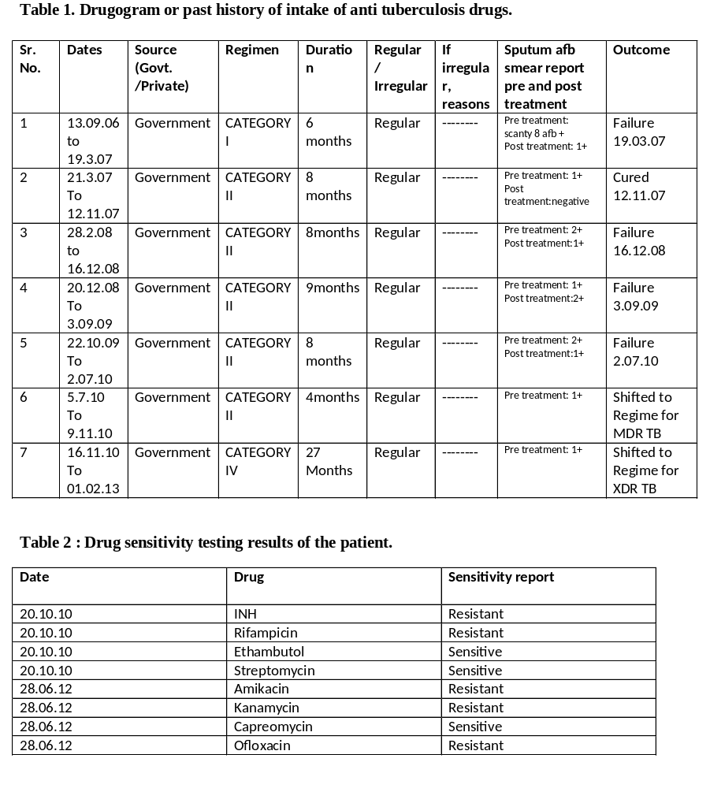

Table 3: Salient aspects of the case
Salient aspects of the case:
- The patient was always regular in taking her anti TB medications.
- Throughout the course of her illness the patient had taken treatment from the government sector and was treated as per the existing guidelines of Revised National Tuberculosis Programme in India.
- When the patient had failed category I* for the first time, she was put on category II** regimen which was addition of a single drug (Streptomycin) to the failed cat I regimen.
- The patient had received the same category II regimen for 5 times till 9.11.10. For the first time she was declared cured based on sputum AFB (Acid Fast Bacilli) smear negative report. The programmatic outcome of category II was failure on 3 times and the 4th time she was shifted to regimen for treatment of MDR TB (Multi Drug Resistant Tuberculosis) after she was diagnosed to be a case of MDR TB.
- The patient was first registered under RNTCP on 13.09.06 and was diagnosed as MDR TB on 20.10.10. She was further diagnosed as XDR TB on 28.06.12.
- After diagnosis of XDR TB on 28.06.12, the patient was finally initiated on regimen for XDR TB on 1.02.13.
- The patient came from lower middle (III) socio economic class.
- Family history of the patient revealed a history of TB contact with her father, who was a chronic alcoholic and took category I anti tuberculosis treatment under RNTCP in 2008. Alcoholism was a risk factor for irregular treatment compliance in the patient. Also the patient was a heavy smoker, which is an independent risk factor for tuberculosis.⁶Her father had died of TB relapse in 2009 after just one month of initiation of category II anti TB regime.
- Throughout the course of her illness the patient had continued her routine activities which involved going to college, public places, etc.
*CAT I is now known as regimen for new patients. **CAT II is now known as regimen for previously treated patients.

Treatment  groups | Type of patient | Regimen
Treatment  groups | Type of patient | Intensive Phase  (IP) | Continuation  Phase (CP)
New | Sputum smear-positive  Sputum smear-negative  Extra-pulmonary  Others | 2H₃R₃Z₃E₃ | 4H₃R₃
Previously  Treated | Smear-positive relapse  Smear-positive failure  Smear-positive treatment after default  Others2 | 2H₃R₃Z₃E₃S3  / 1H₃R₃Z₃E₃ | 5H₃R₃E₃
The number before the letters refers to the number of months of treatment. The subscript after the letters refers to the number of doses per week. The drugs are as follows: Isoniazid (H), Rifampicin (R), Pyrazinamide (Z), Ethambutol (E), and Streptomycin (S).
Table 4: RNTCP Treatment Regimes

Table 5: MDR TB suspects as per current programme guidelines
MDR TB suspects as per current programme guidelines:
1. All failure of new TB cases.

2. Smear positive retreatment cases who remain smear positive at 4th month onward.

3. All pulmonary TB cases who are contacts of known MDR TB case.

4. All smear positive retreatment cases at diagnosis.

5. All smear positive follow up result in a new or previously treated cases.

6. All smear negative treatment cases at diagnosis.

7. HIV-TB co infected cases at diagnosis.

Table 6: Regimes under PMDT
Regimes under PMDT | Intensive phase (IP)* | Continuation Phase (CP)** | Reserve/ substitute drugs
Regimen for MDR TB | 6 -9 Km Lvx Eto Cs Z E | 18 Lvx Eto Cs E | PAS, Mfx, Cm
Regimen for XDR TB | 6-12 Cm, PAS, Mfx, High dose-H, Cfz, Lzd, Amx/Clv | 18 PAS, Mfx, High dose-H, Cfz, Lzd, Amx/Clv | Clarithromycin, Thiacetazone
*Intensive Phase for MDR TB: 6 to 9 months. Intensive Phase for XDR TB: 6 to 12 months.
**Continuation phase for MDR and XDR TB: 18 months.
Drugs: Km-Kanamycin, Lvx-Levofloxacin, Eto- Ethionamide, Cs- Cycloserine, Z –Pyrazinamide, E- Ethambutol, PAS- Para Amino Salicylic Acid, Mfx- Moxifloxacin, Cm- Capreomycin, H- Isoniazid, Cfz- Clofazimine, Lzd – Linezolid, Amx/Clv- Amoxyclav

