Adherence to the Principles of Medical Ethics Among Iranian Physicians in Mazandaran Province

Ahmad Ghaderi¹; Farhad Malek^{2,}*; Mohammad Mohammadi¹; Somayeh Rostami Maskopaii³; Amir Hamta⁴; Seyyed Abdollah Madani⁵

1. Medical Ethics PhD Candidate, Medical Ethics and History of Medicine Research Center and Department of Medical Ethics, Faculty of Medicine, Tehran University of Medical Sciences, Tehran, Iran
2. Internal Medicine Department, Kowsar Hospital, Semnan University of Medical Sciences , Semnan, Iran
3. Educational Research, Mazandaran University of Medical Sciences, Sari, Iran
4. Department of Epidemiology and Biostatistics, faculty of Health, Qom University of Medical Sciences, Qom, Iran
5. Traditional and Complementary Medicine Research Center, Mazandaran University of Medical Sciences, Sari, Iran

*Corresponding author: Farhad Malek, Internal Medicine Department, Kowsar Hospital, Semnan University of Medical Sciences, Semnan, Iran. Tel: + 98- 23 33437822, Fax: + 98- 23 33437838, E-mail: farhadmalek42@yahoo.com

Abstract
Background: One of the most important issues in the field of public health is medical ethics considerations. Medical ethics is a set of behaviors of physicians or medical teams, during work that appears as individual characteristics about patients, their relatives, community, workplace and colleagues. Medical ethics and medical services require particular principles that are known as principles of medical ethics. Ethics is very important in medical profession. This science reminds physicians‎ about ethics ‎rules, teaches‎ physicians how to treat patients and it is considered as the most important part of science and medical commitment. Medical ethics is classified to four principles, including autonomy, beneficence, non-maleficence and justice. These four principles are obstacles to unethical health care.
Objectives: The purpose ‏of this research is studying adherence to the principles of medical ethics among iranian physicians in Mazandaran province in 2014.
Patients and Methods: This research is an applied and descriptive – analytical study. The researcher made questionnaire has been used for collecting information and Pearson correlation coefficient for the relationship between variables.
Results: Results show that in the principle of autonomy, less than 50% of physicians adhere to 6 items, between 11 surveyed items. Participants believe that in the principles of beneficence and non-maleficence, about 40.7 of physicians adhere to effort and seriousness to acquire knowledge and skills after graduation and during their work. In the principle of justice, more than half of participants believe that physicians ''do not discriminate between patients on the basis of their property, social status or race."
Conclusions: The results show that physicians are aware of the principles of medical ethics; however adherence to these principles requires more training to physicians‎‎.

Keywords: Ethics; Medical; autonomy; beneficence; non- maleficence, justice.

Background
Medical ethics is a main component of medical education that intended to empower physicians in ethical decision making. (1) Medical ethics is in the category of applied ethics. Applied ethics focuses on professional rules and responsibilities in different fields. It is not only limited to bioethics issues but it is also included non-medical issues such as the economic issues (2). Applied ethics examines, solves and challenges ethical problems that health authorities including doctors, psychiatrists, dentists, and nurses are facing with them. Today, most human activity is discussed as a branch of applied ethics. And issues and questions such as how should I act? How we can decide about doing something that is morally correct? And such these issues are considered in the field of applied ethics. Many industrialized countries understand that inattention to ethical issues and evading the responsibilities and social obligations, can lead to the loss of that organization. Therefore, many successful companies have been trying to value researches about professional ethics due to they understand the importance of developing ethical strategy, and believe that an ethical culture should pervade organizations. Professional ethics refers to the logical use and consistent communication, knowledge, clinical skills, emotions and values in the medical profession (3). Professional ethics means that people should not acquire particular privilege by doing harm others or violating healthy competition (4). Professional ethics is obligations of a profession towards people(5). Medical ethics is very important among all branches of professional ethics. In fact, medical ethics is defined as an agreement between health-care professionals and the society that they serve (6). The reason for emphasizing the importance of medical ethics is that its issues are more than general ethic. Adherence to medical ethics can guide physicians clinical performance and helps to be trained as a physician. Not only it can improve physicians knowledge about biomedical research but also it guides health care policy. Good medical ethics is coherent, clear, accurate, logical, compatible and it has measurable indicator (7). Medical ethics has four principles included autonomy (obligation to respect for patient decision), beneficence (obligation to provide and balance benefit against the risks), non-maleficence (obligation to prevent from harm) and justice (obligation to fairness in the distribution of resources and risks) (8). Beauchamp and Childress describe autonomy, beneficence, non-maleficence, and justice as the normative standards of conduct (9). Considering that the medical ethics is an applied subject and provides systematic solutions to help the physician in moral issues, the purpose ‏of this research is studying adherence to the principles of medical ethics among iranian physicians in Mazandaran province in 2014.
Medical ethics is a science which examines the relationship between patient and physician, currently, four main principles of medical ethics are considered to help in ethical decision (Figure 1). In fact, the principles of medical ethics are acceptable criteria for good medical ethics (10). The aim of good medical ethics should be trying to earn the highest standard of human health to enjoy of their life (11). These principles are very effective in the field of medical ethics, and they are basis of ethical evaluation of health care (7) and they would be as an obstacle to unethical health services (12). Adherence to ethical principles is very important that managers of health care systems consider it specially.

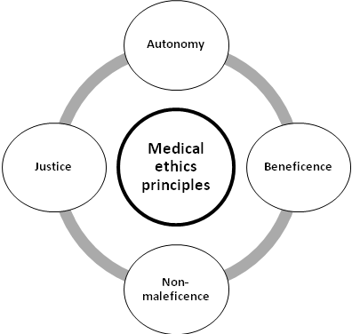
Figure 1: Medical ethics principles

"Autonomy" is a Greek word, it means respecting to patients decision. Today, patient autonomy is an accepted principle of medical ethics (13) and it is considered as one of the most important principles of communication between patient and physician. Autonomy as an ethical principle and bio ethical recognizes human capacity to determine their own destiny. According to This principle, patient independence must be respected by physicians (14). Autonomy is defined as the capacity of making choices (15). According to the principle of autonomy, patients have the right to make their own decisions about medical treatment. Autonomy has two necessary conditions, liberty and agency. Liberty means patient do not be controlled by other factors; and agency means patient should have the ability to decision-making.
"Beneficence" refers to actions which improve people welfare and comfort, and the concept of beneficence in medical terms, means doing activities which are useful for patients. In biomedical ethics principles, beneficence is considered as one of main criteria of ethical principles and health care. Beneficence is one of the fundamental principles of medical ethics. According to principle of beneficence, physicians should consider the most benefit for patients and avoid unnecessary actions that do not have any physical or mental effects on patients (16). The principle of beneficence, physicians should adhere to programmed action for patient. (17).
"Non-maleficence" means do no harm (18). Many physicians believe that this issue should be considered as a basic principle of treatment process. The main duty of the therapists is providing the best service, and also physicians must not harm a patient. According to “Minimalistic” view even if physicians are not obliged to benefit the patient, their duty is avoidance of harming patients. However, many medical actions are practically followed by risks which are inevitable. The physicians should attempt to cure patients with the least injury at the time of diagnosis, treatment or rehabilitation. Therefore, physicians are allowed to cure patient with a method that its advantages are more than disadvantages (19).
“Justice" is an effective subject in social health. It is one of the most important principles and heading in medical ethics. Not only does it allocate medical resources to patients, but it also provides living conditions for all people to keep them healthy and far away from disease. In fact, justice in medical ethics is equitable distribution of resources among patients, therefore all patients who suffer from one kind of disease should benefit from equal health services and facilities (20); without considering their property, social status and race.
The medical ethics principles examine the relationship between physician and patient. Good communication between physician and patient has the fundamental role in the health care and it is an effective factor to improving patient health. Trust is the most important factor of creating appropriate communication between physician and patient, and it will have positive impact on improving and increasing effectiveness of treatment. Thus, it causes increasing patient satisfaction with treatment, obedience to physician orders and respect for patient autonomy. According to last study in Iran, there is a lack of trust between physicians and patients, thus they are looking for an appropriate strategy to improve that. Due to the importance of medical ethics principles, present research is examining iranian physicians belief in Mazandaran province by questions like ‘’ do physicians behave well as they were trained’’ and ‘’do physicians are sufficiently aware of medical ethics?”

Objectives: The purpose ‏of this research is studying adherence to the principles of medical ethics among iranian physicians in Mazandaran province in 2014.

Patients and Methods
This research is an applied and descriptive- analytical study. Researcher made questionnaire was used to examine physicians belief. The research questionnaire consists of 25 specialized items and 6 general items. First, the questionnaires were completed by 40 physicians and its validity was confirmed by medical ethics experts. Calculated results in the software SPSS 16 show that questionnaire reliability by Cronbach’s alpha coefficient was confirmed by 0.818%. Then, in random sampling method, questionnaires were completed by 300 physicians. The reliability and validity of the scale were calculated through Cronbach's alpha coefficient and factor analysis (KMO test) the results show 83% and 87%, respectively. Therefore, the questionnaire is reliable and valid.

Results
Due to beneficence and non-maleficence have almost similar concept; these variables were examined as one concept. Physicians belief about principles of autonomy, beneficence and non-maleficence and justice has been assessed by eleven, four and ten items, respectively. Participants general characteristics are stated in table 1.
Table 1: General characteristics of participations
item | variables | present
Sex | male | 67.7
Sex | female | 32.3
Accommodation | native | 83
Accommodation | non-native | 17
Education | general physician | 63
Education | specialist physician | 37
Occupation | governmental job | 43
Occupation | self-employed | 20.3
Occupation | working in clinic | 20.3
Occupation | governmental hospital employee | 4.3
Occupation | private hospital employee | 2.7
Occupation | others | 9.3

Cronbach's alpha coefficient in the principles of autonomy, beneficence and non-maleficence and justice are 0.606, 0.626, and 0.816, respectively; which represents internal harmony and fairly high correlation between the items of the research.

Assessment of autonomy principle
Respect for patient autonomy has specific value in medical ethic (21). This principle is focused on the independence or liberty of patient. It means that patient can decide freely (18).
Autonomy respects the ability of the individual to make decisions on their own health and future (17). According to Self-determination Theory (SDT), autonomy is a basic psychological need, satisfaction of which may lead to enhanced intrinsic motivation and related beneficial outcomes (22). Figure 2 represents adherence to principle of autonomy in Mazandaran province. 44% of participants believe that physicians consult with patient before any action. 48.7% of participants declared that physicians get patients consent. 12.7% of participants asserted that physicians use unethical methods to diagnosis of disease. 14% of participants believed that physicians use unethical methods to treat patients. 40% of participants believed that physicians get to appointments with patient on pre-set time. Most participants (59%) declared that physicians can communicate with patients very well. Also 44.3% of participants asserted that communication skills of physicians with patients family are fairly good. 39% of participants believed that physicians listen carefully to patients and converse with them. 43% of participants believed that physicians inform patients of diagnosis, cause of disease and treatment. 56.3% of participants believed that physicians care about patients rights based on freedom of decision-making. Most participants (91.7%) believed that physicians keep patients information completely confidential.
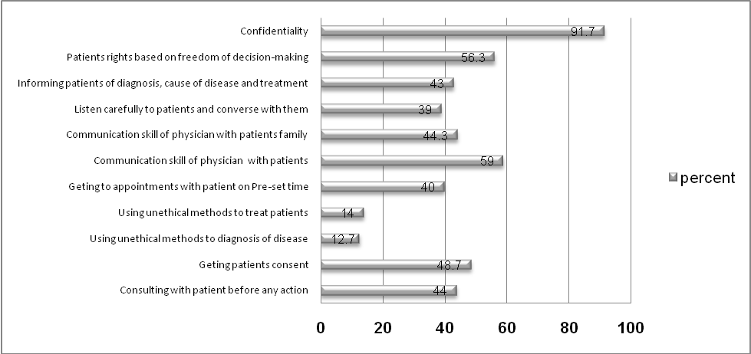
Figure 2: Adherence to principle of autonomy in Mazandaran province

Assessment of beneficence and non-maleficence principles
Beneficence is considered a core principle of medical ethics (23). This principle of beneficence states that a physician should protect patient interest and is responsible for providing facility to improve health and well-being of patient. The principles of beneficence ‎indicates important items such as kindness, humanism, love, compassion, humanity and so on in order the interests of others (18). The principle of beneficence emphasizes on provision of benefits patients (24). The principle of beneficence is one of four bioethical principles, which also include non-maleficence, autonomy, and justice. Beneficence is an ethical term; it is the obligation to act for the benefit of others (25). According to the principle of non-maleficence, physicians must not harm a patient through carelessness, malice, vengeance, or dislike (26). Figure 3 indicates adherence to the principles of beneficence and non-maleficence among physicians in Mazandaran ‎province. 86% of participants believed physicians attempt to minimize patient physical damage. And also 71% of participants asserted that physicians attempt to minimize psychological damage of patients. 40.7% of participants believed that physicians strive to get knowledge and skills after graduation and during their work. 35.7% of participants believed that physicians adhere to provide information to patients and training programs to enhance their empowerment.

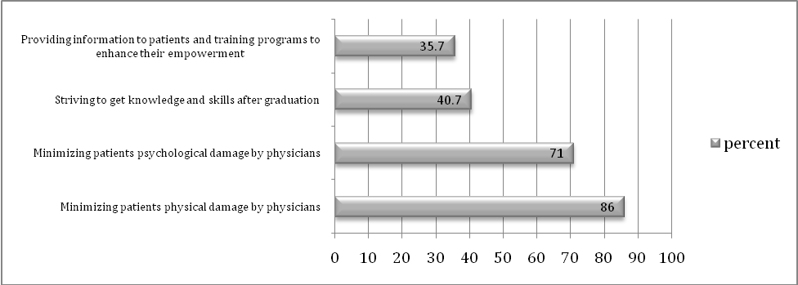
The Figure 3: Adherence to the principles of beneficence and non-maleficence among physicians in Mazandaran ‎province

Assessment of justice principle
Justice is one of the most important principles of medical ethics that must be completely obeyed in the health system. In distribution of medical resources it regard for fairness. This principle emphasizes ethics, law, and public policy. Who should receive scarce medical resources, and how should we distribute them in order to realize the best outcomes? (27). Justice can be subdivided into three categories: Fair distribution of scarce resources (distributive justice), respect for people rights (rights based justice) and respect for morally acceptable laws (legal justice) (28). Figure 4 indicates adherence to the principles of justice among physicians in Mazandaran‎ province. 55.3% of participants believed that physicians do not meddle their personal opinions in health care services. 50.3% of participants asserted that physicians try to provide health services to cure them completely. 55.3% of participants stated that physicians respect for patients equality right during making decision to provide health care services. 63.7% of participants believed that physicians respect for patients demands during making decision to provide health care services. Most participants (71%) believed that physicians regard for patients priorities during making decision to provide health care services. 59.7% of participants believed that physicians provide health services based on decisions that ministry of health and the medical council have made them. 47.3% of participants believed that physicians protect patients interests and prevent from wasting of country resources. 61.7% of participants believed that physicians do not discriminate between patients on the basis of their property. 54.1% of participants believed that physicians do not discriminate between patients on the basis of their social position. Most of participants (71%) believed that physicians do not discriminate between patients on the basis of their race.

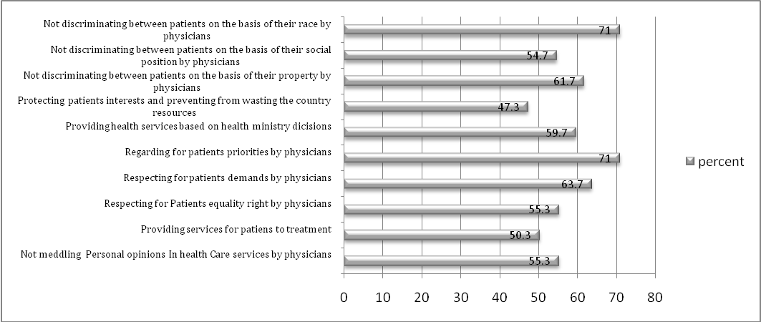
The Figure 4: Adherence to the principles of justice among physicians in Mazandaran‎ province.

Pearson correlation coefficient is used for measure relationships between variables.
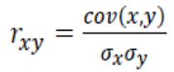
Pearson correlation coefficient is classified as follows:
    - weak and probably meaningless relationship: r= 0-0.2
    - low correlation that needs to be investigated: r = 0.2- 0.4
    - acceptable correlation: r = 0.4-0.6
    - high correlation: r = 0.6-0.8
    - extremely high correlation: r= 0.8-1

Pearson correlation coefficient indicates that there is significant relationship between variables. In table 2, the variables which had acceptable, high and extremely high correlation with each other, are mentioned. Table 2 indicates correlation coefficient of medical ethics principles variables between Mazandaran physicians.

Table 2: Correlation between variables of medical ethics principles
Reviews the autonomy principle items
variables | Significance level |  | variables
Absence of using unethical method to diagnosis of disease by physicians | .671 | High Correlation | Absence of using unethical method to treatment by physicians
Communication skill of physician with patients | .661 | High Correlation | Communication skill of physician with patients family
Listen carefully to patients and converse with them | .431 | Acceptable Correlation | Getting to appointments with patient on pre-set time
Listen carefully to patients and converse with them | .492 | Acceptable Correlation | Informing patients of diagnosis, cause of disease and treatment
Informing patients of diagnosis, cause of disease and treatment | .431 | Acceptable Correlation | Patients rights based on freedom of decision-making
Reviews the beneficence and non-maleficence principle items
Minimizing patients physical damage by physicians | .432 | Acceptable Correlation |  | Minimizing patients psychological damage by physicians
Reviews the justice principle items
Providing services for patients to treatment | .531 | Acceptable Correlation |  | Respecting for patients equality right by physicians
Respecting for patients demands by physicians | .421 | Acceptable Correlation |  | Providing services for patients to treatment
Respecting for patients demands by physicians | .464 | Acceptable Correlation |  | Respecting for Patients equality right by physicians
Respecting for patients demands by physicians | .452 | Acceptable Correlation |  | Regarding for patients priorities by physicians
Providing health services based on health ministry decisions | .414 | Acceptable Correlation |  | Regarding for patients priorities by physicians
Not discriminating between patients on the basis of their property by physicians | .477 | Acceptable Correlation |  | Not discriminating between patients on the basis of their race by physicians
Not discriminating between patients on the basis of their social position by physicians | .527 | Acceptable Correlation |  | Not discriminating between patients on the basis of their race by physicians
Not discriminating between patients on the basis of their property by physicians | .629 | High Correlation |  | Not discriminating between patients on the basis of their social position by physicians

Discussion
Iravani (2012) examined principles of ethics and religious in medical research and believes that physician prefer patients interests more than their own interests, they respect for all aspects of patient included physical, mental, and social, physicians feel responsibility for treating patients and transferring them to other medical centers. They usually get permission from patient for diagnosis, treatment. They respect for patient privacy (29). According to the findings of this study, less than 50% of physicians adhere to principles such as consulting with patient before any action, getting patients consent, getting to appointments with patient on pre-set time, listening carefully to patients and conversing with them, informing patients of diagnosis, cause of disease and treatment. Khademolhosseini, et al (2009) have concluded that physician adhere to the principle of autonomy about 37‎% (30). Although autonomy implies that physician should consult with patient before any action. On the other hand, getting patient consent and informing patients, demonstrate respect for patient autonomy. Certainly adherence to these instructions can maintain patient autonomy but also it does enhance the ability of physicians to help patients. According to the principles of professional medical conduct, physicians should explain different type of diagnostic methods to patient clearly while getting patient consent. In present study 87.3% participants asserted that physicians do not use unethical methods to diagnosis of disease. However, in the similar studies, Rafi Zadeh, et al (2007) concluded that one of the cases of malpractice of general physicians has been misdiagnosed (31). Present study shows that physicians respect for patients rights and keep their information private. Ghaljeh, et al (2010) concluded that physicians and nurses adhere to the patient rights moderately. (32). Garbin, et al (2008) concluded 44% of dentists have been aware of the principles of professional ethics. However, they did not maintain patient medical record confidentiality (33). In the principles of beneficence and non-maleficence, effort and seriousness to acquisition of knowledge and skills are adhered by physicians‎ less than 50% after graduation ‎and during work. Fadare, et al (2012) concluded that the knowledge of medical ethics by Nigerian medical doctors is grossly inadequate. There is an urgent need for enhancement of the teaching (34). Also, many researchers believe that medical staff should perform whatever that is helpful for patients. It is essential to have adequate knowledge to recognize a helpful action; therefore, medical staff should promote their knowledge and skills to increase beneficence to patients. Rafizadeh, et al (2007) studies indicate most of physicians malpractice are due to the lack of skill (31). Therefore, serious and effective education is essential commitment that should be considered by Mazandaran physicians. In the principle of beneficence there is acceptable correlation between physicians action to minimize physical harm and physicians action to minimize psychological harm. According to the principle of justice, physicians should not refuse to treat patients because of racial discrimination. In present study, physicians do not discriminate between patients on the base of race. Bohrani, et al (2012) concluded that 71% of dentists don't care to patients sex and nationality (race, colour, etc.) in treatment (35). In The principle of justice, less than half of participants (47.3%) believe that physicians adhere to preservation the interests of the patient, and avoid wasting the country resources. While in ethical principles and professional commitment, physicians should protect patients interests and prevent from wasting of country resource. In the medical professional conduct physicians should avoid imposing unnecessary cost on patient and waste of health system resource. Present study has had some limitations; for instance, only one province has been studied. And physicians (general physicians, specialists) who were active in continuous education programs have participated in this survey. Ultimately, this study faced with temporal limitation. Therefore, it is recommended that future investigations perform without locative and temporal limitation and include more general physicians, specialists and sub specialists. In conclusion, medical ethics, as a basic branch of public morality provides a valuable framework to define medical care norms. According to present study, there is a significant relationship between variables in four principles of medical ethics. Results show that adherence to indicators of beneficence, non-maleficence and justice have been almost good; however, physicians ethical behavior in the principle of autonomy has not been acceptable. Physicians pay less attention to consulting with patient before any action, getting their consent, getting to appointments with them on pre-set time, listening carefully, conversing and informing them of disease diagnosis. Therefore, the first priority of health care system should be changing physicians attitude about adherence to the principles of medical ethics, especially the principle of autonomy. Since physicians belief has been not desirable about adherence to some indicators of medical ethics, therefore, it is recommended that health care system to hold more ‎workshops and continuing education programs related to education the principles of ‎medical ethics and promotion of medical community culture to change the of Physicians attitude.

Funding/Support
This article does not have conflict of interest and financial support.

References
- Miles SH, Lane LW, Bickel J, Walker RM, Cassel CK. Medical ethics education: coming of age. Acad Med. 1989; 64(12):705-14. PMID: 2686674
- Collste G. Applied and Professional Ethics. Kemanusiaan the Asian Journal of Humanities. 2012; 19 (1): 17- 33.
- Dehghani A, Mosalanejad L, Dehghan-Nayeri N. Factors affecting professional ethics in nursing practice in Iran: a qualitative study. BMC Med Ethics. 2015; 16(1): 61. PMID: 26354119
- Jos, P H. Social contract theory: implications for professional ethics. Journal of Public Administration. 2006; 36(5): 139-55.doi: 10.1177/0275074005282860
- Liaschenko J, Peter E. Nursing ethics and conceptualizations of nursing: profession, practice and work. J Adv Nurs. 2004; 46(5):488-95. PMID:15139937
- Nathanson V. Medical ethics in peacetime and wartime: the case for a better understanding. International Review of the Red Cross.2013; 95 (889), 189–213. doi:10.1017/S1816383113000775
- Page K. The four principles: Can they be measured and do they predict ethical decision making? BMC Medical Ethics. 2012; 13: 2-8. PMID:22606995
- Beachamp TL, Childress JF. Principles of Biomedical Ethics. 5th Ed. New York: Oxford University Press; 2001.
- Prasad GV. A moral dilemma argument against clinical trials of incentives for kidney donation. Transplant Res. 2015; 4:3. PMID:26199722
- Gillon R. Defending the four principles approach as a good basis for good medical practice and therefore for good medical ethics. J Med Ethics. 2015; 41(1):111-6. PMID:25516950
- Serour GI. What is it to practise good medical ethics? A Muslim's perspective. J Med Ethics. 2015; 41(1):121-4. PMID:25516952
- Beauchamp TL. Methods and principles in biomedical ethics. J Med Ethics. 2003; 29 (5):269-74. PMID: 14519835
- Blais CM, White JL. Bioethics in practice - a quarterly column about medical ethics: ebola and medical ethics - ethical challenges in the management of contagious infectious diseases.The Ochsner J. 2015; 15(1):5–7. PMID:25829872
- Naik AD. , Carmel B. Dyer, Mark E. Kunik, Laurence B. McCullough. Patient Autonomy for the Management of Chronic Conditions: A Two-Component Re-conceptualization. Am J Bioeth. 2009; 9(2): 23–30. PMID:19180389
- Reach G. Patient autonomy in chronic care: solving a paradox. Patient Prefer Adherence. 2014; 8: 15–24. PMID: 24376345
- Rhodes R. Good and not so good medical ethics. J Med Ethics. 2015; 41(1):71–4. PMID:25516940
- Cheong MA, Tay SK. Application of legal principles and medical ethics: multifetal pregnancy and fetal reduction. Singapore Med J. 2014; 55(6): 298–301. PMID:25017403
- Tsai Daniel F-C. Ancient Chinese medical ethics and the four principles of biomedical ethics. Journal of Medical Ethics. 2015; 25(4):315-21. PMID:10461594
- Saeedi Tehrani S, Madani M. Bioethical principles and medical futility. Iranian Journal of Medical Ethics and History of Medicine, ijme. 2015; 7(6):1-14.
- Chung KC, Pushman AG, Bellfi LT.A systematic review of ethical principles in the plastic surgery literature. Plast Reconstr Surg. 2009; 124(5):1711-8. PMID:20009860
- Varelius J. The value of autonomy in medical ethics. Med Health Care Philos.2006; 9(3): 377–88. PMID:17033883
- Meng L, Ma Q.Live as we choose: The role of autonomy support in facilitating intrinsic motivation. Int J Psychophysiol. 2015. PMID: 26344180
- Salzano FM. Bioethics, population studies, and geneticophobia. J Community Genet. 2015; 6(3): 197–200. PMID: 25575494
- Stanley R. Applying the four principles of ethics to continence care. Br J Nurs. 1998; 7(1):44-51. PMID:9495956
- Gallagher SM. The beneficent nature of chronic wound care. Ostomy Wound Manage. 1999; 45(5):16-7. PMID: 10647471
- Oberbaum M, Gropp C. Martin Heidegger, beneficence, health, and evidence based medicine--contemplations regarding ethics and complementary and alternative medicine. Harefuah. 2015; 154(3):192-5. PMID: 25962251
- Runzheimer J, LarsenJ L. Medical Ethics for Dummies. First edition. United State. Published by Wiley Publishing; 2011.
- Gillon R. Medical ethics: four principles plus attention to scope. BMJ. 1994; 309(6948):184-8. PMID: 8044100
- Iravani Sh. Ethics and religious principles in Medical research. J Army Univ Med Sci. 2013; 11 (3): 252-59.
- Khademolhosseini Z, Khademolhosseini M, Mahmoudian F. The Ethical and Behavioral Role of Physicians in Compliance of Medical Directives by the Patient in the Treatment Process. The Iranian Journal of Medical Ethics. 2009; 3(8): 91-101.
- Rafizadeh Tabai Zavareh S, Haj Manoochehri R, Nasaji Zavareh M.Frequency of General Practitioners’ Malpractice in complaints which referred to the Commissions of Forensic Center in TehranFrom 2003 to2005.Scientific Journal of Forensic Medicine(IJFM). 2007; 13(3): 152-57.
- Ghaljeh M, Zakeri Z, Rezaee N, Abedzadeh R. Physicians and nurses awareness and function about patient’s right charter in Zahedan. Iranian Journal of Medical Ethics and History of Medicine, ijme. 2010; 3 (0 and 2):69-75.
- Garbin CA, Garbin AJ, Saliba NA, de Lima DC, de Macedo AP. Analysis of the ethical aspects of professional confidentiality in dental practice. J Apple Oral Sci 2008; 16(1): 75-80. PMID:19089294
- Fadare JO, Desalu OO, Jemilohun AC, Babatunde OA. Knowledge of medical ethics among Nigerian medical doctors. Niger Med J. 2012; 53(4):226-30. PMID:23661883
- Bahrani F, Farzin M, Nozari L. Shiraz dentists’ knowledge of professional ethics. Iranian Journal of Medical Ethics and History of Medicine, ijme. 2012; 5 (6):69-80.

