HEAT TRANSFER ENHANCEMENT BY USING TWISTED TAPE WITH SQUARE HOLES AND ALTERNATE AXIS

Mr. Pravin V. Mahakalkar

M.Tech Student [H&P] ,Dept. of Mechaanical Engg ,

SSPACE, Wardha, India

161017mahakalkar.pravin90@gmail.com

Prof. S. S. Jawre

Assistant Professor , Dept. of Mechanical. Engg ,

SSPACE, Wardha, India

jawre.sandip@gmail.com

Abstract— An experimental and numerical study was conducted to investigate the flow friction and heat transfer performance in tube with twisted tape having circular hole at the centre, Reynolds number range of 25000–95000. The study aims at improving the heat transfer efficiency of heat exchanger. The friction factor, Nusselt number and the overall thermal performance parameters of an align, twisted tape having circular hole at the centre have been obtained and compare with the plain tube. The comparisons showed that, compared with the plain tube, the tube with twisted tape without circular hole has further improved convective heat transfer performance by about 40% and whereas lowered flow friction. The twisted tape having circular hole at the centre tube shows about 50% greater thermal performance than, twisted tape without circular hole. In this paper we are only studying the case of simple forced convection heat transfer, in which we are not using any twisted tape, we are concentrating on finding a level that from which we have to work toward enhancement process by using twisted tape, and by using twisted tape with square hole and alternate axis.

Keywords: Heat transfer improvement technique, Passive methods, Tape inserts Heat transfer Rate,
Heat transfer without twisted tape.
1. Introduction
Heat transfer enhancement techniques refer to the improvement of thermal performance of heat exchangers. The heat transfer enhancement techniques are performed in wide spread applications. The results of those studies have been shown that although heat transfer efficiencies are improved, the flow frictions are also considerably increased. In this report the various wavy twisted tapes are used for heat transfer enhancement having various twist ratios. The strips are expected to induce a rapid mixing and a high turbulent and longitudinal vortex flow like a delta wing, of course, resulting in an excellent rate of heat transfer in the tube. Existing enhancement techniques can be broadly classified into three different categories:

(a) Active method: This method involves some external power input for the enhancement of heat transfer; some examples of active methods include induced pulsation by cams and reciprocating plungers, the use of a magnetic field to disturb the seeded light particles in a flowing stream, etc.
(b) Passive method: These methods generally use surface or geometrical modifications to the flow channel by incorporating inserts or additional devices. For example, use of inserts, use of rough surfaces etc.
(c) Compound method: When any two or more of these techniques are employed simultaneously to obtain enhancement in heat transfer that is greater than that produced by either of them when used individually, is termed as compound enhancement.

Different types of inserts are.
1. Twisted tape and wire coils 2. Ribs, Baffles, plates
The present paper Contributes for review of tape inserts.
Twisted tape: Twisted tapes are the metallic strips twisted with some suitable techniques with desired shape, inserted in the flow and dimension.

2 EXPERIMENTAL SETUP AND PROCEDURE :-

The apparatus consist of blower fitted with the test pipe. The test section is surrounded by band heater. Six thermocouple are placed in the air system at the entrance and exit, of the test section and two thermocouple are embedded on the test section to measure the air temperature. Test pipe is connected with the delivery side of the blower along with the orifice to measure flow of air through pipe. Input through the heater is given to a dimmerstat and measured by Voltmeter and Ammeter. A temperature indicator is provided to measure surface temperature of wall in the test section.

DIAGRAMS:

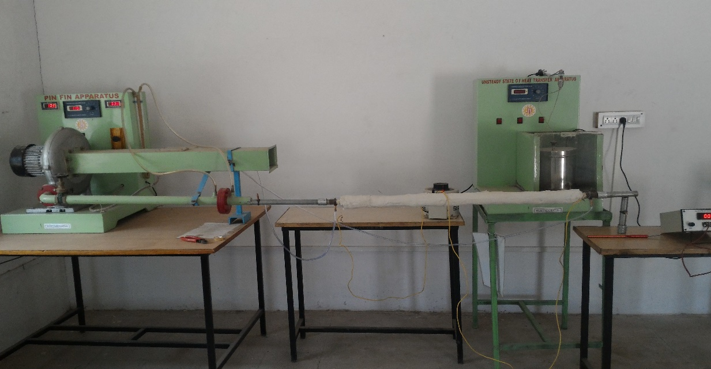

Fig. 1 Experimental Setup.
2.1 Experimental Procedure
Make sure that connections of the thermocouple are properly attached with the surfaces whose temperature is to be measured. Switch on the Heater input and Centrifugal Blower input. Using rheostat increase the supplied air heater input. Start taking readings with time, set as zero. The blower is started and mass flow rate of air is adjusted suitably with the help of gate valve to have turbulent flow. The mass flow rate of air is measured with the help of orifice meter. Pressure difference between inlet and outlet side of the pipe is recorded with the help of U-Tube Manometer and attached scale. Before taking the readings the steady state condition is maintained. Initially the readings on plain tube then tube with twisted tape without hole and the on tube with twisted tape with square holes and alternate axis were taken. This is to validate and compare the performance of tube with twisted tape with square holes and alternate axis with twisted tape without hole. The temperature readings T_{i} (Ambient temperature), T₁ (Air temperature at inlet side), T₅ (Air temperature at outlet side), and T₂ to T₄ (temperatures at different location in test section) were recorded with the help of Digital Temperature Indicator present with the apparatus.

3. Standard Formulation Used :-

The data reduction of the measured results is summarized in the following procedures:
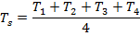 | 3.1
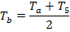 | 3.2
Discharge of Air:  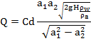 | 3.3
Mass flow rate of air =  Velocity | 3.4
Cross sectional Area:  =  Reynolds Number: | 3.5
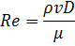  Heat transfer Coefficent: | 3.6
Where | 3.7
Experimental Nusselt number:  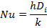 | 3.8
Pressure drop  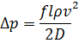  Enhancement Efficiency  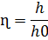 | 3.9  3.10

4. Result :-
4.1 Pressure Drop:
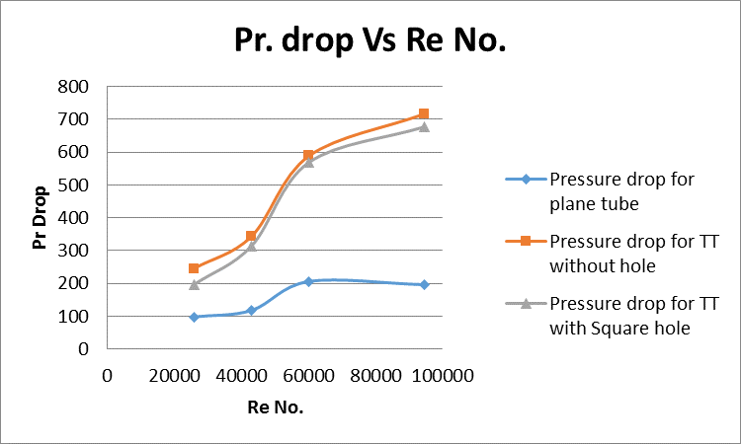
Fig.4.1.1: Pressure drop Vs. Re No for Plain tube, tube with twisted tape without hole, tube with twisted tape with hole.
Over the studied Reynolds number range, twisted tape without hole shows the highest friction factors, which are slightly higher than twisted tape with holes and plain tube . Pressure drop goes on increase as Re no also increases. In case of insert twisted tape without hole pressure drop is maximum because tape has large material than the twisted tape with hole that’s why pressure drop is maximum.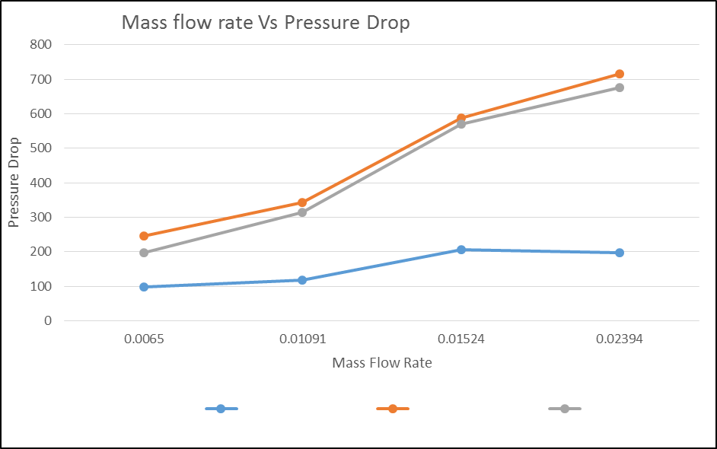 4.1.2 mass flow rate Vs Pressure Drop for plane tube, without holes And with square holes
In this Condition the mass flow rate are Constant for three condition, without square holes the pressuere drop is maximum as compare to the with square holes and plane tube. In case of insert twisted tape without hole pressure drop is maximum because tape has large material than the twisted tape with hole that’s why pressure drop is maximum.
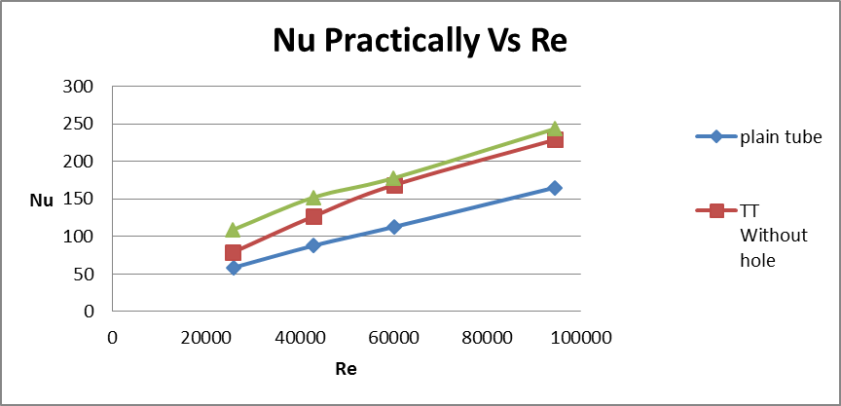
Fig.4.1.3: Nusselt no Vs. Reynolds No for plain twisted tape and twisted tape with square hole and alternate axis.
For the tube with twisted tape with square hole and alternate axis Nusselt number is about 40 to 50 % higher than the plain tube within the Reynolds number range of 25,000 to 95,000.It is obvious to get the same graph plots for the heat transfer coefficient. Heat transfer enhancement can occur with the same rate in turbulent flow region due to twisted tape with square hole and alternate axis in case of flow through tube.
4.3 The Thermal Performance:
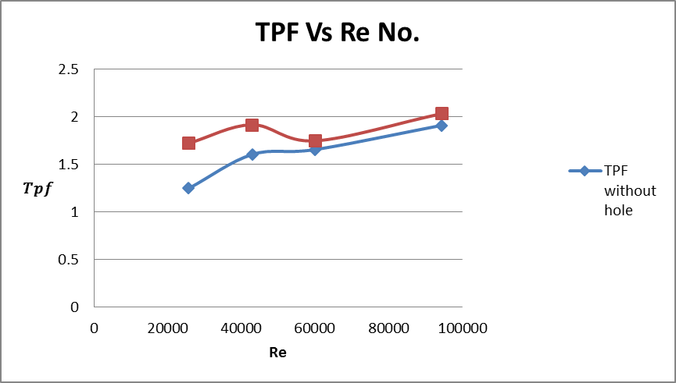
Fig.4.1.5: Thermal Performance factor Vs Re No.
Fig.4.1.5 shows the variation of thermal enhancement factor with Reynolds number. The thermal enhancement factors for the staggered array tend to decrease with increasing Reynolds number. Theoretical thermal performance is increases. With the use of almond dimples, the thermal enhancement factors are in a range between, 1to0.8 respectively for the Re No range 25000 to 95000 respectively.
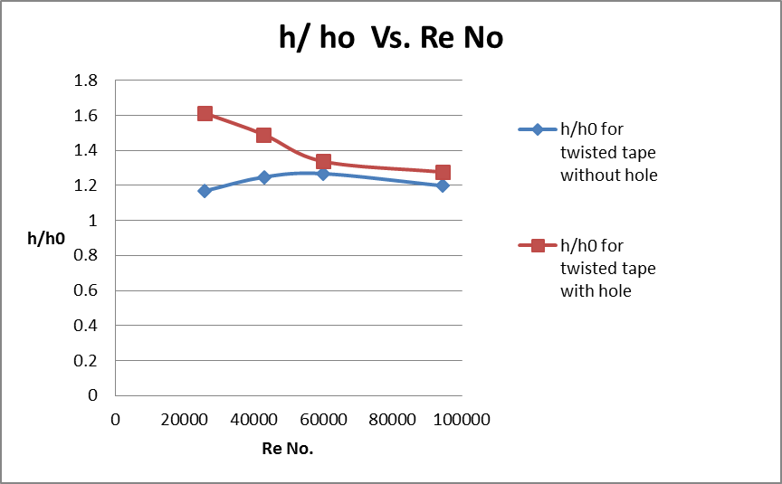
Fig.4.1.6. Avg. heat transfer coefficient for twisted tape without hole and twisted tape with hole Vs. Reynolds number
The heat transfer coefficient can be calculated from the thermal conductivity of the working fluid and the Nusselt number. Like the Nusselt number comparisons, the average heat transfer coefficient ratios h/h₀ with respect to the baseline data at the interface are plotted for both the twisted tape with hole and twisted tape without hole. The h/h0 Plot show same pattern as the Nu/Nu0 plot. The h/h0 Plot of twisted tape with holes case is higher than the twisted tape without hole case.

5. CONCLUSIONS AND SUMMARY

The heat transfer enhancement, thermal performance and friction factor characteristics of twisted tape inserted tube will be investigated experimentally. The experiments will be performed for the tube fitted with twisted tapes with different pitches.
1) The increase or decrease of Nusselt number obtained for the tube with twisted tape inserts in comparison to those of the plain tube values.
2) The friction factor for the tube equipped with twisted tape inserts will be compared with those of the plain tube values.
3) The maximum thermal enhancement efficiency (η) possible with the twisted tape inserted tube with a particular configuration among the tested ones.
4) The empirical correlations will be developed in the proposed study which will predict the Nusselt number and friction factor.

References

[1]. Eiamsa-ard, N.Piriyarungroj, C.Thianpong, S.Eiamsa-ard, A case study on thermal performance assessment of a heat exchanger tube equipped with regularly-spaced twisted tapes as swirl generators, Case Studies in Thermal Engineering 3(2014)86–102
[2]. Bodius Salam , Sumana Biswas , Muhammad & Mostafa Kamal Bhuiya , “Heat Transfer Enhancement in a Tube Using Twisted Tape Insert”, Proceedings of the 13th Asian Congress of Fluid Mechanics, Page 835- 838.
[3] Iftikarahamad H. Patel, Dr. Sachin L. Borse, Experimental Investigation of Heat Transfer enhancement over the dimpled surface, International Journal of Engineering Science and Technology (IJEST), Vol. 4 No.08 August 2012.
[4] Kaustaubh Kumbhar, Dr. Sachin L. Borse,Heat Transfer enhancement by using twisted tapes with elliptical holes, International Journal of Applied Engineering Research (IJAER), Vol. 10 No.07 August 2015.
[5] A. V. N. Kapatkar, B. Dr. A. S. Padalkar and C. Sanjay Kasbe, Experimental investigation on heat transfer enhancement in laminar flow in circular tube equipped with different inserts, Proc. of. Int. Conf. on Advances in Mechanical Engineering (2010) pp. 58-63
[6]. S. Naga Sarada, A.V. Sita Rama Raju, K. Kalyani Radha, L. Shyam Sunder, Enhancement of heat transfer using varying width twisted tape inserts, International Journal of Engineering, Science and Technology, Vol.2, No. 6, 2010, pp. 107-118.

[7] Naga Sarada S., Kalyani K. Radha and A. V. S. Raju, Experimental investigations in a circular tube to enhance turbulent heat transfer using mesh inserts, ARPN Journal of Engineering and Applied Sciences, VOL. 4, NO. 5, July (2009), pp. 53-60.
[8] S.W Chang, Tsun Lirng Yang andJin Shuen Liou, Heat transfer and pressure drop in tube with broken twisted tape insert, Experimental Thermal and Fluid Science Vol. 32 (2007), pp. 489- 501.
[9] Suhas V. Patil, P. V. Vijay Babu, Experimental Studies on Heat transfer and friction factor through isothermal square duct with twisted tape inserts, Proceeding of the International Conference on Advanced Science, Engineering and Information Technology Malaysia (2011), pp. 77-82
[10] Paisarn Naphon, "Heat transfer & pressure drop in horizontal double pipes with & without twisted tape inserts." International Communications in Heat and Mass Transfer, 2006,33,2,166-175.

 

