Increase In Cervix Cancer Incidence Among Women Below 50 Years-Of-Age In Sweden. Does HPV vaccination play a role?
Lars Andersson, Dept. of Physiology & Pharmacology, Karolinska institutet, SE-171 77 Solna, Sweden
e-mail: lars.andersson2@outlook.com
Tel. No.: +46 8 524 800 00
No competing interest or funding support. Similar work has not been submitted elsewhere.
Abstract
The Center for Cervix Cancer Prevention in Sweden has in a year-report (1) noted a large increased incidence of invasive cervix cancer, especially during the two last recorded years, 2014 and 2015. I have subgrouped the data according to age, using the statistical database of the National Board of Health and Welfare in Sweden. The increase in cervix cancer incidence was shown to be most prominent in women 20-49 years-of-age while no apparent increase was observed in women above 50 years-of-age. It has earlier been noted by the FDA that women exposed to the human papilloma virus (HPV) prior to vaccination had a more unfavorable outcome than placebo controls. The possibility that HPV vaccination could play a role for the increase in cervix cancer incidence by activating cervix cancer disease in women previously exposed to HPV is discussed.
Main Article
The Center for Cervix Cancer Prevention in Sweden has in a year-report (1) noted a large increased incidence of invasive cervix cancer, especially during the two last recorded years, 2014 and 2015. A continuing rise of 1.7 % yearly since 2005 has been observed. The increase in cervical cancer was statistically significant (p=0.03). The information was based on data from the statistical database managed by the National Board of Health and Welfare in Sweden. The author of the report suggested that it is important to track the causes of these major changes. Data, therefore, need to be further analyzed. Clinical stage in the diagnosis and histological type of cervical cancer, as well as changes in different quality parameters in the screening program, need to be considered. However, at present no explanations were given for the increase in cervix cancer incidence by the Center of Cervix Cancer in their year-report.
To better understand possible reasons for the increase in cervix cancer incidence, I have subgrouped the data according to age, using the statistical database of the National Board of Health and Welfare. The increase in cervix cancer incidence was shown to be most prominent in women 20-49 years-of-age while no apparent increase was observed in women above 50 years-of-age (Figure 1). When the number of cases in the 20-49-year age group was compared for 2006 and 2015 it was seen that the difference in the number of cases was 115 (202 cases for 2006 and 317 cases for 2015). The relative increase in cervix cancer incidence was 50 % when the incidence for 2015 was compared with the incidence for 2006.
In Sweden, there are 1.9 million women between 20-49 years-of-age according to Statistics Sweden in 2015. The incidence of cervical cancer is therefore 0.17 ‰ in this population. In Figure 2 the relative change is given in each 5-year age group cohort between 2006 and 2015, further illustrating the increased cancer incidence of the younger age groups.

Figure 1. Increase in incidence of cervix cancer in younger women (<50 years-of-age) as compared with women ≥50 year-of-age. The number of cases/100 000 women from 2006 to 2015 is shown.
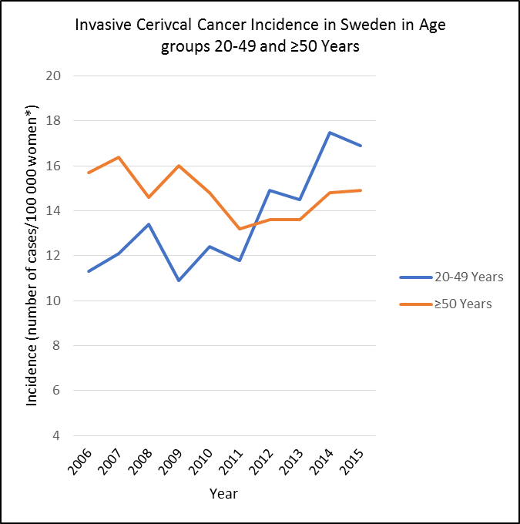
* age-adjusted according to the standard Swedish population in 2000

Figure 2. The relative change in percent of invasive cervical cancer incidence in Sweden between 2006 and 2015 in different age groups. The figure is based on data from the statistical database at the National Board of Health and Welfare in Sweden. The cancer incidence is age-adjusted according to the standard Swedish population in 2000.
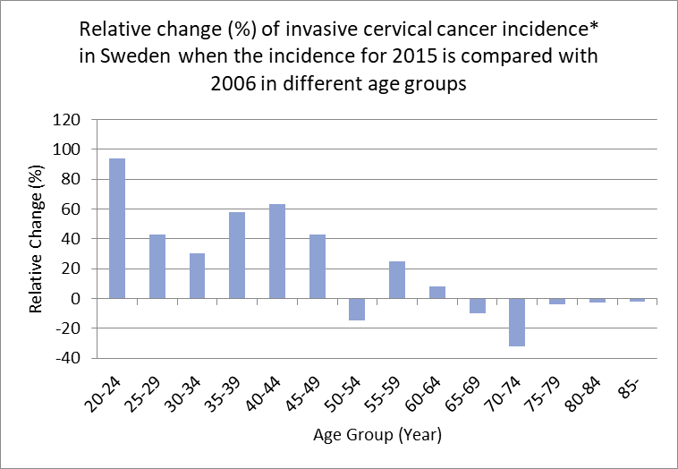
Possible explanations for the increase in cervix cancer incidence among young women are discussed in this article.
A change in routines or other technical or methodological changes during this period would be the first explanation to consider. The selective change in younger women and that the increase was noted in most counties in Sweden argue against this explanation. Neither was such an explanation given by the Center for Cervix Cancer Prevention in Sweden in their Year-report.
Immigration could be another possibility to explain the increase in cervix cancer incidence. However, the 20-49-year women population has only increased by 8% between 2006 and 2015. Females constitute a minority of the immigrants. Immigrant women from the Middle East are probably not so exposed to the HPV virus to explain the increase. Women from Africa could have higher levels of HPV. However, they are a minor part of the female immigrants for these years. Neither was immigration mentioned as a reason for the increase in cervix cancer in the year-report by the Center for Cervix Cancer Prevention in Sweden.
A third possibility is that HPV vaccination could play a role for the increase in cervix cancer incidence. During the efficacy review of Gardasil by the FDA a concern was raised for disease enhancement (increase in CIN 2/3, cervical adenocarcinoma in situ or worse) in a subgroup analysis of subjects who had evidence of persistent infection with vaccine-relevant HPV types at baseline (2). In these individuals, the efficacy was -25.8 % (95 % CI: -76.4, 10.1 %). Thus, vaccination of cases with HPV 16/18 oncogenes showed a worse outcome than did placebo although the FDA statisticians thought it was difficult to draw any firm conclusions. In their analysis, the FDA included only cases with HPV 16/18. These cases could consist of a mixture of different oncogenes including HPV 16/18. If cases with other HPV oncogenes not containing HPV 16/18 had been included in the analysis, the efficacy data could have been even more negative. The negative efficacy finding is consistent with the common knowledge that vaccination can cause reactivation of both target and off-target latent viruses (3-9). For Gardasil, evidence of a selective and significant reactivation of the oncogenic non-target HPV types 52 and 56 has been reported in the genital tract in women (10). They studied women 13-22 and 23-40 years-of-age from 2008 to 2013. The target HVPs (16 and 18) decreased only in the younger age group but oncogenic non-target HPVs increased in both groups, 20-40 % and 8-30 %, respectively. The group aged 23-40 had, therefore, a marked increase in the total burden of oncogenic HPVs which may be consistent with the findings in the FDA report where the efficacy of the HPV-vaccine was negative for non-naïve women (i.e. women who are infected with HPV 16/18 oncogenes before vaccination). The increase in non-target oncogenic HPVs was specific for the HPV-oncogenes HPVs 52/56 since no change was noted for 10 other non-target HPVs. Preneoplastic lesions containing HPVs 52 and/or 56 would be of concern, either together with the target 16/18 types or other non-target oncogenic HPVs.
It should be noted that the surrogate biomarker of the primary efficacy parameter of cervical cancer used in the Gardasil clinical trials has a low sensitivity and a low positive predictive value for cervix cancer. Therefore, a great uncertainty regarding unexpected undue secondary efficacy-effects of Gardasil vaccination may occur. Any reactivation of oncogenic HPVs may counteract the efficacy of Gardasil at any age of vaccination.
There are more than 200 types of HPVs, of which 12 are currently classified as high-risk cancer types (11). HPV may be found in non-sexually active girls (12). It may be transmitted through non-sexual means, either by way of mother to child, fomites, self-inoculation or nosocomial infection (13), or via blood (14-15). The virus can lie latent in any tissue and escape detection by standard techniques (16). It can also be redistributed systemically during the lytic cycle into previous virus-free tissues (auto-inoculation), for example infecting an earlier virus-free cervix. Recently, it was shown that previous HPV positive women with normal cytology remained at increased risk of preneoplasia (CIN3) despite two follow-up HPV-negative tests (17). “Proving that HPV is absolutely gone is, of course, impossible”, states Brown and Weaver in an Editorial from 2013 (18). Therefore, non-naïve-individuals can be seen among females at all ages. Sometimes these individuals have measurable HPV-virus and sometimes not.
Since the vaccine is recommended up to 45 years in the European Economic Area, it is possible that the vaccination has facilitated the development of new or existing cervical cancer among women who were non-naïve at the time of vaccination. Vaccination against HPV has started in Sweden during the study period. Gardasil, the vaccine mostly used in Sweden, was approved in 2006. The increase in incidence of cervix cancer between 2006 and 2015 was 50 % (corresponding to 115 absolute cases). Therefore, the vaccination coverage of the Swedish population does not need to be very high to explain a role for the vaccine. The findings could be consistent with on-demand vaccination. In the US, a lower number of non-naïve patients will be vaccinated since the FDA only allows the use up to 18 years of age.
Could the HPV-vaccination cause an increase in invasive cervical cancer instead of preventing it among already infected females and thereby explain the increased cancer incidence reported by the Center for Cervix Cancer Prevention in Sweden? The answer to this question is vital for correctly estimating the benefit-risk of this vaccine.

References
- Nationellt Kvalitetsregister för Cervixcancerprevention (NKCx), Center för Cervixcancerprevention: http://nkcx.se/templates/_rsrapport_2017.pdf
- FDA Gardasil Clinical Review 2006: https://www.fda.gov/downloads/biologicsbloodvaccines/vaccines/approvedproducts/ucm111287.pdf
- Walter R, Hartmann K et al. Reactivation of herpesvirus infections after vaccinations? The Lancet 1999;353:810
- Bayas J-M, González-Álvarez R, Guinovart C. Herpes zoster after yellow fever vaccination. J Travel Med 2007;14:65-66
- Rothova A, de Groot JDF, Mudrikova T. Reactivation of acute retinal necrosis after flu H1N1 vaccination. Br J Ophthalmol 2011;95:291
- Hwang CW Jr, Steigleman WA et al. Reactivation of herpes zoster keratitis in an adult after varicella zoster vaccination. Cornea 2013;32:508-9
- Hassman LM, DiLoreto Jr DA. Immunologic factors may play a role in herpes simplex virus 1 reactivation in the brain and retina after influenza vaccination. IDCases 2016;6:47-51
- Jastrzebski A, Brownstein S et al. Reactivation of herpes zoster keratitis with corneal perforation after zoster vaccination. Cornea 2017;36:740-42
- Lieberman A, Curtis L. HSV2 reactivation and myelitis following influenza vaccination. Hum Vaccin Immunother 2017;13:572-73
- Söderlund-Strand A, Uhnoo I, Dillner J. Change in population prevalences of human papillomavirus after initiation of vaccination: The high-throughput HPV monitoring study. Cancer Epidemiol Biomarkers Prev 2014;23:2757-64
- Human papillomavirus vaccines: WHO position paper, May 2017, http://www.who.int/wer
- Hamsikova E, Smahelova J et al. The prevalence of HPV infections in HPV-vaccinated women from the general population. APMIS 2017;125:585-95
- Ryndock EJ, Meyers C. A risk for non-sexual transmission of human papillomavirus? (Editorial) Expert Rev Anti Infect Ther 2014;12:1165-70
- Bodaghi S, Wood LV et al. Could human papillomaviruses be spread through blood? J Clin Microbiol 2005;43:5428-34
- Chen A C-H, Keleher A et al. Human papillomavirus DNA detected in peripheral blood samples from healthy Australian male blood donors. J Med Virol 2009;81:1792-96
- Freitas AC, Mariz FC et al. Human papillomavirus vertical transmission: review of current data. Clin Infect Dis 2013;56:1451-56
- Polman NJ, Veldhuijzen NJ et al. HPV-positive women with normal cytology remain at increased risk of CIN3 after a negative repeat HPV test. Br J Cancer 2017;Sep 7:1-5
- Brown DR, Weaver B. Human papillomavirus in older women: new infection or reactivation? (Editorial Commentary) J Infect Dis 2013;207:211-12

