Immunization Perception and Awareness among Mothers attending OPD of a Tertiary Care Hospital of Karachi, Pakistan.

Javeria Shamim¹
MBBS (DMC), Dow University of Health Sciences, Karachi.
Email: drjaveriashamim2017@gmail.com
Contact Number: 03333502829
Mailing Address: Flat # H-1, ground floor, PNSC Housing Complex, Sector 15-A/3, Bufferzone, North Karachi, Karachi-Pakistan.

CORRESPONDING AUTHOR
Javeria Shamim
MBBS (DMC), Dow University of Health Sciences, Karachi.
Email: drjaveriashamim2017@gmail.com
Contact Number: 03333502829
Mailing Address: Flat # H-1, ground floor, PNSC Housing Complex, Sector 15-A/3, Bufferzone, North Karachi, Karachi-Pakistan.

CONFLICT OF INTEREST:
None
SOURCE OF FUNDING:
This research did not receive any specific grant from funding agencies in the public, commercial, or not-for-profit sectors
STATEMENT REGARDING SIMILAR SUBMISSION:
The submission is not under consideration for publication in any other journal.
Immunization Perception and Awareness among Mothers attending OPD of a Tertiary Care Hospital in Karachi, Pakistan.

ABSTRACT
Immunization plays tremendous role in significant reduction of childhood morbidity and mortality. This study was aimed to assess immunization perception and awareness among mothers attending OPD of a tertiary care hospital in Karachi.

This was a hospital-based cross-sectional study. We included 200mothers<50years of age, visiting Civil Hospital Karachi during December2015-January2016 using non-probability convenient sampling technique.

Of these, 187(93.5%) had awareness about EPI. Overall, 179(89.5%) considered EPI advantageous for health, 20(10.0%) assumed neither advantageous nor harmful, 1(0.5%) considered hazardous for health by assuming vaccines have contraceptive effect, and aggravating illness in a child. However, 176 mothers recently had kids<5years old. Of these, 129(64.5%) were fully vaccinated kids, 56(28.0%) were partially vaccinated while 15(7.5%) were non-vaccinated. Only 144(72.0%) mothers were vaccinated against tetanus during pregnancy. Most common reason for vaccine refusal in non vaccinated children was lack of awareness(47.8%).Awareness about EPI was statistically related with immunization status of children and also with the age of the mother, socioeconomic status, and residence. Immunization of child and antenatal immunization of mother were also associated.

Vaccination coverage was suboptimal. Emphasizing to conduct awareness programs is the hour's need.
INTRODUCTION:
Immunization is among the safest and cost effective public health intervention of this century. Immunization programs play tremendous role in significant reduction of childhood morbidity and mortality worldwide as far as vaccine preventable diseases are concerned [1,2]. Immunization can either be routine or supplemental. Routine immunization, for example, includes expanded program on immunization, while supplemental immunization refers to conducting mass immunization campaigns (for example national immunization days for polio campaigns) to eradicate vaccine preventable diseases [3,4]. The World Health Organization (WHO) has introduced Expanded Program on Immunization (EPI), which was targeted at immunization of a child fully against vaccine preventable diseases.

Unfortunately, this goal is not achieved yet by many developing countries across the globe [5]. A study conducted in West Region of Cameroon showed that 85.9% children were completely immunized according to parent's recall and vaccination card while 84.5% were fully vaccinated according to the vaccination card record [6]. Whereas, according to Malaysian study, 4.5% were partially immunized and 0.1% received no vaccine at all [7]. However, in Afghanistan, only 51% children were completely vaccinated [8], while in India, 53% were fully vaccinated [9].

Therefore, assessment of mother’s knowledge, perception and practice of childhood immunization in Pakistan has become the hour's need. This study was aimed to assess immunization perception and awareness among mothers attending OPD of a tertiary care hospital in Karachi.
METHODS:
This was a hospital based cross-sectional study. Data were collected from mothers attending OPD of a tertiary care hospital i.e. Civil Hospital Karachi. The study was conducted during December 2015- January 2016. The sample size was 200. Non-probability convenient sampling technique was used. We included those mothers who consented to participate, visiting OPD of a tertiary care hospital i.e. Civil Hospital Karachi during December 2015 and January 2016 and mothers less than fifty years of age. We excluded those mothers who did not consent despite adequate explanation, and mothers older than fifty years. Data collected from mothers included mother’s age, mother’s highest educational level, reason of non-immunization, socioeconomic status, religion, ethnicity, area of residence, total number of pregnancy and live birth, immunization status of mother during pregnancy against tetanus, number of children under five years of age and immunization status of children. We used self-administered, closed-ended cross-sectional interviewer administered questionnaire in English and Urdu language after informed consent. We briefed the patients regarding the main objective of this study and assured them of their confidentiality and autonomy of the responses. Data entry and analysis were done using SPSS version 16.0. A p-value of <0.05 was considered significantly positive. The authors declared that there was no conflict of interest. This research did not receive any specific grant from funding agencies in the public, commercial, or not-for-profit sectors.
RESULTS:
Total 200 mothers participated. As far as the age of mothers is concerned, 25 (12.5%) were less than 20 years of age, 58 (29.0%) mothers were 21- 25 years, 64 (32.0%) mothers were 26- 30 years old, 32 (16.0%) were 31- 35 years while 21 (10.5%) mothers were 36 -40 years of age.

Among them, 119 (59.5%) had no formal education, 23 (11.5%) and 17 (8.5%) were educated till primary and secondary respectively, 27 (13.5%) did matriculation, 12 (6.0%) did intermediate while 2 (1.0%) did graduation and above.

Regarding monthly income, 18 (9.0%) were unemployed earning member in the family, 56 (28%) mothers received less than Rs.10,000/-,101 (50.5%) mothers received Rs.11,000- 20,000/month, 10 (5.0%) and 11 (5.5%) earned Rs.21,000-30,000/- and more than Rs.30,000/-. However, 4 (2.0%) of them were not willing to tell us the exact amount.

In terms of religion, 196 (98.0%) were Muslims, 3 (1.5%) were Hindus, while, 1 (0.5%) of them was Christian.

As far as ethnicity is concerned, 60 (30.0%) of them were Pathans. Whereas, 28 (14.0%), 10 (5.0%), 36 (18.0%) and 23 (11.5%) were Punjabi, Hazaray walay/Saraiki ,Baloch and Mahajir respectively. While 34 (17.0%) and 7 (3.5%) mothers were Sindhi, Maheshwari/Marvari and Memon, respectively.

However, 180 (90.0%) were living in urban areas, while, 20 (10.0%) belonged to rural areas.

Of these, 187 (93.5%) had awareness about EPI, 179 (89.5%) considered them advantageous for health, while, 20 (10.0%) assumed they were neither advantageous nor harmful. However, 1 (0.5%) considered it hazardous for health. Those who considered EPI hazardous for health or neither advantageous nor harmful, overall, expressed their opinion about EPI as, 5 (2.5%) considered these vaccines to have contraceptive effect, 2 (1.0%) thought they aggravate illness in a child, hence child should not be immunized, whereas 193 (96.5%) considered them necessary for health.

Total 177 (88.5%) kids were vaccinated. Among these, 10 (5.0%) were vaccinated at birth only, 66 (33.0%) were vaccinated till 9 months, 68 (34.0%) till 15 months, 9 (4.5%) till 2 years whereas, 24 (12.0%) till 5 years.

Total number of pregnancy and live births, total number of immunized kids, mother's immunization against tetanus during pregnancy, number of tetanus doses during pregnancy and total number of kids under 5 years of age were also asked [Table I].

Recently, 176 mothers have kids of less than 5 years of age at home. As far as immunization status of these kids <5 years of age was concerned, 129 (64.5%) were fully vaccinated, 56 (28.0%) were partially vaccinated while 15 (7.5%) received no vaccine at all.

However, only 144 (72.0%) mothers were vaccinated against tetanus during pregnancy [Table I].

VARIABLES |  | FREQUENCY(PERCENT)
Total number of pregnancy | <5  6-10  >11 | 159(79.5%)  40(20.0%)  1(0.5%)
Total number of live births | <5 children  6-10 children  >11 children | 175(87.5%)  24(12.0%)  1(0.5%)
Total number of immunized kids | None of them  1 child  2 children  3 children  4 children  5 children  6 children  7 children | 17(8.5%)  70(35.0%)  62(31.0%)  30(15.0%)  11(5.5%)  6(3.0%)  3(1.5%)  1(0.5%)
Mother's immunization against tetanus during pregnancy | Vaccinated  Non vaccinated | 144(72.0%)  56(28.0%)
Number of tetanus doses during pregnancy | No dose  1 dose  2 doses  3 doses | 57(28.5%)  4(2.0%)  102(51.0%)  37(18.5%)
Total number of kids <5years | No child<5 years  1 child  2 children  3 children  4 children | 24(12.0%)  84(42.0%)  63(31.5%)  25(12.5%)  4(2.0%)

Table I: Immunization status of children and their mothers

Around 23 (11.5%) kids were non- vaccinated. Most common reason for non-immunization among these 23 kids was lack of awareness (47.8%) as told by the 11 mothers [Figure I].

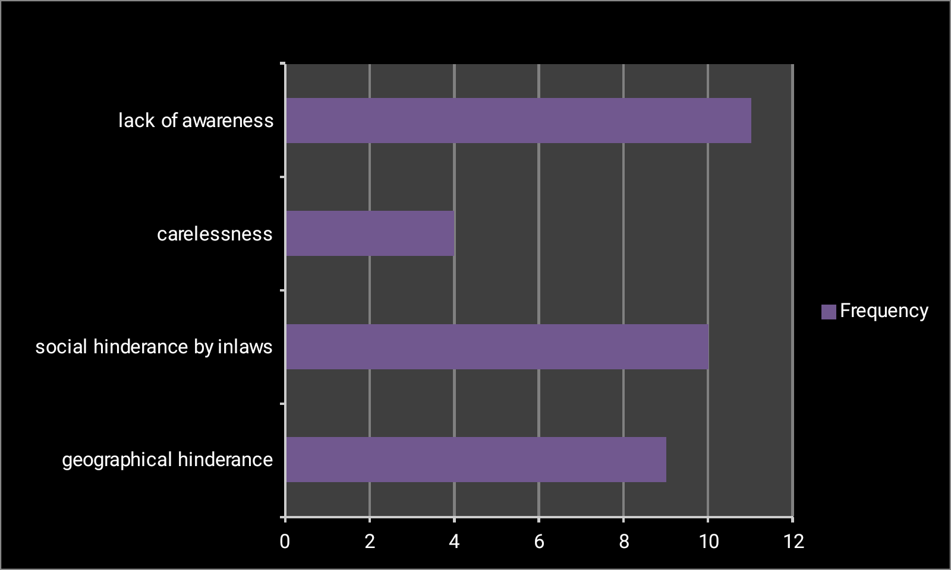

Figure I: Reason of non-immunization

Highest proportion of mothers (192=96.0%) agreed that EPI promotes healthy growth of a child. Whereas, 139/200 (69.5%) favored that EPI should be offered at doorsteps. However, 61 (30.5%) did not support this idea. One of them (0.5%) also suggested that awareness must be spread in this regard while pneumonia prevention strategies should be introduced.

Immunization status of mother and their kids were related (p-value<0.05) [Figure II].
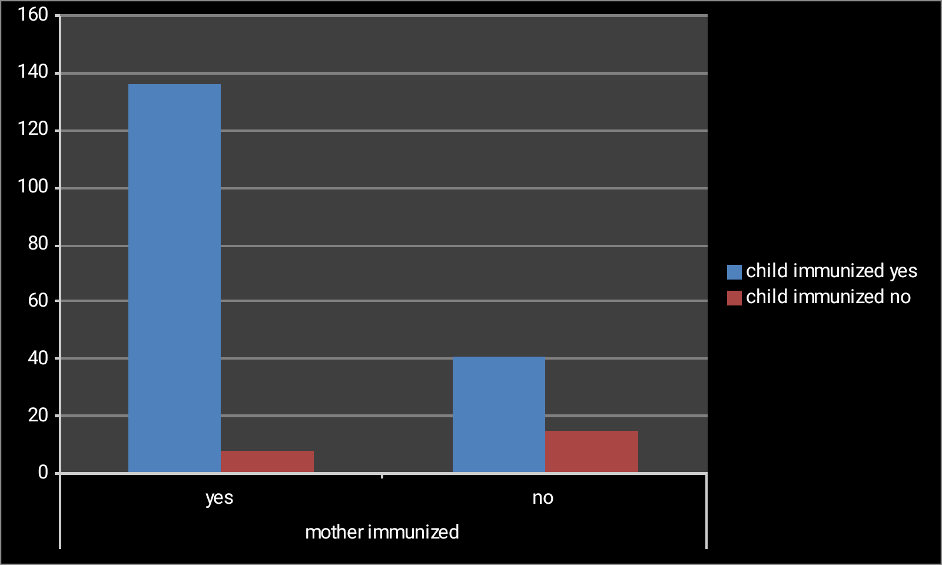

Figure II: Immunization status of mother and their children

Awareness about EPI was related (p-value<0.05) with the immunization status of the child as well as with the age of the mother, socioeconomic status, residence. The immunization status of child was statistically related with the age at which they received last vaccine (p-value<0.05) while education of the mother and awareness about EPI was not related statistically.
DISCUSSION:

Despite introduction and implementation of expanded program on immunization, many children of the developing countries still remain either partially vaccinated or non- vaccinated. Pakistan is one of them, where their significant proportion remains either partially vaccinated or non-vaccinated at all [10].

Our study showed that in Karachi, recently, 176/200 interviewed mothers (88.0%) had kids <5 years of age. Amongst the kids of these mothers, only 129 (64.5%) kids less than 5 years of age were fully vaccinated, 56 (28.0%) kids were partially vaccinated while 15 (7.5%) of them received no vaccine at all. This proportion was slightly higher as compared to a study at Myanmar, which exhibited 25.8% of kids were partially immunized [11]. However, from a health survey conducted in Pakistan in 2007- 2008, 66% of children remained partially immunized [12]. The reduction in the proportion of partially vaccinated kids, no doubt suboptimal, but indicated an increasing number of children receiving minimally some of the vaccines according to EPI and improvement in the implementation of EPI as it was previously.

The socio-demographic status matters as well. Most of the mothers were young (26-30) years old (32.0%) and majority had no formal education (59.5%).There were still a few kids, who were partially vaccinated while numerous remained non-vaccinated. Despite this, formal education and awareness were not statistically related with EPI. This was contrary to a previous study in Karachi, which showed that designing a simple educational intervention improved the vaccination rate for hepatitis B/ DPT by 39% [13].

Awareness about EPI was also related with the age of mother and immunization status of child. This was also depicted by a study of Haryana, India which showed that awareness was interlinked with the age of mother and immunization status of child [14]. Socioeconomic status and residence had great impact on routine immunization. Low socio-economic status and area of residence was also focused by a study at Vietnam, stating these as causative factors for variations in timely immunization [15]. Area of residence and immunization status was also focused in another study conducted at Burkina Faso [16]. Ethnicity and awareness about immunization were interlinked. This was also supported by a similar study in Karachi [17].

Immunization status of mother against tetanus during antenatal period and immunization status of a child were interlinked. This was also consistent with an Indian study, exhibiting thatthose mothers who did not receive tetanus during pregnancy were likely to show ignorant behavior towards child immunization as well [9].

According to our study, 93.5% respondents visiting OPD of tertiary care hospital had awareness about EPI and 96.0% agreed that EPI promotes healthy growth of a child. It was similar to a previous study, in terms of awareness about polio immunization, where 96% respondents had awareness [18]. Participants in our study also suggested (69.5%) that EPI should be offered at doorsteps just like polio vaccine. They appreciated the idea to organize awareness programs related to EPI and pneumonia prevention strategies.

The most common reason for non vaccination was lack of awareness. Other reasons were social hindrance by family members, geographical hindrance ( in terms of being short of money in reaching health care facility, or residing in area situated far away from health care facilities), carelessness and ignorant attitude of mothers while other reasons included financial hindrance. This was in contrast to an American study, stating non availability of vaccines to be the most common cause according to 56% mothers, whereas lack of awareness was the second most common cause, according to 16% [19]. In China, lack of supplies and awareness were the causes as well [20]. Previous Pakistani researches showed missing vaccination card was the most common reason for dropping out of EPI [21]. Another study showed misconceptions, unawareness and geographical hindrance to be the primary causes [22].

We recommend that not only mothers should be educated regarding the significance of immunization on child's health and EPI, but each and every member of the community must be made aware in this aspect [15, 23] . We also put forward the suggestion of offering EPI at doorsteps just like polio vaccine, as suggested by 69.5% of the mothers. Awareness programs related to EPI must be organized, and pneumonia prevention strategies should be discussed with them.

Since we used self administered questionnaire, we couldn't exclude the information bias. It might be a significant hindrance in evaluating a meaningful relationship and a trend.

We recommend future study in this regard which could achieve data not only from other tertiary care hospitals but also from primary and secondary health care facilities.

CONCLUSIONS:
Vaccination coverage was still suboptimal. Majority of the mothers had awareness about EPI, but, a few of them were still unaware and held a very low opinion about the concept of immunization. Most of the mothers were young and had no formal education. Still a few kids were partially vaccinated while numerous remained non-vaccinated. Most common reason for non-immunization was lack of awareness. Therefore, awareness programs emphasizing significance of immunization, especially EPI for vaccine preventable diseases, should be conducted to improve the knowledge, perception and attitude of mothers about immunization. Also, policies should be introduced and implemented in this regard. Mothers should be counseled regarding timely vaccination and their queries must be addressed. EPI should be offered at door steps like polio eradication programs in rural areas so that geographical hindrance will no longer remain an issue. Awareness programs about pneumonia prevention strategies should be conducted as well.
REFERENCE:
[1] Adisa OP, Akinleye CA, Obafisile CI, Oke OS. Childhood immunization perception and uptake among mothers of under-five children attending immunization clinics in Osogbo, South Western, Nigeria. Research Journal of Health Sciences. 2016;4(3):186-94.

[2] Negussie A, Kassahun W, Assegid S, Hagan AK. Factors associated with incomplete childhood immunization in Arbegona district, southern Ethiopia: a case–control study. BMC Public Health. 2015;16(1):27.

[3] Verguet S, Johri M, Morris SK, Gauvreau CL, Jha P, Jit M. Controlling measles using supplemental immunization activities: a mathematical model to inform optimal policy. Vaccine. 2015;33(10):1291-96.

[4] Khan MM, Sharma S, Tripathi B, Alvarez FP. Budget impact of polio immunization strategy for India: introduction of one dose of inactivated poliomyelitis vaccine and reductions in supplemental polio immunization. Public health. 2017;142:31-38.

[5] Wagner AL, Boulton ML, Sun X, Huang Z, Harmsen IA, Ren J, et al. Parents’ concerns about vaccine scheduling in Shanghai, China. Vaccine. 2017;35(34):4362-67.

[6] Russo G, Miglietta A, Pezzotti P, Biguioh RM, Mayaka GB, Sobze MS, et al. Vaccine coverage and determinants of incomplete vaccination in children aged 12–23 months in Dschang, West Region, Cameroon: a cross-sectional survey during a polio outbreak. BMC Public Health. 2015;15:630.
DOI 10.1186/s12889-015-2000-2

[7] Ahmad NA, Jahis R, Kuay LK, Jamaluddin R, Aris T. Protary immunization among children in Malaysia: Reasons for incomplete vaccination. Journal of Vaccines & Vaccination. 2017;8(3):1-8.

[8] Mugali RR, Mansoor F, Parwiz S, Ahmad F, Safi N, Higgins-Steele A, et al. Improving immunization in Afghanistan: results from a cross-sectional community based survey to assess routine immunization coverage. BMC Public Health 2017;17(1):290.

[9] Francis MR, Nohynek H, Larson H, Balraj V, Mohan VR, Gagandeep Kang G, et al. Factors associated with routine childhood vaccine uptake and reasons for non- vaccination in India:1998-2008. Vaccine 2017.
http://scholar.google.com.pk/scholar?hl=en&as_sdt=0%2C5&as_ylo=2014&q=childhood+immunization+in+india&btnG=#d=gs_qabs&p=&u=%23p%3Dp1ujGslXoGgJ

[10] ul Haque M, Waheed M, Masud T, Malick WS, Yunus H, Rekhi R, et al. The Pakistan Expanded Program on Immunization and the National Immunization Support Project: an economic analysis. The World Bank; 2016 Nov.

[11] Than SL, Mongkolchati A, Laosee O.Determinants of incomplete immunization among hill tribe children aged under two years in Myanmar. Journal of Public Health and Development 2016:14(2);17-31.

[12] Bugvi AS, Rahat R, Zakar R, Zakar MZ, Fischer F, Nasrullah M, et al. Factors associated with non-utilization of child immunization in Pakistan: evidence from the Demographic and Health Survey 2006-07. BMC public health. 2014;14(1):232.

[13] Owais A, Hanif B, Siddiqui AR, Agha A, Zaidi AK. Does improving maternal knowledge of vaccines impact infant immunization rates? A community-based randomized-controlled trial in Karachi, Pakistan. BMC Public Health. 2011;11:239. doi: 10.1186/1471-2458-11-239.

[14] Upadhyay RP, Chowdhury R, Mazumder S, Taneja S, Sinha B, Martines J, et al. Immunization practices in low birth weight infants from rural Haryana, India: Findings from secondary data analysis. J Glob Health. 2017;7(2):020415.
doi: 10.7189/jogh.07.020415.

[15] Minh An DT, Lee JK, Van Minh H, Trang NT, Thu Huong NT, Nam Y, et al. Timely immunization completion among children in Vietnam from 2000 to 2011: a multilevel analysis of individual and contextual factors. Glob Health Action. 2016;9:29189. doi: 10.3402/gha.v9.29189.

[16] Kagoné M, Yé M, Nébié E, Sié A, Müller O, Beiersmann C. Community perception regarding childhood vaccinations and its implications for effectiveness: a qualitative study in rural Burkina Faso. BMC Public Health. 2018 Mar 6;18(1):324. doi: 10.1186/s12889-018-5244-9.

[17] Sheikh A, Iqbal B, Ehtamam A, Rahim M, Shaikh HA, Usmani HA, et al. Reasons for non-vaccination in pediatric patients visiting tertiary care centers in a polio-prone country. Archives of Public Health. 2013;71(1):19.

[18] Ahmad IM, Yunusa I, Wudil AM, Gidado ZM, Sharif AA, Kabara HT. Knowledge, attitude, perception and beliefs of parents/care givers about polio immunization. Int J Public Heal Res. 2015;3(5):192-99.

[19] Le Roux K, Akin-Olugbade O, Katzen LS, Laurenzi C, Mercer N, Tomlinson M, et al. Immunisation coverage in the rural Eastern Cape - are we getting the basics of primary care right? Results from a longitudinal prospective cohort study. S Afr Med J. 2016;107(1):52-55.

[20] Zhang S, Pan J, Wang Z. A Cross-Sectional Survey to Evaluate Knowledge, Attitude and Practice Regarding Measles Vaccination Among Ethnic Minorities. Ethnicity & disease. 2015;25(1):98-103.

[21] Bham SQ, Saeed F, Shah MA. Routine immunization in children and unsatisfactory polio campaigns; a cross sectional survey conducted at Darul Sehat Hospital, Karachi. Ann Abbasi Shaheed Hosp Karachi Med Dent Coll. 2016;21:29-36.

[22] Khowaja AR, Zaman U, Feroze A, Rizvi A, Zaidi AK. Routine EPI coverage: subdistrict inequalities and reasons for immunization failure in a rural setting in Pakistan. Asia Pacific Journal of Public Health. 2015;27(2):NP1050-9.

[23] Oyo-Ita A, Nwachukwu CE, Oringanje C, Meremikwu MM. Cochrane Review: Interventions for improving coverage of child immunization in low‐and middle‐income countries. Evidence‐Based Child Health: A Cochrane Review Journal. 2012;7(3):959-1012.

