Main file

To,
The Editor In Chief,
Indian Journal of Medical Ethics.

Sub: Submission of Manuscript
Sir,

I am hereby submitting the manuscript entitled “STUDY THE IMPACT OF SMALL GROUP TEACHING TO ENHANCE THE KNOWLEDGE OF “MEDICAL ETHICS IN CLINICAL PRACTICE” AMONG UNDERGRADUATE MEDICAL STUDENTS BY BRAIN STORMING EXERCISE..” as an original article for possible publication in your esteemed Journal .I also declare that this manuscript is neither published nor under consideration in any other journal.
Thanking you.

Yours sincerely
Dr. Anand Agrawal
Professor & Head
Department of Respiratory Medicine
BPSGMCW Khanpur Kalan
Sonepat (Haryana).
Mobile: 9812197352
Email : ashidocbps@yahoo.com

Authors:

1.Dr. Anand Agrawal
Professor & Head
Department of Respiratory Medicine
BPSGMCW Khanpur Kalan Sonepat.
Mobile No. 9812197352
Email: ashidocbps@yahoo.com

2. Dr. Kamaljeet singh
Assistant Professor
Department of Respiratory Medicine
BPSGMCW Khanpur Kalan Sonepat.
Mobile no. 9886702435
Email:drksingh20@gmail.com

3.Dr. Mukesh Kumar
Professor
Department of Physiology
BPSGMCW Khanpur Kalan Sonepat.
Mobile no. 8685817300
Email:mkumar5031@rediffmail.com

Corresponding Author:

Dr. Anand Agrawal
Professor &Head
Department of Respiratory Medicine
BPSGMCW Khanpur Kalan
Sonepat (Haryana).
Mobile: 9812197352
Email : ashidocbps@yahoo.com

Total word count
Abstract :297

Main Article: 2542
Total no. Of References: 20

Total no. Of Table: 5
Total no. Of Figure: 2

Acknowledgement: NIL

Source of support: NIL

Conflict of Interest: NIL

Contributors Detail: Corresponding author responsible for the concept, design, manuscript preparation and statistical analysis, second author contributed in collecting literature, reviewing article and editing, rest of the author’s contribution in collecting data, compiling, searching review of literature.

Running Head: Impact of Small group teaching to enhance medical ethics

Acknowledgement: Project completed under the guidance of Prof. Tejender singh and Prof. Dinesh Badyal , convener of advance course in medical education (ACME) under MCI at CMC Ludhiana.

Title

Study the impact of small group teaching to enhance the knowledge of “Medical ethics in clinical practice” among undergraduate medical students by brain storming exercise.

Abstract:
Background: Researchers found that Innovation in teaching methodology for intrigue subjects enhance the retention of content as well as improve the learning process in under medical graduates. Perhaps small group teaching consider as an effective mode of imparting the knowledge though underexplored yet.
Aim and Objectives: Study the impact of small group teaching to impart the knowledge of the subject among under graduate medical students by using a brain storming exercise.
Methodology: An observational descriptive study was designed by including 40 students of 4th semester after taking written consent . Four batches of 10 students was formed which took part in four separate session of group discussion at the interval of 15 days. Pre and post questionnaire having 10 similar questions, based on Likert scale with maximum score of 50 and minimum of 10, was attempted by all students. Feedback form was also filled at the end of session. Data analyzed by using SPSS version23. Paired t test, Chi/Fisher’s Exact test was used as test of significance, P value<0.05 consider as significant.
Results : The mean post session score of the students was found (42.32±4.29),which was significantly higher than pre score (32.75±4.08 ; t=-12.18; p=0.000)of existing knowledge ,while 85 % of students get success to achieve highest level of grades in terms of score compare to initial pre session status which was only 7.5%, (p=0.000001).Group discussion was endorsed by 90% of participants as a most acceptable as well as popular mode for interactive teaching ,to impart the knowledge of intrigue subject among undergraduates.
Conclusions: Small group teaching through brain storming exercises was endorsed as an effective as well as most acceptable method of interactive teaching to impart the knowledge of practical aspects besides this it was also proved as a significant mode of teaching for intrigue subject.

Key Words: Small group teaching , Teaching methodology, Medical ethics, Professionalism

INTRODUCTION

The global trend toward innovative teaching learning is gathering momentum toward dynamic mindset instead of traditional didactic lectures. The impact of effective teaching plays a crucial role in the learning outcomes in professional education. There are different mode of teaching; lectures, tutorials, seminars, brainstorming, videotapes, class discussions, small group discussions, case studies, role playing etc^{.[1,2,3]} perhaps , lecturing to a large class is the usual mode of teaching while small group teaching is only limited to the bed side clinics among most of the leading medical colleges of India.^{[4]} Perhaps didactic lecture is an old traditional means of imparting knowledge to a large group, though it should not be endorsed as an effective way of teaching or encouraging higher order of thinking among students. ^{[5]}
According to recent research in teaching learning reform the small size of class will produce significant benefits for the teachers as well as for the students. ^{[6,7]} Moreover the small numbers of , the students in a group will receive more individual attention, the teachers will be able to manage the students in a better way, apart from this discipline problems are likely to be less and there is more interaction between the students and the teachers. ^{[8,9]} therefore we have conducted present study to assess the impact of small group discussion through brain storming exercise based on issues of bioethics in practical life during day to day practice among students so that active learning can be initiated by this mode of teaching.

AIM & OBJECTIVES
Aim:
Study the impact of small group discussion trough brain storming exercise pertaining to Medical ethics on existing knowledge of under graduate medical students.
Specific Objectives:
- To assess the pre and post knowledge of Bioethics among II Professional MBBS (Para clinical year; IV Semester) students after session.
- To interpret the feedback of students after completion of session.

METHODOLOGY

Study design and participants
An observational descriptive study was carried out among the 40 medical undergraduates of 2nd Professional batches, , of a BPSGMCW Medical college , Sonepat , Haryana India. Institutional ethics committee (IEC) clearance was taken before starting of project . All selected students were briefed on the study's purpose, and requested to participate in it. Students were assured that participation was voluntary, and confidentiality would be maintained. Informed verbal consent was taken from those who chose to participate. Four sessions of four different groups was conducted 15 days apart, to assess awareness pertaining to medical ethics . Pretested questionnaire was designed containing 10 close ended questions, based on Likert scale 1 to 5 , while maximum point given to most acceptable answer as per MCI medical ethics regulations. (Annexure 1).Maximum score was 50 and minimum was 10 , duration of test was 15 minute, and results was categorised on basis of score index (40-50 outstanding, 30-39 very good, 20-29 good, 15-19 fair, 10-14 poor). Test was conducted before and after the session of brain storming thought type exercise (Annexure 2). All four situation based brain storming exercises was distributed among 2 groups of 5 students (Total 10 students) in each session .20 minutes given for small group discussion and 30 minute given for large group discussion including both the groups . In large group discussion researcher has moderated the whole discussion process , and After detailed intra and inter group discussion the post questionnaire based test with similar questions, was conducted . At the end of entire exercise a scale based (5 points) feedback form was given to students to fill individually( Annexure3).

Data analysis
The collected data from pre and post questionnaire as well as feedback form was analysed by using standard statistical software SPSS version 23. In the form of proportions, bar diagrams, and mean score with standard deviation. Student t test (Paired) was used to compare the means of continuous variables and chi square /Fisher’s exact test was used as a test of significance for categorical variables ,p value <0.05 will be consider as significant.

STUDY DESIGN ALGORITHM
Total study subjects (2nd Professional Medical Under Graduate)
N=40

Sub Group A1
N=5

Session 1
Group 1
N=10
Sub Group B1
N =5
Small Intra Group Discussion with 4 Brain storming Exercise (20 Minute)

Session 2
Group 2
N=10
Sub Group A 2
N=5

Pre Questionnaire Assessment (15Minute)

Each session conducted 15 days apart
(With same case scenarios and Moderator)

Sub
Group B2
N=5

Large Inter Group Discussion With Moderator (Researcher) (30 minute)
Post Questionnaire Assessment
(15Minute)

Session 3
Group 3
N=10
Sub Group A 3
N=5

Sub
Group B3
N=5

Session 4
Group 4
N=10
Sub
Group A 4
N=5

Post session Feedback Survey of all the participating Subjects

Sub
Group B4
N=5

Data Analysis
Data Collection and compilation
Outcome

OBSERVATIONS AND RESULTS

Activity was started with the counselling of students .They were comfortable during the session and discussed their scenarios freely among their corresponding sub group. Forty students had took part in the teaching activity of scenario based group discussion after written consent, in four separate session held 15 days apart.
Before conducting the session the pre assessment was done through questionnaire having 10 closed ended questions based on Likert scale with maximum score of 50 and minimum only 10. The mean pre assessment score was found 32.75±4.08, which was significantly increased (42.32±4.29; p=0.000) at the end of intensive small and large group discussion session as shown in Table 1.

Table1: Mean score of total response with standard deviation and Paired t test on pre and post assessment with p value.
SN | TEST | Mean score  N=40 | SD | SE | r | p | Paired t | P  (2- tail)
1. | Pre | 32.75 | 4.08 | 0.64 | 0.297 | 0.063 | -12.18 | 0.000
2. | post | 42.32 | 4.29 | 0.67

After analyzing the each pre and post response for each question separately by using paired student t test among all the students, it was observed that there are significant increment in the knowledge of subjects in context to each question after group discussion .However in sixth question the pre and post change of score was not found statistically significant (p=0.507), in fact if we look at pretest score of this question(Q. 6. “In an operation which may result in sterility the consent of both husband and wife is not needed”) we found that it was very high in comparison to other response, hence relative shift of knowledge seems less shown in Table 2.

Table2: Mean score of each response with standard deviation and Paired t test on pre and post assessment with p value.
SN | TEST | Mean score  N=40 | SD | SE | r | p | Paired t | P  (2- tail)
1. | Pre Q1 | 3.22 | 1.14 | 0.18 | -0.05 | 0.748 | -5.24 | 0.000
1. | PostQ1 | 4.45 | 0.87 | 0.13
2. | Pre Q2 | 3.20 | 1.13 | 0.17 | -0.20 | 0.902 | -2.92 | 0.006
2. | PostQ2 | 4.02 | 1.34 | 0.21
3. | PreQ3 | 2.77 | 0.91 | 0.14 | 0.112 | 0.492 | -10.46 | 0.000
3. | PostQ3 | 4.70 | 0.82 | 0.13
4. | PreQ4 | 3.17 | 1.29 | 0.20 | 0.01 | 0.949 | -5.15 | 0.000
4. | PostQ4 | 4.37 | 0.70 | 0.11
5. | PreQ5 | 2.20 | 0.99 | 0.15 | -0.016 | 0.920 | -4.98 | 0.000
5. | PostQ5 | 3.47 | 1.26 | 0.19
6. | PreQ6 | 4.8 | 0.56 | 0.08 | 0.059 | 0.716 | 0.670 | 0.507
6. | PostQ6 | 4.6 | 1.07 | 0.16
7. | PreQ7 | 3.1 | 1.05 | 0.16 | 0.228 | 0.157 | -6.67 | 0.000
7. | PostQ7 | 4.30 | 0.72 | 0.11
8. | PreQ8 | 1.62 | 0.95 | 0.15 | 0.035 | 0.830 | -4.84 | 0.000
8. | PostQ8 | 2.92 | 1.43 | 0.22
9. | PreQ9 | 4.0 | 0.87 | 0.13 | 0.037 | 0.819 | -2.73 | 0.009
9. | PostQ9 | 4.5 | 0.78 | 0.12
10. | PreQ10 | 4.6 | 0.67 | 0.10 | -0.172 | 0.289 | -2.69 | 0.010
10. | PostQ10 | 4.9 | 0.26 | 0.04

On categorizing the pre and post score of test, it was observed that only 3 (7.5%)students were lie in the category of outstanding grade in pre session assessment though after the session of discussion majority of them 34(85%) shifted in outstanding grade which was found statistically significant also (p=.000001) Shown in Table3, Graph 1.
Table 3 : Distribution of student on basis of pre and post test score.
SN | Score Index  Likert scale | Grade | Pre test  (No of student ) | % | Post test  (No. of student) | % | P value(Two tail)  (Fisher Exact)
1. | 40-50 | Outstanding | 3 | 7.5 | 34 | 85 | 0.0000001
2. | 30-39 | Very good | 28 | 70 | 5 | 12.5 | 0.000000245
3. | 20-29 | Good | 9 | 22.5 | 1 | 2.5 | 0.0143
4. | 15-19 | Fair | - | - | - | - | -
5. | 10-14 | poor | - | - | - | - | -

Graph1: Bar diagram shows percentage of pre and post test score grade on Likert scale
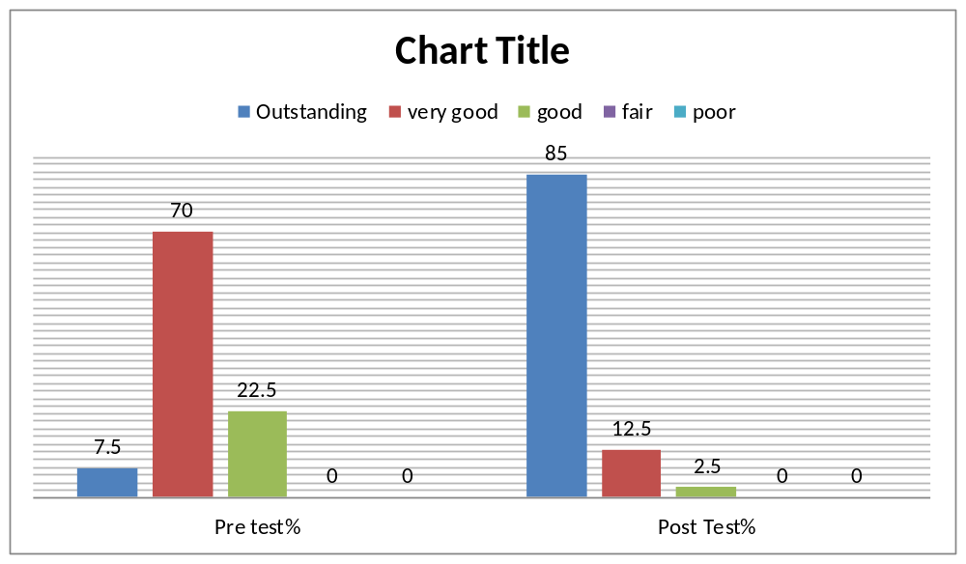

Pre and post session feedback grade analysis also shows that there are significant change in knowledge of student after conducting the interactive session, besides this the thinking about the interactive session like group discussion in teaching and significance of bioethics in professional life also get changed significantly after the session. Most of the students are agree in their feedback that such interactive session during teaching will be helpful in understanding the subject in a better way, shown in (Table 4)

Table 4: Pre and post session Mean feedback grade with SD and p value of significance.
SN | FQ |  | Mean grade  N=40 | SD | SE | r | p | Paired t | P  (2- tail)
1. | Grade your knowledge pre and post brain storming exercise session on medical ethics | Pre Session | 2.27 | 0.96 | 0.15 | 0.102 | 0.53 | -9.78 | 0.000
1. |  | Post Session | 4.22 | 0.91 | 0.14
2. | Grade your thinking about significance of such session during your MBBS course. | Pre session | 2.62 | 1.27 | 0.20 | 0.110 | 0.50 | -7.14 | 0.000
2. |  | Post session | 4.37 | 1.03 | 0.16
3. | Grade the importance of medical ethics in your professional life | Pre session | 3.20 | 1.20 | 0.19 | -0.020 | 0.90 | -6.49 | 0.000
3. |  | Post session | 4.72 | 0.84 | 0.13
4. | Grade the concept about the teaching of medical ethics to undergraduate through group discussion will be helpful in better understanding of subject | Pre session | 2.82 | 1.15 | 0.18 | 0.019 | 0.90 | -7.18 | 0.000
4. |  | Post session | 4.55 | 1.01 | 0.15

While asking the suggestions for better understanding of Bioethics among undergraduate in feedback form as an open ended question , most of them 36(90%) suggested group discussion, however 9(22.5%) suggested that medical ethics must be incorporation in UG and PG course, besides this many of them believe that lecture, role play , seminar, debate, quiz, brain storming exercise and conference certainly enhance the knowledge of Bioethics among undergraduate students as Shown in Table 5; and Graph 2.

Table 5: Distribution of students as per their suggestions for future activity of Bioethics to increase awareness among Under graduate.

S N | SUGGESTIONS BY THE STUDENTS | ABRE. | f | %
1. | Group discussion | GD | 36 | 90
2. | Counselling of students during UG. period | COS | 2 | 5
4. | Lectures on medical ethics | L | 4 | 10
5. | Conducting a drama or play | RP | 4 | 10
8. | Including medical ethics as a subject in UG and PG. courses | IOS | 9 | 22.5
9. | Debate | D | 3 | 7.5
10. | Seminar | S | 7 | 17.5
11. | Sharing of personal experience | SPE | 5 | 12.5
12. | Conference | CON | 2 | 5
13. | Brain storming exercise | BSE | 5 | 12.5
14. | Quiz | Q | 1 | 2.5
15. | Article writing | AW | 1 | 2.5
16. | Question on ethics should be a part of exam | EX | 1 | 2.5

Graph 2:Bar diagram shows Suggestions of students for future mode of academic activity pertaining to Bioethics in the institute.
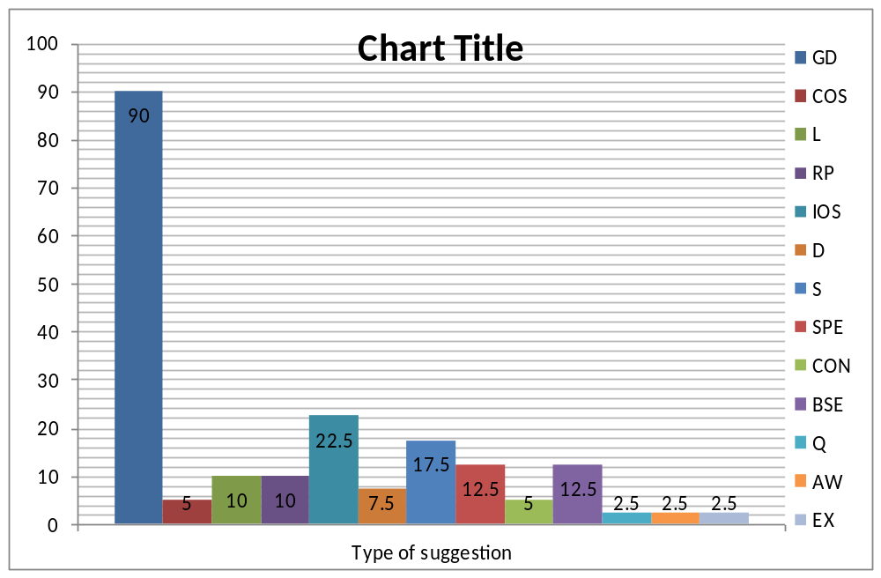

Pre and post session observations shows scenario based small as well as large group discussion improve the knowledge of students pertaining to bioethics at statistically significant level besides this at the end of session majority of the participants has endorsed group discussion as an effective interactive teaching mode for imparting the awareness of bioethics among under graduate medical students.

DISCUSSION

Whether teaching in tutorial, seminars or in clinics, the small group teaching, environment provides the opportunity to discuss without hesitation or inhibition , it also facilitate to receive and give immediate feedback besides this it allows more hands on task to facilitate academic experience. Apart from this it enhance the confidence among students and helpful in motivating them. Therefore the effort toward developing active learning was based on meaningful learning which ensures understanding and applying concepts rather than memorizing only .
By the current observation awareness of bioethics was limited among undergraduate medical students before conducting the session, similar to other conducted research ^{[10,11,12]} though it get increased significantly at optimum level after imparting the knowledge through interactive scenario based group discussion ,besides this it was endorsed as significant as well as most popular mode of teaching by the participants. Perception about the significance of bioethics in their life also gets increased after detailed discussion over various aspects of ethical issues which could be encountered frequently in their life. Chatterjee et al ^{[13]} in his cross sectional descriptive study conducted among under graduate students observe that 50% of medical students were not much aware of medical ethics ,though in present study this figure is quite less 22.5%, however after intensive discussion in groups this figure further declined to 2.5% which is quite significant. Kumar et al ^{[14]} reviewed that teaching of medical ethics must be incorporated in the curriculum of undergraduate as well as postgraduate teaching in India and it must also be evaluated . In a recent research published in Indian journal of medical ethics in 2014 conducted by Janaki Ram and his colleague also endorse that medical and dental postgraduate students of south India not equipped much to resolve the ethical dilemmas they encounter hence incorporation of medical ethics in curriculum is need of time^{[15,16]}. Moreover it was assessed that there is an urgent need of formulating the definite plan for teaching bioethics by using more practical and interactive way to create clear concept among undergraduate to alleviate future constrains as well as complication of practical life pertaining to it ^{[17,18,19,20]}. Besides this popularity of group discussion as an innovative teaching mode for intrigue subjects was much more higher than conventional lecture indicate towards the requirement of changes in teaching environment of medical field to break its monotony . ^{[8,9]}
In present study scenario based group discussion was used in the form of brain storming exercise as a major tool of teaching to impart the crucial knowledge of bioethics. Results were convincing and found statistically significant when compared the knowledge of pre and post interactive session besides this in feedback analysis this technique was endorsed by the participants significantly . Hence using newer innovative and interactive teaching mode have potential to enhance the outcome of learning as well as improve the understanding of intrigue subject.
It was also observed by the present study that majority of the student took interest in group activity with enthusiasm and completed their task with in time limit however at few moment it seems that they need more time for discussion to make consensus on scenarios apart from this few of the students in small group were not hold their own opinion rather just synchronize with their colleagues. Though it consume more time to discuss small area of curriculum than conventional lecture, however understanding as well as concept is buildup in better way by interactive group discussion.
It was also reflected in the attitude of Students as they were happy and feeling enlighten at the end of session due to active participation . Cheerful endorsement as well as positive feedback was received from the majority of participants , for conducting such scenario based interactive group discussion not only for teaching bioethics but also for other clinical topics of the subject in future. We can also use video clips of role play in place of entirely scenario based group discussion which help him in better orientation by visualizing the concept.
Only a group of student took part in pilot study, results were convincing therefore we endorse that it could be included in our future teaching methodology for more robust output.

CONCLUSION
In an era of reforms in teaching learning methodology ,it seems inappropriate to teach practical aspects of Medical ethics as well as other intrigue topics , only by teacher centered didactic lectures , hence interactive group discussion on core topics will be helpful in inculcating the practical knowledge among medical undergraduates. Opting out more student centered tools of teaching and its integration in methodology will be helpful to create interest of students in non palatable but essential subjects.

References:

- David J. ABC of learning and teaching in medicine Teaching small groups. BMJ 2003 ;326(1) :492-94.
- Zaher E, Ratnapalan S . Practice-based small group learning programs. Can Fam Physician 2012;58:637-42.
- Tofade T, Elsner J and Stuart TH. Best Practice Strategies for Effective Use of Questions as a Teaching Tool. American Journal of Pharmaceutical Education 2013; 77 (7) ; 155:1-9.
- Annamalai N, Manivel R, Palanisamy R. Small group discussion: Students perspectives. International Journal of Applied and Basic Medical Research 2015;5(Suppl 1):S18-S20.
- Pal R, Kar S, Zaman FA, Jha DK, Pal S. Assessment of Impact of Small Group Teaching Among Students in Community Medicine. Indian Journal of Community Medicine : Official Publication of Indian Association of Preventive & Social Medicine 2012;37(3):170-73.
- RathnakaR U.P., Sheetal D. Ullal, PReethi G. Pai, RajeShWaRi S., Pemminati SUDhaKaR, ShivaPRaKaSh G. et al, Is Small Group Teaching among the Under Graduate Dental Students Really Effective?, Journal of Clinical and Diagnostic Research 2011;5(4): 822-25.
- AbubAKir M. SAleh, NAMir G. Al-TAWil, NAzAr P. ShAbilA, TAriq S. Al-hAdiThi, A Qualitative Assessment of The Small Group Teaching at Hawler College of Medicine, Journal of Clinical and Diagnostic Research 2013 , 7(5): 883-87.
- Romero-Caldero ´n R, O’Hare ED, Suthana NA, Scott-Van Zeeland AA, Rizk-Jackson A, et al. Project Brainstorm: Using Neuroscience to Connect College Students with Local Schools. PLoS Biol 2012;10(4): e1001310.
- Meo SA. Basic steps in establishing effective small group teaching sessions in medical schools. Pak J Med Sci 2013;29(4):1071-1076.
- Modi JN, Anshu ,Gupta P, Singh T. Teaching and assessing professionalism in the Indian Context. Indian Pediatrics.2014;51:881-88.
- Mahajan R., Aruldhas BW, Sharma M, Badyal DK, Singh T .Professionalism and ethics: A proposed curriculum for undergraduates. International Journal of Applied and Basic Medical Research 2016;6(3):157-163.
- Murrel VS. The failure of medical education to develop moral reasoning in medical students. Int J Med Educ. 2014; 5: 219–22
- Chatterjee B, Sarkar J. Awareness of medical ethics among undergraduates in a West Bengal medical college. Indian Journal of Medical Ethics.2012 ;9(2):93-100.
- Kumar KR. Ethics in medical curriculum; Ethics by the teachers for students and society, Indian J Urol. 2009; 25(3): 337–339.
- Janakiram C, Gardens SJ. Knowledge, attitudes and practices related to healthcare ethics among medical and dental postgraduate students in south India. Indian Journal of Medical Ethics.2014; 11(2): 99-104.
- Roy Ahn, Kristina T., Zaid A, and Thomas F.B.. The Need for Professional Standards in Global Health. AMA Journal of Ethics. 2015; 17(5): 456-60.
- Benatar D. Bioethics and health and human rights: a critical view. J Med Ethics 2006;32:17–20.
- John D. Loike, Rush BS, Schweber A, and Fischbach RL, Lessons Learned from Undergraduate Students in Designing a Science-Based Course in Bioethics. CBE—Life Sciences Education 2013;12:701–710.
- Roger SP . A Compulsory Bioethics Module for a Large Final Year Undergraduate Class, Bioscience Education 2009; 13(1):1-21.
- Gordana P. Bioethics and medicine, Croat Med J. 2013;54:1-2.

