Assessment of Parental Attachment on Unborn Child among
First time Child bearing couple
V.Dhanalakshmi* , Dr.Nalini.S.J**
* Research Scholar,Sri Ramachandra University ,Chennai,**,Principal,Sri.Ramachandra College of Nursing,Chennai.
Correspondence
V.Dhanalakshmi,
Reader(OBG)
Apollo College of Nursing,Dr.M.G.R.Medical University.
Chennai-95, India
E.mail id:dhanalakshmi_vn@yahoo.co.com
Abstract
Aim: Attachment starts when mother finds out about her pregnancy and this is the real start point for fetus dialog with his/her surrounding world. In this study researcher focuses on parental attachment on unborn child among first time child bearing couple. The Aim of this study were to assess and compare the parental attachment on unborn child among first time child bearing couple and to find out the association of parental attachment with selected demographic variables.
Methods: Descriptive research design was used to assess the Parental attachment on unborn child among first time child bearing couple visiting antenatal OPD at selected hospital, Chennai. 60 first time child bearing couple were (antenatal mothers (60) and her partners (60)) selected by convenient sampling over a period of one month. The Maternal Antenatal Attachment Scale (MAAS;Condon, J. (1993) and Paternal Antenatal Attachment Scale (PASS; Condon, J. (2015) were used to assess maternal & paternal antenatal bonding to the unborn baby.
Results: The. Results of this revealed that the maternal antenatal attachment (M=78.166,SD=3.0927) was statistically significant than paternal antenatal attachment (M=55.70,SD=3.5990) on unborn child among first time child bearing couple.
Conclusion: This study concluded that maternal antenatal attachment was significantly higher than paternal antenatal attachment on unborn fetus among first time child bearing couple.
Key words: Attachment, Parental Attachment, Maternal Antenatal Attachment, Paternal Antenatal Attachment,Unborn Child,First time child bearing couple

Introduction
Attachment is a deep and enduring emotional bond that connects one person to another across time and space (Ainsworth, 1973; Bowlby, 1969). The theory of prenatal attachment posits that a unique relationship develops between parents and fetus long before a child is born. Since its introduction in the 1970’s by a few key individuals, notably nurses, measures of prenatal attachment have been developed to enable the assessment of maternal and paternal fetal attachment. Research has suggested that prenatal attachment motivates good health practices during pregnancy, facilitates adaptation to the role of parenthood, and perhaps even serves as a protective factor against perinatal depression, making this theoretical approach to pregnancy important across the disciplines of medicine, psychiatry, and social work, both academic and clinical. So, Researchers decided to assess parental attachment during antenatal period on unborn child especially for first time child bearing couple. Objective of the study were to assess and compare the parental attachment on unborn child among first time child bearing couple and to findout the association of parental attachment with selected demographic variables
Materials and Methods:
Descriptive research design was used to assess the Parental attachment on unborn child among first time child bearing couple visiting antenatal OPD at selected hospital, Chennai. The study carried out 60 samples (antenatal mothers (60) and her partners (60)) selected by convenient sampling over a period of one month. The Maternal Antenatal Attachment Scale (MAAS;Condon, J. (1993) and Paternal Antenatal Attachment Scale (PASS; Condon, J. (2015) were used to assess maternal & paternal antenatal bonding to the unborn baby. The MAAS scale included 19 items and the PAAS 16 items which focus on feelings, attitudes and behaviours towards the foetus with responses recorded on a 5 point Likert Scale. Many of the questions required the respondent to select their answer based on their experience in the previous two weeks. Inclusion criteria of this study were Couple who were visiting at 28th week of gestation to antenatal OPD at the time of data collection, able to read, write english and or tamil. Exclusion criteria of this study were antenatal mothers who were visiting antenatal OPD without their partner.
Results:
Table 1 showed that the Comparison of Maternal Antenatal Attachment and Paternal Attachment on unborn child among First time child bearing Couple.

Table1
Comparison of Maternal Antenatal Attachment and Paternal Attachment on unborn child
among First time child bearing Couple.
N=60
Variable | Mean score | SD | t test
Maternal | 78.166 | 3.0927 | 36.66812***
Paternal | 55.70 | 3.5990 | 36.66812***
***P<.00001

Results revealed in this table is mean score of maternal antenatal attachment (M=78.166,SD=3.0927) is higher than paternal antenatal attachment (M=55.70,SD=3.5990) on unborn child among first time child bearing couple. (P<.00001).Hence maternal antenatal attachment is more than paternal antenatal attachment on unborn child.

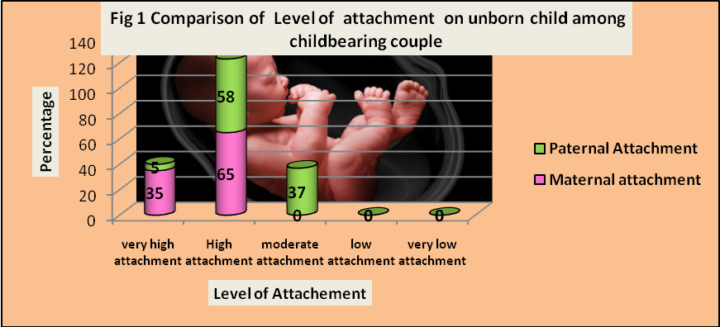

Fig 1 showed that comparison of level of attachment on unborn child among first time child bearing couple which explained that most of the mothers had very high attachment(35%)in comparison with her partner(5%) and also majority of mothers were having high attachment (65%)than her partner(58%),whereas only partner alone had moderate attachment over unborn child (37%).

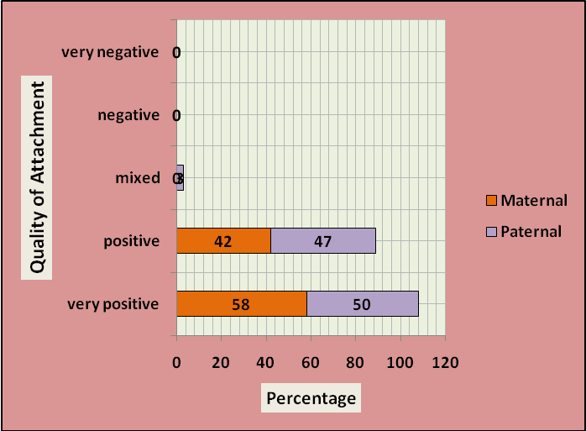
Fig 2 Comparison of quality of attachment on unborn child among
first time child bearing couple

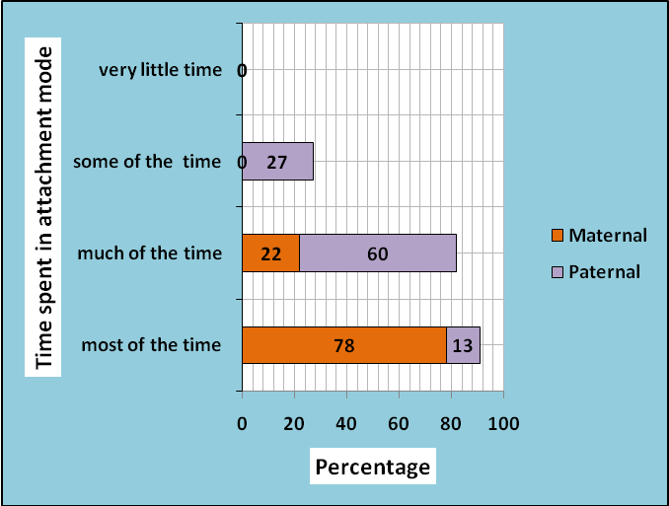
Fig 3 Comparison of Time spent in attachement mobe on unborn child among first timechild bearing couple

Fig 2& Fig 3 illustrated that the sub scales of Maternal antenatal attachment Scale and Paternal attachment scale which are quality of attachment and Time spent in attachment mode on unborn child among first time child bearing couple.
Fig 2 indicated that more than half of the mothers had very positive attachment than her partner on unborn child (58%,50%), whereas nearly half of the mothers had positive attachment than her partner on unborn child (42%,,47%).Fig 3 illustrated that majority of mothers are spending most of the time with her baby compared with her partner.(78%,13%) .In regard to much of the time category, partner of antenatal mother were spending much of the time with their unborn child than mother (60%, 22%).
As per the instructions of MAAS &PASS, While calculating subscale in antenatal attachment scale all items were included except item 7 (Over the past two weeks I have felt that the baby inside me is dependent on me for its well-being) did not loaded on in maternal antenatal attachment and also items 6 (Over the past two weeks I think of the developing baby mostly as) and 13(When the baby is born I would like to hold the baby) in paternal antenatal attachment did not loaded on subscales, and were only included in the total attachment score. Because those items only will be loaded on either factor strongly enough for inclusion on subscales.
The association of maternal antenatal attachment scale was not found significantly with age, Educational status, Age at marriage, Type of family, Occupation and source of information. But Paternal antenatal attachment scale was found significantly associated with occupation (P<0.5) except age, Educational status, Age at marriage, Type of family and Source of information.
Discussion:
The Present study was conducted to assess the Parental attachment on unborn child among first time child bearing couple which explained that most of the mothers had very high attachment (35%)in comparison with her partner(5%) and also majority of mothers were having high attachment (65%)than her partner(58%),whereas only partner alone had moderate attachment over unborn child (37%).
This finding was supported by “A comparative study was conducted to assess the maternal and paternal fetal attachment among 50 expectant mothers and 50 expectant fathers (couples). The major findings of the study showed that expectant mothers had more fetal attachment than paternal fetal attachment in expectant fathers as per their mean difference. Mean percentage of expectant mothers (74.128%) and expectant fathers (64.496%) as per level of attachment. ACKNOWLEDGEMENT:
It’s my pleasure and privilege to record my deep sense of gratitude to Dr.LathaVenkatesan,Principal,Apollo College of Nursing, Chennai and my guide Dr.S.J.Nalini, Principal,Sri Ramachandra college of Nursing, for her inspiring guidance, valuable suggestions, constant encouragement for the completion of the study.
Funding: No funding sources
Conflict of interest: None declared
Ethical approval: The study was approved by the Institutional Ethics Committee.

References:
- Ainsworth ,M.D.,& Wittig, B.A.(1969). Attachment and exploratory behavior of one-
year-olds in a strange situation.London: Methuen.
- Ainsworth, M.D.S., Blehar, M.C., Waters, E., & Wall ,S. (1978). Patterns of attachment:
A psychological study of the Strange Situation. Hillsdale, NJ: Erlbaum.
- Bowlby ,J. (1969). Attachment and loss. Basic Books. USA: New York.
- Condon J, Corkindale C, Boyce P. and Gamble E. (2013). A longitudinal study of father-
to-infant attachment: antecedents and correlates. Journal of reproductive and
infant psychology, 31, pp. 15-30.

