**Title: Evaluation of transparency and policies in clinical research in selected medical institutions of India**   
Kirtimaan Syal

**Address:**

Molecular Biophysics Unit,

Indian institute of Science, Bangalore 560012  
E-mail- [k_syal@mbu.iisc.ernet.in](mailto:k_syal@mbu.iisc.ernet.in) Phone: +91 80 22932836

**Abstract**

It is rightly said that ‘today’s clinical research is tomorrow’s healthcare’. But research should not be done at the cost of the human subjects. This study was done with an aim: to analyze the present policies and safety measures in interest of human subjects, to inquire about reported accidents, compensation scheme and to know the major beneficiaries of the clinical research. Applications as per the Right to Information Act (2005) were filed in the six institutes of India, which includes AIIMS-Delhi, AIIMS-Bhubaneshwar, AIIMS-Bhopal, PGIMER-Chandigarh, JIPMER-Pondicherry and AFMC-Pune for information on clinical trial studies. **All institutes informed that they follow ICMR guidelines for clinical research. The majority of the projects involving clinical research were funded by the Government of India and not by the Western pharmaceutical companies/private sector.**  **Most of the institutes did not maintain records of accidents in clinical research and compensation. AIIMS-Delhi said that such details were third party information which was confidential. The participation of private sector in clinical research was found to be inappreciable and the institutes were not transparent enough in the context of clinical research. Government should encourage the participation of private sector and should form stringent regulatory guidelines to ensure the transparency.**

**Introduction**

In recent times, India has become one of the ideal hubs for conducting clinical research due to the availability of the diverse patient population, trained human resources and need of less investment in comparison to the other countries. Clinical trials are ultimately beneficial for patients, but incidents of deaths/injury of the participants in clinical trial studies have raised many difficult questions. As per the Government of India, 2,868 drug trial participants died between 2005 and 2012, out of which, 89 were proven to be linked to the testing of drugs. The compensation amounts ranging from Rs 55,000 to 4,200,000 were paid to the victims. Many reports indicated the occurrence of illegal clinical research and related deaths. The Supreme Court of India held weak government policies and regulatory measures responsible for these deaths. Lack of clear guidelines for the calculation of the compensation amount was observed (1-2). Many concerns were raised in the context of the process of informed consent in clinical research, the policy for compensation for injury/death to trial participants and the transparency of the process. In 2013, the Ministry of Health and Family Welfare introduced multiple amendments with an aim to improvise policies for the compensation in clinical research related injury/death, process of clinical research and the working of ethical committees (3-4). The Government of India announced these policies after the detailed consultations and analysis.

The objective of this study was to evaluate the regulation of clinical research in representative hospitals/research institutes of India. Do these institutes (which are included in this study) follow the guidelines given by Indian Council of Medical Research (ICMR) for clinical research? Who funds the clinical research in India? Is it very much anticipated private sector/multi-national pharmaceutical companies or the Indian Government? The latter question is very important as it may help in understanding the truth about the negatively popularized view, that the Indian population is being used as the guinea pigs for experiments by multinational pharmaceutical companies (5). How many deaths/major injuries due to the clinical trials have been reported? How they were compensated? In order to get the answer to these questions and understand/assess the current situation, the Right to Information (RTI) applications (as per RTI Act, 2005) were filed in six representative institutes of India; AIIMS-Delhi, AIIMS-Bhubaneshwar, AIIMS-Bhopal, PGIMER-Chandigarh, JIPMER-Pondicherry and AFMC-Pune, in order to understand and evaluate the current scenario.

The survey was done in general public where they were asked for their interest in participation in hypothetical clinical research study for cancer treatment.

The ultimate goal of the clinical research should be the well being of humans which should not be done at the cost of human subjects. It is essential for clinical researcher to publicly disclose the study design, possible benefits for populations in which research is conducted, to report accurate results and restrict the deliberate entry of patient into a placebo group especially when effective alternative treatments are available. The objective of this study was to evaluate and understand the policies/conditions of clinical research in India.

**Material and Methods**

***Right to Information Act (2005) and applications*** (Figure 1)

The Right to Information Act (2005) gives right to information to Indian citizens. It covers most of the institutions under the control of public authorities. This Act was implemented with an objective to promote transparency and accountability. As per this Act, public authority should reply expeditiously or within thirty days (6). All government institutions have Public Information Officers (PIOs) and they may be approached for the access to information. It is mandatory for the PIO to respond within the time limit and if the PIO fails to give decision on the request, it shall be regarded as the refusal of the request, and they could be penalized by the Central Information Commission (CIC). If the information sought is related to the life or liberty of a person, then it should be provided within 48 hours of the request, but that was obviously not the case for our RTI applications (6).

We sent applications to the PIOs of the medical institutes where they provided the adequate assistance. Drafts worth Rs 10 per application, in addition to the photocopying/electronic resources charges, were enclosed with the application.

Private medical institutions were excluded from this study as their records cannot be accessed by the RTI application. A list of government institutions was prepared based on their research output as mentioned in the given reference (7). From these institutes, 4 institutes were selected on the basis of location. In case of multiple institutions at the specific location, institutes were selected randomly. An attempt was made to cover institutes from all regions of India. AIIMS-Bhopal and AIIMS-Bhubaneshwar were included in the study so as to evaluate the policies of the newly formed institutes. AIIMS-Delhi and PGIMER-Chandigarh from North India, AIIMS-Bhubaneshwar from East India, AIIMS-Bhopal from Central India, AFMC-Pune from West India and JIPMER-Pondicherry from South India, were included in this study.

.

All of the included institutes are involved in world class research as apparent from their publication/research output. India has many other world class-representative institutes as well, but they were excluded simply to cover institutes from all over India and to avoid handling/analysis of large amount of data.

*Following information was requested by means of RTI*

“Details of the procedure for Ethical Clearance of clinical research projects were requested”. These details may help to understand the procedure and the scrutiny of the projects.

### “List of the ongoing clinical research projects, with the list of their sponsors, i.e. Government/ private firms, was requested.” This information was requested in order to classify the major beneficiaries of clinical research in India and to understand who drives the clinical research in India.

### “List of reported clinical hazards due to the research/clinical trials from the time of the establishment of the institute was asked.” It was asked to know the frequency of clinical hazards.

* “Compensation policy of the institutes in cases of clinical hazard was requested.”
* “What are the statistics for approval of projects? How many projects were proposed? How many were accepted and denied?” This information was asked to understand the scrutiny of projects.
* “Is there **any concerted move to educate the public on ethical issues confronting medical practice and research? And to incorporate bioethics as a subject in the medical, nursing, paramedical and biotechnology courses?” This is essential to increase the awareness among physicians, paramedics, researchers and the general public.**

**It was informed that if the information is voluminous, it could be provided via CD/electronic source or as per their convenience.**

**Results**

**Response to RTI application**

**All institutes responded to the RTI application as per Indian law within the time limit. It was observed that the majority of the clinical research projects was funded by the Indian government (Figure 2). Based on the source of funding, it could be suggested that the clinical research projects are majorly driven by ‘Government of India’ in these institutes, which is against the much popularized media reports that Indians are being exploited by Western pharmaceutical companies.** Such media reports lead to the negative impression of clinical research in the country which might turn away the potential participants of clinical trial study (3, 5). And this may in turn negatively affect the benefit of the patient population at large. **Most of the institutes reported that they did not maintain records of accidents in clinical research and compensation. AIIMS-Delhi said that such details were third party information (which was confidential) and such information could only be obtained either directly** from the principal investigator (PI)/sponsor or given after the permission from PI/ sponsors. None of the institutes gave the information about the number of clinical research projects denied by their Institute Ethical Committees during the scrutiny of projects. T**he centralized maintenance of records was suggested to the directors/faculties/residents of these institutes where many of them responded positively and promised to look into the suggestion. It was informed that all institutes follow ICMR guidelines for studies involving clinical research as given in reference (8). All institutes mentioned about the seminars and workshops organized by them in response to the query related to their potential role in creating awareness. Further, it was observed that the AIIMS-Delhi reported the maximum number of the projects funded by Western Pharmaceutical Sector and Indian Pharmaceutical Sectors. AIIMS-Bhubaneshwar and AIIMS-Bhopal indicated that they have been established recently and they are still in the process of scrutinizing projects. JIPMER- Pondicherry initially said that the procedure of the application is not as per their guidelines, but later received some information. Most of the information provided by the institutes was analyzed and presented here.**

**Discussion**

Since time immemorial, patients/human volunteers have been subjected to experimentation for the purpose of clinical trials and research for the benefit of society at large. The Nuremberg Code devised ethical guidelines in clinical research to protect the rights and to ensure safety of the research participants. The World Health Organization announced the guidelines in ‘Declaration of Helsinki’ (in year 1964). The ICMR issued the ‘Guidelines for Biomedical Research on Human Subjects’(issued in year 2000, revised in the year 2006) (8).

The findings from this study are relevant in context of exposing the lack of transparency in the selected medical institutions. Also, the information on funding tells that government is the major funding source for clinical research. Government should take up steps to increase involvement of the private sector. At the same time, regulation and supervision of the project should be more stringent so that involvement of the private sector should not harm the interest of human subjects.

**It was predicted that the majority of the clinical research projects were funded by the Western pharmaceutical sector as per the proposition popularized by the media. But, this proposition was found to be wrong. Information on hazards and compensation associated with clinical research could not be obtained from any of the institute. Some of the institutes did not maintain such records and other institutes which maintained the records claimed it to be a third party information (which could not be disclosed). Certainly, there is a scope of improvement in policies of the hospitals/research institutes in the context of the access to the information on clinical research and record management.** RTI inquiry indicated that the most of the clinical research studies are funded by the government which invests public money, so how can any hospital/research institute deny such information to the public especially when most of its projects are funded by public money. Also, clinical research was only possible due to the voluntary donation of samples from patients, therefore denial of access to information and improper management of such records is ethically incorrect. Physicians/Researchers are still not held accountable for the patient samples. Many times the precious human samples are wasted by not reporting the findings or by not using the samples or not processing it correctly thereby resulting in a loss of the sample. Ideally, patients should be informed about the objectives, risks involved and benefits of the experiments/study before the collection of the sample. Most of the time, minor-hazards of clinical research are not even noticed and in case of major hazards like death/major injury, the process of getting justice/ proving that the hazard was due to the clinical trial, is very difficult/complex (except for the cases where the doctrine of res ispa loquitur or “the thing speaks for itself” is invoked and no proof of negligence is required beyond the accident itself). The degree of risk should also be evaluated considering that one type of risk may be acceptable in research on cancer, but may not be acceptable in other type of the research. The participants of the study should be clearly informed and must not be pressurized/ forced to participate in the study. Physicians should not influence the patients for participation. In fact, patients should be informed that the current treatment regime would not be altered due to their decision. This would save patients from exploitation.

**As per the survey, the three major cause of low participation of potential patients in clinical research are lack of trust, insurance and lack of accountability. 40% of the general public in India responded positively for participation in such hypothetical cancer treatment study which is a very good proportion. On the other side, deficit of trust was also exposed in general public during the survey. Most of the educated subjects were hesitant to trust government agencies for clinical research study.** It should be explained to potential participants that their participation is crucial for advancement of medical treatment. Participation should be given proper compensation for their participation. And those participants who cant afford costly medicines should be given the proper treatment free of cost. All of the mentioned points may further help patients in making up their decision to participate in the study.

The major limitation of this study is the lack of stress on the conditions, environment and system of clinical research in India(9). Also, the private institutes were not covered in this study. The private sector is completely inaccessible to the public in general. Provisions should be made in the current law so that information on clinical research in the private health sector could also become accessible to the general public. Further, disclosure of such information should not be reactive but proactive. Government should amend the current laws so that all information related to health institutes (government or private) could be accessed by anyone. Another lacunae of this study is the less number of institutes that were covered which would be taken care off in subsequent studies. The data and practices followed by these institutions may not reflect the situation representative of the whole nation, therefore the study would be expanded in future. It is suggested that the m**anagement of clinical research records should be directly under the hospital. T**he institutes should publish the details of all the clinical research on the web, this would not only increase their credibility towards patients/general public, but also might increase their efficiency as then they could not afford to waste the human sample without giving proper explanation. **Statistical data on hazards of clinical research and benefits of such studies should be available on the web. This might help the human volunteers to make the decision to participate in clinical research. Canada is one of the countries which have recently introduced the similar model where** the information on clinical trials including the sponsor's protocol number, the protocol title, the drug details, the medical condition for which it is beneficial, the trial sponsor's name, the control number for the trial, and the status of the trial have been made available on the web(10). India and other countries should consider it as well for the betterment of clinical research. **Confidentiality is another important aspect that has to be taken care of while disclosing the information. It is recommended that any information about the identity of the patient should not be disclosed which is anyway irrelevant to the conclusions. The provision of compensation should be specified on institutes’ websites. Also, the institute should periodically organize events for spreading awareness on research methodology and ethical guidelines in medical research.** Patients are still susceptible to the exploitation and their protection is the collective responsibility of the physicians, researchers and government. The clinical research should be directed as per the needs of the patients and not under the influence of any one. New research should be carried out only on the basis of the preceding evidence. Research projects should be carefully drafted with specific objectives and should include the provisions for the protection of human subjects. The guidelines for **good clinical practice** should be followed and the primary objective of all studies should be to ensure the safety of the participants. Recently, inspection of the Indian sites by the Food and Drug Administration (FDA, USA) indicated inaccurate records, flawed execution of the investigational plan, improper management of consent related documents and the poor drug accountability. Such type of studies (at sites) should be immediately discontinued (11-12). Ethics in the field of medicine have global relevance and this work might help us in understanding the challenges and limitations of medical laws/ethics in bio-medical research in the developing nations (13-16).

In future, such study would be extended to the other institutes. Also, the difficult conditions and poor management system faced by researchers/clinicians and patients should be exposed. RTI act could be a useful tool in this regard. Collaborations should be made in order to increase the scope of such studies. Public interest Litigation (PIL) has been planned in this context so that clinical research can come under the purview of accessible information. India has great scope for clinical research, and regulatory parameters/transparency should not be the limiting factor. We should aim for creating a positive atmosphere in society which should be encouraging for research (17).

**References:**

1. Gupta YK, Pradhan AK, Goyal A, Mohan P. Compensation for clinical trial-related injury and death in India: challenges and the way forward. Drug Saf. 2014; 37:995-1002.

2. Ghooi RB. The Nuremberg Code-A critique. Perspect Clin Res. 2011; 2:72-76.

3. Shukla S. India's amended trials regulations spark research exodus. Lancet. 2013; 382:845.

4. Ministry of Health and Family Welfare, Government of India. Available via DIALOG. http://www.mohfw.nic.in/index1.php?lang=1&level=5&sublinkid=4481&lid=2641. 2013.

5. Burt T, Dhillon S, Sharma P, Khan D, Mv D, Alam S, et al. PARTAKE survey of public knowledge and perceptions of clinical research in India. PLoS One. 2013; 8:e68666.

6. RTI. The Right to Information Act. Available via DIALOG. http://rtigovin/webactrtihtm. 2005.

7. Prathap G Gupta BM. Ranking of Indian Medical Colleges for their research performance during 1998-2008. Annals of Library and Information Services 2011; 58:203-10.

8. ICMR. Ethical guidelines for biomedical research on human participants. ICMR, New Delhi. 2006.

9. Thatte UM, Bavdekar SB. Clinical research in India: great expectations? J Postgrad Med. 2008; 54:318-23.

10. Canada H. Consultation on Health Canada's Public Clinical Trials Database. Available via DIALOG http://wwwhc-scgcca/dhp-mps/prodpharma/proj/enreg-clini-info/index-engphp. 2013.

11. Bhatt A. Clinical trials in India: Way forward. Perspect Clin Res. 2014; 5:53-54.

12. Maiti R. Clinical trials in India. Pharmacol Res. 2007; 56:1-10.

13. Gillon R. What attributes should clinical ethics committees have? BMJ. 2010; 340:c2946.

14. Masterton G, Shah P. How to approach a research ethics committee. Advances in Psychiatric Treatment. 2007; 13:220-7.

15. McLean SA. What and who are clinical ethics committees for? J Med Ethics. 2007; 33:497-500.

16. Ramesh SV. Sharing individual patient data from clinical trials.Perspect Clin Res. 2015; 2:71-72.

17. Poongothai S, Unnikrishnan R, Balasubramanian J, Nair MD, Mohan V. Why are clinical trials necessary in India? Perspect Clin Res. 2014; 5:55-9.

**Figure 1**: Methodology

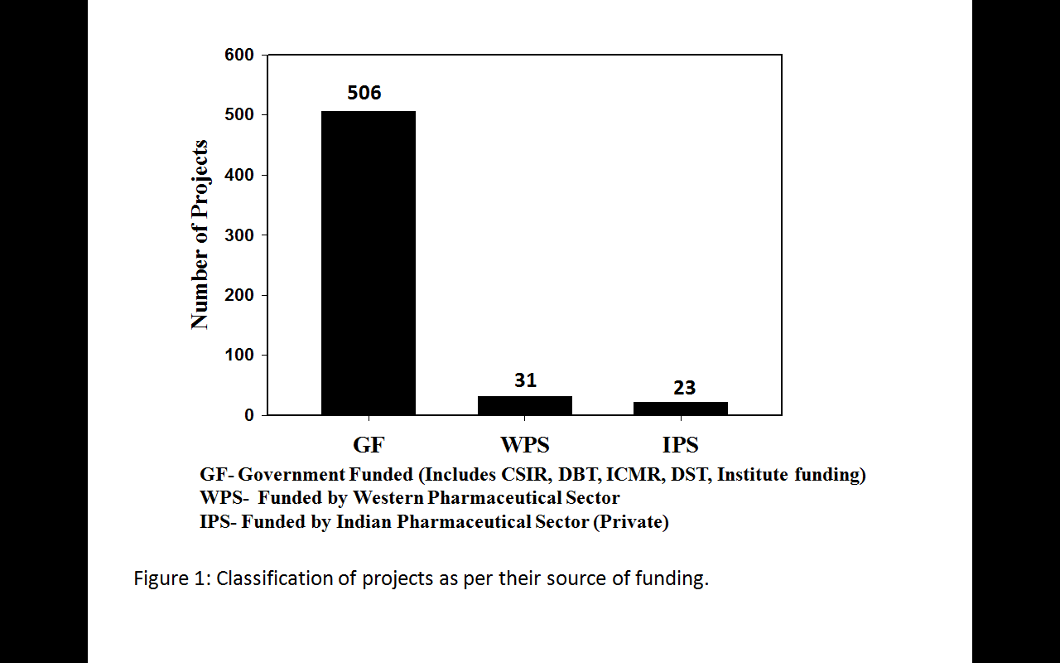

**Figure 2**: Classification of projects on the basis of their source of funding. IPS comprises of the companies of Indian origin and WPS includes the pharmaceutical companies of origin in Western countries (includes their Indian subsidiary, if there is any).