**A COMPARISON STUDY BETWEEN TYPES OF**

**AUGMENTED FEEDBACK ON FUNCTIONAL**

**TASK**

**VivekaNarana,AnanthNagaraj**

**Faculty of thereapeutic sciences, Asia Metropolitan University, Kemacahaya 11, Batu 9, Cheras-43200, Malaysia.**

**\*For Correspondance: Faculty of thereapeutic sciences, Asia Metropolitan University, Cheras-43200, Malaysia. Email: anaphysioforyou@gmail.com, Ph: +60 182404329.**

A**BSTRACT:**

**SCOPE:**The aim of this study was to examine the effect of augmented feedbacks needed when helping a patient learn a functional task.

**OBJECTIVE:**Our objective is to study which among the various types augmented feedback is precisely effective for a normal individuals helps in motor learning to perform a functional task accurately.

**METHOD:** 10 normal university students were choose as subjects to learn basketball penalty shoots and feedbacks were randomly assigned to each person. There will be 5 modes of feedback such as immediate, concurrent, terminal, summary and delayed where each subject will be analysed with each feedbacks. One week of intervention will be given on each feedback, for 20 minutes on each day. A week of washout period will be given before the subject switched to another feedback. Intervention period and practice time will be similar for all the feedbacks.

**RESULT:** The post-testresults as compared to pre-test show immediate feedback has promising effect in learning the functional task as compared to other feedbacks at p<0.5 in same subject. The results also show the subject’s ability to learn and perform functional task effectively is significant different when the he/she is exposed to different feedbacks at p<0.05.

**CONCLUSION:** There is an increase in effectiveness when immediate feedback was used for normal subjects. Overall our study also show the individual’s precision in performing functional task varies when different feedback is given.

**INTRODUCTION**

The important of developing good conditioning feedbacks based on the specific psychological demands of each conditions as considered a key factor to successful performance of functional task. Motor skills is a learning complex process that requires temporal, spatial and hierarchical organization of the CNS are not directly observable but rather are inferred from changes in motor behaviour. Performance result is improved from practice or experience and frequently used measure of learning1.

There are two types of feedback intrinsic and extrinsic. In intrinsic feedback it occurring as natural result of movement or provided by extrinsic, augmented sensory cues. Vestibular, cutaneous signal, proprioceptive and visual are intrinsic feedback and auditory, tactile cues and visual cues are extrinsic feedback1.Augmented feedback about the end result or overall outcome of the movement is termed knowledge of performance (KP)1. Augmented feedback about nature or quality of the movement is termed knowledge of results (KR)1.The relative importance of KP and KR varies according to the skill being learned and the availability of feedback from intrinsic sources1.

There are few types of augmented feedback such as concurrent feedback is given during task performance while terminal feedback is given at the end of task performance1. Summary feedback, feedback given after a set number of trials (example: after every other trial or every third trial)1.Delayed feedback, feedback given after a brief time delay (example: a 3-second delay), can also be beneficial in allowing the learner a brief time for introspection and self-assessment1. Immediate feedback is given just after the task is performed1.Engrams or long term memory traces are laid down over the years as macromolecular changes in neurons and structural changes in synapse throughout the cerebral cortex2. These forms the basis of learning at an intellectual level and of skill acquired through practice2. The direct result of practice is motor learning and highly dependent on feedback processes and sensory information2.

**METHODS**

**SUBJECTS**

Our study selected 10(N=10)3 normal amateur basketball players with age ranging from 20-30 years subjects using convenience sampling method. Subjects are randomly assigned with 5 modes of feedback.This is to determine the effect of augmented feedbacks on motor skill acquisition.All the subjects were free from known neurological disorders and musculoskeletal disorders which is an exclusion criteria.All subjects have met the inclusion criteria: age range from 20 – 30 years and occasional basketball players.

**STUDY PROCEDURE/DESIGN:**

10 samples

**Immediate feedback**

Washout period

**Concurrent feedback**

Washout period

**Terminal feedback**

Washout period

**Summary feedback**

**Delayed feedback**

Washout period

Figure 1 shows one – way repeated measure design

The 10 subjects will assigned with feedbacks randomly, each subject will be analysed with concurrent feedback, terminal feedback, immediate feedback, delayed feedback, and summary feedback. Subjects will be performing the tasks. The pre-test measurement will be taken for 10 shotsfor throwing the basketball standing from free throwlineand how many shots were thrown accurately in to the basket. One week of intervention will be given to each subjects on their own feedbacks in proper biomechanics of basketball diagrams and 20 minutes of practice will be given on each day4.

Then post-test will be taken for 10 shots of trials after one week of intervention.One week of washout period will be applied5. Again pre-test will be taken for 10 shots of trials and followed by other feedbacks. This procedure will be applied to immediate feedback, concurrent feedback, terminal feedback, summary feedback and delayed feedback. All data collected is then analysed for its results.

**OUTCOME MEASURES**

The primary outcome measure used during the study was 10 shots for throwing the basketball standing from free throw lineand how many shots were thrown accurately. The subjects were required to throw the ball in the basket for 10 shots. They were then evaluated based on the number of shots thrown accurately before and after the intervention.

**DATA ANALYSIS**

Data was analysed using parametric test in accordance with the nature of the data and dependent t-test was used to evaluate the difference within the group after undergone intervention. Dependent ANOVA was used to evaluate the difference between both interventions after both group had undergone.

**RESULTS AND DISCUSSION**

**RESULTS AND DISCUSSION**

The key finding of this study was that different type of augmented feedback helps to improve skill acquisition innormal individuals. We found there is a ameliorative improvement in our participants when they underwent immediate feedback(Table2). A similar study was done by Grossman S et al (2015) stated that immediate feedback shows significant effect7. We didn’t found other feedback show similar improvement in skill acquisition. In addition, similar finding found by Molier BI et al (2010 ) stated that it is not possible to determine which combination of aspects and type of augmented feedback are most essential for beneficial effect on motor activities8.

Although the participants in the present study were taught with correct biomechanics of throwing, poor learning effect was observed even thought our subjects received a closely monitored feedback. We presume that the results would have been better if visual feed back(videos) or pamphlets with pictoral description about the proper biomechanics of throwing were presented as our subjects as they received only the auditory ques for improving the functional task.A similar study done by Sigrit R et al (2013) stated that terminal visual feedback was most effective in contrast with concurrent feedback fostered the correction of task irrelevant errors, which hindered learning9. Another study by Walsh CM et al (2009) stated that terminal feedback group performed significantly better as measured by execution time, checklist and global rating score compared to concurrent feedback groups performance decreased significantly10.

Overall difference between group immediate, concurrent, terminal, and delayed feedbacks found there is significant difference in our participants on repeated measure (Table3). Finally it is possible that the results reflect consolidation effects and that the improved motor performance may be retained in the future.

Table 1:

Demographic data

|  |  |
| --- | --- |
| **Age** | 21.9 ± 2.13 |
| **Gender** | F = 60%M = 40% |
| **Height** | 165 ± 11.18531 |

Table 2:

Table 2 below shows pre-test and post-test difference calculated with dependent t-test.

|  |  |  |  |  |
| --- | --- | --- | --- | --- |
| Type of feedback | Mean | SD | P value | 95% CI |
| Immediate | 3.8 | 0.7888 | -3.2061, p< .05 | 0.5171,  2.4829 |
| 5.3 | 1.2517 |
| Concurrent | 3.9 | 1.4491 | -1.7179, p> .05 | -0.2452,  2.4452 |
| 5 | 1.4142 |
| Terminal | 3.6 | 1.7764 | -1.5492, p> .05 | -0.4274,  2.8274 |
| 4.8 | 1.6865 |
| Summary | 3.3 | 0.9487 | -1.655, p> .05 | -0.1886,  1.5886 |
| 4 | 0.9428 |
| Delayed | 3.9 | 1.7288 | -1.524, p> .05 | -0.4543,  2.8543 |
| 5.1 | 1.792 |

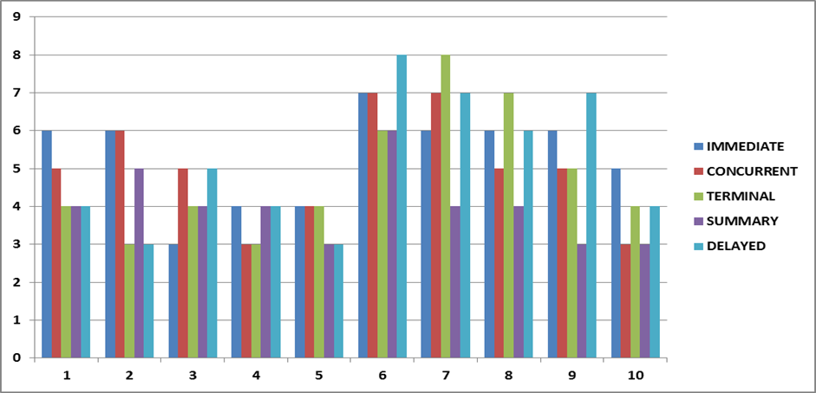

Figure 2Histogram shows the comparative outcomes of our feedback for same subjects

Table 3:

Table 3 below shows overall comparison between groups

|  |  |  |  |
| --- | --- | --- | --- |
| **SS** | **df** | **MS** | **F** |
| **Between** | 10.12 | 4 | 2.53 |
| **Within** | 94.6 | 50 | 2.102 |
| **-Error** | 36.28 | 36 | 1.008 |
| **-Subjects** | 58.32 | 9 | 6.48 |
| **Total** | 104.72 | 49 |  |
| **F-Statistic** | **Critical Value** | **Result** | **Conclusion** |
| 2.51 |  | Reject the null hypothesis | The compared groups differ significantly, F(4,36) = 2.51, p < 0.05 |

**CONCLUSION**

The finding of this study shows that subjects who had undergone immediate feedback increased their accuracy while performing the task whereas those who had undergone concurrent, terminal, summary and delayed feedbacks showed no significant improvement on their rate of skill acquisition.

When 5 groups where compared before and after the washout period there were significant difference found during the performance of the task leading as to believe there is differences in the effectiveness on all the feedbacks.

Though immediate feedback shows effectiveness alone with significant difference, being more so, the study shows that there are more benefits as well as an increase in the rate of skill acquisition when concurrent, terminal, summary and delayed feedbacks in an attempt to perform a task.

**ACKNOWLEDGEMENT**

Authors are very much thankful to the Management and Faculty of Therapeutic Science for providing the necessary facility and encouragement to complete the research work.

**REFERENCES**

**REFERENCES**

1. Susan B.O’Sullivan, Thomas J .Schmitz: Physical rehabilitation( 5th edition) (474,478)
2. Susan B . O’Sullivan.Thomas J . Schmitz . George D . Fulk :Physical rehabilitation(6th edition), (411)
3. Chris N.Kladospoulos and Jennifer J.MC Comas , The effect of form training on foul shooting performances in member of a woman ‘s college basketball team.The graduate school and university centre of the new york.(2001,34,329-332)
4. Driskell J.E, Copper C, and Moran A. (1994) Does Mental Practice Enchance Performance? Journal of applied Psychology, Vol 79, No. 481-492.
5. Caithness G,Osu R,Bays P,Chase H,Klassen J,Kawato M,Wolpert DM,Flanagan JR,Failure to consolidate the consolidation theory of learning for sensorimotor adaptation tasks.J Neurosci.2004 Oct 6;24(40):8662-71
6. Keller K., Engelhardt M. (2013) muscle atrophy caused by limited mobilitation .Sportverletz Sportschaden.2013 May;27(2):91-5.doi: 10.1055/s-0033-1335159.epud 2013 Mar 21.
7. Grossman S, Conelius J.Simulation Pedagogy With Nurse Practitioner Students: Impact of Receiving Immediate Individualized Faculty Feedback.creat Nurs. 2015;21(2):100-9.
8. Molier BI, Van Asseldonk EH, Hermens HJ, Jannink MJ.Nature, timing, frequency and type of augmented feedback; does it influence motor relearning of the hemiparetic arm after stroke? A systematic review.2010, Vol. 32, No. 22 , Pages 1799-1809 (doi:10.3109/09638281003734359)
9. Sigrist R1, Rauter G, Riener R, Wolf P. Terminal feedback outperforms concurrent visual, auditory, and haptic feedback in learning a complex rowing-type task.J Mot Behav. 2013;45(6):455-72. doi: 10.1080/00222895.2013.826169. Epub 2013 Sep 5.
10. Walsh CM1, Ling SC, Wang CS, Carnahan H. Concurrent versus terminal feedback: it may be better to wait.Acad Med. 2009 Oct;84(10 Suppl):S54-7. doi: 10.1097/ACM.0b013e3181b38daf.