**AUTOPSY IN CASES OF CUSTODIAL TORTURE : INDIAN PERSPECTIVE**

**Name of author:** A.J. Patowary MD

Professor of Forensic Medicine

Assam Medical College & Hospital, Dibrugarh, Assam, India.

PIN: 786002

Mobile: 9435018221

Email: [drajpatowary@gmail.com](mailto:drajpatowary@gmail.com), [aj.patowary@nic.in](mailto:aj.patowary@nic.in)

**Statement of Authorship:**

In relation to the article titled “Autopsy in Cases of Custodial Torture : An Indian Perspective” I, A.J. Patowary declare that

* the whole concept of the work (the incision) described in this article is derived by me and is a original work of mine.
* there is no funding from any individual or any organisation government or private, or there is no conflict of interest in anyway with anyone.
* the article has not been sent to any other journal for publication.
* all the photographs attached to the article are also of mine and no body has any claim on them.

**ABSTRACT:**

Autopsy is cases of suspected and unnatural deaths are the vital piece of evidence in detection of the crime and that in case of custodial death become the only piece of evidence as there is seldom any independent eye witness to narrate the incident; many a time the findings in the autopsy become the only evidence which can prove or nullify the commission of the offence. National Human Right Commission of India in the directions issued from time to time has categorically stressed the need of the careful and thorough autopsy examination in such cases. The main hurdle faced by the Forensic Medicine specialist in such cases is in the detection of hidden injuries in the body of the alleged victim of custodial torture without mutilation of the body. This article is intended to highlight the dissection method in custodial torture deaths with necessary precaution to be taken in such cases.

**Key Words:** Autopsy, torture, custodial death, human right, cosmetic autopsy incision.

**Key features:**

* Autopsy incision especially designed for the cases of death due to alleged torture has been described in this article.
* Exposure of whole circumference of the body as well as all the four limbs is achieved in this autopsy incision.
* There cannot be any hidden injury in any part of the body in this incision technique.
* Examination of the penis and scrotum as well as the oral cavity in cases with rigor mortis, where mouth cannot be opened is included.
* All the incisions remain hidden, except in the anterior aspect of the shoulder joint, so cosmetic integrity of the cadaver is achieved.

**INTRODUCTION:**

Torture in the custody is being practiced all over the world to extract truth or confession or the desired statement from the person in custody. In the process, different methods are used both psychological as well as the physical torture to extract the statement from the man in custody. Though the psychological tortures leave more trauma to the person [1,2,3,4], it cannot be visualised, only the effect is seen in the person; the physical torture on the other hand usually leaves more evidence in the form of different type of injuries on the body which can be visualised. Many a time the physical tortures resulting in deep sited bruise or other injury also become difficult to visualise during the routine autopsy examination. So, care is to be taken while dissecting the body during autopsy so that no injury can remain hidden.

As per the Indian legal system, there is no provision for torture in the custody and any kind of death in custody is treated as culpable homicide provided the provision under CrPC sec 46, the right of private defence can be used in such cases where a police officer can use force extending up to causing death of the person as may be necessary to arrest a person accused of an offence punishable with death or imprisonment for life. In all such cases there is strict guideline from the National Human Right Commission of India in regards of investigation, autopsy as well as reporting such cases [5,6,7,8].

The National Human Right Commission in the letter dated Aug. 10, 1995, from then Chairperson, Justice Ranganath Misra to the Chief Ministers of all the states categorically said that, “The Commission is of a prima-facie view that the local doctor succumbs to police pressure which leads to distortion of the facts. The commission like that all post-mortem examinations done in respect of deaths in police custody and in jails should be video-filmed and cassettes be sent to the commission along with the post-mortem report” [6,7].

Justice M.N. Venkatachaliah, Chairperson, in his letter to all the Chief Ministers (No. NHRC/ID/PM/96/57), dated March 27, 1997, where he categorically said that in number of instances the commission has noticed that the post-mortem reports appeared to be doctored due to the influence / pressure to protect the interest of the police / jail officials. He also said that there is hardly any outside independent evidence in cases of custodial violence, the fate of the cases depends entirely on the observations recorded and the opinion given by the doctor in the post-mortem report. If the post-mortem examination is not thoroughly done or manipulated to suit vested interest, then the offender cannot be brought to book and this would result in travesty of justice and serious violation of human rights in custody would go on with impunity [6,7].

A meticulously performed autopsy not only helps the law enforcing agencies to find out the truth, but many a time helps the innocent to prove his or her innocence. Similarly, a carelessly performed autopsy not only hides the evidence but may lead to travesty of justice. So, we have to take utmost care to find out all the possible injuries or evidence while performing an autopsy in cases of alleged custodial torture, so that there is no scope for any unnoticed / unexplored injury in the body of the alleged victims.

**DISADVANTAGES OF PRESENTLY PRACTICED INCISIONS:**

Most of the time, the autopsy surgeons in India use basic three types of incision, namely-

* **“I” shaped incision:** exposure to the neck structure particularly in both sides of the neck is not adequate.
* **“Y”-shaped incision:** visualization of the neck structure is difficult.
* **Modified Y-shaped incision:** visualization of the neck structures in the front of the neck and to some extent, also the sides of the neck is achieved.

In none of the above incisions, exposure of the posterior aspect of neck, thorax or abdomen is achieved, so hidden injuries may remain undetected in those areas. Apart from these, there is another incision practiced in some center i.e. **cosmetic autopsy incision** [9,10,11,12] **(**which was developed in the year 2006b**y** this author)and the advantages are -

* + Whole circumference of the neck, thorax and abdomen is exposed so, better detection of injuries.
  + Abdomen is closed in two layers so, no seepage from abdominal cavity.
  + All the incision marks remain hidden except the mark of curved incision in the front of the shoulder joint so, better acceptance for the relative of the deceased.

But, though in this incision, the whole circumference up to the trunk is exposed, it also failed to addresses the issue of hidden injury in the limbs which are the most vulnerable part in such cases. So, to detect any injury in the suspected areas of the body, many a time, the autopsy surgeons have to make some incisions on the suspected areas for confirming the presence or absence of any injury, thus mutilating the body with multiple incision marks, which imparts a negative impact on already marooned relatives of the deceased.

So, we have to adopt the autopsy incision which will help in exposing all part of the body with minimum visible external marks on the body, so that we can explore all the hidden injuries and at the same time satisfy the relatives of the deceased with minimum external marks; extended cosmetic autopsy incision fulfils these all the criteria where whole of the body is exposed with minimum external marks on the body.

**EXTENSION OF COSMETIC AUTOPSY INCISION:**

The incision is designed to expose the whole of the body so as to find out all the possible injuries in all parts of the body and at the same time, most of the incisions remain hidden when viewed from the front except one incision mark in the front of the shoulder joint; the steps of the incision are follows [9,10,11,12].

1. **Positioning the body:** body is placed in prone position with a wooden block under the shoulder, so that the neck remains in flexed position (Fig-1).
2. **Incision on the back:**
   1. Scalp incision is made from one mastoid process to the mastoid process of the other side in coronal plane through the vertex. (Fig-2)
   2. The incision is extended bilaterally through the posterior border of the sternocleidomastoid and then through the posterior border of the trapezius to the posterior aspect of acromion process. (Fig-2)
   3. A curved incision is made bilaterally from the tip of acromion up to the mid axillary line in the axilla through the medial border of the posterior aspect of the shoulder joint which is then extended up to the iliac crest through the mid axillary line bilaterally. (Fig-2)
3. **Reflection of the posterior flap:** the posterior flap of the scalp is reflected back up to the occiput and anteriorly up to the supra-orbital ridges. The posterior flap is then reflected back making superficial strokes by the scalpel on the subcutaneous tissues, continued through the neck, then the back of the chest and back of the abdomen up to the superior border of sacrum. Thus, the whole flap of the skin is reflected back up to the superior border of the sacrum exposing the whole of the back of the head, neck, chest and abdomen (Fig-3).
4. **Exposure of the lower limbs:** from the iliac crest, the incision is extended round the buttocks up to the midpoint in gluteal folds, then through the middle of the each of the thighs in posterior aspect extending through the popliteal fossa up to the posterior border of the heel. Incision is then extended by both lateral and medial borders of the sole of foot up to the metatarso-phalangeal joints (Fig-4).

The skin flaps are reflected both medially and laterally to expose the whole circumference of the lower limbs up to the heel (Fig-5). The flaps in the sole of foot are reflected distally up to the metatarso-phalangeal joints to expose the sole (Fig-6).

**Exposure of the anterior aspect**

1. **Positioning the body:** After completion of the examination of the posterior aspect, the flap of the skin is replaced back and the body is turned back to the supine position with a wooden block under the shoulder to keep the neck in extended position.
2. **Incision in the front:** 
   1. A curved incision is made from the acromion process through the medial border of the shoulder joint to the mid axillary line bilaterally, as was made in the posterior aspect (Fig-7).
   2. Another incision is made from the mid axillary line on the iliac crest bilaterally over the inguinal ligament, to meet at the symphysis pubis (Fig-8).
   3. The skin with the superficial tissue flap is reflected up, up to the root of the neck and then to the inferior margin of the mandible bilaterally taking care not to injure the rectus sheath and the neck structures. (Fig-9)

This way, the whole of front of the neck chest and abdomen is exposed.

1. **Opening the abdominal cavity:** To open the abdominal cavity, a para-medial incision is made on the rectus near the symphysis pubis, which is extended upward by keeping the index and the middle fingers as guard up to the xiphoid process using a scissors or enterotome (Fig-10) which is then extended bellow the costal margin bilaterally up to the anterior axillary line to open the peritoneal cavity. (Fig-11).

**Opening the thorax:** The sternum is removed by cutting at the costochondrial junction and then separating the sterno-clevicular joint to open the thorax.

Now after separating the diaphragm, the whole of the thorax and abdomen can be examined.

1. **Exposure of the oral cavity:** The skin flapis then reflectedupwardup just below the angles of the mouth; an incision is made on the muscles of the lower lip on the alveolar margin from midline, extending laterally up to the temporomandibular joints bilaterally to expose and open the whole of the oral cavity. Examination of the teeth can also be done in this way and can be noted (Fig-12).

After examination, on repositioning the flap back, the facial appearance reverts back to the original without any sign of disfiguration (Fig-13).

1. **Exposure of the upper limbs:** incision iscontinuedfrom the axilla through the posterior medial border in the arm and forearm up to the medial aspect of the wrist joint, then through the medial border of the palm up to the 5th metacarpo-phalangeal joint from where incision is continued through the base of the fingers towards lateral aspect and then through the lateral border of palm up to the lateral border of thanner eminence (Fig-14). Skin flaps are reflected to both sides of the incision up to the wrist; the skin of the palm is reflected proximally to expose the whole of the palm. (Fig-15)
2. **Exposing the Penis and scrotum:** A rhomboid shaped incision is used with one angle of it in the symphysis pubis, two on the thighs by the lateral aspect of the scrotum and lower angle at the anterior margin of the anus. The skin is reflected from all directions towards the centre to expose the scrotum and penis to examine any injury to the penis and scrotum. (Fig-16)

The anal cannel and the rectum which is one of the vulnerable area for custodial torture can be examined while reflecting the gluteal flaps medially and then removing the rectum between two ligatures from inside.

The vaginal canal in female can also be examined in the same way like that in case of examination of the penis and scrotum using the same rhomboid shaped incision.

The cranial cavity is to be opened as usual using autopsy saw and examined for any findings.

**Closing of the incisions** [9,10,11,12]

The sternum is replaced back to its position. The abdomen is closed by stitching the rectus and the costal margin (Fig- 17). Now the flap of the skin is replaced back. The incision over the inguinal ligament is stitched first then the bilateral mid axillary incisions up to the axilla. Stitches are continued on the arm and the forearm, the palmer flap is replaced back and stitched together. Then the stitches are continued in the front on the curved incision in the medial border of the shoulder. The body is then turned back to stitch the curved incision on the medial margin of the shoulder joint in the back and then on the incisions on both sides of the posterior aspect of the neck up to the mastoid process and then continued to close the scalp incision. Incisions on the lower limb is then stitched, the sole is replaced back and stitched properly (Fig-18).

**Advantages of this incision**

Stitches are not noticed in the neck region which remain visible in others; so better acceptability for the relatives of the deceased (Fig-18).

But the most important advantage of this incision is that, all the injuries in the body including those in the back of the neck, thorax and abdomen as well as the limbs can be visualized which is not achieved in any of the other incisions (Fig-19, Fig-20).

**Conclusion:**

The cases of custodial deaths are always with allegations and counter allegations with wide publicity in the media. Similarly, the persons indulging in torture in the custody are not going to inflict injuries in the exposed areas of the body, rather will choose the areas which usually are not noticed in external examination. So, the role of autopsy surgeon become very much important, as many a time the autopsy findings alone become the evidence for or against the allegation; there is hardly presence of any witness in such cases when it is occurring in the custody of the police or defense personals. So, each and every such autopsy should be meticulous, complete with detailed findings which only will help in finding the fact.

So, this incision technique hold good to serve the purpose as there is no scope for any hidden injury in any part of the body; the whole surface of the body is exposed and so can be examined and documented by photograph and video recording, which is mandatory in such cases [13,14,15]. As there is exposure of whole of the body surface, which cannot be achieved by any other incisions mentioned at the beginning this article, the autopsy surgeon can very well address the presence or absence of any hidden injury in any part of the body supported by documentation by photograph and video recording during autopsy .

So to conclude, this is the ideal method of incision for the autopsy in cases of death due to custodial torture.

**PHOTOGRAPHS OF THE INCISION:**

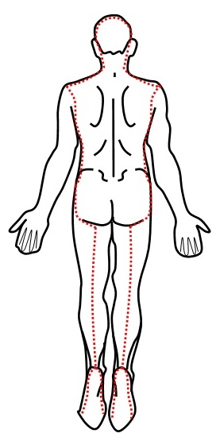 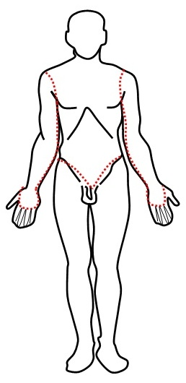

|  |  |
| --- | --- |
| Incisions plan in prone position | Incisions plan in supine position |

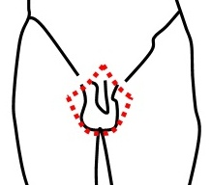

|  |
| --- |
| Incisions plan in perineal area |

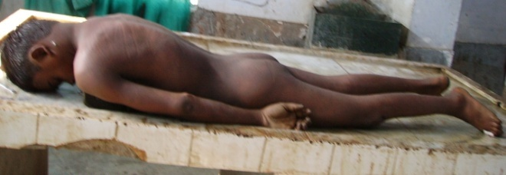 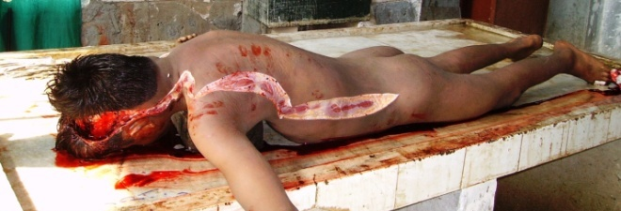

Fig. 1 Positioning the body in prone position Fig. 2 Scalp incision and extension up to the iliac crest

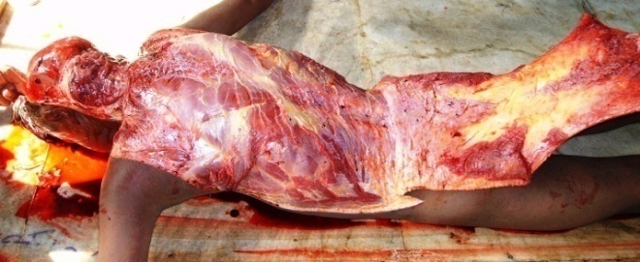 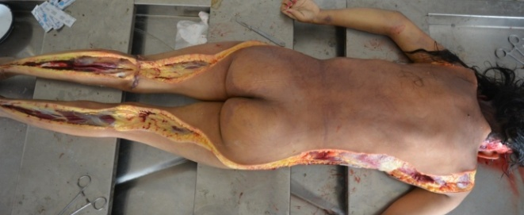

Fig. 3 Reflection of posterior flap Fig. 4 Extension of incision up to the heel

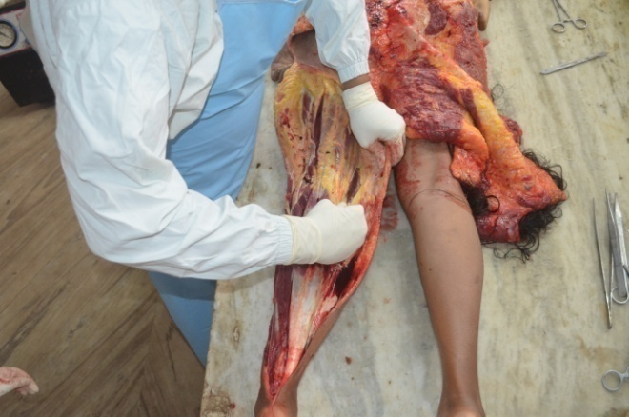 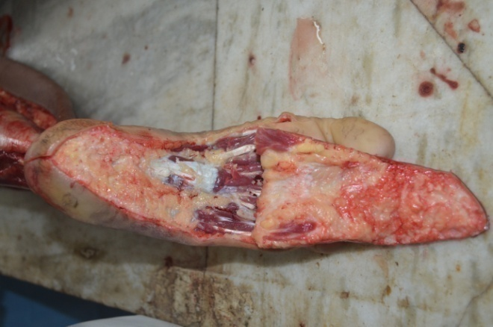

Fig. 5 Reflection of medial and lateral flaps Fig. 6 Reflection of sole of foot

in lower limb

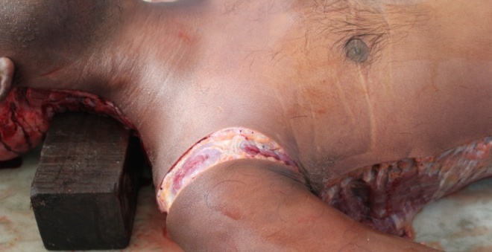 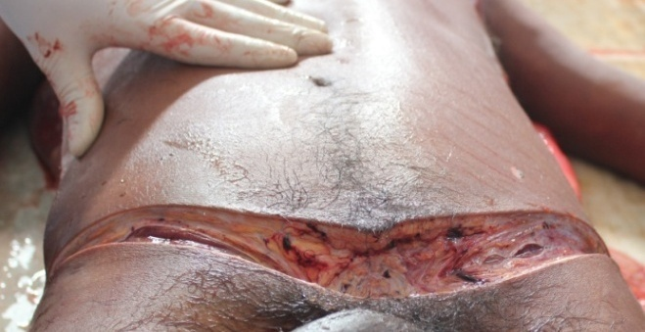

Fig. 7 Anterior incision on shoulder joint Fig. 8 Anterior incision on inguinal

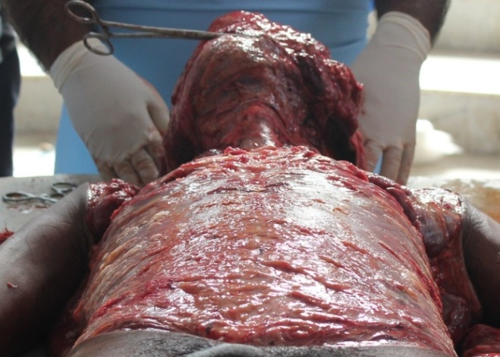 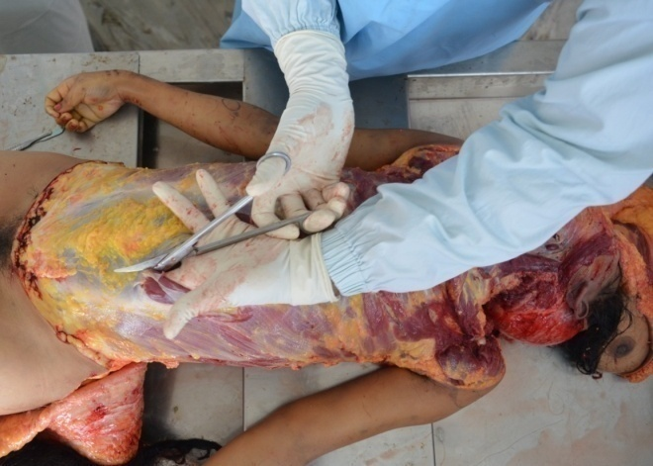

Fig. 9 Reflection of anterior flap Fig. 10 Para medial incision on rectus

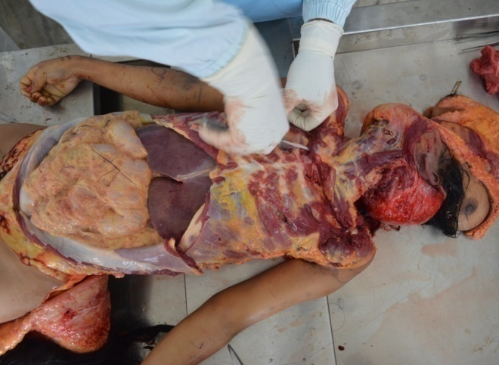 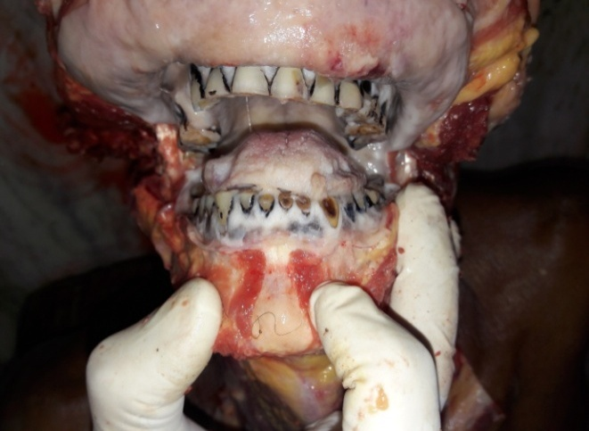

Fig. 11 Exposure of peritoneal contents by Fig. 12 Exposure of teeth and oral cavity

sub-costal dissection

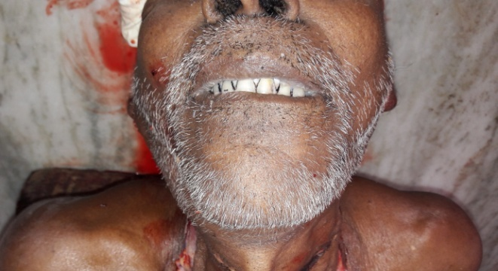 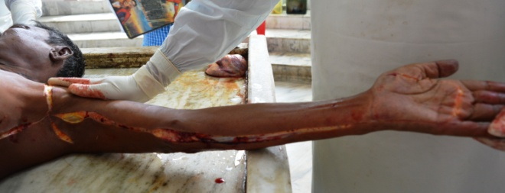

Fig. 13 View after replacement of the flap Fig. 14 Incision on upper limb up to palm

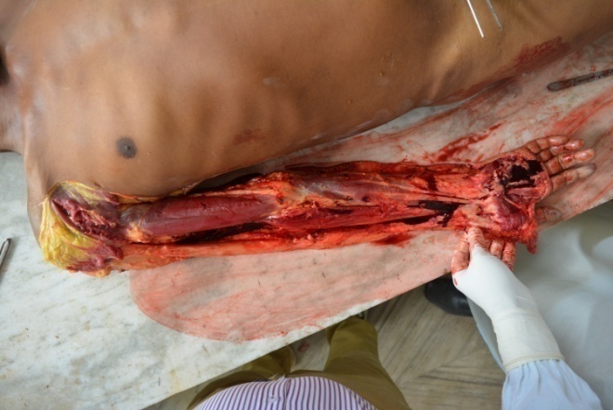 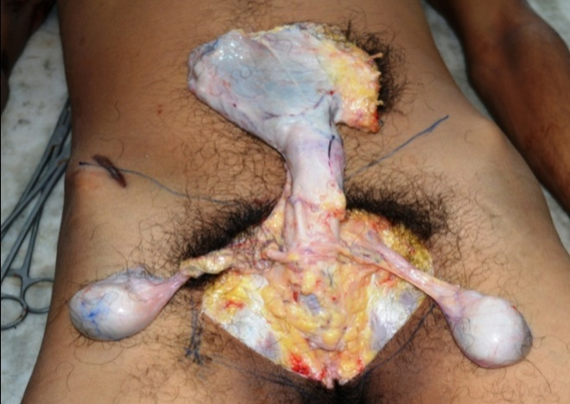

Fig. 15 Exposure of the upper limb tissue Fig. 16 Exposure of the penis and scrotum

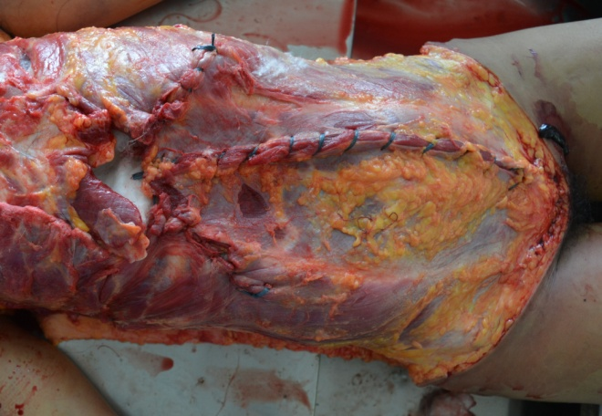 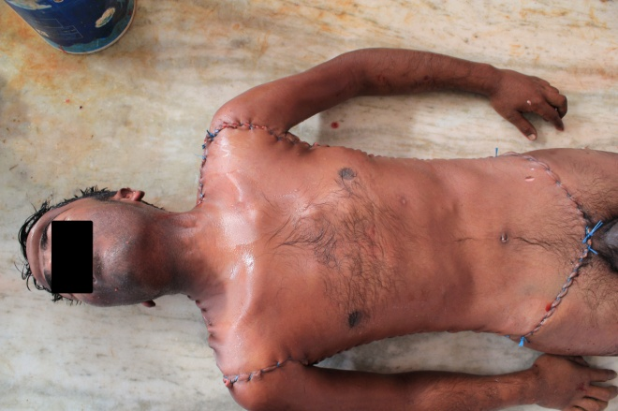

Fig. 17 Closure of the abdominal muscles Fig. 18 View after completion

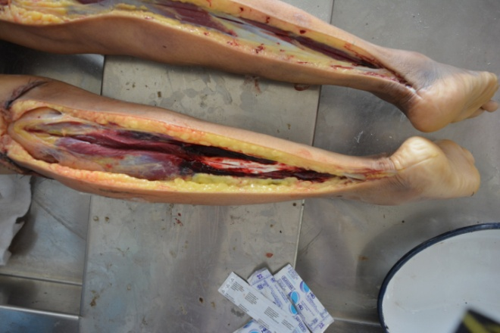 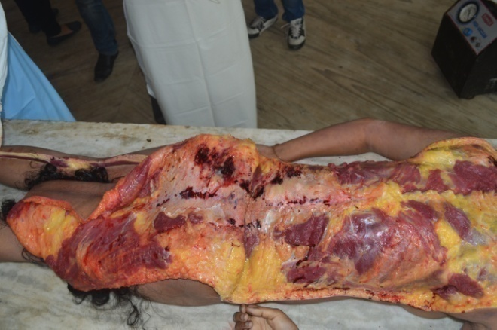

Fig. 17 Deep bruise not detected externally Fig. 18 Bruises on the back not detected externally

**REFERENCES**

1. Break them down – systemic use of psychological torture by us forces. Cambridge: Physicians for Human Rights; 2005.
2. Karmakar RN. Forensic Medicine and Toxicology. Kolkata: Academic Publishers; 2006.
3. Sydney A. A Moral Military. Philadelphia: Temple University Press; 2009; p. 158.
4. Eisenman SF. Abu Gharib Effect. London: Reaktion Books Ltd; 2007.
5. National Human Right Commission of India. NHRC guidelines regarding arrest. [online]. [cited 2016 Jul 01]; Available from URL: <http://nhrc.nic.in/>
6. National Human Right Commission, India- List of Important Instructions / Guidelines Issued by the Commission. [online]. [cited 2016 Jul 01]; Available from URL: <http://nhrc.nic.in/>
7. National Human Right Commission, India. Custodial deaths. [online]. [cited 2016 Jul 01]; Available from URL: <http://nhrc.nic.in/cdcases.htm>
8. Bansal YS, Murali G, Singh D. Custodial Deaths – An Overview of the Prevailing Healthcare Scenario. Journal of Indian Academy of Forensic Medicine. 2007; 32(4):315-7.
9. Mahanta P (Ed). Modern Text Book of Forensic Medicine & Toxicology. New Delhi: Jaypee Brothers Medical Publishers (P) Ltd; 2014.
10. Pillai VV. Text Book of Forensic Medicine & Toxicology. Hyderabad: Paras Medical Publication; 2015.
11. Patowary AJ. The fourth incision - a cosmetic autopsy incision technique. Am J For Med Pathol. 2010;31(1):37-41.
12. Patowary AJ. The fourth incision - a few modifications in autopsy incisions. J Indian Acad Forensic Med. 2010;32(3):234-8.
13. National Human Right Commission of India. Guidelines for video-filming and photography of post-mortem examination in case of death in police action. [online]. [cited 2016 Jul 01]; Available from URL: <http://nhrc.nic.in/Documents/Guidelines_for_video_photography_of_PME_death_in_police_action.pdf>
14. Patnaik AK. Model protocol for autopsies in custodial deaths. Issues In Medical Ethics. 1999; 7(2):48-49.
15. National Human Right Commission of India. Letter to all home secretaries regarding the revised instructions to be followed while sending post-mortem reports in cases of custodial deaths. [online]. [cited 2016 Jul 01]; Available from URL: <http://nhrc.nic.in/Documents/PostMortemReportInstructions.pdf>

**Acknowledgement:**

I am very much thankful to all my PGTs and the junior faculties for their active help and support while dissecting the cases as well as for taking of the photographs during dissections. Thank you students.

I am also thank full to all those for their encouragements and particularly the mortuary attendants of Gauhati Medical College & Hospital, who helped me in this procedure..

I pay my sincere homage to all the departed souls whose cadavers were dissected in the incision technique, may their soul rest in eternal peace.