**"Bare foot to No Foot"! Mycetoma - a neglected tropical disease, scenario in Rajasthan**

Dr. Prabhu Prakash*, Dr. P. C. Gupta **

* Professor Microbiology, Dr. S.N. Medical College, Jodhpur

** Principal Specialist, Surgery, District Hospital, Paota, Dr. S.N. Medical College, Jodhpur

Mail ID [--- dr.prabhuprakash@gmail.com](mailto:---%20dr.prabhuprakash@gmail.com)

**Abstract:**

Mycetoma is a tropical disease which is caused by a taxonomically diverse range of actinomycetes (actinomycetoma) and fungi (eumycetoma). “Mycetoma” means a fungal tumor. Mycetoma is a chronic, granulomatous, subcutaneous tissue infection caused by both bacteria (actinomycetoma) and fungi (eumycetoma). This chronic infection was termed *Madura foot* and eventually *mycetoma*, owing to its etiology. Inoculation commonly follows minor trauma, predominantly to the foot and hence is seen more among the barefoot-walking populations, common among adult males aged 20 to 50 years. The hallmark triad of the disease includes tumefaction, fistulization of the abscess, and extrusion of colored grains. The color of these extruded grains in the active phase of the disease offers a clue to diagnosis .The disease was only recently listed by the World Health Organization (WHO) as a neglected tropical disease (NTD)1. This recognition is the direct result of a meeting held in Geneva on February 1, 2013, in which experts on the disease from around the world met to identify the key research priorities needed to combat mycetoma2. Critically, economical, reliable, and effective methods are required to achieve early diagnosis of infections and consequential improved therapeutic outcomes. Molecular techniques and serological assays were considered the most promising in the development of novel diagnostic tools to be used in endemic settings. Improved strategies for treating eumycetoma and actinomycetoma are also considered.

**Key Words-- Madura Foot, Actinomycetoma, Eumycetomas, WHO, NTD**

**Introduction**:

**Neglected tropical diseases** (NTDs) are a diverse group of communicable diseases that prevail in tropical and subtropical conditions in 149 countries and affect more than one billion people, costing developing economies billions of dollars every year. They mainly affect populations living in poverty, without adequate sanitation and in close contact with infectious vectors and domestic animals and livestock. On 28 May 2016, the 69th World Health Assembly approved a resolution recognizing [mycetoma](http://www.who.int/buruli/mycetoma/en/) as a neglected tropical disease. Currently there are 17 infections listed by the World Health Organization as neglected tropical diseases and three others are cited as neglected conditions. Until July 2013, mycetoma was absent from the WHO list, even though its estimated prevalence of two per 100,000 inhabitants was comparable to that of other recognized neglected diseases, such as Buruli ulcer and Human African trypanosomiasis. Mycetoma is an implantation mycosis , characterized by large tumor-like swellings and located mainly in the extremities. It can be caused by taxonomically diverse microorganisms, both of bacterial (actinomycetoma) and fungal origin (eumycetoma)  The most common causative agents include the fungus Madurella mycetomatis and the actinomycetes Nocardia brasiliensis, Actinomadura madurae, Streptomyces somaliensis and Actinomadura pelletieri 3,4.

The disease is mainly found in tropical and subtropical regions of the world, and the majority of patients are reported from Mexico, Senegal, Sudan, and India, but its true prevalence and incidence are not well defined5. Furthermore, there are no rapid diagnostic tools, while treatment, especially for eumycetoma, is unsatisfactory, resulting in high morbidity, including amputation of limbs. On February 1, 2013, a landmark meeting was held in Geneva, Switzerland that was attended by experts on mycetoma from around the world. Its aim was to review all currently available information and to identify knowledge gaps and research priorities. It was concluded that basic epidemiological information is lacking: it is not known how many people are suffering from mycetoma or where the disease is most prevalent. Furthermore, early detection of mycetoma is difficult, while treatment is far from satisfactory for eumycetoma patients. “Including mycetoma on the WHO List gives the disease the political prominence it so desperately needed. Funding bodies can now consider taking up the disease. It will also allow global programs to be set up, which would better define the epidemiology, the risk factors, as well as treatment strategies, and early identification of cases. On 28 May 2016, the 69th World Health Assembly approved a resolution recognizing [mycetoma](http://www.who.int/buruli/mycetoma/en/) as a neglected tropical disease.

Mycetoma is a chronic subcutaneous granulomatous infectious disease caused by a diverse etiology of bacterial and fungal agents; referred to as actinomycetoma and eumycetoma respectively, characterized by tumor like swellings and discharge of grains. The bacteria and fungi cross the skin barrier via accidental, traumatic, subcutaneous implantation of etiological agents from its saprobic source by thorn, splinters or nails to produce inflammatory disorder. Mycetoma is endemic in areas where the vegetation comprises principally of thorn pricks, minor abrasions and trauma in skin also plays important role in introduction of etiological agents in subcutaneous tissue. Being an implantation mycosis, its common sites of involvement are lower and upper limbs, although other sites can also be involved. Disseminated form may occur. The predisposing factor for mycetoma are a variety of environmental and social factors such as rainfall, temperature, soil and abundance of thorny sharp vegetables material on land which is capable of inoculation of mycetoma agents and as habit of walking bare footed and carrying goods on the back etc. Mycetoma of perineum is probably due to working of farmers in squatting position and wearing inadequate clothes around groin thereby subjected to injuries by thorns and splinters. Use of wicks for removal of wax from ear is a common feature among rural folk. This may be responsible for entry of agents leading to mycetoma of middle ear. Similarly mycetoma of back is due to habit of carrying goods like wood, bags of grains, stones or other articles contaminated with soil on aforesaid areas which produces minor abrasions through which organism gain entry. The disease occurs more frequently between ages 20-40 and is more frequent in men. It is more commonly seen in farmers, field laborers and herdsman who come in contact with soil and in endemic areas where fungal spores causing Mycetoma are prevalent.

Disease advances slowly over months or years, typically with minimal pain. Symptoms include swelling, multiple draining sinus with extrusion of pus admixed with granules. Pain when experienced, is usually secondary to superimposed infections of bone involvement. Although it is rarely fatal, mycetoma causes considerable morbidities developing deformities and potential disability. The diagnosis is not difficult and usually performed by microscopic examination of grains and its culture. But the patients generally seek medical attention late in the disease process. The treatment of mycetoma depends on the etiology, while actinomycetoma is usually treated with antibiotics only and has a decent cure rate; eumycetoma is treated with a combination of antifungals drugs and surgery. Unfortunately, recurrent infections are common and amputations are needed in non-responding patients.

Mycetoma is a devastating disease; patients are among the most neglected of the neglected. They are poor, stigmatized, and often live in remote and rural areas. It is a slow growing bacterial or fungal infection, which develops into a chronic infection of the skin tissues and, if left untreated, eventually results in amputation of limb. Children and young adults are particularly at risk. With existing anti-fungal drugs and surgery, only 35% of people living with the fungal form of the disease, known as eumycetoma, are cured. Infection can come from the soil or animal dung and it is thought that it enters the body after the skin has been pricked, for example by a thorn.

**Epidemiology:**

Mycetoma typically presents around the Tropic of Cancer between latitude 15° South and 30° North (also known as “mycetoma belt”), a predominant geographic distribution in the tropical and subtropical regions of the world. Mycetoma is frequently reported in rural active population of India, being a part of the mycetoma belt, but the exact burden of and the epidemiology of the disease are not exactly delineated.

The disease has been widely reported from Mexico, Sudan, Senegal and India but its true prevalence is yet to be defined. A rough estimate of the global burden of mycetoma was done by Sande et al in which 8763 cases were reviewed. The estimated prevalence for the endemic areas of mycetoma, Mexico and Sudan, were 0.15 and 1.81 cases per 100,000 inhabitants, respectively5. Maximum cases were reported from Mexico followed by Sudanand India. Limited case reports were identified from Uganda, Rumania, Nigeria, Bulgaria, and Thailand 6. The studies have also highlighted the differences existing within a country with respect to its prevalence and causative species. In India Rajasthan accounted for majority of cases reported per year (33.3 cases) followed by Tamilnadu (16.8 cases) and West Bengal (13.2 cases) respectively. The distribution of causative agent also differed as 62.5% of mycetoma cases in Rajasthan were found to have fungal origin while 54.3- 83.3% of all mycetoma case in other states were those of actinomycetoma. Hence there is an indispensable necessity to map the mycetoma cases in order to establish its true prevalence.

The disease is endemic in Rajasthan. In the North West part of Rajasthan where the average rainfall is low i.e. less than 350 mm, maduromycotic type of mycetoma is more common which shows presence of black granules whereas in South East Rajasthan where the average rainfall is high i.e. more than 600 mm, actinomycotic mycetoma is more common which shows presence of Red, yellow or white granules7,8 (Mathur et al, 1979). The disease is most prevalent in North West region, which accounted for two third of the patients.

Based upon the nature of soil and rainfall the state has been divided into three arbitraryn regions:

1. North West desert region -consisting of districts Ganganagar, Bikaner, Churu, Jaisalmer, Barmer and Jodhpur with annual rainfall of less than 350 mm.
2. Central regions of plains consisting of districts Jhunjhunu, Sikar, Jaipur, Nagaur, Ajmer, Pali, Jalore with annual rainfall of 350 -550mm.
3. South East - Aravali hill region consist of Sawai Madhopur, Bhilwarw, Chittorgarh, Udaipur, Sirohi, Dungarpur and Banswara with annual rainfall of more than 600 mm.

The most common species of mycetoma encountered in North-West part of Rajasthan is Madurella mycetomatis which presents usually with discharge of black granules at the site of lesion 9.

In the South -East part of Rajasthan actinomycetoma is more commonly seen and the most common species of actinomycetoma is Streptomyces somaliensis.

A large number of organisms have been described. Carter (1860) was the first to establish the fungal etiology of mycetoma. A balanced classification of etiological agents of mycetoma was given by Winslow and Steen.

**Classification of Mycetoma:**

1. ***Agents causing eumycetoma (maduromycetoma):***

(1) Madurella mycetmatis and Madurella grisea. (2) Exophiala Jeanseleni (Phialophora jeanselmi). (3) Allescheria boydii. (4) Aceromium species. (5) Pyrenochaeta romeroi. (6) Leptosphaeria sensgalensis and L. tompkinsii. (7) Curvularia lunata and C. geniculata. (8) Neotenstudina Rosatii. (9) Aspergillus brasileinsis. (10) Fusarium species.

***B) Agents causing Schizomycetoma:***

*(a) Agents causing actinomycetoma:*

(1) Actinomadura madurae. (2) Actinomadura pelletieri. (3)   
 Streptomyces somaliensis. (4) Nocardia brasiliensis. (5) Nocardia caviae. (6)   
 Nocardia Asteroids.

(b) *Agents causing Botromycosis:*

(1) Staphylococcus spp. (2) Escherischia coli. (3) Proteus spp. (4) Pseudomanas.   
 (5) Streptococcus spp. (6) Actinobasillus lignriesi.

Generally only one of the agents mentioned above causes mycetoma. Rarely more than one agent belonging to same or other groups may cause disease in same patients at different sites or at same site.

**CASE REPORT**:

A young 35 years old female came with complaints of multiple sinuses, discharging purulent fluid and history of passing black granules since last 2-3 years, pain in swelling since last 4-6 months. Local examination revealed a painful swelling with irregular scarred area and multiple sinuses discharging purulent fluid. On investigations, hematological and urine examination were normal. VDRL and HIV 1 and 2 tests were non-reactive. Radiological examination revealed no bony involvement. Sample (Black granules) were collected by applying saline dressing. Multiple dark black or black granules 2-4 mm in size, collected from patients dressing. Granules ere hard in consistency and were processed for 40% KOH mount and microscopy revealed thick mycelium . Samples were transported and processed on the same day of collection. In cases of delay, they were stored under refrigeration at 4°C for no longer than 24 Culture was done on SDA with antibiotics and after 2-3 weeks of culture typical fungal colonies of Madurella.

**Direct demonstration:**

For direct visualization of fungal elements smears from purulent exudates and grains obtained were stained with Gram's stain and Ziehl Neelsen stains. The examination of samples following preparation of mounts with 10% potassium hydroxide (KOH) was also be done. Histopathological examination of tissue sections and impression smears was done following Haematoxylin and Eosin (HE), Gomori methenamine silver (GMS) or periodic acid Schiff's (PAS) to identify fungal elements.

**Isolation and identification:**

All samples were homogenized aseptically followed by inoculation on to two sets of Sabouraud’s dextrose agar (with and without chloramphenicol and gentamicin) and blood agar. The one set of SDA tubes and blood agar plate will be incubated at 37°C and another set of SDA at 25°C. Identification of the etiological agent were based on microscopy as well Mycelial growth will be identified by its morphological features.

The key to successful management of mycetoma lies in early diagnosis of the condition. Early cases without lesions are almost impossible to identified since they do not show classical sign of mycetoma and grains are still absent. The available diagnostic tools include imaging to determine the extent of the lesion along different tissue plan and cytological, histopathological examinations and culturing of grains to identify the causative agent. Deep surgical biopsy material is needed for the latter to procedure. Identification of causal agents to the species level with histology is next to impossible while culturing them is difficult and time consuming specially for non sporulating fungi. How ever since the treatment of the etiologies is entirely different12, a definite diagnosis in the form of histopathological examination and culture is mandatory. There have been notable advances in the newer modalities for early diagnosis as well as improved molecular technique for species identification of etiological agents. Sero-diagnosis though not useful in diagnosis of mycetoma is helpful in follow up of the patients as well as epidemiological survey. One of the most characteristics features of the mycetoma is poor response to the therapy. When the diagnosis and therapy are early, the response is better. For mycetoma of any etiology, there is no resolution of the infection without medical or surgical intervention. Therapeutic measures consist of prolonged courses of antibiotic or antifungal often combine with surgery. Patients with eumycetoma are usually manage with surgical debridement and oral antifungal drugs11 such as ketoconazole, voriconazole, itraconazole and intravenous amphotericin B. Whereas actinomycetoma are treated with sulfamethoxazole trimethoprim, streptomycin, amikacin with or without depsone and periodic surgical debridement. Carbapenam, oxazolidinones and triazoles have emerged as promising therapeutic options but access to drug therapy in developing countries like India remains limited by the poor availability and high cost. Given the fact that majority of the population in India still rely on agriculture and field work for their lively hood. Mycetoma can significantly affect their life. Awareness of the characteristics of the disease on the part of the clinician, use of newer modalities for the early diagnosis and management along with effective IEC intervention to the population at risk can significantly improve the prognosis or the disease.

## Surgical Care:

## Surgery is recommended for localized mycetoma lesions that can be excised completely without residual disability. Surgical reduction of large lesions can improve the patient's response to medical treatment. However, partial surgical resection without subsequent use of appropriate antimicrobial or antifungal agents is prone to failure. Distinction between eumycetoma and actinomycetoma is very important as treatment is medical for the later, whereas fungal infection (eumycetoma) responds to surgery only.

The development of methods for early diagnosis and therapeutic monitoring will result in better therapeutic outcomes. Improvement of therapeutic strategies in eumycetoma will also reduce the burden of disease. Now that the key research priorities have been highlighted, it is time to implement them. The WHO has taken an important first step by including mycetoma on the list of NTDs. Further recognition by the international community is needed. Resources need to be made available to design control efforts and improve patient management.

**Recommendation:**

Practice of working bare foot in field should be banned. There is:

1. At present data are lacking regarding incidence and prevalence of disease for proper implementation of preventing measures.
2. Proper knowledge about natural habitat and the mode of transmission will help in preventing measures to reduce the number of mycetoma cases worldwide.
3. Developing new, fast and cheap diagnostic tools which can help in early case detection and scope of better therapeutic outcome.
4. There is demand of new therapeutic options for eumycetoma.
5. A simple, reliable biomarker for cure is urgently needed to assess the response to treatment.

**Conclusion:**

Given the fact that majority of the population in India still rely on agriculture and field work for their lively hood. Mycetoma can significantly affect their life. Awareness of the characteristics of the disease on the part of the clinician, use of newer modalities for the early diagnosis and management along with effective IEC intervention to the population at risk can significantly improve the prognosis or the disease.

**References:**

1. WHO (2013) The 17 neglected tropical diseases. Geneva: World Health Organization.
2. Van de Sande WWJ (2013) Global burden of human mycetoma: a systematic review and meta-analysis. PLOS Negl Trop Dis 7: e2550.
3. The mycetoma knowledge gap: identification of research priorities. [van de Sande WW](http://www.ncbi.nlm.nih.gov/pubmed/?term=van%20de%20Sande%20WW%5BAuthor%5D&cauthor=true&cauthor_uid=24675533), [Maghoub el S](http://www.ncbi.nlm.nih.gov/pubmed/?term=Maghoub%20el%20S%5BAuthor%5D&cauthor=true&cauthor_uid=24675533), [Fahal AH](http://www.ncbi.nlm.nih.gov/pubmed/?term=Fahal%20AH%5BAuthor%5D&cauthor=true&cauthor_uid=24675533), [Good fellow M](http://www.ncbi.nlm.nih.gov/pubmed/?term=Goodfellow%20M%5BAuthor%5D&cauthor=true&cauthor_uid=24675533), [Welsh O](http://www.ncbi.nlm.nih.gov/pubmed/?term=Welsh%20O%5BAuthor%5D&cauthor=true&cauthor_uid=24675533), [Zijlstra E](http://www.ncbi.nlm.nih.gov/pubmed/?term=Zijlstra%20E%5BAuthor%5D&cauthor=true&cauthor_uid=24675533). [PLoS Negl Trop Dis.](http://www.ncbi.nlm.nih.gov/pubmed/24675533) 2014 Mar 27;8(3):e2667
4. Bakshi R, Mathur DR (2008) Incidence and changing pattern of mycetoma in western Rajasthan. Indian J Pathol Microbiol 51: 154–155.
5. Chakrabarti A, Singh K (1998) Mycetoma in Chandigarh and surrounding areas. Indian J Med Microbiol 16: 64–65.
6. Joshi KR, Sanghvi A, Vyas MC, Sharma JC (1987) Etiology & distribution of mycetoma in Rajasthan, India. Indian J Med Res 85: 694–698.
7. Mathur D, Joshi K, Mathur A. An etiological and pathological study of mycetoma in western Rajasthan. Curr Med Pract. 1979;23:151-161
8. Mathur DR, Prakash P, Gupta PC (1994): Red Grain Mycetoma in Western Rajasthan. Indian J. Dermatol Venerol Leprol. 60; 99-100.
9. Venugopal PL, Venugopal TL. Actinomadura madurae causing mycetoma in Madras. Indian J Pathol Microbiol. 1991;34:119-125.
10. Sharif H, Clark D, Aabed M. Mycetoma: comparison of MR imaging with CT. Radiology. 1991;178:865-870.
11. Mahgoub E. Medical management of mycetoma. Bull World Health Organ. 1976; 54:303-310.
12. Ahmed AO, Abugroun ES (1998). Unexpected high prevalence of secondary bacterial infection in patients with mycetoma. J Clin Microbiol 36: 850–851.

1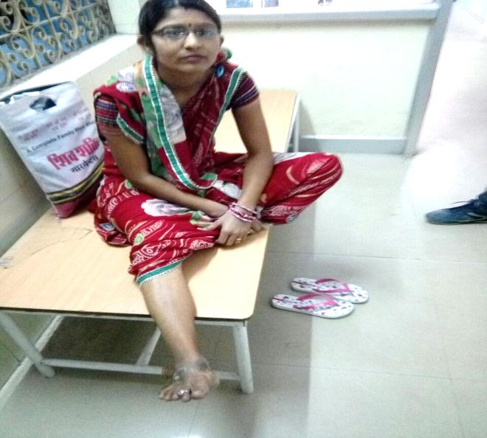

2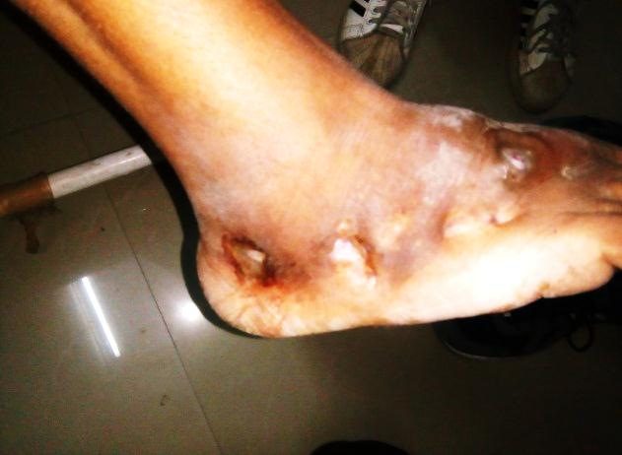 3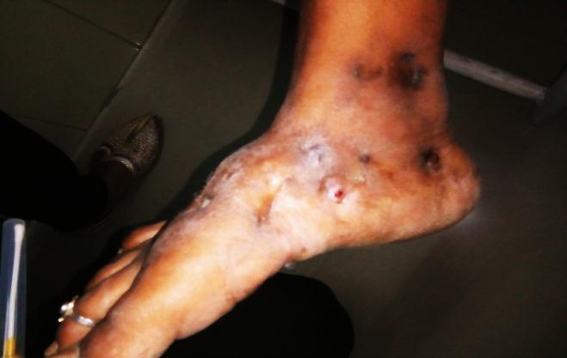

4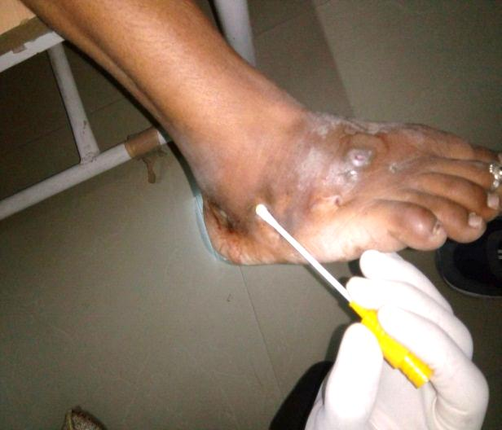 5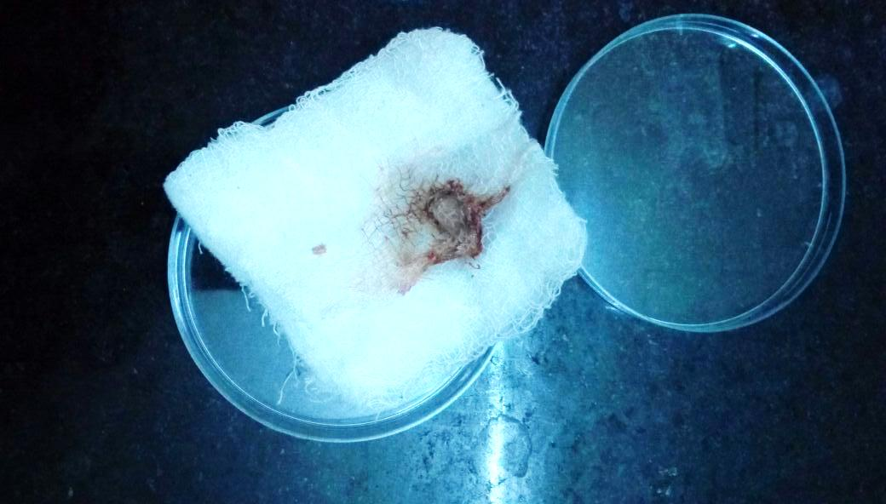

1. Younge female with lesions on Right Foot
2. 2&3 --Multiple sinuses with Black Granules coming out from sinuses.
3. Sample collection from sinuses
4. Saline dressing showing Black Granules which can be collected an used for KOH Mount and Fungus Culture.

**Mail Id---** [**dr.prabhuprakash@gmail.com**](mailto:dr.prabhuprakash@gmail.com)

**DrPrabhuPrakash,**

**Chopasni Housing Board ,**

**First Puliya,**

**JODHPUR.**

**9413322110**