**Quality of life parameters should be included in the preoperative informed consent in patients with chronic rhinosinusitis scheduled for functional endoscopic sinus surgery.**

Sir,

Functional endoscopic sinus surgery (FESS) is effective in patients with chronic rhinosinusitis who have failed medical treatment [1]. Indeed, these patients bear a significant disease burden, as the nasal congestion, the purulent nasal discharge, the postnasal drainage, and the recurring headache inevitably affect their physical and emotional well-being, and thus their quality of life [2].

However, in addition to the medical effectiveness of FESS, measured in terms of improved symptom control, or lack of work absenteism as undisputed measures of treatment success, quality of life has been increasingly recognized as an important outcome parameter for patients [2]. Hence, in addition to the expected clinical effectiveness of FESS, appropriate preoperative informed consent requires that the patient be aware of the effect of the proposed intervention on his/her quality of life.

In a prospective study conducted at a tertiary University Hospital, 84 patients filled in the Glasgow Benefit Inventory (GBI) [3], a validated questionnaire focusing on quality of life after a surgical intervention, one year after a FESS operation for chronic rhinosinusitis (without nasal polyps). The GBI consists of three domains, which assess a patient’s perception on the success of a certain operation regarding the general benefit, physical health status, and social support, respectively. The study sample comprised 49 men and 35 women, with a mean age of 45.4 years (SD=±14.2).

Table 1 shows the descriptive statistics for the GBI subscales. The median value for the general benefit subscale was 33.33 (IQR: 18.75-52.08), for the physical health status 16.67 (IQR: 0.00-50.00), for social support 0.00 (IQR: 0.00-16.67), and for the overall (total) QoL 27.78 (IQR: 19.44-44.44). In addition, the respective proportion of patients who perceived benefit from the operation was 92.9% for the general subscale, 56% for the physical health status, 41.7% for social support, and 94% for the overall quality of life (Fig. 1). A comparison of the GBI scores between men and women, by employing the non-parametric Mann-Whitney test, did not reveal significant differences, either regarding the respective subscales, or the overall quality of life (p>0.05). Correlation analysis of the GBI subscales with age showed negative and low correlation between the patients’ age and their general benefit score (Spearman's r=-0.22, p=0.042).

Hence, the use of the GBI in the present study allowed quantitative assessment of an otherwise subjective parameter, such as the postoperative quality of life after FESS. Thus, not only FESS has a positive impact on the health status of chronic rhinosinusitis patients, but is also beneficial for their overall quality of life. This outcome is extremely important for medical ethics, as the process of obtaining preoperative consent presupposes that this consent is informed. Quality of life considerations can be taken into account during treatment planning and become part of preoperative counselling in patients undergoing FESS for chronic rhinosinusitis, in order to provide realistic patient expectations. Patients with chronic rhinosinusitis are likely to experience improvements in their quality of life after FESS, irrespective of their gender. This improvement may be more limited in older patients. Issues pertaining social support are not likely to be postoperatively affected, probably because their leverage in the everyday life of chronic rhinosinusitis patients is limited.

**References**

1) Fokkens W, Lund V, Mullol J Bachert C, et al. European Position Paper on Rhinosinusitis and Nasal Polyps 2012. *Rhinology* 2012; 50 Suppl (23):1–299.

2) Salhab M, Matai V, Salam MA. The impact of functional endoscopic sinus surgery on health status. *Rhinology* 2004; 42(2):98-102.

3) Robinson K, Gatehouse S, Browning GG. Measuring patient benefit from otorhinolaryngological surgery and therapy. *Ann Otol Rhinol Laryngol* 1996; 105(6): 415-422.

**Tables**

*Table 1*

*Postoperative patient score according to the GBI subscales*

|  |  |  |  |  |
| --- | --- | --- | --- | --- |
|  | Minimum | Maximum | Mean (SD) | Median (IQR) |
| Total score | -16.67 | 58.33 | 28.11 (18.26) | 27.78 (19.44 - 44.44) |
| General subscale | -29.17 | 75.00 | 32.94 (23.59) | 33.33 (18.75 - 52.08) |
| Social support | 0.00 | 66.67 | 13.10 (18.49) | 0.00 (0.00 - 16.67) |
| Physical health | -16.67 | 100.00 | 23.81 (30.09) | 16.67 (0.00 - 50.00) |

**Figures**

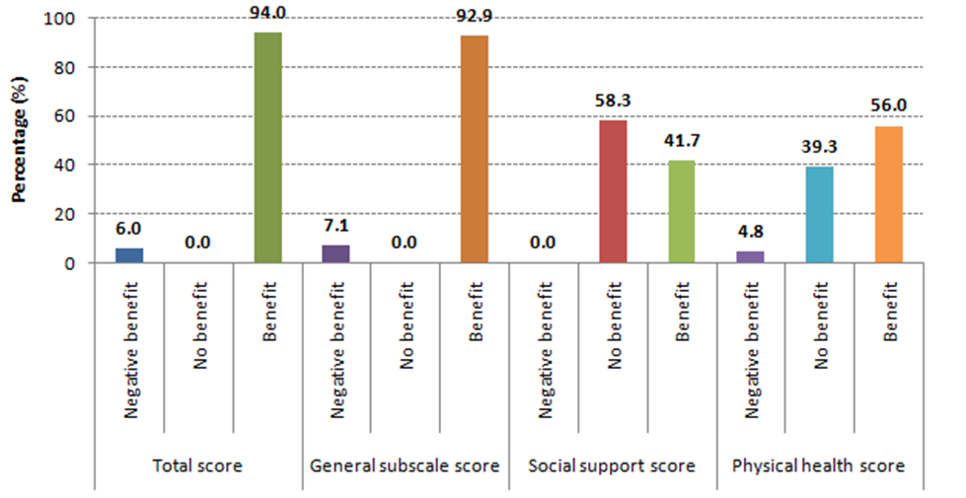

*Figure 1*

*Proportion of patients with negative benefit, no benefit and post-FESS benefit according to the GBI subscales*