**Regulations of Informed Consent: University Supported Research Processes and Pitfalls in Implementation**

**Naif Nasser Almasoud and Badaruddin Abbasi**

Imam Abdulrahman Bin Alfaisal University (IAU) Dammam, Saudi Arabia

Address correspondence and reprint requests to: **Badaruddin Abbasi** , Deanship for Scientific Research IAU, P. O. Box 1982, Dammam 31441, Saudi Arabia. Tel: +966-333-32414. E-mail: [babukhsh@uod.edu.sa](mailto:babukhsh@uod.edu.sa)

**Abbreviations**: CIOMS, Council for International Organizations of Medical Sciences; Co-I, Co-Investigator; DSR, Deanship of Scientific Research; IP, principle investigator; IRB, Institutional Review Board; KACST, King Abdulaziz City of Science and Technology; KAIMRC, King Abdullah International Medical Research Center; NCBME, National Committee of Biomedical Ethics; SCRELC, Standing Committee for Research Ethics on Living Creatures;

**Keywords**: Informed Consent; Institutional Review Board; University Research; Ethics; Regulations; Saudi Arabia; Research Integrity.

**Running title**: Regulations of Informed Consent.

**Abstract**

**Background:**The main responsibility of the Deanship of Scientific Research (DSR) is not only to fund the research but more importantly to protect and promote the rights and benefits of research participants and to monitor and review research projects for compliance. To this date, the Deanship of Scientific Research has designed a qualitative research study to find out the level of adherence to the National/International Regulations while administrating informed consent to determine its process and pitfalls.**Methodology:** The qualitative research study was undertaken in which 40 Principal Investigators administrated a questionnaire through Qualtrics online survey software to find the satisfaction level on the grant process in The University of Dammam and evaluate the informed consent process of The University of Dammam Standing Committee for Research Ethics on Living Creatures (SCRELC) approved research projects.

**Results:**The results were presented as simple proportions, means, frequencies, bar charts, and odds ratios with 95 % confidence intervals. The level of statistical significance was set is at P ≤ 0.05. Results showed that 80% of the participants were satisfied with the support being offered through DSR by the University of Dammam. Whereas, responding to questions on informed consent process, it was noted that there is a significant gap between knowledge and practice of obtaining informed consent from the research participants.

**Conclusion**: The findings warrant a strong need to disseminate national and international codes and conduct and national law and build a capacity of researchers in Research Integrity and informed consent process in Saudi Arabia

**Introduction**

The Deanship of Scientific Research (DSR) at the University of Dammam is dedicated to expand and reinforce its commitment to research, creative activity and intellectual curiosity. The Deanship of Scientific Research expects faculty and staff to continue their professional development through active participation in research and other scholarly pursuits adhering National Guidelines , International codes, Acts, Declaration and Regulations. Furthermore, the Deanship of Research will contribute towards the training of postgraduate students, local scientists, engineers, architects and clinicians in order to fulfill the objectives of the University of Dammam.

In this regard the main responsibility of the Deanship of Scientific Research is to protect and promote the rights and benefits of the research participants; in view of this the Standing Committee for Research Ethics on Living Creatures has been constituted by the University of Dammam with its secretariat located in the Deanship of Scientific Research. In 2010, by the authority of the Ministers Council in Saudi Arabia, Article 321, entitled The Law of Ethics of Research on Living Creatures (hereinafter, Law), was enacted, the Law aims to establish a general basis and required controls for dealing with living creatures, their parts, and genetic materials in the field of research according to professional ethics without contradiction with the Islamic concepts. The Law was followed by the Implementing Regulations of the Law of Ethics of Research on Living Things (hereinafter, Implementing Regulations) in 2012, which explains many of the points in the articles of the Law and provides instructions for its implementation. The Law and the Implementing Regulations together form one unit.1 No research entity is allowed to conduct research on living creatures unless and until required procedures are completed according to both the Law and the Implementing Regulations, the latter of which indicates the National Committee’s role in regulating research: “Research shall be subject to periodic inspection by the National Committee in accordance with the Regulations” (Article 3). Therefore, DSR aims through this article to explore and analyze the content of the Law and determine the degree to which it adheres. Very few studies have been conducted in the Middle East about the implementation of research ethics guidelines. However, some have appeared recently, such as the "Clinical research law in Jordan: an ethical analysis."2Professionals on the subject have expressed their feelings about the deficiencies in research regarding Ethical guidelines and regulations in other studies conducted. Finally, a study reviewed all of the existing national regulations in The Arab region: "Review of National Research Ethics Regulations and Guidelines in Middle Eastern Arab Countries"4, this last study includes a concise review of the Law and mentions some deficiencies, but it was limited to the Law and did not consider the Implementing Regulations published more recently. Consequently, DSR decided to include both the Law and the Implementing Regulations in this paper, especially since Decision No. 321 included by the Ministers Council in the Law refers to the Implementing Regulations by the National Committee of Biomedical Ethics (NCBME).

1.2 Primary Objective

Evaluate the status of administrating informed consent is the SCRELC approved research projects.

Secondary Objectives

1. To create and sustain relevant high quality Research Integrity by adhering to the

highest moral and ethical conduct in research

1. To develop and sustain effective mentoring mechanism for continued supervision and education
2. Create awareness in the communityabout the participation in research /Clinical Trials.
3. To improve compliance of National / International Guidelines, codes and conduct.

1.3 Rationale

After preliminary proposal evaluation and SCRELC approval, the researchers in conformity with the objectives of research study undertake research activities. First and foremost consideration in this regard is selection of research participants/ subjects. Majority of all research proposals submitted to the SCRELC for ethical clearance are hospital / laboratory based research studies, where visiting patients are mainly selected for participation.

As one of the duties of SCRELC is to monitor and review research project for compliance, theDeanship of Scientific Research has designed the Qualitative Research to find out the level of adherence to the National /International Regulations while administrating Informed Consent, its process and pitfalls if any.

**Methodology**

## *Eligibility Criteria for Participants*

**The study was designed to be a qualitative research in which questionnaires were given to 200 randomly selected study participants in order to find the comprehensiveness of the Informed Consent Process as part of the** University Supported Research Study.

*****Design and Sample Size Analysis*****

One hundred and fifty grant proposals were approved by the institutional review board (IRB) and 40 investigators were randomly selected to participate in the study. The participants were explained about the purpose of research and assured confidentiality and privacy. Research questions and responses were coded and entered into a single text document using standard online Qualtrics survey software. Quantitative data was then entered online and analyzed.

*****Ethical Protection of the Study Participants*****

**Before taking the informed consent, the participation in the research study was informed that the participation is voluntary, the participants wereexplained of the purpose of research and were also assured of their confidentiality, possible risks and benefits of the study were also shared with the study participants.**

*****Data Management*****

**The questionnaire was a standard, open-ended questionnaire and was administered online.The exact wording and sequences of the questionswas determined in advance; respondents were asked the same questions in the same order in open ended format. Once the respondents answer the questions, it increases the chances of comparability of responses. Each study participant’s response wasmarked by a unique identifier, listed beneath the corresponding question by the software.** The results were then presented as simple proportions, means, frequencies, bar charts, and odds ratios with their 95 % confidence intervals. The level of significance set is at P ≤ 0.05.

**Results**

Investigators, through an online survey invited researchers of funded /non funded projects to participate in the survey to assess the funding mechanism and informed consent process. Thirty seven researchers participated in the survey and 85% of participants were satisfied with the support being offered through DSR by the University of Dammam. Detailed explanation is reflected in figure-1 and Table -1 is about the satisfaction level on documentation.

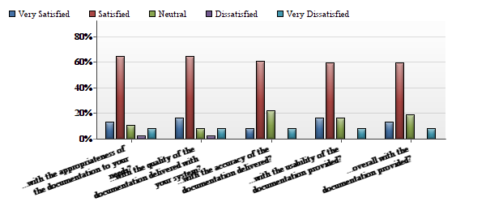

*Fig .1 showing the distribution of satisfaction on the documentations handling by Deanship of scientific Research*

|  |  |  |  |  |  |  |  |  |
| --- | --- | --- | --- | --- | --- | --- | --- | --- |
| # | Question | Very Satisfied | Satisfied | Neutral | Dissatisfied | Very Dissatisfied | Total Responses | Mean |
|  | Appropriateness of the documentation to your needs? | 13.51% | 64.86% | 10.81% | 2.70% | 8.11% | 37 | 1.27 |
|  | Quality of the documentation delivered with your system? | 16.22% | 64.86% | 8.11% | 2.70% | 8.11% | 37 | 1.22 |
|  | Accuracy of the documentation delivered? | 8.33% | 61.11% | 22.22% | 0.00% | 8.33% | 36 | 1.39 |
|  | Usability of the documentation provided? | 16.22% | 59.46% | 16.22% | 0.00% | 8.11% | 37 | 1.24 |
|  | Overall with the documentation provided? | 13.51% | 59.46% | 18.92% | 0.00% | 8.11% | 37 | 1.30 |

Tab 1.*Showing the distribution of satisfaction on the documentations handling by Deanship of scientific Research*

Further investigators were asked to respond to the Overall satisfaction level on communication between Investigators and DSR service management again the majority of respondents were satisfied with the communication and response of the deanship on their questions, quarries and concerns,(Figure- 2, Table 2-3) however almost 16% were not satisfied with the communication response of the DSR.

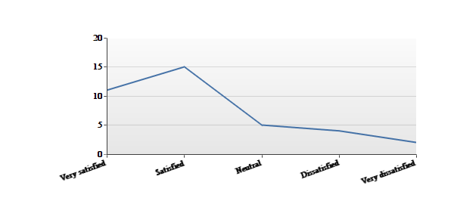

*Figure 2Overall satisfaction levels on communication between Investigators and DSR service management*

|  |  |  |  |  |  |  |
| --- | --- | --- | --- | --- | --- | --- |
| **#** | **Answer** | |  |  | | --- | --- | |  |  | | **Response** | **%** |
| 1 | Very satisfied | |  |  | | --- | --- | |  |  | | 11 | 30% |
| 2 | Satisfied | |  |  | | --- | --- | |  |  | | 15 | 41% |
| 3 | Neutral | |  |  | | --- | --- | |  |  | | 5 | 14% |
| 4 | Dissatisfied | |  |  | | --- | --- | |  |  | | 4 | 11% |
| 5 | Very dissatisfied | |  |  | | --- | --- | |  |  | | 2 | 5% |
|  | Total |  | 37 | 100% |

*Table -2 Overall satisfaction levels on communication between Investigators and DSR service management*

|  |  |
| --- | --- |
| **Statistic** | **Value** |
| Min Value | 0 |
| Max Value | 4 |
| Mean | 1.22 |
| Variance | 1.34 |
| Standard Deviation | 1.16 |
| Total Responses | 37 |

*Table 3 Showing the statistics of overall satisfaction levels on communication between Investigators and DSR service management*

In order to improve the facilitation and awareness among researchers, the participants of study were asked :“Deanship of Scientific Research (DSR) understands the service needs of Researchers” again more than 80% of total responded replied in agreement (Fig -3, Table 4-5).13 % disagree that the DSR fully understands the needs of University investigators.

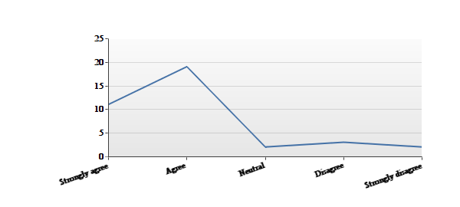

*Fig - 3 Showing that the DSR understands well the needs and requirements of the Researchers*

|  |  |  |  |  |  |  |
| --- | --- | --- | --- | --- | --- | --- |
| **#** | **Answer** | |  |  | | --- | --- | |  |  | | **Response** | **%** |
| 1 | Strongly agree | |  |  | | --- | --- | |  |  | | 11 | 30% |
| 2 | Agree | |  |  | | --- | --- | |  |  | | 19 | 51% |
| 3 | Neutral | |  |  | | --- | --- | |  |  | | 2 | 5% |
| 4 | Disagree | |  |  | | --- | --- | |  |  | | 3 | 8% |
| 5 | Strongly disagree | |  |  | | --- | --- | |  |  | | 2 | 5% |
|  | Total |  | 37 | 100% |

*Table -4 Showing the DSR understands well the needs and requirements of the Researchers*

|  |  |
| --- | --- |
| **Statistic** | **Value** |
| Min Value | 0 |
| Max Value | 4 |
| Mean | 1.08 |
| Variance | 1.19 |
| Standard Deviation | 1.09 |
| Total Responses | 37 |

*Table - 5Showing the statistics of whether theDSR understands well the needs and requirements of the Researchers*

So the majority of 85% study participants agreed that the services and support offered by DSR is great but 16% were not fully satisfied and required for the DSR to improve the services and support system.( Fig-4 , table -6 and 7).

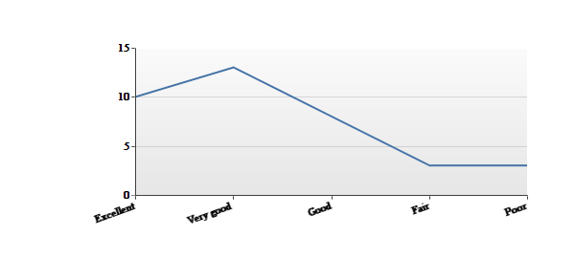

*Fig -4 Showing the overall quality, services and support of DSR*

|  |  |  |  |  |  |  |
| --- | --- | --- | --- | --- | --- | --- |
| **#** | **Answer** | |  |  | | --- | --- | |  |  | | **Response** | **%** |
| 1 | Excellent | |  |  | | --- | --- | |  |  | | 10 | 27% |
| 2 | Very good | |  |  | | --- | --- | |  |  | | 13 | 35% |
| 3 | Good | |  |  | | --- | --- | |  |  | | 8 | 22% |
| 4 | Fair | |  |  | | --- | --- | |  |  | | 3 | 8% |
| 5 | Poor | |  |  | | --- | --- | |  |  | | 3 | 8% |
|  | Total |  | 37 | 100% |

*Table -6Showing the overall quality, services and support of DSR*

|  |  |
| --- | --- |
| **Statistic** | **Value** |
| Min Value | 0 |
| Max Value | 4 |
| Mean | 1.35 |
| Variance | 1.46 |
| Standard Deviation | 1.21 |
| Total Responses | 37 |

*Table -7Showing the statistics of overall quality, services and support of DSR*

After collecting the base line information on the performance of our own department i.e. Deanship of Scientific Research, we questioned the participants regarding the enrollment of their research participants and processing of informed consent: “Have you started recruiting Research Participants?”

After The IRB approval till the filling of responses a significant percentage of 83% started recruiting research participants however 17% did not. (Fig -5, table 8 and 9)

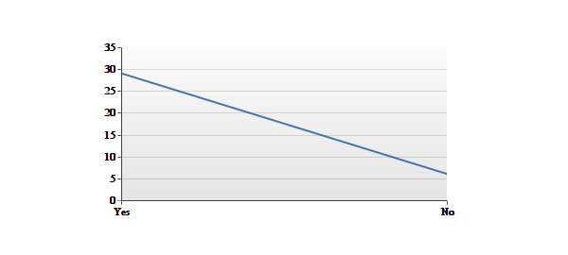

*Fig-5 Showing the status of recruiting Research Participants*

|  |  |  |  |  |  |  |
| --- | --- | --- | --- | --- | --- | --- |
| **#** | **Answer** | |  |  | | --- | --- | |  |  | | **Response** | **%** |
| 1 | Yes | |  |  | | --- | --- | |  |  | | 29 | 83% |
| 2 | No | |  |  | | --- | --- | |  |  | | 6 | 17% |
|  | Total |  | 35 | 100% |

*Table – 8Showing the status of recruiting Research Participants*

|  |  |
| --- | --- |
| **Statistic** | **Value** |
| Min Value | 1 |
| Max Value | 2 |
| Mean | 1.17 |
| Variance | 0.15 |
| Standard Deviation | 0.38 |
| Total Responses | 35 |

*Table - 9Showing the statistics of recruiting Research Participants*

When inquired about who the responsible person to obtain the informed onsent was (write only (PI, Co-I and or Research Assistant) 75% responded PI, 8% Co-I and 17% to Research Assistant (table 10 and 11)

|  |  |  |  |  |  |  |
| --- | --- | --- | --- | --- | --- | --- |
| # | **Answer** | |  |  | | --- | --- | |  |  | | **Response** | **%** |
| 1 | Principal Investigator | |  |  | | --- | --- | |  |  | | 27 | 75% |
| 2 | Co-Investigator | |  |  | | --- | --- | |  |  | | 3 | 8% |
| 3 | Research Assistant | |  |  | | --- | --- | |  |  | | 6 | 17% |
|  | Total |  | 36 | 100% |

*Table - 10Showing the status of recruiting Research Participants*

|  |  |
| --- | --- |
| **Statistic** | **Value** |
| Min Value | 1 |
| Max Value | 3 |
| Mean | 1.42 |
| Variance | 0.59 |
| Standard Deviation | 0.77 |
| Total Responses | 36 |

*Table - 11Showing the statistic of recruiting Research Participants*

Responding to question, whether or not a signed copy of Informed Consent was handed over to study Participant? Majority of Participants i.e. 63% replied yes whereas, 37% said the study participants were notgiven copies of informed consent..(Fig -6, Table 12) with mean value 1.37 with SD 0.77.(Table-13)

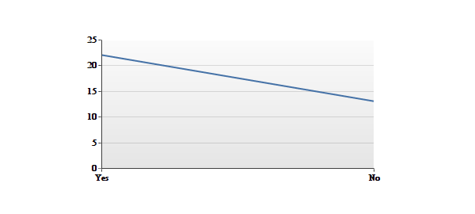

*Fig -6Showing who handed over the copy of signed Informed Consent to study Participant*

|  |  |  |  |  |  |  |
| --- | --- | --- | --- | --- | --- | --- |
| **#** | **Answer** | |  |  | | --- | --- | |  |  | | **Response** | **%** |
| 1 | Yes | |  |  | | --- | --- | |  |  | | 22 | 63% |
| 2 | No | |  |  | | --- | --- | |  |  | | 13 | 37% |
|  | Total |  | 35 | 100% |

*Table- 12Showing who handed over the copy of signed Informed Consent to study Participant*

|  |  |
| --- | --- |
| **Statistic** | **Value** |
| Min Value | 1 |
| Max Value | 2 |
| Mean | 1.37 |
| Variance | 0.24 |
| Standard Deviation | 0.49 |
| Total Responses | 35 |

*Table-13Showing statistics on who handed over the copy of signed Informed Consent to study Participant*

Upon the question “ Who signed the informed consent? ” in majority of cases i.e. 72% ,the informed consent form was signed by the PI , followed by Research Assistants 16% and 13% by the Co-Investigator (fig -7 Table 13) and SD 0.54 (table 14).

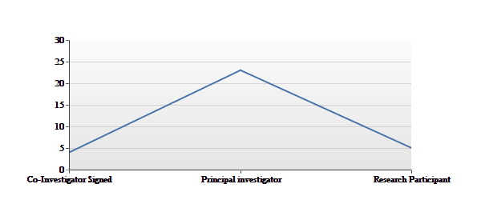

*Fig - 7 Shows who signed the informed consent*.

|  |  |  |  |  |  |  |
| --- | --- | --- | --- | --- | --- | --- |
| **#** | **Answer** | |  |  | | --- | --- | |  |  | | **Response** | **%** |
| 1 | Co-Investigator Signed | |  |  | | --- | --- | |  |  | | 4 | 13% |
| 2 | Principal investigator | |  |  | | --- | --- | |  |  | | 23 | 72% |
| 3 | Research Participant | |  |  | | --- | --- | |  |  | | 5 | 16% |
|  | Total |  | 32 | 100% |

*Table-13Shows who signed the informed consent*.

|  |  |
| --- | --- |
| **Statistic** | **Value** |
| Min Value | 1 |
| Max Value | 3 |
| Mean | 2.03 |
| Variance | 0.29 |
| Standard Deviation | 0.54 |
| Total Responses | 32 |

*Table- 14Showsstatistics on who signed the informed consent.*

Responding to question “Did you mention the contact person's name and phone number on the informed consent form, in case the participant wanted to contact?” only 31 participants responded. Figure – 8 and Table 15shows that 81 % mentioned the contact person's name and phone number on the informed consent form in case participant wanted to contact and 19% of researcher did not mention the required information on the form.

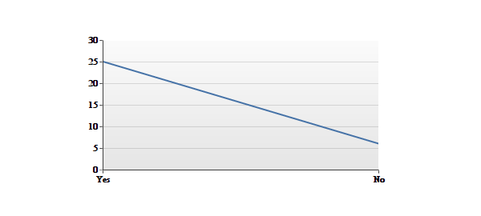

*Figure - 8Showsphone number included in the informed consent form, in case participant wants to contact*

|  |  |  |  |  |  |  |
| --- | --- | --- | --- | --- | --- | --- |
| **#** | **Answer** | |  |  | | --- | --- | |  |  | | **Response** | **%** |
| 1 | Yes | |  |  | | --- | --- | |  |  | | 25 | 81% |
| 2 | No | |  |  | | --- | --- | |  |  | | 6 | 19% |
|  | Total |  | 31 | 100% |

*Table –15Showingwhether phone number was included in the informed consent form, in case participant wants to contact.*

|  |  |
| --- | --- |
| **Statistic** | **Value** |
| Min Value | 1 |
| Max Value | 2 |
| Mean | 1.19 |
| Variance | 0.16 |
| Standard Deviation | 0.40 |
| Total Responses | 31 |

*Table –16Showingstatistics on the inclusion of phone number in the informed consent form, in case participant wants to contact.*

Figure - 9Table17 shows that according to researchers participating in this study 90% of their study participants informed and understood the nature of the research and the risks and benefits and alternatives available to them, whereas 10% of the participants could not get such information.

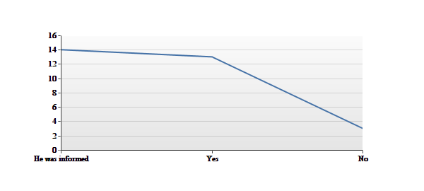

*Figure-9Showing that the Participants wereinformed and wellunderstood the nature of Research,the risks and benefits and alternatives available to them*

|  |  |  |  |  |  |  |
| --- | --- | --- | --- | --- | --- | --- |
| **#** | **Answer** | |  |  | | --- | --- | |  |  | | **Response** | **%** |
| 1 | He was informed | |  |  | | --- | --- | |  |  | | 14 | 47% |
| 2 | Yes | |  |  | | --- | --- | |  |  | | 13 | 43% |
| 3 | No | |  |  | | --- | --- | |  |  | | 3 | 10% |
|  | Total |  | 30 | 100% |

*Table – 17 Shows that the Participants were informed and understood the nature of the research, risks and benefits and alternatives available to them*

|  |  |
| --- | --- |
| **Statistic** | **Value** |
| Min Value | 1 |
| Max Value | 3 |
| Mean | 1.63 |

*Table – 18 Shows the statistics of Participants who were informed and who understood the nature of the research and its risks*

In another question our study participantswere asked:   
“Did you give adequate time to your study participants to sign the informed consent?”. And according to the answers 87% of cases study participant had an adequate time to sign the informed consent whereas, 13% of study participants could not get enough time to sign the informed consent. (Figure -10, Table-19) and SD 0.35.

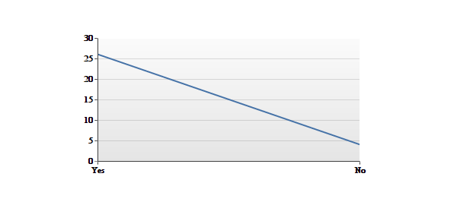

*Figure -10Shows that the study participants were given adequate time to sign or not*

|  |  |  |  |  |  |  |
| --- | --- | --- | --- | --- | --- | --- |
| **#** | **Answer** | |  |  | | --- | --- | |  |  | | **Response** | **%** |
| 1 | Yes | |  |  | | --- | --- | |  |  | | 26 | 87% |
| 2 | No | |  |  | | --- | --- | |  |  | | 4 | 13% |
|  | Total |  | 30 | 100% |

*Table -19Showsthat the study participants were given adequate time to sign or not*

|  |  |
| --- | --- |
| **Statistic** | **Value** |
| Min Value | 1 |
| Max Value | 2 |
| Mean | 1.13 |
| Variance | 0.12 |
| Standard Deviation | 0.35 |
| Total Responses | 30 |

*Table -20Shows the statistics of study participants being given adequate time to sign or not*

It was a very surprising finding for us to see 57% responses where our study participants confirmed that project related testsand procedures were undertaken on the same dayas the informed consent was signed and in only 39% cases within 2-3 days of signing the informed consent. In a more surprising finding 4% of respondents confirmed that project related tests /procedures were undertaken before getting signature on informed consent. (Figure -11, Table-19)

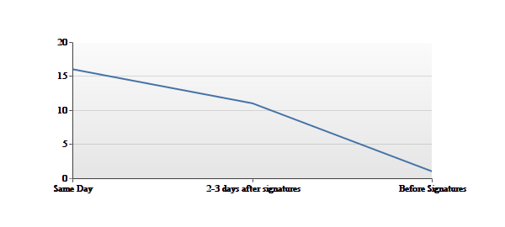

*Figure - 11 Shows when the project related tests /procedures were undertaken*

|  |  |  |  |  |  |  |
| --- | --- | --- | --- | --- | --- | --- |
| **#** | **Answer** | |  |  | | --- | --- | |  |  | | **Response** | **%** |
| 1 | Same Day | |  |  | | --- | --- | |  |  | | 16 | 57% |
| 2 | 2-3 days after signatures | |  |  | | --- | --- | |  |  | | 11 | 39% |
| 3 | Before Signatures | |  |  | | --- | --- | |  |  | | 1 | 4% |
|  | Total |  | 28 | 100% |

*Tab. 19 Showswhen the Project related tests /procedures were undertaken*

|  |  |
| --- | --- |
| **Statistic** | **Value** |
| Min Value | 1 |
| Max Value | 3 |
| Mean | 1.46 |
| Variance | 0.33 |
| Standard Deviation | 0.58 |
| Total Responses | 28 |

*Tab. 20-Shows thestatistics on when the project related tests /procedures were undertaken*

Did PI discuss the alternative treatment options available to patient?86% discussed the alternative options available to him even if he refuses to participate but 14% of respondent confirmed that they did not discuss the alternative treatment options with their study participant.( figure -12, Table-21)

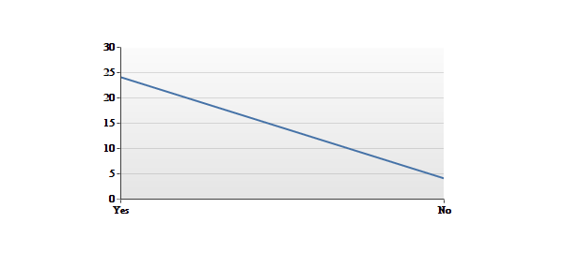

*Figure -12Showswhether the PI discussed the alternative treatment options available to the patient.*

|  |  |  |  |  |  |  |
| --- | --- | --- | --- | --- | --- | --- |
| **#** | **Answer** | |  |  | | --- | --- | |  |  | | **Response** | **%** |
| 1 | Yes | |  |  | | --- | --- | |  |  | | 24 | 86% |
| 2 | No | |  |  | | --- | --- | |  |  | | 4 | 14% |
|  | Total |  | 28 | 100% |

*Tab -21Shows whether the PI discussed the alternative treatment options available to the patient*

|  |  |
| --- | --- |
| **Statistic** | **Value** |
| Min Value | 1 |
| Max Value | 2 |
| Mean | 1.14 |
| Variance | 0.13 |
| Standard Deviation | 0.36 |
| Total Responses | 28 |

*Tab -22Shows whether the PI discussed the alternative treatment options available to the patient*

In response to the time given to research participants to answer the questions on research participation before signing the informed consent in 34% responses only ten minutes were given followed by , 20 minutes in 21% of responses and 30 minutes or more in 45% of the total responses.(figure -13 Table 23)

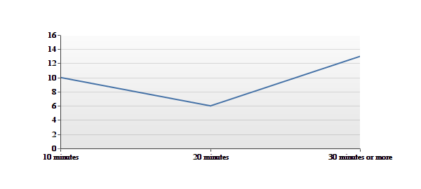

*Figure 13- Shows thetime given to the research participants in order to answer their questions*

|  |  |  |  |  |  |  |
| --- | --- | --- | --- | --- | --- | --- |
| **#** | **Answer** | |  |  | | --- | --- | |  |  | | **Response** | **%** |
| 1 | 10 minutes | |  |  | | --- | --- | |  |  | | 10 | 34% |
| 2 | 20 minutes | |  |  | | --- | --- | |  |  | | 6 | 21% |
| 3 | 30 minutes or more | |  |  | | --- | --- | |  |  | | 13 | 45% |
|  | Total |  | 29 | 100% |

*Table 23-Shows the time given to research participants in order to answer their questions*

|  |  |
| --- | --- |
| **Statistic** | **Value** |
| Min Value | 1 |
| Max Value | 3 |
| Mean | 2.10 |
| Variance | 0.81 |
| Standard Deviation | 0.90 |
| Total Responses | 29 |

*Table 24 -Statistics on the amount of time given to research participants to answer their questions*

When new information is available after study has been started 39% respondent will continue with the protocol, 35% were of the view that participants will be informed and the response of 26% was that the IRB will be informed. (Figure -14 table- 25)

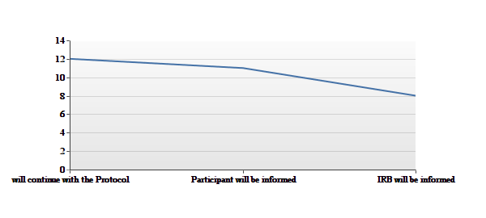

*Figure 14 Shows who will be informed when new information available after study has been started.*

|  |  |  |  |  |  |  |
| --- | --- | --- | --- | --- | --- | --- |
| **#** | **Answer** | |  |  | | --- | --- | |  |  | | **Response** | **%** |
| 1 | Will continue with the Protocol | |  |  | | --- | --- | |  |  | | 12 | 39% |
| 2 | Participant will be informed | |  |  | | --- | --- | |  |  | | 11 | 35% |
| 3 | IRB will be informed | |  |  | | --- | --- | |  |  | | 8 | 26% |
|  | Total |  | 31 | 100% |

*Table 25- Shows who will be informed when new information available after study has been started.*

|  |  |
| --- | --- |
| **Statistic** | **Value** |
| Min Value | 1 |
| Max Value | 3 |
| Mean | 1.87 |
| Variance | 0.65 |
| Standard Deviation | 0.81 |
| Total Responses | 31 |

*Table 26. Statistics on who will be informed when new information available after study has been started.*

Finally,we inquired:“Who was responsible to keep the copies of informed consent form after getting signed?”, 71% of responded that the responsibility to keep the signed copies of informed consent is with Principal investigator, 6% co-investigator and 23% with research assistant. (Figure 15- Table 27)

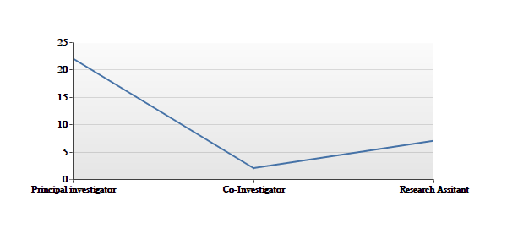

*Figure 15 Showing, who will keep the copies of informed consent forms after getting them signed.*

|  |  |  |  |  |  |  |
| --- | --- | --- | --- | --- | --- | --- |
| **#** | **Answer** | |  |  | | --- | --- | |  |  | | **Response** | **%** |
| 1 | Principal investigator | |  |  | | --- | --- | |  |  | | 22 | 71% |
| 2 | Co-Investigator | |  |  | | --- | --- | |  |  | | 2 | 6% |
| 3 | Research Assistant | |  |  | | --- | --- | |  |  | | 7 | 23% |
|  | Total |  | 31 | 100% |

*Table 27 Showing who will keep the copies of informed consent forms after getting them signed.*

|  |  |
| --- | --- |
| **Statistic** | **Value** |
| Min Value | 1 |
| Max Value | 3 |
| Mean | 1.52 |
| Variance | 0.72 |

*Table 28 – Showingthe statistics on who will keep the copies of informed consent forms after getting them signed.*

**Discussion**

Our findings clearly reflect the need to raise the awareness to adherence with National and International Guidelines, Codes, Guidelines and Laws. According to Articles (11.1) and (11.2) in the Implementing Regulations, no research can be conducted before the collection ofan informed consent signed by each research participant or legally appointed guardian to assure voluntary participation in the research. According to Article (11.2), all the following elements must be included in the informed consent: the title of the research; the name of the research institute; the objectives of the research; the risks, alternatives, confidentiality of all procedures and treatments; the period of the research; the type of samples that will be taken; that assurance that participation is voluntary; the consequences of withdrawal; the contact details of the researcher; the signature of each research subject; the date of consent; and the method of compensation. Article 12 states that "the researcher shall explain, in a comprehensible way, to the human subject or his/her guardian, all possible outcomes including unfavorable outcomes resulting from withdrawal of the informed consent if any".Informed consent must be documented (Article 13). All elements of complete informed consent stated in international research ethics guidelines, such as the GCP (Good Clinical Practice), are mentioned in the Implementing Regulations.5Consent can be waived according to Article 14, "If it is not possible to link information obtained by the researcher from the records or bio-pathological samples with the source person or if the outcomes related to individuals are available to the public."

**Respect for Research Subjects**

No research can be conducted without assuring full voluntariness and acceptance of each research subject and before getting his or her free and informed consent (Article 11). Article 17 states: "Researchersare not to exploit the condition of the human on whom the research is carried out, in any way, and the person shall not be under any coercion or exploitation."

No exploitation can be used for trafficking in fetal or human tissues and genetic data (Article 19). Privacy and confidentiality must be respected (Article 34). All research will be monitored by the monitoring offices to ensure compliance with scientific backgrounds and to maintain the research integrity. Issues related to harm and all kinds of violations will be monitored as well (Articles 8, 9, and 10). Article 1.1 gives the definition of a Safety Assessment and Information Monitoring Committee: A group of scientists, physicians, and statisticians independent from researchers, whose task is to review accumulated data during clinical experiments for prompt analysis and to observe any significant likelihood towards a certain trend in the results or unacceptable side effects requiring a recommendation for suspension of research or the modification of its plan. However, a committee by this name is not mentioned anywhere else in the Implementing Regulations, nor is it mentioned in the Law.

The conduct of clinical research is important in advancing the health of society. However, since such researches must involve human beings, a coordinated and comprehensive human subject protection program must be implemented to protect the rights and welfare of human subjects. Having clear and well-reasoned research ethics guidelines and regulations will ensure better care of research subjects and more respect for their rights. Much is being done in this regard all over the world, including the countries in the Middle East.6

The Law includes seven ethical requirements for research, which are stated by many authors.The Law and the Implementing Regulations provide many details about the structure, functions and aims of local ethics committees.Oversight at three levels, two regulatory and one administrative, assure the independent review of research in the Kingdom of Saudi Arabia. The National Committee of Bioethics (NCBE) gives national oversight to research on living creatures, exercising its control through the administrative branch called the Research Ethics Monitoring Office, which in turn oversees the work of the Local Committee. Local Committees function as independent review boards in each establishment that carries out research on living creatures. The provisions of the Law and Implementing Regulations for these entities are found in Articles 4, 5, and 6 (National Committee), 8 and 9 (Monitoring Office), and 10 (Local Committee).

The NCBE ensures that the Implementing Regulations, among other objectives, will govern sending biological samples outside of the Kingdom, supervisethe local committees, building a database of national information of Saudi society related to genetic materials, making ethical controls of clinical research and human rights and respecting confidentiality, and coordinating with other countries and organizations.

Many such committees exist in Saudi Arabia, not only in a large research center, such as the Ministry of Health, KAIMRC, King Faisal University, but also in many research centers and hospitals throughout the country. According to the Implementing Regulations (Article 10), Local Committees are established by the local establishment (public or private corporate entity engaged in research activities on living things) and then monitored by the NCBME. Many ethics committees have stated the importance of reviewing research proposals in many international guidelines, including the Declaration of Helsinki and CIOMS (Council for International Organizations of Medical Sciences) Guidelines.7

Numerous parts of the Law address the importance of minimizing risks, and the benefits must at all times override the risks. Minimal risksares more important when it is related to research on vulnerable groups. The Declaration of Helsinki and CIOMS guidelines, and many other guidelines and authors stress that the risk cannot be more than minimal.8 The Law and the Implementing Regulations show a lot of interest in vulnerable groups through a specific chapter dedicated to conducting research on prisoners, children or pregnant women.

The Law and the Implementing Regulations consider Islam a source of ethics and research ethics. Article (1.3) “Principles Governing Provisions of the Law and its Regulations,” states:In interpretation and application, the provisions of the Law and its Regulations shall be subject to TheShariah provisions as adopted by official bodies in the Kingdom, laws and controls set by the National Committee, and principles of human rights, without prejudice to provisions of Sharia.

Even though no certain Islamic resource or fatwa has been identified as the basis of the Law or the Implementing Regulations, all seven ethical requirements set out in the Law and the "Implementing Regulations match the Islamic Opinion expressed by the Islamic Organization of Medical Sciences IOMS.9 Moreover, fatwas have been released by many international and national juridical councils, specificallythe International Islamic Fiqh Academy, the Islamic Fiqh Council, the Dar-Alifta Al-Misrriyah, among others.10

It is easy to see how the four main ethical principles reflect on the different articles of Saudi law. Requiring local ethics review, respecting social factors, mandating informed consent and other requirements agree with the principles of respect of person. Favorable assessment of risks and benefits, besides other articles reflect respecting of beneficence and non-maleficence principles. Fair selection of research subject comes from the justice principle.

**CONCLUSION**

Saudi Arabia is one of the few Arab countries in the Middle East that has national regulations that govern clinical research. As such, the Law should be used as an example for other countries in the Arab region on the subject of the significance of having national regulations that regulate clinical research and offer protection to research subjects.

Conducting research is very important to medical advances and consequently to enhancing medical care. However, conducting research violates the rights of and causesharm to research participants or communities. Having good guidelines to regulate clinical research plays a significant role and is sure tohelp in offering better protection.

This paper has discussed important aspects of informed consent process and pitfalls in university supported research and implementing regulations and has shown a respect for the ethical requirements mentioned by many authors. These requirements include independent review of research, informed consent, scientific validity, fair subject selection, favorable risk benefit assessment, respect for enrolled subjects, and social value. Therefore, DSR suggests that this law shouldbe used as a reference to research ethical guidelines in the region.

**Implications**  
The findings warrant a strong need to disseminate national and international code and conduct and national law and build capacity of researchers in Research Integrity and informed consent process in Saudi Arabia.

**Acknowledgement**

This work was supported in part by Deanship of Scientific Research, University of Dammam Supported Research Study Grant(2014266).