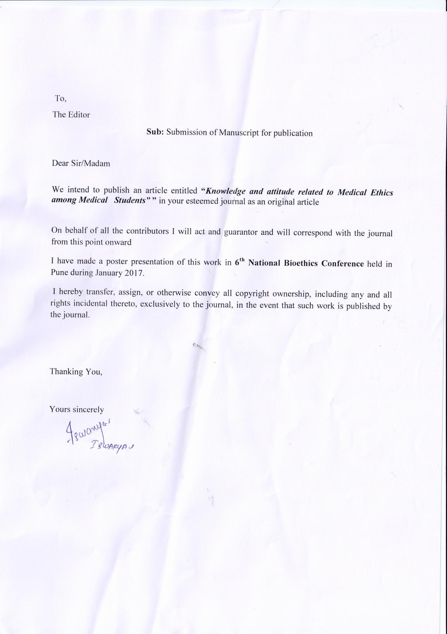

Original Article

**“*Knowledge and attitude related to Medical Ethics among Medical Students”***

**Running Head:** Knowledge and attitude to Medical Ethics

**Authors:**

1. **Dr. Iswarya S**, Assistant Professor, Dept of Community Medicine PSG Institute of Medical Sciences & Research

Mailing address: Dept of Community Medicine

PSG IMS& R,

Coimbatore

Tamil Nadu

641004

Mobile Number: 9843542576

e-mail address: ishwarya3386@gmail.com

1. **Dr. Bhuvaneshhwari S**, Professor, Dept of Pharmacology, PSG Institute of Medical Sciences & Research

Mailing address: Dept of Community Medicine

PSG IMS& R,

Coimbatore

Tamil Nadu

641004

Mobile Number: 9865561463

e-mail address: bhuvana1421@gmail.com

**Corresponding Author:** Dr. Iswarya, PSG IMS&R

**Disclaimers:** None

**Source of support:** None

