TITLE

EFFECT OF MUSCLE ENERGY TECHNIQUE ON UPSLIP AND INFLARE DYSFUNCTION OF SACROILIAC JOINT: A CASE REPORT

1. Saumya Srivastava

Affiliated to: Nitte University, Mangalore, Karnataka

Mailing address: Nitte institute of Physiotherapy, Derlakatte, Mangalore, Karnataka, 575018

Mobile number: 9740244077

Email id: [saumyasri2000@yahoo.com](mailto:saumyasri2000@yahoo.com)

1. Dr. Dhanesh Kumar KU

Affiliated to: Nitte University, Derlakatte, Mangalore, Karnataka

Mailing address: Nitte institute of Physiotherapy, Derlakakatte, Mangalore, Karnataka, 575018

Mobile number: 9019431417

Email id: dhaneshphysio@yahoo.co.in

1. Dr. Harramb Mittal-

Affiliated to: Apollo Hospital, Bangalore, Karnataka

Mailing address: Apollo hospital, Benerghatta road, Bangalore, Karnataka, 560076

Mobile number: 9318850811

Email id: [dr_harramb@yahoo.co.in](mailto:dr_harramb@yahoo.co.in)

Source of support: All the equipment used in the study is provided by Nitte University.

Conflict of interest: none

Disclaimer:  the details in the article are author’s own work and not the funders/institutions.

**ABSTRACT:** Sacroiliac joint dysfunction is an important pain generator of low back. Upslip and inflare is a rare type of dysfunction with no documented evidence regarding its management. Here we report a case of 31 year old female patient with this dysfunction, who underwent 4 days of Muscle Energy Technique (MET). The technique works by reducing tension in the muscle and thus correcting the malalignment. The patient showed improvement in symptoms at the end of the 4th day and difference in the pre and post values of Pain Pressure Threshold (PPT), Visual Analogue Scale and Oswestry Disability Index (ODI) was seen. Till date, no study has been done to see the effect of MET on upslip and inflare sacroiliac joint dysfunction. We suggest the use of MET in effectively treating this less frequent type of dysfunction.

Keywords: sacroiliac joint dysfunction, muscle energy technique, low back pain, malalignment, upslip, inflare.

**INTRODUCTION**

Sacroiliac joint (SIJ) dysfunction refers to the pain resulting from the abnormal position of the anatomic landmarks of the right and the left innominate bones(1).Prevalence rate is 13.8% - 47.9%, out of which most frequent mal-alignment is rotational (80-85%), pelvic flare (40-50%) and upslip (15-20%)(2,3,4). Patients with SIJ dysfunction presents with pain at the Posterior Superior Iliac Spine (PSIS), groin, buttock, and lower limb(5,6). Functional activities like standing, walking, climbing stairs aggravate pain, lying and sitting position reduces pain. SIJ can normally move 2 degrees upward and downward. Excessive upward translation can result in the ‘upward fixation’ of an innominate which is referred to as SI joint ‘upslip’(2)*.*

An upslip is identified through palpation of heights of 3 bony landmarks: Anterior Superior Iliac Spine (ASIS), Posterior Superior Iliac Spine (PSIS), Iliac crest (7). An upslip is diagnosed when all the 3 landmarks are elevated when compared to the contralateral side (8). An upslip can occur due to traumatic injury to a muscle or an uneven muscular tension on one side compared to other, that can pull the innominate in an upward direction (2).

An‘inflare’is an inward movement of the innominate, around the vertical axis in the transverse plane (2). It can be determined by measuring the distance between the umbilicus to ASIS on either side (2, 9). Affected side will demonstrate a shorter distance as compared to the contralateral side(2,10)**.** Imbalance of muscles or positional faults can lead to inflare dysfunction. Inflare is frequently seen in association with an upslip. An upslip may withstand treatment efforts using the muscle energy technique (MET) until a concomitant ‘inflare’ has been corrected first (2).

Muscle energy technique (MET) is a part of manual therapy which was, first proposed by Mitchell. It involves the use of therapist prompted muscular activation by the patient (9,11). MET has been an effective technique in successfully treating commonly occurring innominate rotation dysfunction (5,12,13). However, the effect of MET in upslip and inflare is not yet demonstrated. Hence the objective of this case report is to identify and treat a type of sacroiliac dysfunction, which is not very common.

**CASE DESCRIPTION**

A 31-year-old housewife visited the centre with the chief complaint of left side low back pain, radiating to left buttock and back of the thigh, till above the knee since 4 months. There was no history of trauma, numbness or previous back ache. After prolonged bending, while washing clothes, the patient first noticed a gradual onset of symptoms on the left side of the back. The following week, pain progressed t to buttock and thigh while climbing stairs. She then consulted a physician who pre­scribed her analgesics, which gave her slight temporary relief. According to the patient, her pain intensity on Visual Analogue Scale (VAS) was 8/10 but mildly irritable. Her pain aggravated with walking, standing for more than 5 minutes, weight shifting to the left side, forward bending and lying on the same side. Her symptoms relieved with sitting and supine lying. The patient did not complain of pain during coughing or sneezing.

**Physical examination**

Just before the patient was examined a low back Oswestry Disability Index (ODI) scale and Visual Analogue Scale (VAS) was administered. The score was 38 and 8 respectively.

Observation: there was no evidence of exaggerated lumbar lordosis, kyphosis or lateral shift. Left iliac crest, left ASIS and left PSIS was elevated. This observation was established by using Palpation meter (PALM), a reliable instrument (12), showed: left innominate was 7 degrees higher than the right side. This was further confirmed by measuring apparent limb length discrepancy using inch tape from umbilicus to medial malleolus on both the sides (2). Right limb length was 105.5 cm and left limb length was 104 cm. These findings signified an upslip dysfunction. It was also noticed during posture evaluation that, left ASIS was closer to the midline. An inch tape measurement was done from umbilicus to right ASIS and left ASIS(2,10). The distance from umbilicus to right ASIS was 15cm and to the left ASIS was 14 cm. This finding suggested a left inflare.

Palpation: patient complained of similar pain medial to left PSIS on the application of a posterior-anterior pressure. Pain pressure threshold was recorded using Algometer(4) was 14N. There was no pain in the lumbar region on subjecting to posterior-anterior pressure grade III over the lumbar spinous processes from L1 to L5.

Range of Motion: active range of motion was done for all the movements of the lumbar spine and it was found that flexion was painful and right side bending was restricted. Hip range of motion was also checked and it revealed restricted left side external rotation.

Muscle length testing: revealed left side quadratus lumborum tightness, left adductor tightness and mild bilateral hamstring tightness.

Special Tests: the patient had negative SLR, negative distraction test, positive fortins finger sign, compression test, thigh thrust test, sacral thrust test, supine to long sitting test, prone knee flexion test, palpation of PSIS heights in sitting position and standing flexion test.

**Course of treatment**

The patient was asked to visit the outpatient department of Physiotherapy of KS Hegde Medical Hospital, Mangalore, Karnataka. Before the intervention patient was administered pain pressure threshold, Visual analogue scale, and Oswestry disability index to record pre-intervention outcome measure.

Treatment Protocol: the patient was given moist heat before starting MET technique for 20 minutes, followed by MET for upslip and inflare for four days (Table 1). The treatment also incorporated ergonomics advices and back strengthening exercises as a part of home program.

**MET for Upslip:**

The patient was made to lie in supine, while the therapist stood at the end of the left leg, facing the patient. The therapist held the left leg in an abduction of 10-15 degrees, with both the hands. The therapist then internally rotated the left leg and pulled the leg inferiorly (fig. 1a), while the patient took deep breaths in and out with efforts for about 3-4 times. During the end of the last exhalation, the therapist applied a quick longitudinal pull on the leg (fig. 1b). The technique was performed for three times. Followed by this, the patient was given rest for ten minutes. Then she was treated for inflare (11).

**MET for Inflare:**

The patient was made to lie in supine, with the left hip and knee flexed and left foot kept on the right knee. Therapist’s right hand was placed over right ASIS of the patient, whereas the left hand was kept on the medial side of the patient’s left knee (fig. 2a).The Patient was asked to perform contraction for 6 seconds, attempting internal rotation of the left leg, while the therapist provides an equal and opposite force towards external rotation (fig. 2b). The therapist then found a new external rotation barrier and repeated the process. The technique was performed for three times (11).

**Table 1: Treatment protocol**

|  |  |  |  |  |
| --- | --- | --- | --- | --- |
| Session | Modality | Manual Therapy | Manual Therapy | Exercises |
| Day 1- Day 3 | Moist heat for 20 minutes | MET for upslip: 4 repetitions followed by rest | MET for inflare: 4 repetitions followed by rest | Advised for back ergonomics |
| Day 4 | Moist heat for 20 minutes | MET for upslip: 4 repetitions followed by rest | MET for inflare: 4 repetitions followed by rest | Taught back strengthening exercises, back care as part of home program |

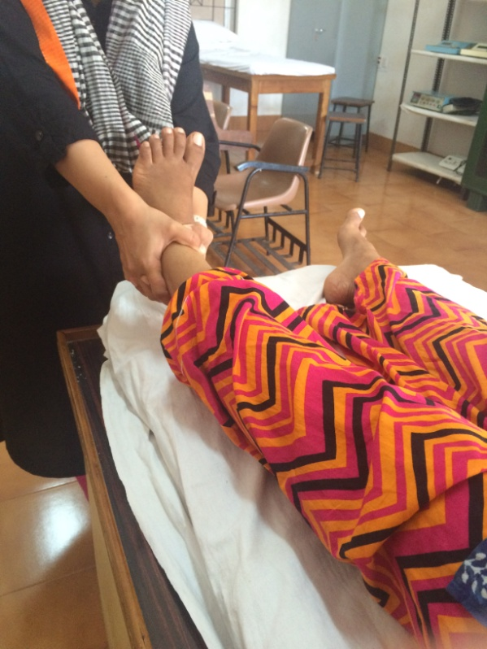

**Figure 1a**

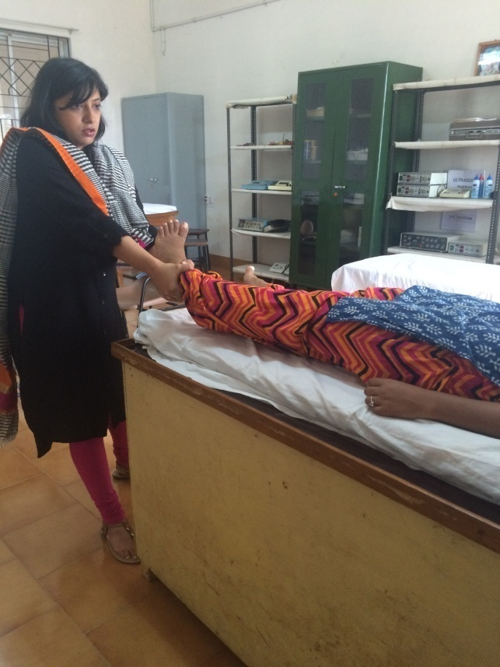

**Figure 1b**

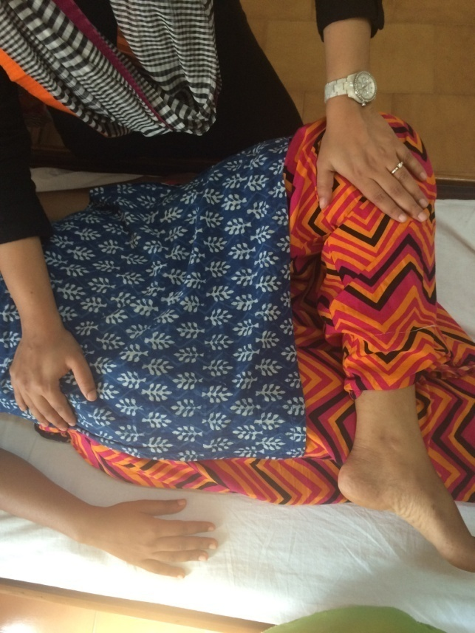

**Figure 2a**

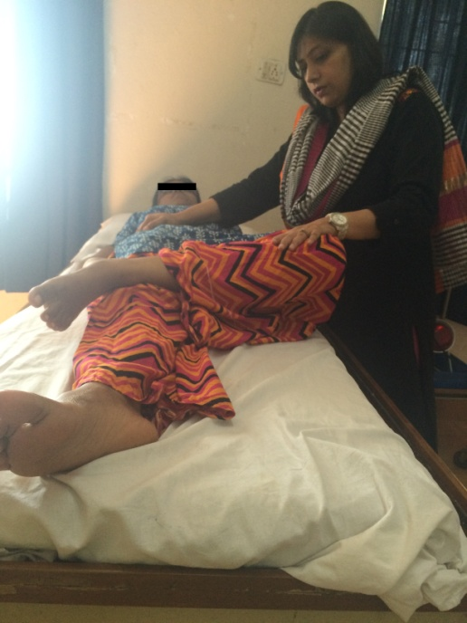

**Figure 2b**

**RESULTS**

After 4 days of treatment sessions, outcome measures were re-assessed. When pre-intervention readings were com­pared to post-intervention readings significant improvement was observed in the scores (Table 2). The patient also confirmed marked improvement in tenderness, pain and functional activities. All the pain provocation tests and tests of symmetry were repeated and found to be normal.

Table 2: Pre and Post intervention data

|  |  |  |
| --- | --- | --- |
| OUTCOME MEASURES | PRE-INTERVENTION | POST-INTERVENTION |
| Pain Pressure Threshold | 14N | 28N |
| Visual Analogue Scale | 8 | 2 |
| Oswestry Disability Scale | 38% | 16% |

**DISCUSSION**

Upslip and inflare dysfunction of SI joint occur less frequently as compared to rotational dysfunction. An upslip is seen only in 5-10% of those having inflare (2). This type of dysfunction occurs less commonly but contributes to a considerable amount of Low Back Pain (10). In the current study, the patient was assessed in detail using diagnostic tests given by Laslett et al (14) and tests of symmetry given by Cibulka and Koldehoff (15). On detailed evaluation patient was diagnosed to have an upslip and inflare dysfunction of the sacroiliac joint. The patient witnessed improvement in symptoms and outcome measures post four day sessions of Muscle Energy Technique. Pain pressure threshold was improved from 14N to 28.44 N. A significant decrease in VAS was observed from 8 to 2 and there was also an improvement in ODI score from 38% to 16%.

There are only a few studies which have been done to find the effectiveness of MET on SI joint dysfunction, specific to rotational malalignment (10, 12). A case report suggested utilization of MET along with stretching exercises in upslip dysfunction leading to testicular pain (7). The current study is the first study to examine the effectiveness of MET on upslip and inflare dysfunction.

An abnormal increase in the muscle tension can lead to malalignment or aberrant position of the joint. This asymmetry which is caused in pelvic unit leads to increased shear stresses on loading which in turn further promotes to upslip/ inflare dysfunctions. Thus causing pain and functional limitations. In the current study, patient had the tightness of left quadratus lumborum and left adductors tightness, which is the probable reason for upslip and inflare dysfunction respectively (2).

The present study has used the techniques as mentioned by Greenman, to correct upslip and inflare. He defined MET as a “manual medicine treatment procedure that involves the voluntary contraction of the subject’s muscle in a precisely controlled direction, at varying levels of intensity, against a distinctly executed counterforce applied by the therapist”. He has stated that MET can be used to lengthen a tightened muscle or strengthen a weakened muscle (11). A tightened or a weakened muscle can lead to malalignment of SIJ and hence lead to a dysfunction. In this study tightened quadratus lumborum and adductors has led to the dysfunction. Usage of MET has reduced the tension in the mentioned muscles by the phenomenon of post isometric relaxation and thus realigning the pelvic unit and thereby relieving symptoms. The technique also takes less time to administer and it uses low force isometric contraction in a pain free position (12). Hence it can be applied to the patient without causing pain or harm.

**CONCLUSION**

Sacroiliac Joint Dysfunction is one of the important pain generator. The types can be diagnosed by detailed history and examination. Management of these dysfunction using MET techniques have found to be beneficial in reducing pain and improving function. However, there is further need of doing study on larger sample size and should also be compared with other manual therapy techniques.

**REFERENCES**

1. Laslett M. Evidence based diagnosis and treatment of painful sacroiliac joint. J Man ManipTher. 2008;16(3):142-52.
2. Schamberger W. The Malalignment Syndrome-diagnosing and treating a common cause of acute and chronic pelvic, limb and back pain. 2nd ed. London. Elsevier; 2013.
3. Kumar NS, Akalwadi A, Babu KV, Wani ZR. Efficacy of adductor pull back exercise on pain and functional disability for sacroiliac joint dysfunction. Int J Physiother. 2015;2(4):667-75.
4. van Leeuwen RJ, Szadek K, de Vet H, Zuurmond W, Perez R. Pain Pressure Threshold in the Region of the Sacroiliac Joint in Patients Diagnosed with Sacroiliac Joint Pain. Pain Physician. 2016 Mar;19(3):147-54.
5. Neha B, Arunmozhi R, Maneesh A, Pooja A. Effectiveness of therapeutic interventions in sacroiliac joint dysfunction. Int J Physiother Res. 2016;4(3):1484-88.
6. Donatelli RA, Wooden MJ. Orthopaedic Physical Therapy. 4th ed. London. Churchill Livingstone: Elsevier; 2009.
7. Leone JE, Middleton S. Non traumatic testicular Pain due to sacroiliac joint dysfunction. J Athl Train. 2016; 51(8):651-57.
8. Mott G, Brusgul JH, Vittone D, Haskvitz EM. The use of manual physical therapy in the treatment of sacroiliitis: a case report [DPT thesis]. Sage Graduate School;2010 [cited 2010 May 11]. Available from Sage Colleges Library Catalog. <http://library.sage.edu/>
9. Chaitow L. Muscle Energy Techniques. 3rd ed. Churchill Livingstone: Elsevier; 2006.
10. Bindra S. Pelvic dysfunction in pregnancy. Indian journal of fundamental and applied life sciences. 2014;4(2):211-215.
11. DeStefano L. Greenman’s Principles of Manual Medicine. 4th ed. Baltimore. Lippincott Williams & Wilkins; 2011.
12. Selkow NM, Grindstaff TL, Cross KM, Pugh K, Hertel J, Saliba S. Short term effect of muscle energy technique on pain in individuals with non-specific lumbopelvic pain. J Man ManipTher. 2009;17(1):E14-8.
13. Bindra S. A study on the efficacy of muscle energy technique as compared to conventional therapy on lumbar spine range of motion in chronic low back pain of sacroiliac origin. Human Biology Review. 2013;2(4):336-48.
14. Laslett M, Aprill CN, McDonald B, Young SB. Diagnosis of sacroiliac joint pain: validity of individual provocation tests and composites of tests. Man Ther. 2005 Aug;10(3):207-18.
15. Cibulka MT, Koldehoff R. Clinical usefulness of a cluster of sacroiliac joint tests in patients with and without low back pain. J Orthop Sports Phys Ther 1999 Feb;29(2):83-92.